The UN General Assembly (November 2010) unanimously passed the resolution to recognize the World Interfaith Harmony Week annually during the first week of February.

The World Interfaith Harmony Week provides a platform where all interfaith groups and other groups of goodwill can show the world what a powerful movement they are. For more details see www.yhteisymmärrysviikko.fi.

Interfaith Harmony Week 2014 in Finland
Events which do not require command of Finnish

MUSIC
Sat 1.2. at 15-17 Opening of the Interfaith Week and
Sacred Music –concert
Musical experiences from different religious traditions
Place: Kulttuurikeskus Caisa, Mikonkatu 17 C, Helsinki
Organiser: FOKUS ry
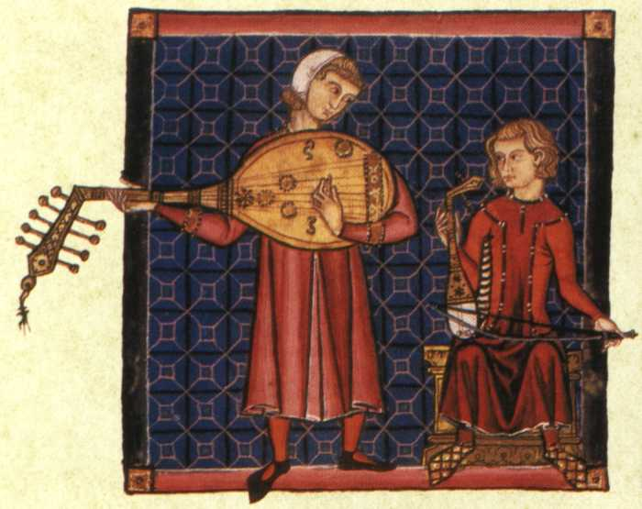
Fiamma Nova: Medieval Iberian songs from a Marian cults which crossed religious boundaries between Christians, Muslims and Jews

Sheine Ite:
Ladino Jewish, east European klezmer and Israeli music

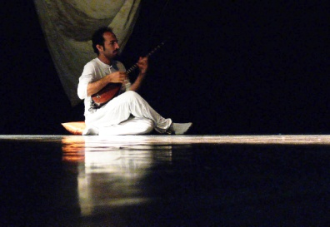
Marouf Majidi: sufi music from Western Iran

plus possibly a group from Fez World Sacred Music Festival (not confirmed)

Thur 6.2. at 18-19 Gregorian chant
Liturgical music of Middle Ages
Place: Kallio Church, Itäinen Papinkatu 2, Helsinki
Organiser: Kallio congregation and FOKUS ry

SEMINAR

Mon 3.2. at 16 Peace Forum: Arab Spring, Israeli Autumn, Palestinian Winter?
Antti Pentikäinen, Finn Church Foreign Aid, Executive Director
”Broader developments in the Middle East and Israel/ Palestine”
Gideon Levy, Journalist
”To be within and feel without: Israeli society and the occupation”
Mouin Rabbani, Institute for Palestine Studies Senior Fellow
”The Question of Palestine: Resolution through Internationalisation”
Place: University of Helsinki, Porthania Auditorium II; Yliopistonkatu 3
Organisers: Hakunilan kansainvälinen yhdistys & ICAHD

OTHER EVENTS

Sat 1.2. at 11-13 Interfaith ’market place’
Place: Kulttuurikeskus Caisa, Mikonk. 17 C, Helsinki
Organiser: MoniHeli ry

Fri 7.2. at 17-19 A Gathering of Cultures
Place: Activity Center Happi, Sörnäisten rantatie 31, Helsinki
Organisers: Buddhist Union, FOKUS ry, The Islamic Council of Finland SINE
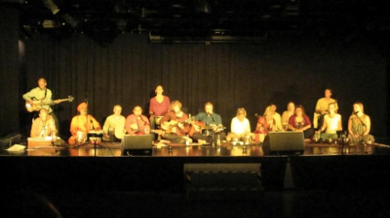
calligraphy workshop, ethnofood, vietnamese dance, music by Bhajan People (photo), Burhan Hamdon, etc.
Sat 8.2. at 14.00 Free soup and dialogue at the Kolmen Sepän patsas
Place: Kolmen Sepän aukio, Helsinki
Organisers: The Islamic Council of Finland SINE and FOKUS ry

