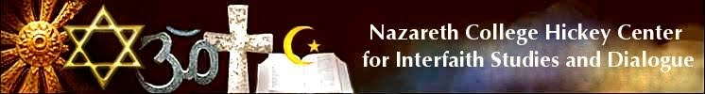

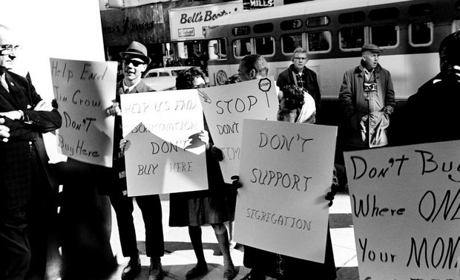

Dr. Martin Luther King’s leadership in “non-violent” resistance to bigotry is vital testimony to the success of the freedom movement in Twentieth Century America. King’s profound journey into American practices evokes the vision of a Beloved Community, an world, in which “trust triumphs over fear and hatred.”

Where: Nazareth College, Otto Shults Community Center Forum
When: February 4, 2014, 7pm
An illuminating review of key elements in the freedom movement, unfolding in the Greater Rochester region, will be led by:

Rev. Dr. John Walker, scholar and Pastor, Christian Friendship Baptist Church

Rev. Dr. Marvin McMickle, President, Colgate Rochester Crozer Divinity School

Imam Hanif Abdul-Wahid, Rochester native and activist, and founding member, Rochester-Monroe County Freedom Trail Commission.

Moderator: Dr. David Anderson, Visiting Community Scholar, Nazareth College
This event is free and open to the public.

Cosponsored by: Religious Studies, The Institute for Pluralism, and the College Lecture Committee

