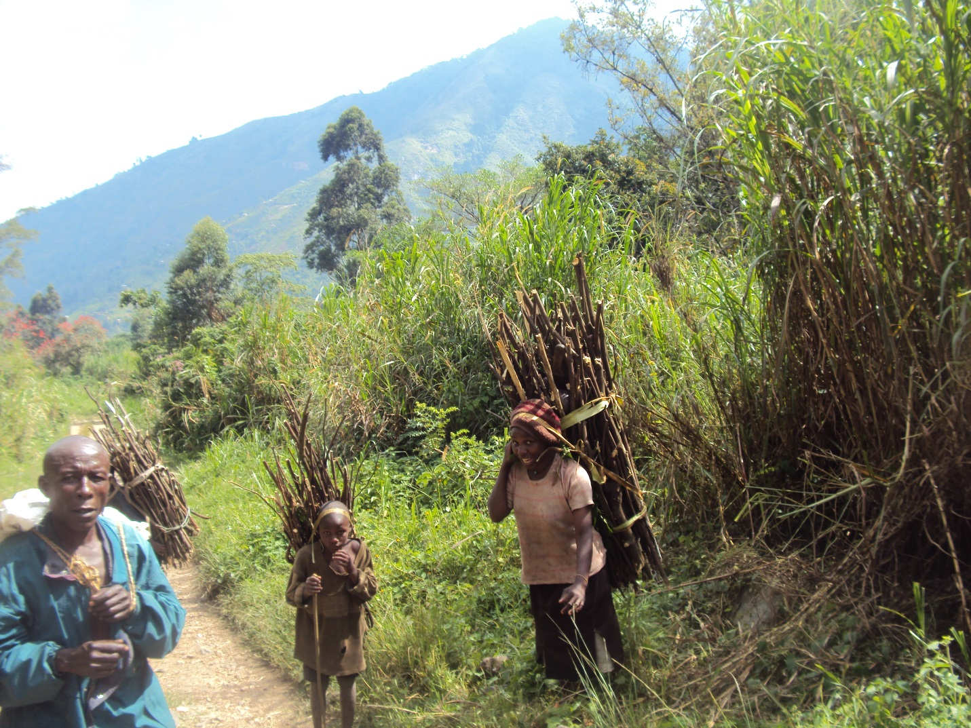
What can the unison in diversity of world religions can do to reach the needy that needs equal services for their necessities in life?

