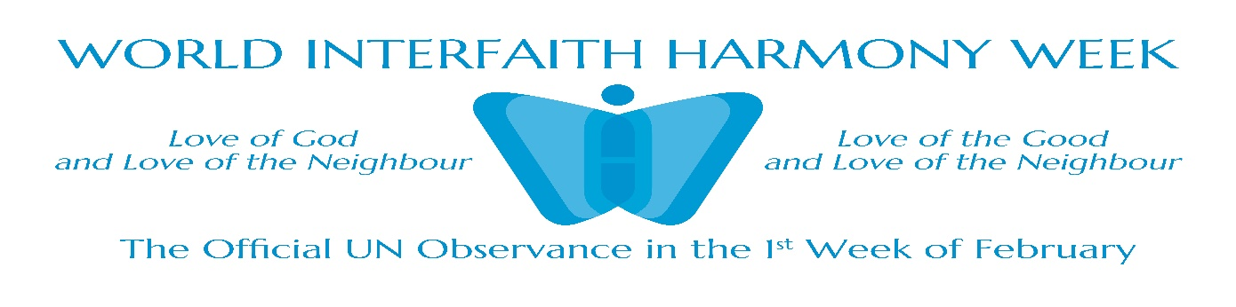
COSMIC COMMUNITY CENTRE
&
United Religions Initiative (URI)
South India Region
Karickom P.O., Kottarakara Kollam, Kerala PIN 691531

REPORT
Greetings from Global Peace promoting NGO!

It is with great pleasure that I, on behalf of Cosmic Community Centre and United Religions Initiative (URI), extend my full support for World Interfaith Harmony Week 2026. As a peace builder through interfaith harmony, justice, healing and unity, this initiative holds immense significance in our increasingly interconnected world. In an era often marked by division, we trust that World Interfaith Harmony Week serves as a powerful reminder of the common threads that bind humanity. By fostering dialogue, respect, and cooperation among people of diverse faiths, we can build bridges of peace and harmony. We embrace this opportunity to celebrate our shared values and work towards a future where tolerance and compassion prevail. Let us harness the power of interfaith understanding to address the challenges that confront our world today.
We are happy to report our programs during the Interfaith Harmony Week, as per the above schedule involving several groups of our associates:
All the programs as planned during the period from 31st January till 7th February 2026 were carried out successfully, creating good awareness among the people of different walks of life through various campaigns, public processions, print and visual meadias, etc.
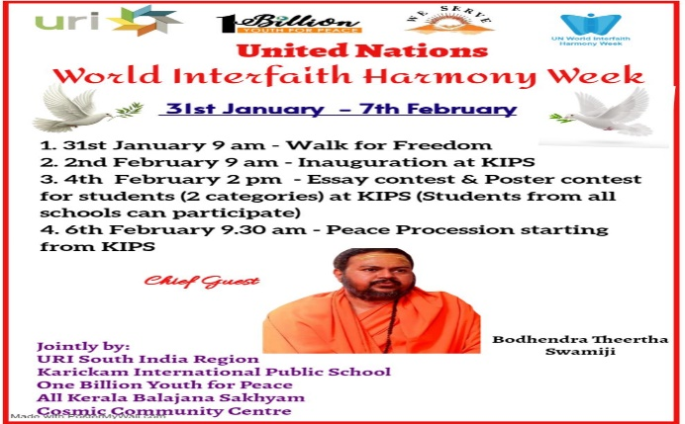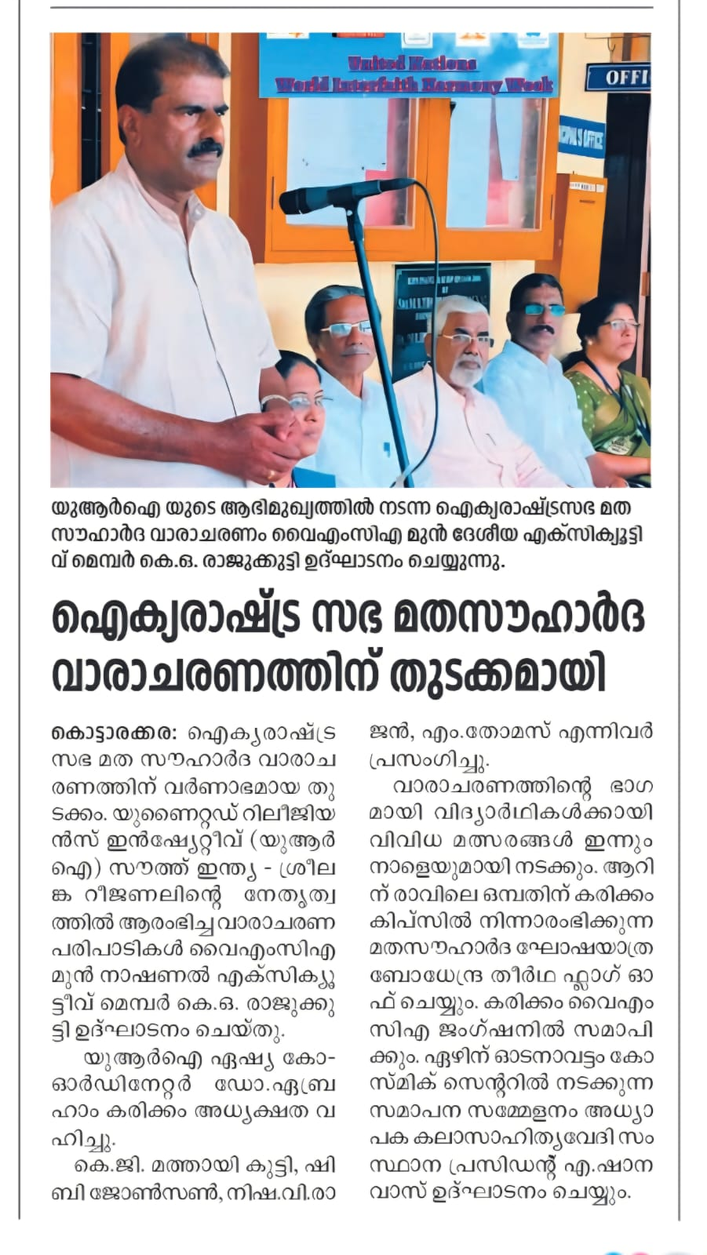

31st January 2026

- Short Film contest amongst Schools on Violence Prevention.

- Walk for Freedom – a silent walk with placards and slogans depicting voices against illegal migration, religiously motivated violence, etc. holding front banners, including that of World Interfaith Harmony Week involving people from all walks of life.

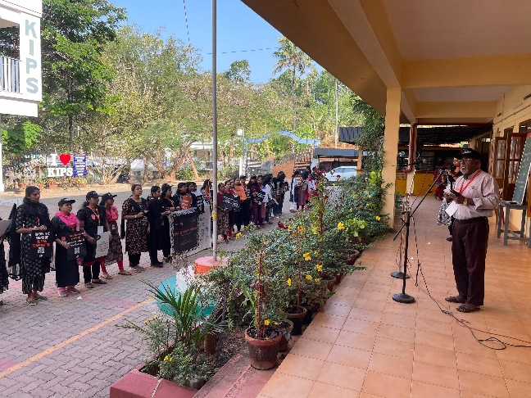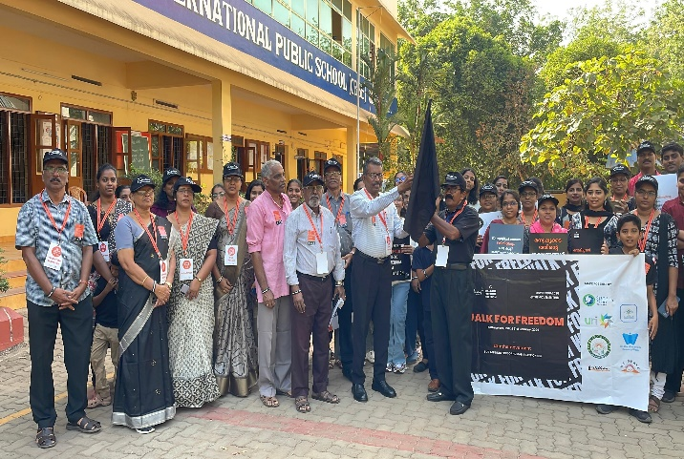

Print Media – Leading Newspaper clippings are furnished below:
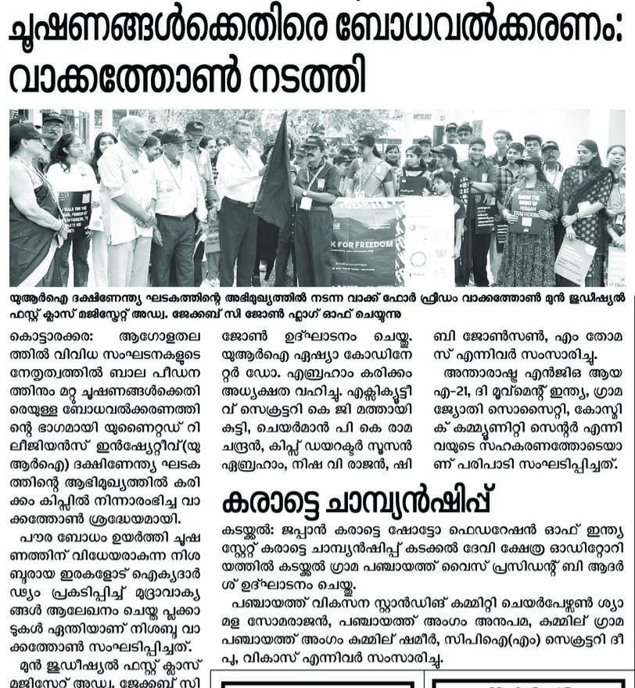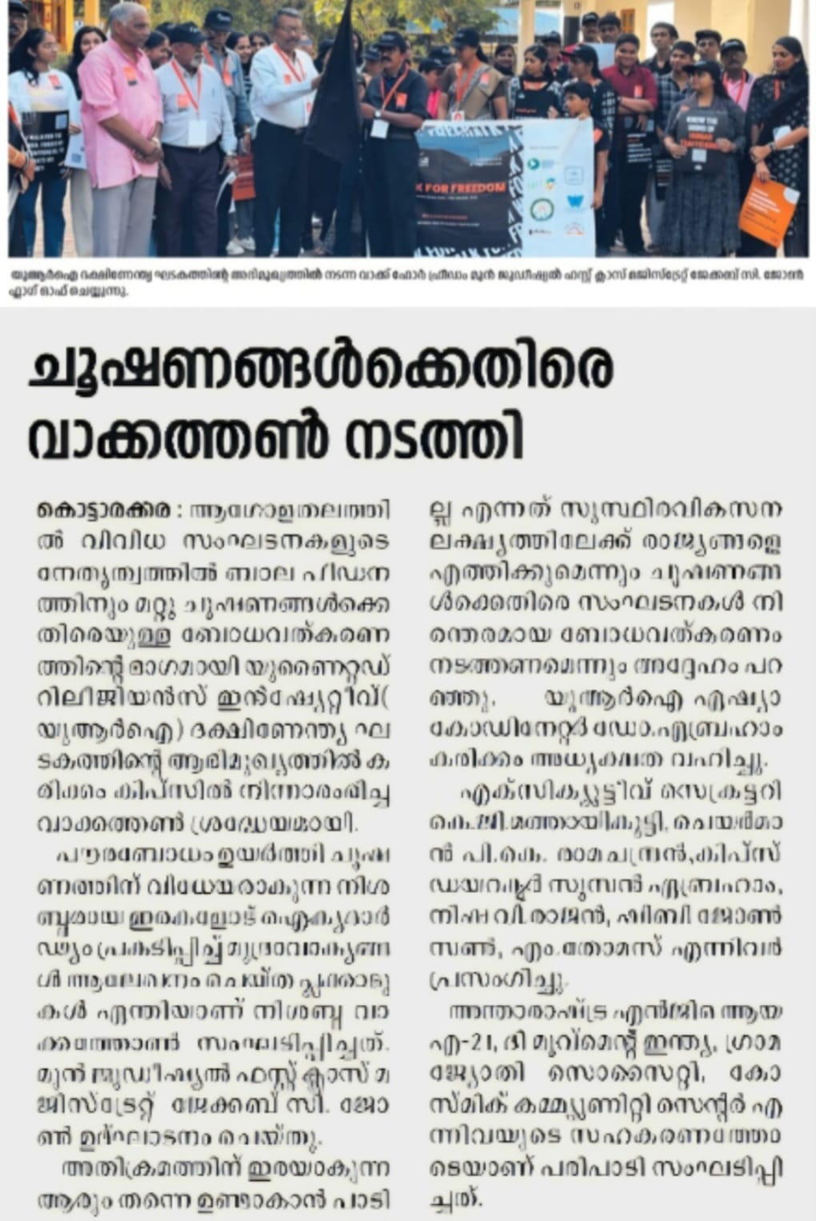

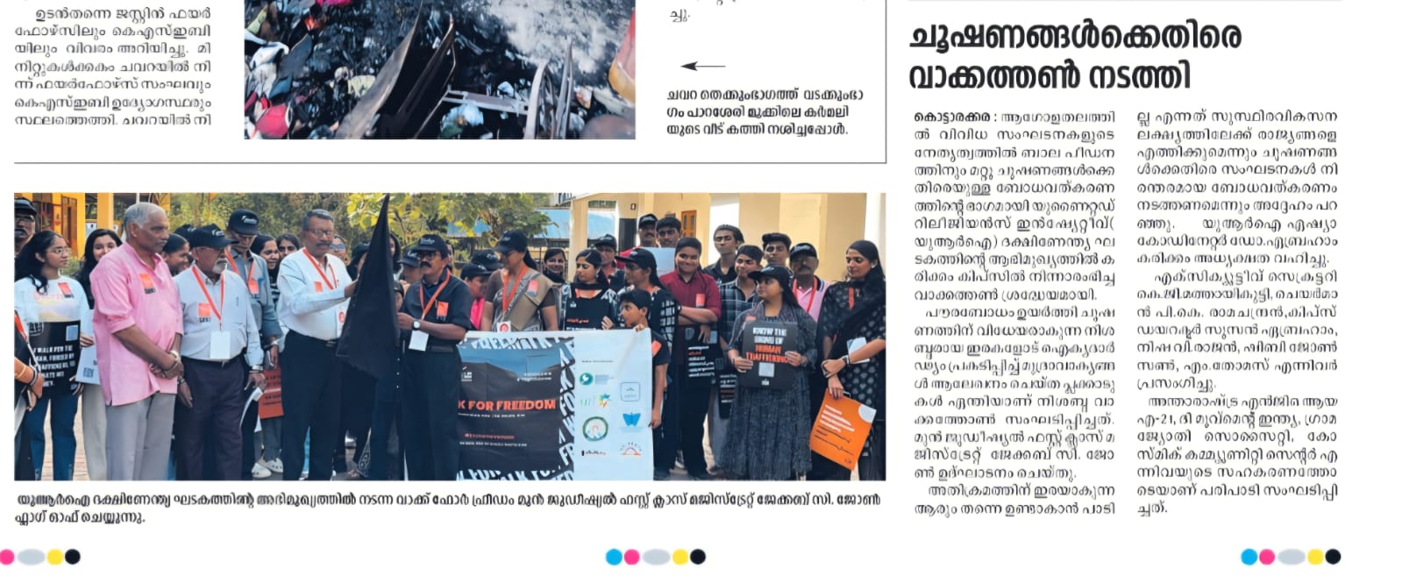

Video link

https://drive.google.com/file/d/1PqcC5fBTFy_frmvLn1tFXE6h-8zhJeN0/view?usp=drivesdk

2nd February, 2026
The United Nations Interfaith Harmony Week Program was inaugurated involving leaders and general public representing different religious, educational, cultural, youth and social organizations.

4th February 2026
Essay Writing and Poster making contests among school children on theme Interfaith Harmony for Social Justice were held at Karickom International Public School (KIPS), Kottarakara.

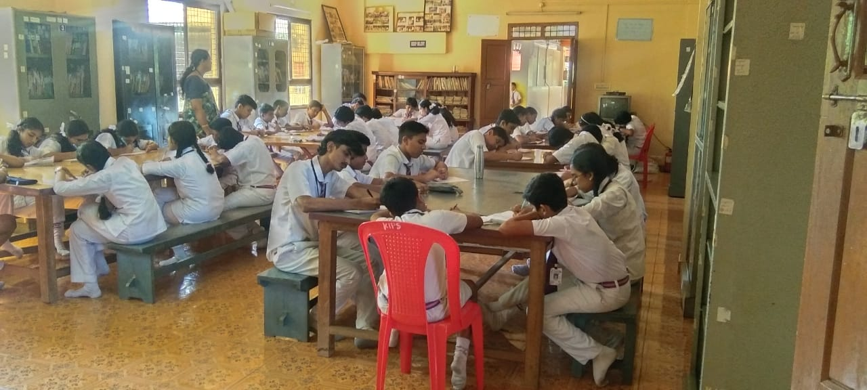
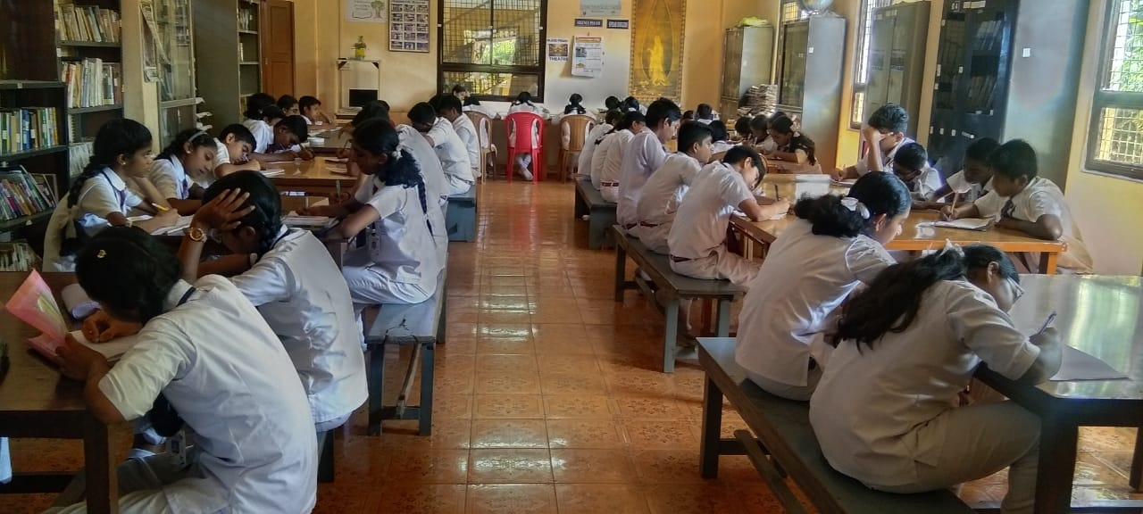

For Poster Making contest, 50 students participated in three categories
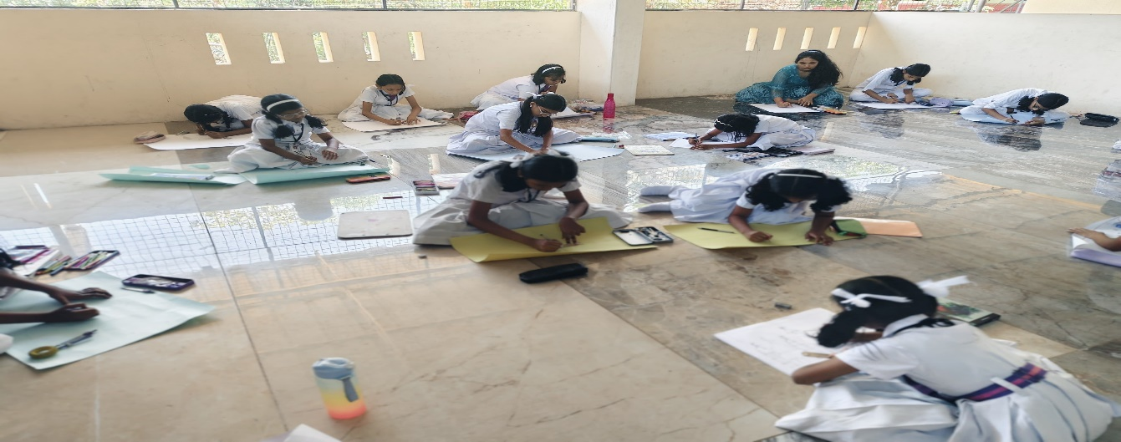
For Essay Writing 25 students took part. The following students were the winners:

Seniors:
First: Kensa William - class 10
Second: Aleena .S- class 8
Senon Bipin- class 8
Third: Grace V. Jose - class 10
Persis Rose Prince- class 10
Juniors:
First: Ansa P. Lagi - class 7
Aleena.S- class-8
Second: Jewel Binu- class 7
Third: Angel Mariam- class 8

Sub Juniors:
First: Naomi Elsa Benny- class 3
Second: Sreya D.S- class 5
Third; Ludiya Biju- class 6

Following are the winners of the Poster Contest in connection with Interfaith Harmony Week:
Seniors:
First: Kensa William - class 10
Second: Aleena .S- class 8
Senon Bipin- class 8
Third: Grace V. Jose - class 10
Persis Rose Prince- class 10
Juniors:
First: Ansa P. Lagi - class 7
Aleena.S- class-8
Second: Jewel Binu- class 7
Third; Angel Mariam- class 8
Sub Juniors:
First: Naomi Elsa Benny- class 3
Second: Sreya D.S- class 5
Third: Ludiya Biju- class 6

Cash awards of 1000, 750 and 500 rupees were given to all the winners of first,second and third prizes respectively. Dr. Abraham Karickam gave away the awards at a special function in International Public School. Prizes to the houses who won first,second and third in the Peace procession were also distributed on the same day.

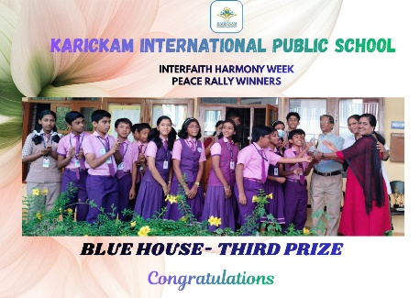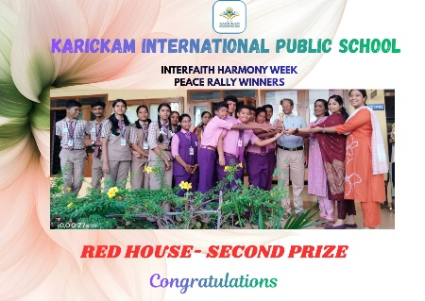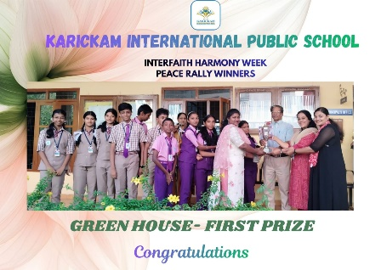
6th February, 2026

A Public Peace Procession through the Main Central Road was conducted involving several like-minded organizations and educational institutions as St. Joseph Nazareth School, Karickam International Public School, All Kerala Balajana Sakhyam, United Religions Initiative South India Region, Global Youth Movement, Kerala Paliative Care Initiative, Matha Aikyavedi, YMCA, and representatives of several Cooperation Circle units proclaiming interfaith harmony wearing costumes of diverse cultural and religious unity in diversities.

Video Link: https://youtu.be/vlBg9A8qlog?si=IXnO-GF-ezfi_y0L

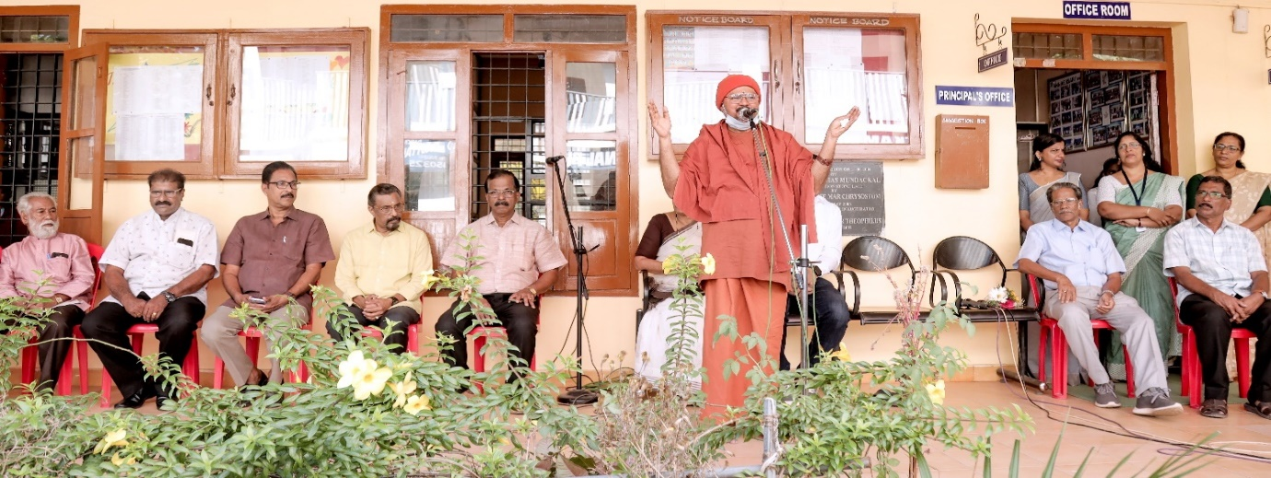
Swamy Bodhendra Theertha inaugurated the program and Flag off ceremony Interfaith Peace procession on 6th February 2026 as part of WIFHW celebration

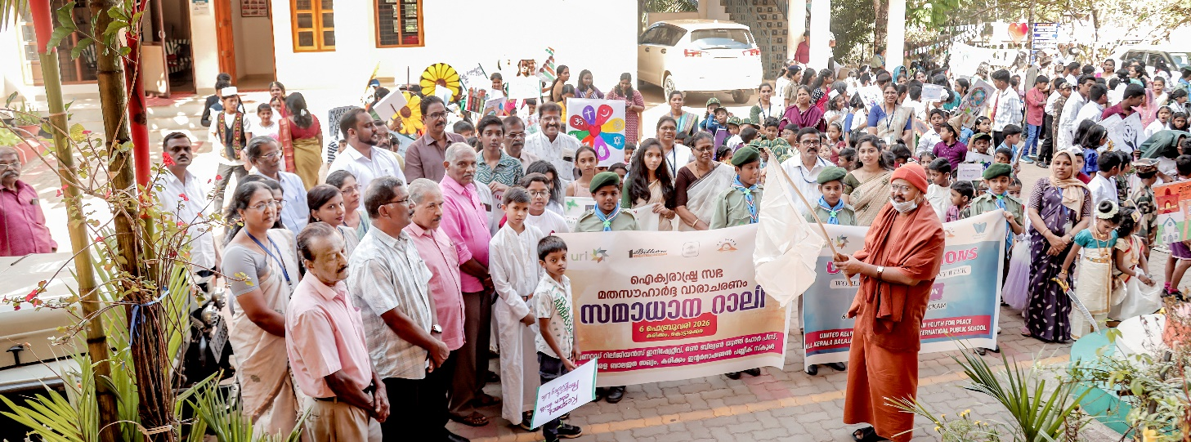

Print Media – Newspaper clippings from Malayalam Manorama, Mathru Bhoomi on the IFHW programs
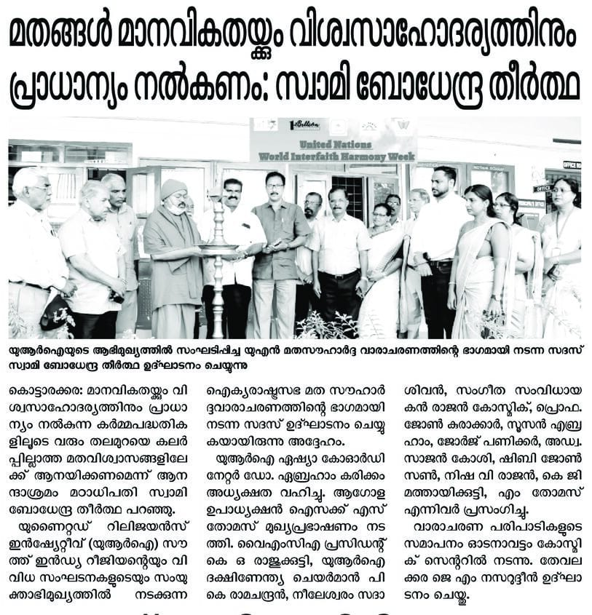
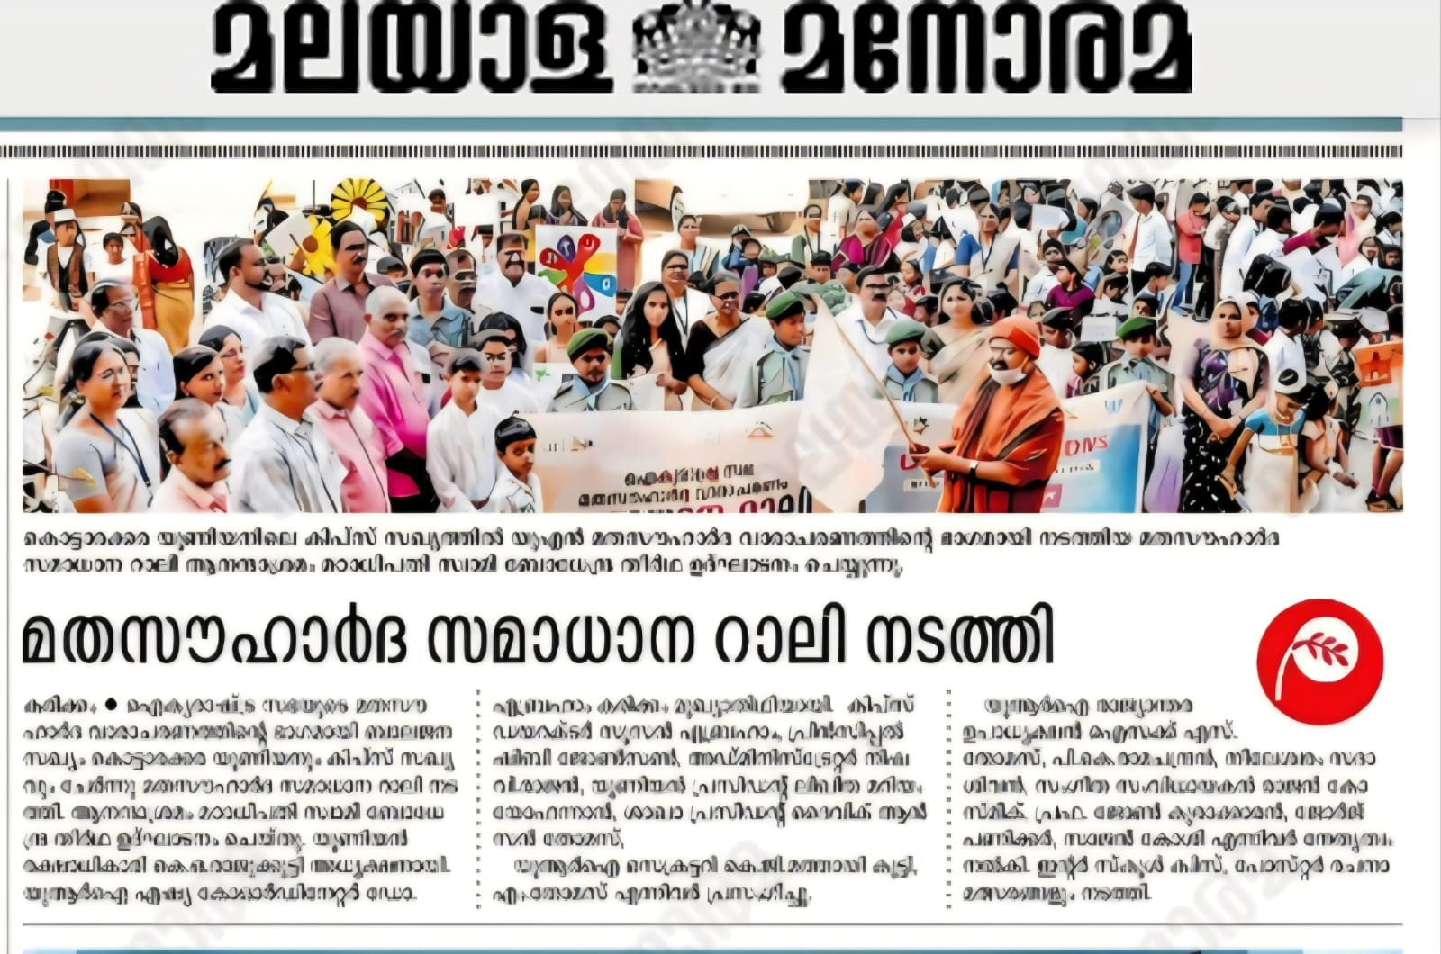

7th February, 2026
The World Interfaith Harmony Week closing ceremony at Odanavattom Art Institute. inviting officials as guests from different departments of government, social activists, community leaders, etc. The winners of the contests were honoured with awards and certificates.

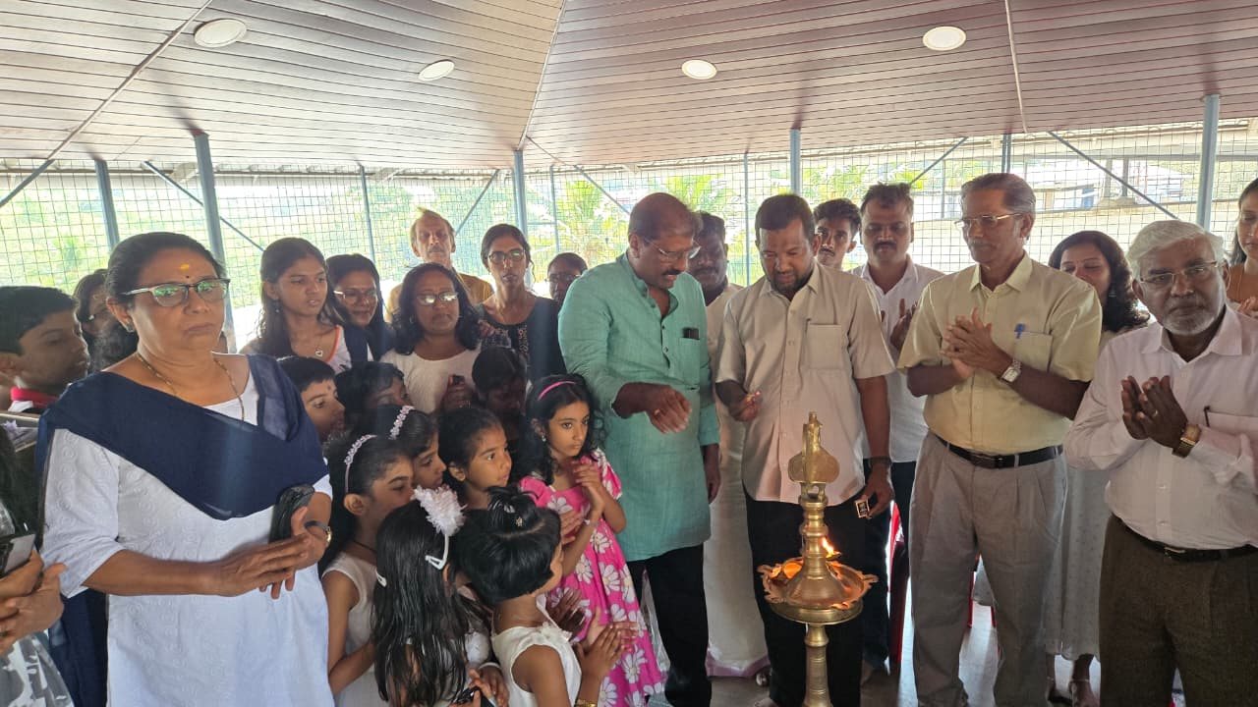

IFHW valedictory Function was held at Art for Peace Cosmic CC, Odanavattom

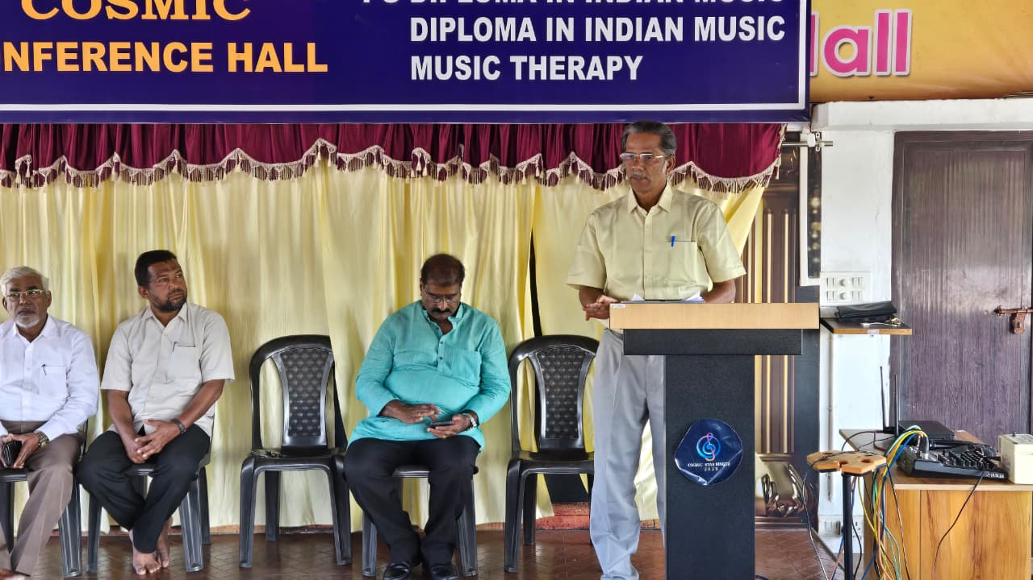

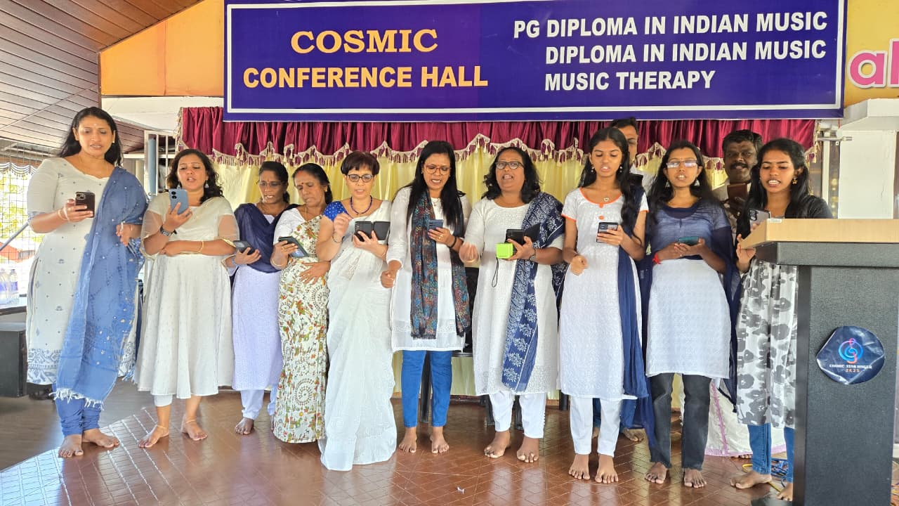

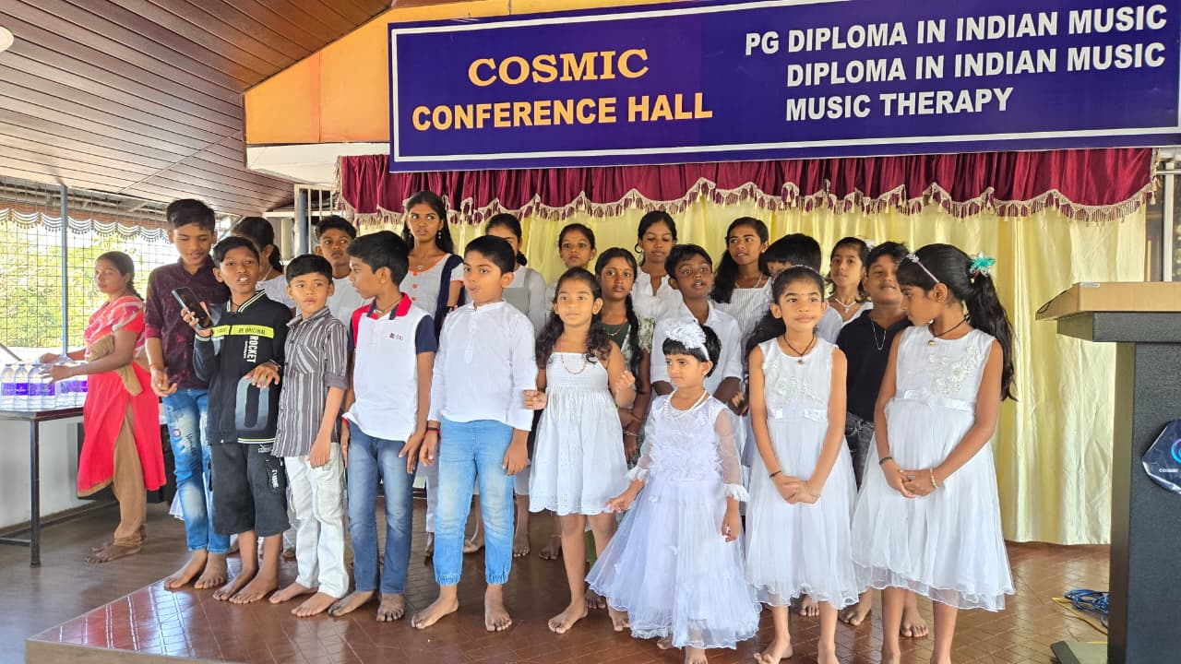

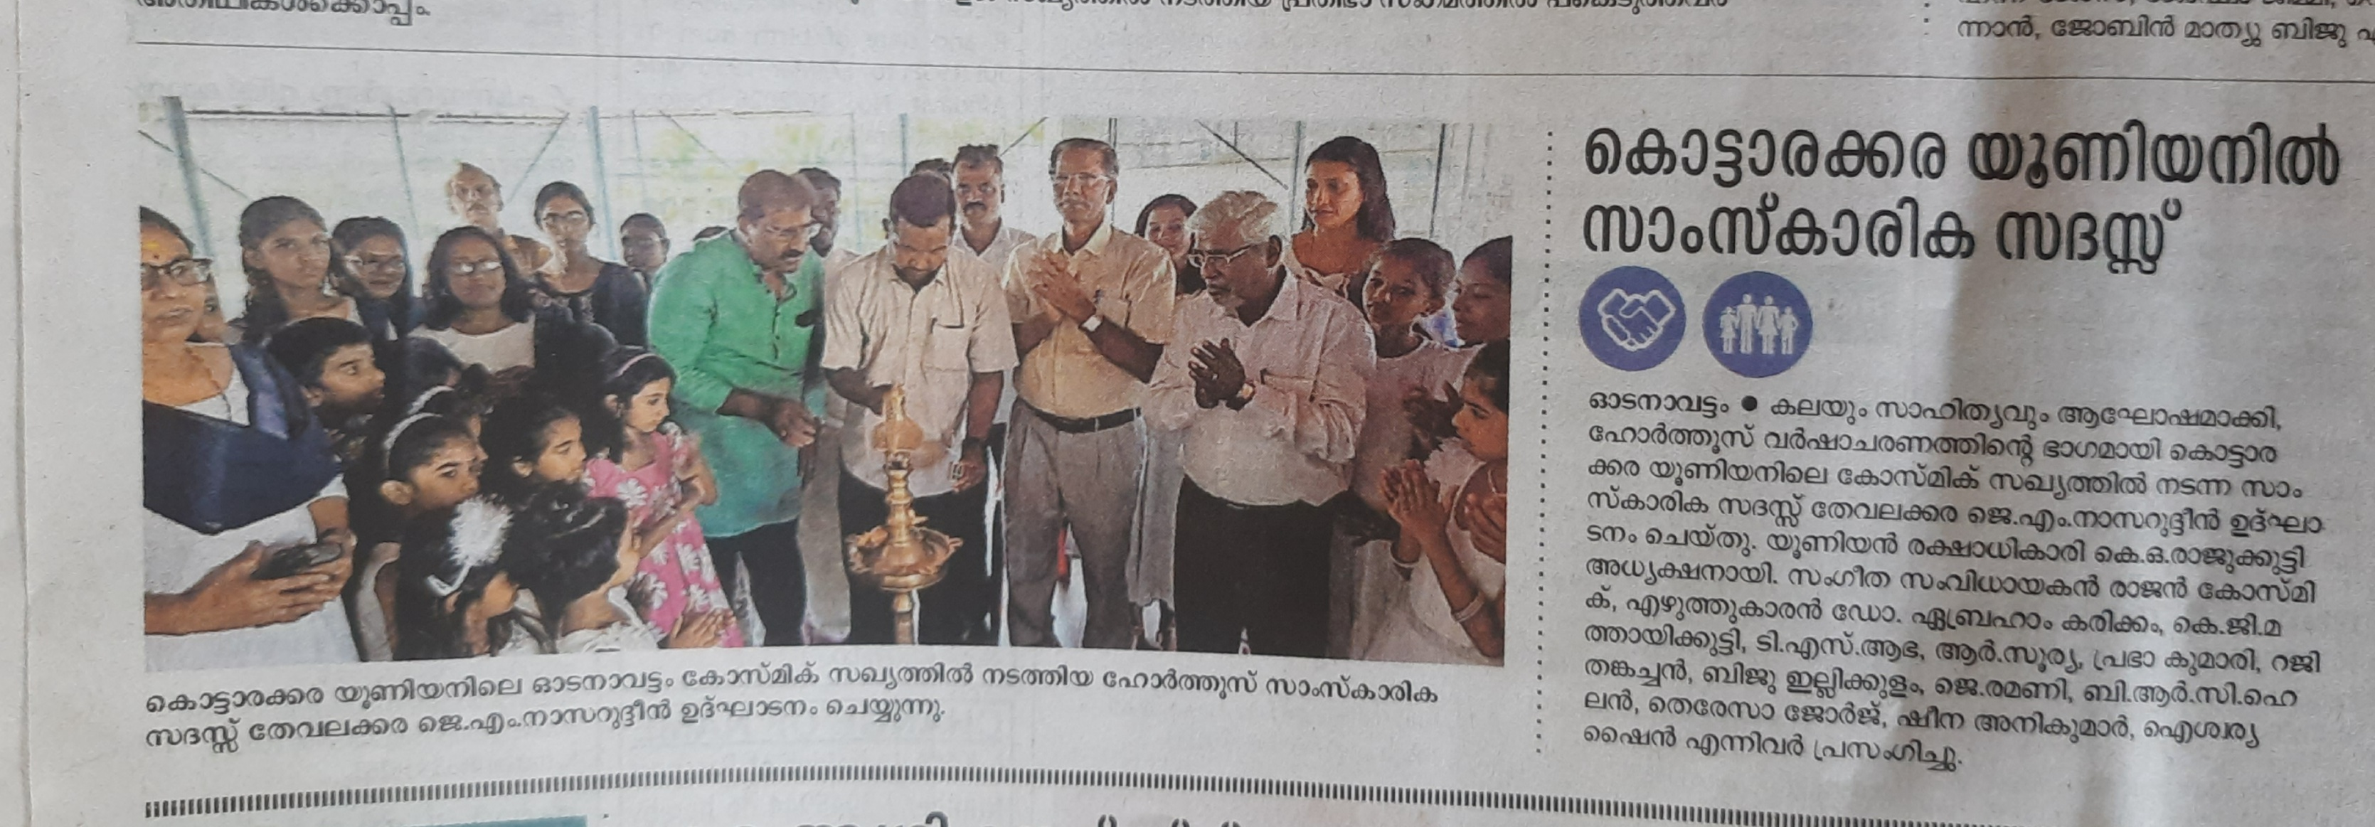

Live on YouTube link : https://youtu.be/vlBg9A8qlog?si=SP50_Ztj7qzTuTm-

We would appreciate it vey much if you kindly acknowledge receipt of this document.

With sincere regards,

Prof. Dr Abraham Karickam, K.G. Mathaikutty
President Executive Secretary
Cosmic Community Centre

Furnished below an expressed view of a Third party on this WIFHW Peace Procession:
Quote
Peace Rally 2026.mp4
Dear URI Colleagues,
As we reflect on World Interfaith Harmony Week (Feb 1–7), I wanted to share a truly inspiring moment from Kerala, India.
On this occasion, I had the privilege of attending the IHW 2026 Peace Rally organized by the URI South India Region. During the event, I presented the “Virtual Embassy of Peace Award” from the Universal Circle of Peace Ambassadors, Switzerland, to Karickam International Public School (KIPS), recognizing their outstanding peacebuilding initiatives and dedication to nurturing a culture of harmony. This recognition is more than an award—it is a call to action. Together, we can ignite hope, foster understanding, and empower youth to shape a peaceful future. There is nothing more powerful than the energy of young people uniting for peace, There is nothing more powerful than the energy of young people uniting for peace, understanding, and interfaith harmony. Let us continue to celebrate and support these efforts around the world as we work together to build bridges of understanding across communities.
With appreciation,
Issac S Thomas
Global Council Vice Chair
email: ithomas@uri.org

