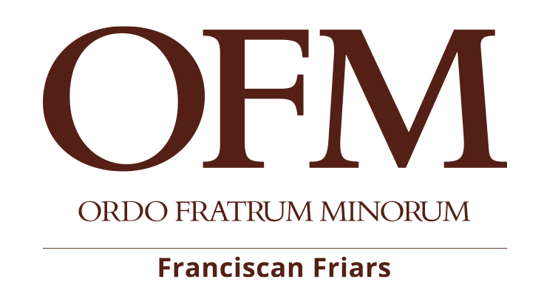
BACK TO NEWS

Visit of the Minister General and the Definitor General to Russia

“St. Francis of Assisi” Foundation

Rosa Dalmiglio- China Disabled People’s Foundation

www.mydream.org.cn

rdalmiglio@hotmail.com

UNESCO-GOODWILL “Artist for Peace” at 2026 WORLD INTERFAITH HARMONY WEEK

11 February 2026
Facing temperatures well below zero, the Minister General, Br. Massimo Fusarelli, visited the Foundation of St. Francis of Assisi in Russia from the 31st January to the 8th February, also carrying out his canonical visitation. The Minister was accompanied on his visit by the Definitor General and Delegate for the same Foundation, Br. Konrad Cholewa, and by the President of the Foundation, Br. Stefano Invernizzi.
The Foundation, which reports directly to the Minister General, currently consists of only six friars: two citizens of the Russian Federation, three Italians and one Vietnamese. Fr. Massimo devoted much time to listening to the friars who are divided between the two communities of Novosibirsk, in Siberia, and St. Petersburg, in the European part of the country. He celebrated the Eucharist and prayed with them, gathered the local chapters, and ‘simply’ spent time in fraternity.
At the end of his visit, the Minister General also convened the Council of the Foundation. The meetings with the pastors of the two dioceses in which the friars are present and carry out their ministry, giving Franciscan witness, were very fruitful: the Archbishop of the Archdiocese of the Mother of God in Moscow, Paolo Pezzi, and his Auxiliary, Nikolaij Dubinin; the Bishop of the Diocese of the Transfiguration in Novosibirsk, Joseph Werth, and his Auxiliary, Stephan Lipke. All the Bishops praised the presence of the friars and asked them not to withdraw from their dioceses, even though they understand the great difficulties involved.
The meetings with the realities in which the friars are directly involved or with which they collaborate for the growth of the Kingdom of God were also very significant. On the 1st February, Br. Massimo met with the parishioners of the Parish of the Immaculate Conception in Novosibirsk, whose parish priest is Br. Vitalij Kostiuk. Here, at the end of the Sunday Mass, during which Fr. Massimo emphasised the 40 years of the Order's presence in Novosibirsk in his homily, he blessed a reproduction of Giotto's fresco depicting the ‘Transitus’ of St. Francis and an icon of St. Francis that will remain permanently in the church, thus officially launching the Franciscan Jubilee Year.
In the afternoon, the Minister met online with the brothers and sisters of the Secular Franciscan Order who are scattered throughout the immense territory stretching from the Urals to the Russian Far East. On the 2nd February, Br. Massimo, Br. Konrad and the friars of the community participated at Mass presided over by Bishop Werth and in the presence of Bishop Lipke in the Cathedral of the Transfiguration, on the occasion of the Day of Consecrated Life, during which the religious men and women renewed their vows to the Lord. Monsignor Werth presented the Minister General and the Definitor with a medal commemorating the consecration of the Cathedral, a symbol of the rebirth of the Catholic Church in Siberia after the period of repression. This was followed by a concert and dinner with all the religious men and women present.
On the 3rd February, the Minister General and Br. Konrad visited our Catholic-Franciscan school ‘Natale del Signore’ (The Nativity of the Lord), directed by Br. Corrado Trabucchi. The school, which is highly regarded by local authorities and parents, has been providing education for over thirty years. The pupils welcomed the guests with joy, sharing lunch with them and offering them a small concert. During their stay in Novosibirsk, they also visited the Sisters of Mother Teresa of Calcutta and the projects led by the Sisters of the Congregation of St. Elizabeth of the Diocesan Caritas, with whom the friars have collaborated, especially in the past.
On the 4th and 5th February, they spent time in Moscow, where they held talks not only with the Archbishop but also with the Custos of the General Custody of the Friars Minor Conventual, whose guests they were, and with the National Minister of the Secular Franciscan Order. Of course, they visited the city's most symbolic places: Red Square, the Kremlin, Christ the Saviour Cathedral, and the Tretyakov Gallery.
Arriving in St Petersburg on the 6th February, they were welcomed by the local fraternity composed of the Guardian, Br. Bernardin Turmann, the parish priest of the Parish of the Sacred Heart, Br. Iuri Cavallero, and Br. Joseph Ngoc Chau, who is now mainly engaged in studying the Russian language. In the late afternoon of the same day, at the Pro-Cathedral of the Assumption, Auxiliary Bishop Nikolaij Dubinin, OFMConv, presided over the Eucharistic celebration in the presence of the entire Franciscan Family of the city (OFM, OFMConv, FMM, OFS), with which the Franciscan Jubilee Year was officially opened. This was followed by a fraternal dinner offered by the Bishop.
On Saturday, the 7th February, after visiting our parish building, which is undergoing renovation, the friars prayed Vespers with the Franciscan Missionary Sisters of Mary and had dinner with them. In St. Petersburg, there was also an opportunity to spend time fraternally with the local community of Friars Minor Conventual and to dialogue via video conference with the friars of the Smolensk Fraternity, belonging to the ‘St. Francis Stigmatised’ Foundation.
Finally, during the meeting with the parishioners of the Sacred Heart parish, with whom the Minister spoke, Br. Stefano, President of the Foundation, thanked the Minister General and Br. Konrad for coming to Russia as brothers amongst brothers to comfort, support and also correct them.
This visit, carried out in the spirit of fraternity, leaves a deep mark on the hearts of the friars and faithful in Russia. Despite the bitter cold, the warmth of the Franciscan charism confirmed once again that, in the light of the Gospel, there are no distances that cannot be bridged. The Jubilee Year that has just begun will be a time of renewal and hope for the entire Foundation as it awaits the celebration of the Chapter, in order to continue walking in the footsteps of St. Francis in this immense land and to bring the word of peace, goodness and reconciliation.

