WORLD INTERFAITH HARMONY WEEK 2026
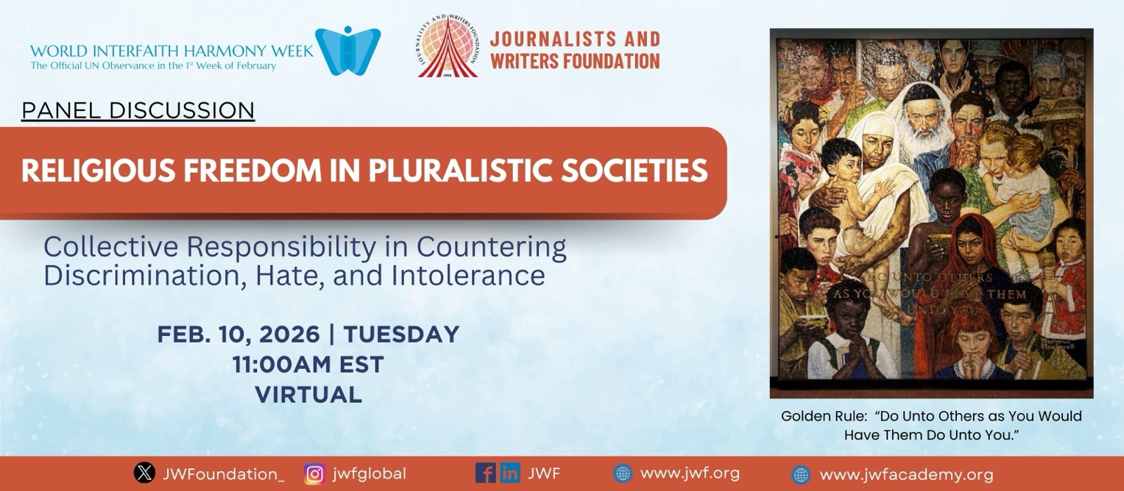

PANEL DISCUSSION
RELIGIOUS FREEDOM IN PLURALISTIC SOCIETIES:
Collective Responsibility in Countering Discrimination, Hate, and Intolerance
February 10, 2026 | 11:00am EST | Virtual

Register Here

World Interfaith Harmony Week offers an important global moment to reflect on peaceful coexistence, mutual respect, and shared values across religious and belief traditions. Across the world, societies are increasingly confronted by religious intolerance, discrimination, hate speech, and identity-based polarization. These challenges affect entire communities and undermine social cohesion and peace.

While journalists and writers play an important role in shaping public narratives, the responsibility to protect religious freedom and combat hatred rests with society as a whole. Families, faith communities, educators, policymakers, civil society organizations, and ordinary citizens all shape attitudes and behaviors through daily interactions and public discourse.

Convened by the Journalists and Writers Foundation (JWF), this panel discussion aims to uphold religious freedom and foster interfaith understanding while countering religious hatred constituting incitement to discrimination, hostility or violence, which is a collective responsibility requiring empathy, dialogue, and ethical engagement from all members of society.

Objectives:
- Promote societal understanding of religious freedom as a cornerstone of peaceful coexistence.
- Examine how discrimination, hatred, and intolerance manifest at community and societal levels.
- Highlight the shared responsibility of all sectors of society in countering prejudice and hate.
- Encourage interfaith and intercultural dialogue as practical tools for social cohesion.
- Empower participants with ethical and values-based approaches to inclusion and respect.
Questions for Discussion
- Why is religious freedom essential for inclusive and democratic societies?
- How do discrimination and religious hatred take root within communities?
- What roles do families, faith institutions, schools, and civil society play in promoting tolerance?
- How can interfaith dialogue move beyond symbolism to lived social practice?
- How should public speech be guided ethically in diverse societies?
- How can societies help prevent societal polarization and ideological extremism?

Expected Outcomes:
- Increased public awareness of religious freedom as a shared civic value.
- Stronger appreciation of interfaith dialogue as a tool for social harmony.
- Practical insights for communities to counter discrimination constructively.
- Reinforced commitment to dignity, respect, and peaceful coexistence.

Moderator
Dr. Rajendran Govender (South Africa)
Commissioner for Cultural Religious and Linguistic Rights
(Confirmed)
Confirmed Speakers
- Prof. Dr. Joan Hernandez Serret (Spain)
Professor, Faculty of Communications, International University of Catalonia
- Prof. Dr. Rocío Cortés Rodríguez (Chile)
Assistant Professor of Theology, Pontifical Catholic University of Chile
- Ms. Ishka Eraman (South Africa)
Attorney and Vice Chairperson, The Hindu Unity Forum of South Africa
- Dr. Ali Unsal (USA)
Theologian and Writer, Deputy Director, WISE Institute NJ
- Dr. Marcel Israel (Bulgaria)
Board Member, Religions for Peace Europe and Bulgaria
Jewish Communities in Bulgaria and Spain

Alignment with OHCHR Call for Input on HRC Resolution 53/1

This panel discussion is aligned with the UN Office of the High Commissioner for Human Rights (OHCHR) Call for Input on “Countering religious hatred constituting incitement to discrimination, hostility or violence”, issued pursuant to Human Rights Council Resolution 53/1 adopted on 12 July 2023. The resolution recognizes the growing global concern regarding religious hatred and its serious human rights impacts, and calls for strengthened normative, legal, policy and administrative responses. By linking grassroots dialogue with global human rights mechanisms, the panel reinforces the principle that countering religious hatred is a shared responsibility of States, institutions and society as a whole.

The Interfaith Harmony Week panel contributes directly to these objectives by examining the drivers, root causes and human rights impacts of religious hatred; identifying gaps in societal, legal and policy frameworks; and proposing preventive and deterrence measures, both offline and online. The JWF intends to consolidate the outcomes of this panel discussion into a formal written submission to the OHCHR as part of its Call for Input. This submission will reflect multi-stakeholder perspectives and provide practical, context-based recommendations aimed at strengthening social cohesion, protecting freedom of religion or belief, and countering incitement to discrimination, hostility or violence.

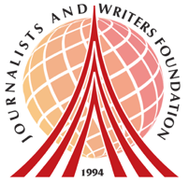
About Us
The Journalists and Writers Foundation (JWF) is an international civil society organization dedicated to the culture of peace, human rights and sustainable development. The JWF promotes diversity and inclusion by creating forums for intellectual and social engagement, generates and shares knowledge with stakeholders, builds partnerships worldwide and develops policy recommendations for positive social change.

This program is led by Dr. Rajendran Govender and Ms. Nancy Falcon who serve as JWF’s Interfaith Committee Members and Advisory Board Members.

Journalists and Writers Foundation
4 West 43rd Street 4th Floor (Suite 419) New York, NY 10036
www.jwf.org | info@jwf.org

* JWF is a 501(c)3 non-profit organization registered in New York State.
* JWF is associated with the United Nations Department of Global Communications

