COSMIC COMMUNITY CENTRE
&
United Religions Initiative (URI)
South India Region
Karickom P.O., Kottarakara Kollam, Kerala PIN 691531

19th January 2026
Respected IFHW support system,
Greetings from Global Peace promoting NGO!

It is with great pleasure that I, on behalf of Cosmic Community Centre, extend my full support for World Interfaith Harmony Week 2026. As a peace builder through interfaith harmony, justice, healing and unity, this initiative holds immense significance in our increasingly interconnected world. In an era often marked by division, we trust that World Interfaith Harmony Week serves as a powerful reminder of the common threads that bind humanity. By fostering dialogue, respect, and cooperation among people of diverse faiths, we can build bridges of peace and harmony. We embrace this opportunity to celebrate our shared values and work towards a future where tolerance and compassion prevail. Let us harness the power of interfaith understanding to address the challenges that confront our world today.
We are planning to organize the following programs during the Interfaith Harmony Week, involving several groups of our associates:

31st January 2026
- Short Film contest amongst Schools on Violence Prevention.

- Walk for Freedom – a silent walk with placards and slogans depicting voices against illegal migration, religiously motivated violence, etc. holding front banners, including that of World Interfaith Harmony Week involving people from all walks of life

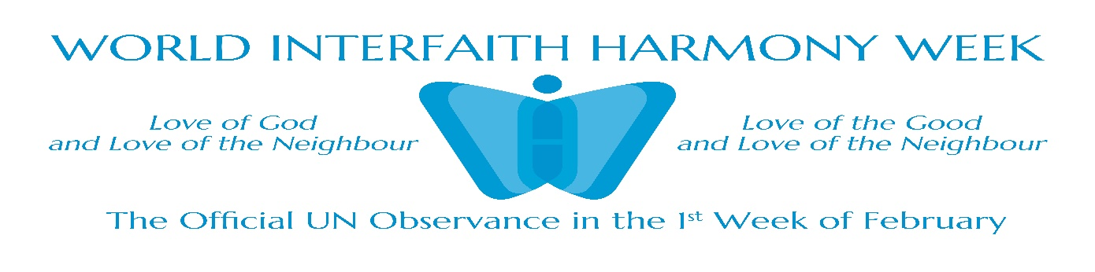
.

2nd January 2026
Essay Writing and Poster making contest among school children on theme Interfaith Harmony for Social Justice to be held at Karickom International Public School (KIPS), Kottarakara.

6th February, 2026
Public Rally through the Main Road involving several like-minded organizations and educational institutions proclaiming interfaith harmony wearing costumes of diverse cultural and religious unity in diversities.

7th February, 2026
The World Interfaith Harmony Week closing ceremony at Odanavattom Art Institute. inviting officials as guests from different departments of government, social activists, community leaders, etc. The winners of the contests will be honoured with awards and certificates.

The reports, videos, photographs on the week’s program will be send before March 2026.

With sincere regards,
Prof. Dr Abraham Karickam, K.G. Mathaikutty
President Executive Secretary
Cosmic Community Centre

