**Report: Art Exhibition at Kolding Library**

**Marking the UN World Interfaith Harmony Week**

**February 4-27, 2025**

**By Cross-Cultural Ministry of Kolding Deanery and Migrant Cooperation and**

**Encounter with other Religions of Haderslev Diocese**

**1 Process, Preparations and Opening**

**More Information: Opening of the Art Exhibition**

1. **Preparations:**
2. Making agreements with the library on the possible dates for the WIFHW Art Exhibition, and the number of display boards we could borrow. Because of many activities happening in the month of February, we were asked to move to another section in the library while still being able to use the central part of the building for the Opening of the Art Exhibition to the public. We thank the personnels of Kolding Library for the great cooperation and assistance we received**.** Special thanks to Anni Schumacher of the Kolding Library, who has been our contact librarian for 7 years.
3. The agreement was that the Art Exhibition could run in about 3 weeks.

As the World Interfaith Harmony Week is globally observed during the first week of February, we agreed to have the Opening of the Art Exhibition on the 5th of February. Artists came to hang their artworks on February 4 from 12 to 6 pm and came back the following day for the Vernissage or the Opening of the Art Exhibition.

1. 22 artists had their art works exhibited. And during the actual hanging of art works, 2 parents came with the art works of their children, making the number of artists as 24**. The artists represented 7countries of origin: Denmark. Poland, Nigeria, Philippines, Lithuania. Romania and Syria.**

Added to the list are the two: Sarah (8 years old) and Christian (9 years old) who were permitted to also get a display board, representing artwork of the children.

1. Information disseminations of the event: through Facebook profiles of private people and Facebook group accounts. Hanging posters on public places and distribution of posters to some public places like shops and churches, and other organizations, by emails and SMS messages.
2. The following people made up the core group who prepared the event through online and face-to-face meetings.

The committee for planning and follow-ups…

**Elizabeth Padillo Olesen** (retired and served as volunteer),

**Michael Markussen,** the pastor of Kolding International Congregation &

chairperson of the board for the Cross-Cultural Ministry, Kolding Deanery.

**Lone Krogh Møller**, the new Coordinator of the Cross-Cultural Ministry of Kolding Deanery

**Camilla Mølbjerg**, the Consultant of the Migrant Cooperation and Church Encounter with Other Religions of the Haderslev Diocese.

**B. Finalizing of the agreement with Kolding Library**

**1. Schedule of the Art Exhibition:**

* February 4: Hanging up of art works on the 23 display boards as provided.
* February 5: Opening/Launching of the Art Exhibition to the public
* February 27: end of the exhibition/ Artists removed their displayed art works which were displayed in **24 days** from February 4- 27 of February.

**2. List of the 22 artists. (see attached)**

The two children came only during the 4th of February during the hanging up. It was good to see that parents wanted to involve the children, and it was our first time having children’s art also on display during the exhibition. Some of a child’s art on pieces of wood, which could not be hanged, were displayed on the table where contact information of artists were also placed.

**3. The Poster** as invitation to the Opening of Art Exhibition was made by Camilla Mølbjerg and she did also the list of the artists used also to spread on Facebook profiles and hanged in public places, sent via e-mails to churches and interested friends.

4**. Total number of exhibited paintings: 84 pieces** in different sizes, with materials

as acrylic paints and oil, coal and pencils, crayons, projecting images of nature, portraits, fellowship, community, and religious symbols and symbols of hope.

We borrowed the total number of display boards: 23 pieces and tables and chairs for the public opening day of the exhibition in the afternoon of February 5. We got what we requested.

5 **One board was used as information on what the Art Exhibition is about:**

* With historical notes on the World Interfaith Harmony Week
* Some texts, sayings or poems that supplement the principles

of the “Love of God and Love of Neighbor and Love of the Good.”

* Poems and drawings by students of the title Tolerances.
* Symbols in religions and Flags of different countries (testing the public’s knowledge on religious symbols and flags of different countries.)

**Enclosed:**

1. List of artists and the countries they represent (7 countries)

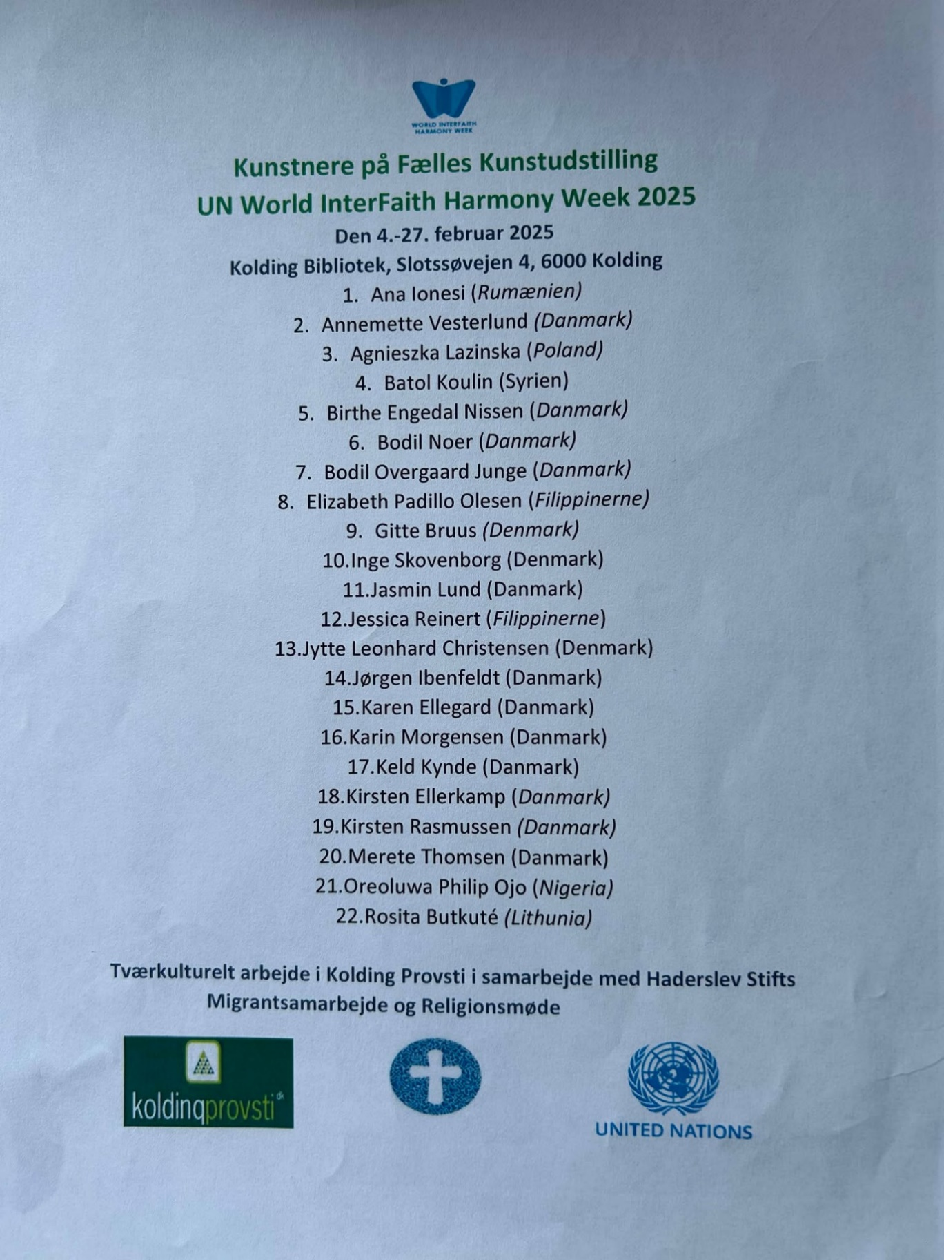

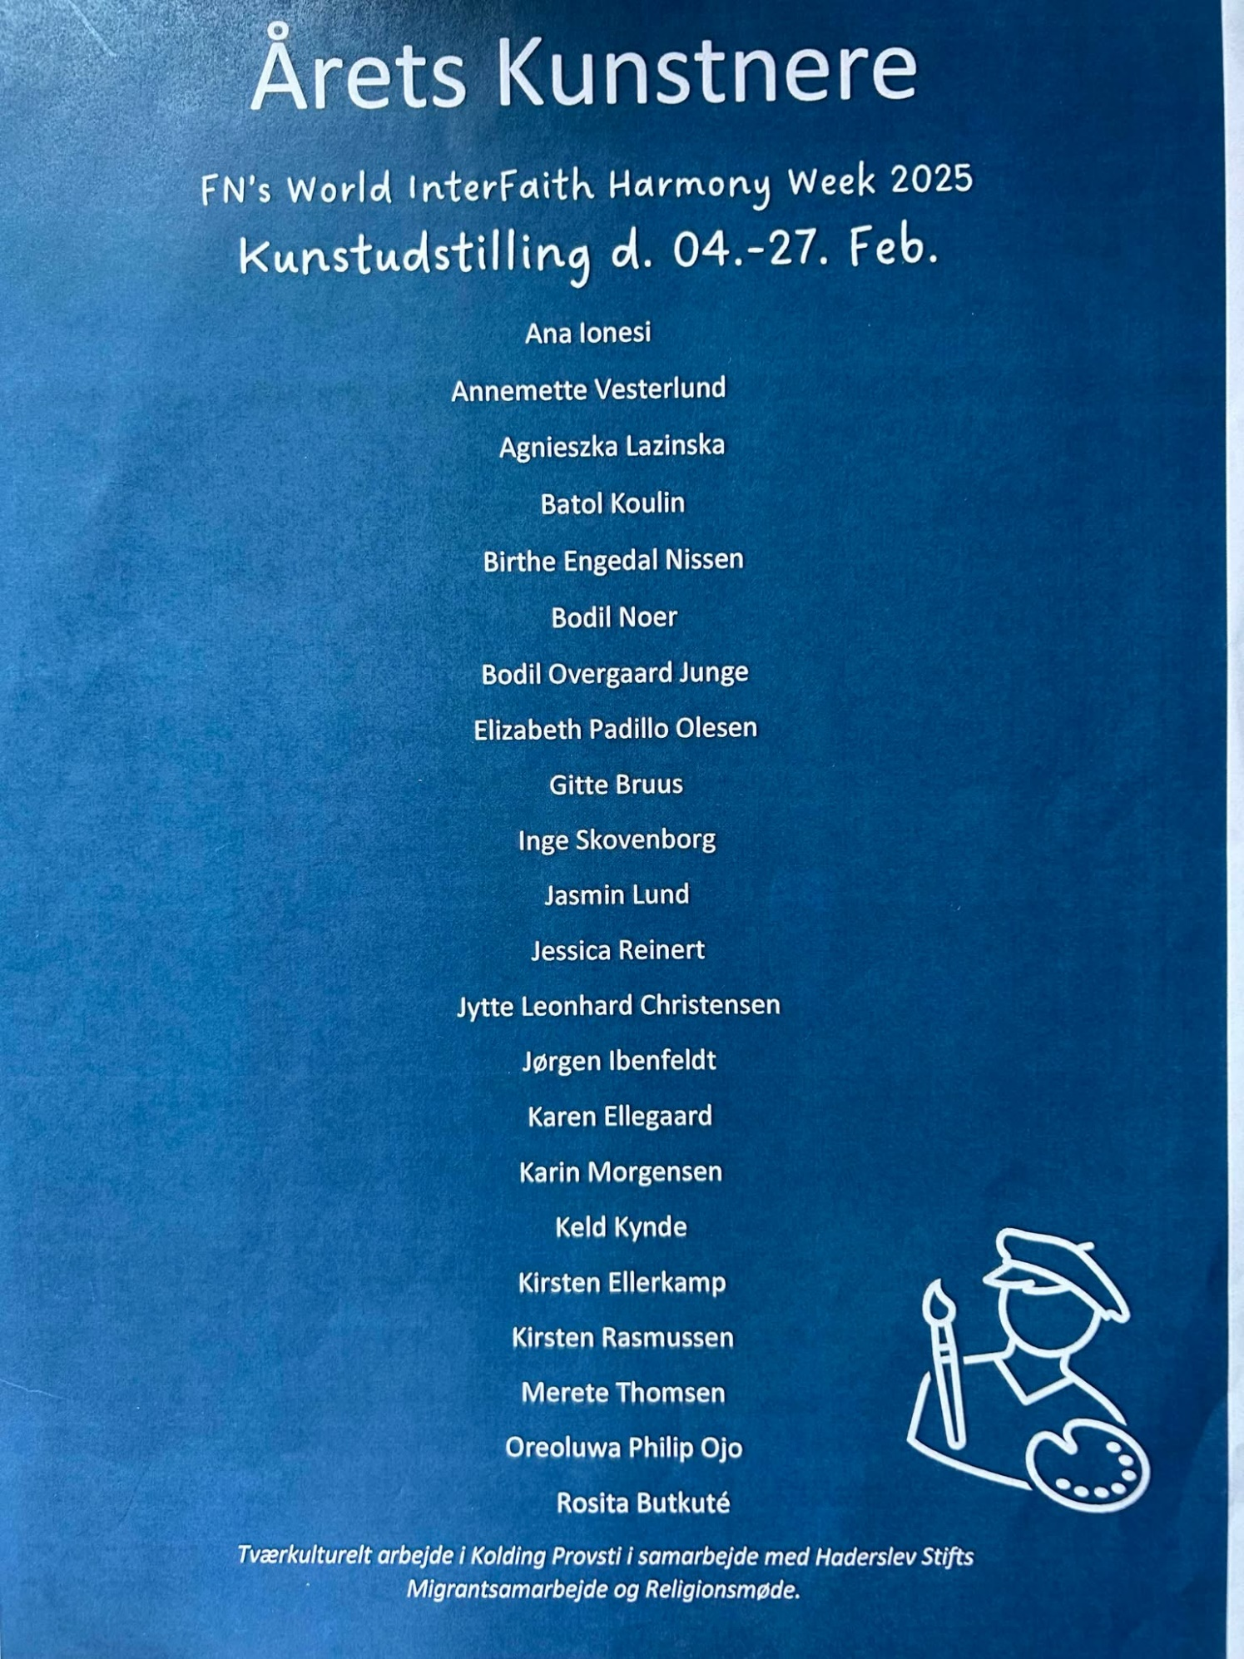

1. The poster was made as invitation to the Opening of the Art Exhibition on

February 5, nicely created the Camilla Møbjerg, the Consultant to the

office of Migrant Work Cooperation and Encounter with Other Religions in

Haderslev Diocese.

**Enclosed: the Poster as invitation to the event**

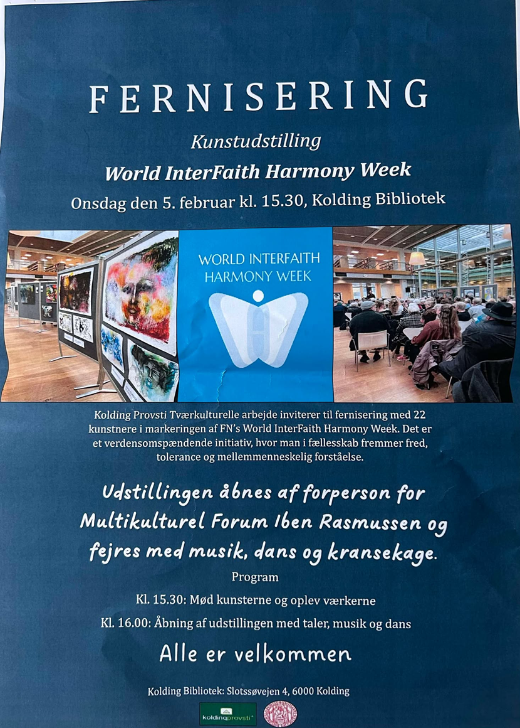

1. **The Opening of the Art Exhibition to the Public**

**February 5, 2025**

**from 4 to 6 pm (with preparations of the place from 1 pm.)**

1. The Invitation to the Opening of Art Exhibition, as poster made by Camilla Møbjerg of Haderslev Stift, Migrant Cooperation and Encounter with other Religions of Haderslev Stift. *(see enclosed poster)*
2. **The list of artists. See the poster as enclosed.**

The names of the two children, 8-year-old Sarah (8 years old) and 9-year-old Christian with their artworks are not on the list. Their paintings were hung up on display boards for the 3-week duration as their submission was only at the 11th hour.

1. **Program during the Exhibition:**

*See the list of the songs as enclosed*.

1. The program started with coffee and tea, peanuts, cakes, biscuits and fruits. People were requested to get time to talk with the artists as they stood on the display boards where their own artworks were hung up.
2. People were back on their seats for full attention to the flow of the program. **Rev. Michael Markussen** was the Master of the Ceremony, giving historical reviews of UN World Interfaith Harmony Week, and welcoming all guests, artists and others, also introducing the Guest speaker.
3. **Community Singing of following songs.**
4. **“Du skal elske din næste som dig selv”** *(Love your neighbor as**yourself):*a church hymn with melody known to most of thepeople who were present.
5. **“God morgen, Lille Land” *(Good morning, you little Country*)**

A popular Danish song, affirming the need to build bridges*.*

1. **The Song, a call for silene and prayer… “ Here vi ties, Her vi bies”**
2. **“If we could consider each other as brother and sister”,summing up the basic principle of WIFW.**

***Note:*** *the first three songs were accompanied by Ejvind Amorsen, organist of Simon Peters Kirke. Kolding Library has its own piano which Ejvind used. The 4th song was accompanied by Elizabeth Padillo Olesen with guitar*.

**4).** **Iben Lehman Rasmussen was the invited speaker; in advisory** council of Kolding Municipality and also the chairperson of the Multi-cultural Forum, comprising 33 ethnic group organizations in town. (*Summary of the speech enclosed.)*

**5) Another Organist Bente Ibenfeldt** gave a musical rendition for community singing, playing her own song composition in Danish language on Christiansfeld, part of Kolding which is also declared as the UNESCO World Inheritance. The text of her music was distributed to the audience and two ladies stood in front to lead the gathered community singing the composed song of Bente.

**6) Three artists spoke about their art and what the event meant for them:**

1. **By Karen Ellengard,** who has been in the art exhibition from its very start. Karen has also been a great help in finding and contacting artists to join in the exhibition.
2. **Jamin Lund**, an artist who represents another kind of type in her work,

where she derives joy from drawing birds and learning from them.

1. **Oreoluwa Philip Ojo,** the new artist from Nigeria with the use of pencils in his drawing, which showed another way of showing images with elegance.

**7) The Ukrainian Dance Group** entertained us with 3 group dances. And led

the audience to join in the community dance*. (See the photos and attached*

*links to reel videos on Facbook)*

1. **Closing of the Exhibition. February 27, Thursday from 12 to 6 pm.**

Artists came to the library to get back their artworks.

A child artist had one of his paintings purchased by a guest.

Even towards the last hour of the exhibition, there were still people coming to see the exhibition. Some artists openly expressed their joy and gratitude for being a part of the event and wish to be invited to the next Art Exhibition in 2026. New names of artists were also suggested as a few expressed desire to be invited. We may need a bigger place for next year.

1. **Visits of Guests to the Art Exhibition**

The library receives 1,000 visits every day. The week of February, which also featured other events hosted by the library, made the Art Exhibition open also to a much higher number of visitors more than expected this year.

Another unexpected thing is that one of our artists, Jasmin Lund, came with her class from school to visit the Art Exhibition and which gave her time to orient the school children on UN World interfaith Harmony Week, and on the art works on the display boards. *(See this report below. Children signed their signatures as support for the FN World Interfaith Harmony Week)*

The table in front of the Art Exhibition displayed contact information about the artists. Programs and information on World Interfaith Harmony Week and other cultural events in town were also made available to the public on this table. The introductory board for the Art Exhibition displayed our Letter of Support in the past years, the history of WIFHW, the symbols of religions, the poems on tolerance, solidarity and harmony written by poets and students were also displayed, plus the list of the artists and info om the Opening of the Art Exhibition.

**General Impact of the Event:**

1 Once again, the event refreshed the minds of the people about the UN World Inter Faith Harmony Week, its history and why we feel good to be supporting it when core principles in religion,” Love of God, Love of Neighbor and Love of the Good” affirm what we have in common. We are not enemies despite our diversity, but we are people who have something in common to enrich each other.

2. It gathers people to use art as a means of demonstrating images of fellowship and community, nature’s beauty, people’s diversity, and differences in cultural and religious backgrounds and therefore recognize and appreciate other creative expressions for common reflection.

3. The opening of the event enables other forms of art in communication aside from paintings but also music, speeches, musical instruments and dances, while recalling the plight of the people in Ukraine because of war, and here we have Ukrainian refugees in town who attempt to live a normal life and share their culture to enrich the community that received them.

Elizabeth, who contacted them, asked if they would like to be paid for their dance performance, they said, “NO”. Their participation with their Ukrainian dance is a token of their deepest gratitude to the Municipality of Kolding who has received them hospitably, graciously and generously and to the Danish government that has granted them **Special Status** as refugees in Denmark.

4. The event brought joy, enabled people to interact with each other and to interact with the artists and to ask about their works of art and to do things together: singing, listening, dancing, eating, appreciating, encountering new and old contacts as people.

5. The artists were happy and proud to be able to share their art, happy to realize that their participation is connected to a global event and will be read or seen by others outside Denmark. We received many good and positive responses and words on the whole program which also inspired us.

6. It has created a fellowship of artists, who met to hang their paintings and helped each other to have a good exhibition, and coming for the Opening of the Art Exhibition and be part of the program, honored, and received a token of gratitude from Haderslev Diocese, which was much appreciated. And the time of taking down of their paintings, gave them also the chance to see each other again, sharing a bit of what the exhibition meant for them, and the future challenge to be able to paint new painting motifs for the possible Art Exhibition in 2026.

7.The event made us feel like one community, necessary in our life for building peace and understanding, not only among us but also for the whole world.

______________

**Enclosures:**

1. **The List of the artists**
2. **The Poster to the Opening of the Art Exhibition as invitation**
3. **Summary of the speech of the Iben Lehman Rasmussen from Kolding Municipality by Camilla Møbjerg:**
4. **The program of the Opening of the Art Exhibition at the Library**
5. **The copy of the songs, as distributed to the people**
6. **The visit of school children led by Jasmin Lund.**
7. **Some photos**
8. **Enclosed reel videos:**
9. **Preparations of the Art Exhibition, hanging up art works. Feb. 4, at 1-6 pm.**

<https://www.facebook.com/reel/1315978686270326>

1. **The Opening of the Art Exhibition , February 5**

<https://www.facebook.com/reel/2302948150069335>

1. **Ukrainian Second Dance for the Art Exhibition**

<https://www.facebook.com/reel/1146444186983127>

1. **More on artists and photos of their art works, random shots**

<https://www.facebook.com/reel/1014815544082794>