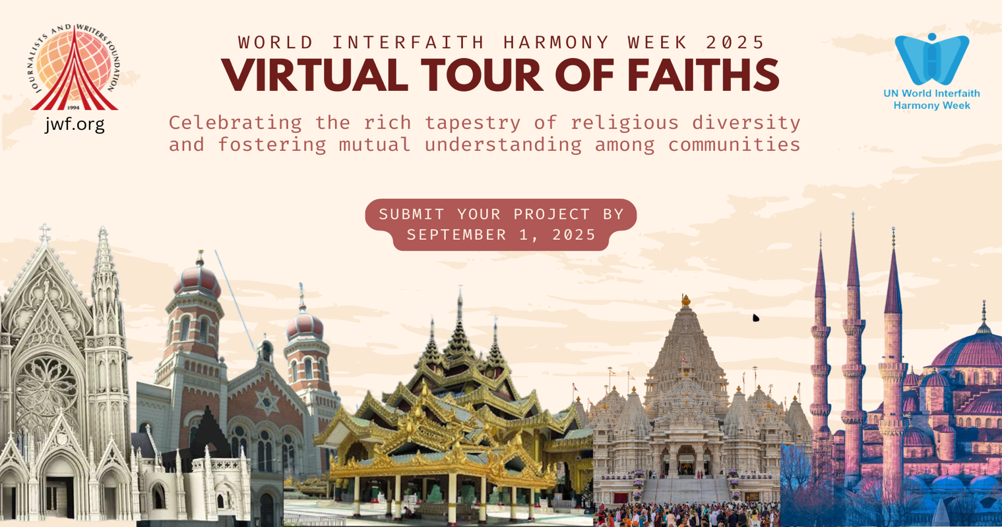

World Interfaith Harmony Week 2025
VIRTUAL TOUR OF FAITHS
Deadline: September 1, 2025

Click Here to Submit Your Project

The Virtual Tour of Faiths is an exciting initiative launching during World Interfaith Harmony Week 2025, celebrating the rich tapestry of religious diversity and fostering mutual understanding among communities. This unique project will offer an immersive, digital journey into key religious institutions, including Hinduism, Christianity, Islam, Judaism, Buddhism, and other religions.

Throughout 2025, selected religious institutions will prepare engaging videos, photographs, and digital content showcasing their places of worship, rituals, sacred texts, and the essence of their faith traditions. These visual narratives will provide insight into the spiritual, cultural, and historical significance of each faith, allowing viewers to experience the beauty and teachings of different religions from around the world.

1. Key Details

Content Development
Participating institutions will produce videos and multimedia content during 2025.

2. Assessment and Review

Submissions will be made by September 1, 2025 for review, with feedback provided for refinement. Final edits are due by December1, 2025.

3. Video Specifications
Each virtual tour video will be no longer than 15 minutes.

4. Launch and Access

The final virtual tours will be broadcast during World Interfaith Harmony Week on February 1-7, 2026. Links to all videos will be hosted on the JWF’s website and YouTube account, disseminated through social media platforms to ensure global access to this enriching experience.

The Virtual Tour of Faiths stands as a testament to the spirit of unity, highlighting the shared values that bind humanity while respecting the unique expressions of each religion. This initiative invites individuals of all backgrounds to explore, learn, and appreciate the profound beauty of diverse faith traditions.

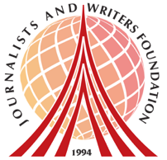
About Us
The Journalists and Writers Foundation (JWF) is an international civil society organization dedicated to the culture of peace, human rights and sustainable development. The JWF promotes diversity and inclusion by creating forums for intellectual and social engagement, generates and shares knowledge with stakeholders, builds partnerships worldwide and develops policy recommendations for positive social change.

This program is prepared and lead by Dr. Rajendran Govender and Ms. Nancy Falcon who serve as JWF’s Interfaith Committee Members and Advisory Board Members at the Journalists and Writers Foundation.

Journalists and Writers Foundation
4 West 43rd Street 4th (Suite 419) Floor New York, NY 10036
www.jwf.org | info@jwf.org

* JWF is a 501(c)3 non-profit organization registered in New York State.
* JWF is associated with the United Nations Department of Global Communications

