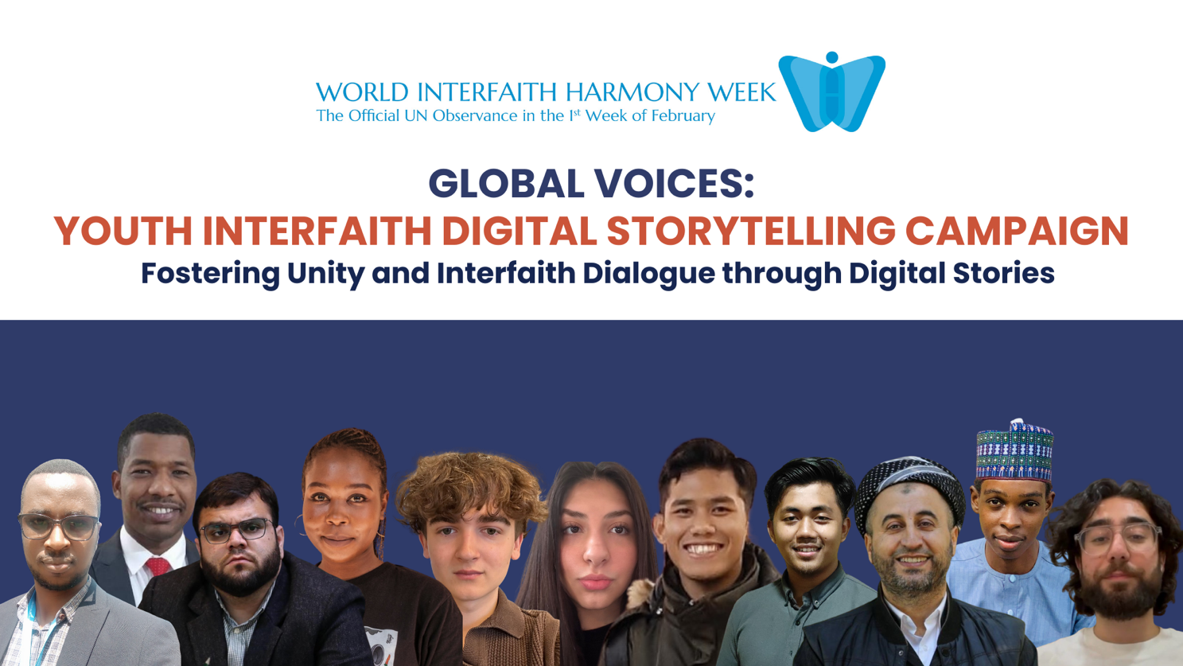

GLOBAL YOUTH VOICES:
Digital Interfaith Storytelling Campaign 2025
Deadline: February 21, 2025

Click Here to Submit Your Video
Description
The Global Youth Voices campaign invites young people from diverse faiths and beliefs to share personal stories of interfaith experiences through digital platforms. Participants can create videos, podcasts, or written narratives that highlight how interfaith dialogue has inspired understanding, unity, and collaboration in their communities.

Objective
Within the framework of this campaign, young people from different parts of the world will be able to choose one of the three options to participate:

- Message or Poem on Peace, Hope, and Harmony: This activity invites individuals or groups to craft messages or poems that express themes of peace, harmony, and unity among diverse faiths and cultures. Participants can present their poems through virtual poetry slams, video recordings, or social media posts, fostering creativity and spreading the message of interfaith cooperation.

- Create a 2–3-minute video recording your message or reciting your poem as part of the "Poem or Message on Peace, Hope, and Harmony" for the World Interfaith Harmony Week.

- A Challenge for Youth: Youth are encouraged to take part in the "Harmony in Action" challenge, where they create innovative projects—such as interfaith murals, cultural exchange workshops, or online dialogue sessions—that promote mutual respect and understanding among different faiths. The most impactful projects can be shared globally as examples of interfaith harmony.
- Create a 2–3-minute video highlighting the projects conducted as part of the "A Challenge for Youth" for the World Interfaith Harmony Week.

- 30 Days of Kindness: This virtual campaign encourages participants to perform acts of kindness over thirty days, emphasizing values shared across faiths, such as compassion and generosity. Activities could range from helping a neighbor to donating to charity, help in an NGO, participate in solidarity event around the world, with participants documenting their acts on social media to inspire others. (Hashtags: #wihw2025, #harmonyweek2025, #interfaith)

- Create a 2–3-minute video describing the activities conducted as part of the "30 Days of Kindness" for the World Interfaith Harmony Week.

Campaign Components

- Target Audience
- Focus on engaging the youth (ages 18-35) from diverse cultural and religious backgrounds.
- Collaborate with youth-led organizations, educational institutions, and influencers to expand reach.
- Submission Guidelines
  - The main criteria for participation, is a 2-3-minute video limit and the use of mobile devices for recording.
  - Participants are encouraged to share genuine, personal stories that highlight positive interfaith experiences.
- Submission Deadline
- The submission deadline is Friday, February 21, 2025.
- Click here to submit your video to the JWF`s WIHW Global Youth Voices Campaign.

- Global Webinar (Virtual)
  - Selected video submissions will be showcased at a global virtual webinar on Wednesday, February 26, 2025, hosted by JWF
  - The webinar will feature prominent speakers, panel discussions, and live interactions with participants to enhance engagement.
- Digital Library on YouTube and recognition
  - A dedicated section on the JWF YouTube channel will be established to serve as a digital library for the campaign.
  - Selected video stories will be uploaded creating a lasting resource for continued inspiration and education.
  - Selected stories will be highlighted on JWF's website and social media, acknowledging the storytellers' contributions.
- Promotion and Outreach
  - The video campaign will be submitted to the World Interfaith Harmony Week’s official website for H.E. King Abdullah II World Interfaith Harmony Week Prize.
  - Social media platforms and partner organizations will be utilized to promote the campaign globally.
- Evaluation and Impact
  - The campaign's impact will be measured through analytics on social media engagement, webinar attendance, and YouTube views.
- Legacy Building
  - The participants will be encouraged to continue sharing their stories beyond the campaign.
  - Opportunities will be explored to collaborate with partners for future interfaith initiatives.
By implementing these components, the "Global Voices" campaign aims to create a vibrant, inclusive, and youth-driven narrative celebrating the power of interfaith dialogue, fostering a sense of unity and harmony among the global community.

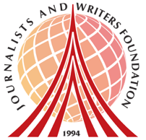
About Us
The Journalists and Writers Foundation (JWF) is an international civil society organization dedicated to the culture of peace, human rights and sustainable development. The JWF promotes diversity and inclusion by creating forums for intellectual and social engagement, generates and shares knowledge with stakeholders, builds partnerships worldwide and develops policy recommendations for positive social change.

This program is prepared and lead by Dr. Rajendran Govender and Ms. Nancy Falcon who serve as JWF’s Interfaith Committee Members and Advisory Board Members at the Journalists and Writers Foundation.

Journalists and Writers Foundation
4 West 43rd Street 4th Floor (Suite 419) New York, NY 10036
www.jwf.org | info@jwf.org

* JWF is a 501(c)3 non-profit organization registered in New York State.
* JWF is associated with the United Nations Department of Global Communications

