Event Report: Global Youth Voices Interfaith Digital Storytelling Screening Webinar
Date: February 12, 2025
Location: Virtual Event
Organizer: Journalists and Writers Foundation (JWF)

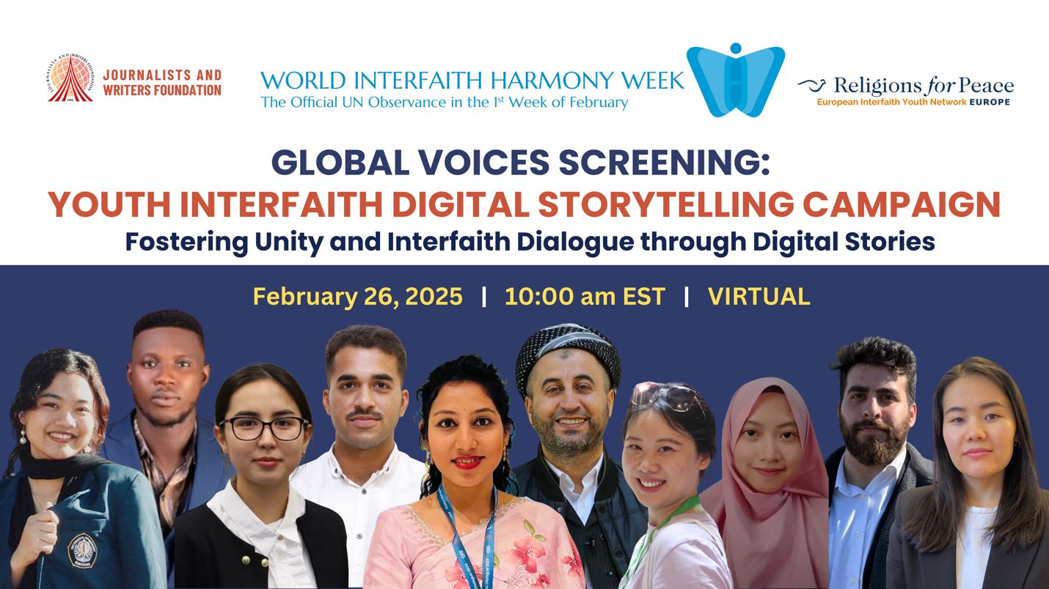

On February 12, 2025, the Journalists and Writers Foundation (JWF) hosted a virtual webinar titled "Global Youth Voices Interfaith Digital Storytelling Screening," presented in observance of the United Nations World Interfaith Harmony Week. The event showcased the power of storytelling and interfaith dialogue through digital narratives created by young people from various faith backgrounds, emphasizing the importance of cooperation and understanding in today’s diverse world.

Welcome and Opening Remarks
The webinar began with a warm welcome from Priyanka Chahal, JWF’s Youth Representative to the United Nations Department of Global Communication. She highlighted the purpose of the event, which was to celebrate storytelling as a means of fostering interfaith dialogue among youth around the globe. Priyanka introduced the two co-hosts—Ashley Kitisya and Yusuf Ali Bulafu—both distinguished alumni from the JWF Youth Leadership Program 2024—who are dedicated to nurturing meaningful conversations and impactful initiatives in their communities.

Highlights of the Event

Celebrating Achievements in Interfaith Dialogue
Ashley Kitisya opened by noting the JWF’s recent achievement of winning a bronze medal in the King Abdullah II Prize for Interfaith Harmony Week 2024, which recognizes efforts in promoting interfaith dialogue. A video of the awarding ceremony was shown, expressing aspirations for unity beyond religious differences.

Inspirational Words from Youth Leaders
Following the introduction, Mehmet Kilic, President of JWF, addressed attendees, sharing insights into the global Youth Voices campaign. He announced that the campaign had received an inspiring 39 videos from participants across 13 countries, showcasing personal stories of interfaith experiences. Kilic emphasized the transformative power of these narratives in bridging divides and fostering peace, encouraging youth to continue using their voices and experiences for positive change.

Video Presentations
The heart of the event centered around the screening of selected youth videos, each addressing themes of understanding, unity, and cooperation among diverse faiths.
- Ahmed Raza from Pakistan created a video with his story on the necessity of interfaith cooperation to address social challenges. He illustrated how his experiences with different religions expanded his understanding and encouraged dialogue.
- Omer Koselli’s video featured the Children of Abraham Coalition, promoting interfaith engagement among Christian, Muslim, and Jewish youth in the United States, emphasizing the importance of peace and dismantling hate.
- Naila, Zakiya, Salsabilla, and Nasiwa from Indonesia participated in a discussion on the significance of mutual respect and understanding among diverse faiths and cultures, sharing insights on how these contribute to harmony.
- Abdulghaffar Khourshid from Iraq spoke about his experiences growing up in a country ravaged by war and the importance of dialogue in building a culture of peace. He highlighted the urgent need for peacebuilding efforts in conflict zones.
- From the Democratic Republic of Congo, Nelly Ninja shared the significance of recognizing the inherent connections between different faiths and cultures while promoting justice and peace, particularly in light of ongoing violence.
- Ali Keles, Selim Kandil, and Vedat Cakmaktepe from North Carolina shared their interfaith experiences as they participated in youth events.
- Adriyana Reyes and his friends shared a wonderful video message in Spanish from Chile that reflected on the role of interfaith dialogue in building peace and harmony in society.
- Etim-Etim Bassey Akpan from Nigeria shared his personal experience in building peace through youth participation in peacebuilding and conflict resolution.
- Firdevs Dilekchi from California talked about her personal story about religious awareness and making friendship through interfaith dialogue.
- Bingjia Jia from China shared her video message that focused on mutual understanding, tolerance, and love for another.
- Paridhi Billore from India shared her poem that resonates on the necessary of interfaith dialogue and understanding.
- Rafa Narryama Rassyantra from Indonesia shared his activities for the 30 Days of Kindness category, which is important for respecting people in daily activities.
- Gulzina Baktybek Kyzy from Kyrgyzstan created a video message that talked about her interfaith understanding among Muslims, Crhistians, and Jews in Poland.

YouTube Videos

The remaining 36 videos were uploaded to JWF’s YouTube Account for people’s view. It was amazing that the videos were view for more than 3000 – 4000 views.

Videos can be viewed at https://youtu.be/oCsvqyqAbks?si=qb11QZChxPp1sF3N

Youth Written Message

Youth Voices also collected written messages from young people on peace, hope, and harmony that was shared with the world on social media platforms. A collection of these messages are attached within this report.

Participant Engagement
The event facilitated a dynamic environment for engagement. Attendees were encouraged to share their stories, reflections, and insights in the chat and were invited to speak during the open floor segment. Abdulghaffar Khourshid and other participants shared their thoughts on the urgency of fostering interfaith dialogue in a world that often highlights division.

Reflections from Experts
The webinar included speeches from notable figures like Dr. Rajendran Govender, who described the event as a transformative experience that reflects the commitment of the youth to interfaith dialogue and understanding. His remarks highlighted the potential of storytelling to change hearts and minds and stressed the importance of unity in diversity.

Conclusion
The digital storytelling webinar concluded with a call to action from JWF President Mehmet Kilic, urging participants to continue advocating for interfaith dialogue in their communities and to share their stories widely. He emphasized that despite differences, the collective goal is to build a world marked by peace, empathy, and understanding.
Ashley and Yusuf wrapped up the session by expressing gratitude to all participants, co-hosts, and contributors, inviting everyone to stay engaged with JWF’s future initiatives and to look out for the release of videos on their YouTube channel.
The Global Youth Voices Interfaith Digital Storytelling Screening served as a powerful reminder of the role of youth in promoting interfaith dialogue and the impact that sharing personal narratives can have on fostering a harmonious world.

