**World Interfaith Harmony Week 2025**

**PANEL**

**INTERFAITH VOICES FOR PEACE AND JUSTICE**

February 12, 2025 | 10:00am EST | Virtual

[**Click Here to RSVP**](https://us06web.zoom.us/webinar/register/WN_rHDUgOB5TAmPAadMj4XsDA#/registration)

Join us for a panel discussion on **Interfaith Voices for Peace and Justice**, designed to promote meaningful interfaith dialogue, mutual understanding, and collaboration among youth leaders from various religious backgrounds around the world. The panel will explore both local and global challenges, focusing on peace, justice, and strong institutions in alignment with Sustainable Development Goal #16: Peace, Justice, and Strong Institutions (SDG #16).

**Objectives**

* **Enhance Interfaith Dialogue:** Foster engaging conversations and activities among youth leaders from diverse faith traditions to promote mutual respect and understanding.
* **Promote Peace and Justice:** Develop and implement community-based projects that tackle local issues related to peace, justice, and human rights, drawing inspiration from the principles of various faiths.
* **Strengthen Institutions:** Advocate for the establishment and reinforcement of fair and inclusive institutions through interfaith collaboration and policy recommendations.
* **Raise Awareness:** Utilize digital platforms and media to promote understanding of the significance of interfaith dialogue in achieving global peace and justice.

**Key Topics for Discussion**

* How can we foster mutual understanding and collaboration among youth from different faiths?
* What is the significance of community-based projects in making real progress toward peace and social justice?
* In what ways can awareness and advocacy of interfaith dialogue contribute to sustainable peace and development, particularly concerning SDG #16?
* How can we build a global network of interfaith youth leaders committed to peace and justice?

The discussion aims to equip participants with renewed hope and practical strategies for implementing local and global peace and justice initiatives through youth partnerships and collaboration.

**Interfaith Voices for Peace and Justice** is an initiative by the Interfaith Working Group of the Journalists and Writers Foundation's Global Youth Leadership Program, Cohort of 2024.

**MODERATOR**

**Ashley Kitisya**

Ashley Kitisya is a Legal Expert and Programs Manager for Africa at the Laudato Si' Movement. As a strategist with a strong background in legal justice and stakeholder engagement, she excels at building partnerships and running impactful campaigns to raise climate awareness. Her work includes energy and climate campaigns and developing outreach strategies to engage the Faith community. Ashley has a proven track record in amplifying climate action, with a particular focus on empowering women and youth leaders across Sub-Saharan Africa. She holds a Postgraduate training in Law and is an LLM in international financial law candidate at Strathmore university with additional training in environmental law and stakeholder engagement.

**LinkedIn:** https://www.linkedin.com/in/ashleykitisya/

**SPEAKERS**

****Ayuba Bazam**

Ayuba Bazam is a dynamic Program Manager with extensive experience coordinating impactful programs at UFUK Dialogue. With a background in Sociology and Anthropology from the University of Maiduguri and a master’s in international Affairs and Diplomacy in progress at Ahmadu Bello University, Zaria, Ayuba is passionate about fostering dialogue, sustainability, and youth empowerment. He has spearheaded over 15 initiatives centered towards interfaith dialogue, youth empowerment, and peacebuilding. Ayuba’s expertise spans project management, interfaith dialogue, and advancing the Sustainable Development Goals through innovative and inclusive programs.

**Spozhmey Munir**

Spozhmey Munir is studying Biological Science at California State University East Bay. She is recognized and honored by Hayward Promise Neighborhood Mentorships.

**Bulafu Yusuf Ali**

Bulafu Yusuf Ali is a public speaker, writer, and advocate for meaningful dialogue, with a background in chemical engineering and Islamic Sharia. My work focuses on bridging diverse perspectives, promoting understanding, and inspiring reflection through engaging conversations and thought-provoking discussions.

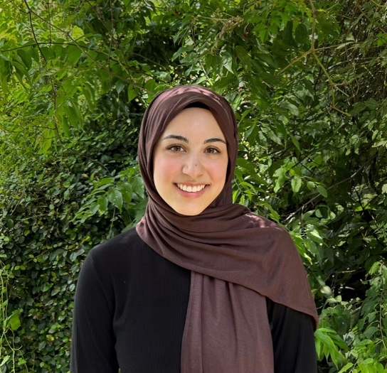**Serra Kazan**

Serra Kazan is an undergraduate Public Health student at Texas A&M University. She believes that learning from one another and building connections are essential for promoting peace and justice in our world. Interfaith discussions provide a space for meaningful dialogue, to come together and advocate for lasting, positive change.

*\*\* This program is prepared and lead by the Interfaith Working Group of the JWF Global Youth Leadership Programme 2024.*

**About Us**

**The Journalists and Writers Foundation** (JWF) is an international civil society organization dedicated to the culture of peace, human rights and sustainable development. The JWF promotes diversity and inclusion by creating forums for intellectual and social engagement, generates and shares knowledge with stakeholders, builds partnerships worldwide and develops policy recommendations for positive social change.

**JWF Global Youth Leadership Programme** (GYLP) is an immersive experience tailored program for a select group of young individuals eager to explore global affairs, platforms, and opportunities. This initiative equips participants aged 18-32 with leadership, teamwork, and communication skills through engagement with the JWF executive team, guest speakers, and experts worldwide. Upon successful completion of the leadership program, participants will receive a Certificate of Completion from the JWF Global Youth Leadership Program.

**Journalists and Writers Foundation**

4 West 43rd Street 4th Floor (Suite 419) New York, NY 10036

[www.jwf.org](http://www.jwf.org) | [info@jwf.org](mailto:info@jwf.org)

*\* JWF is a 501(c)3 non-profit organization registered in New York State.*

*\* JWF is associated with the United Nations Department of Global Communications*

*\*Tentative Program\**

*Welcome Remarks by Mehmet Kilic, President, JWF (2-3 mins)*

*Brief Remarks by Priyanka Chahal, JWF Youth Representative to the UN DGC (1-2 mins)*

*Introduction of the Moderator by Mehmet Kilic (1 min)*

*Opening Remarks by Ashley Kitisha, Moderator*

*Introducing Speakers 1-4*

*Speeches by Speakers*

*Moderators Questions to Speakers*

*Q& A Session*

*Questions by the Audience*

*Concluding Remarks by the Moderator*

*Closing Remarks*

*Closing Remarks by Mehmet Kilic*

*Reminders Priyanka Chahal*