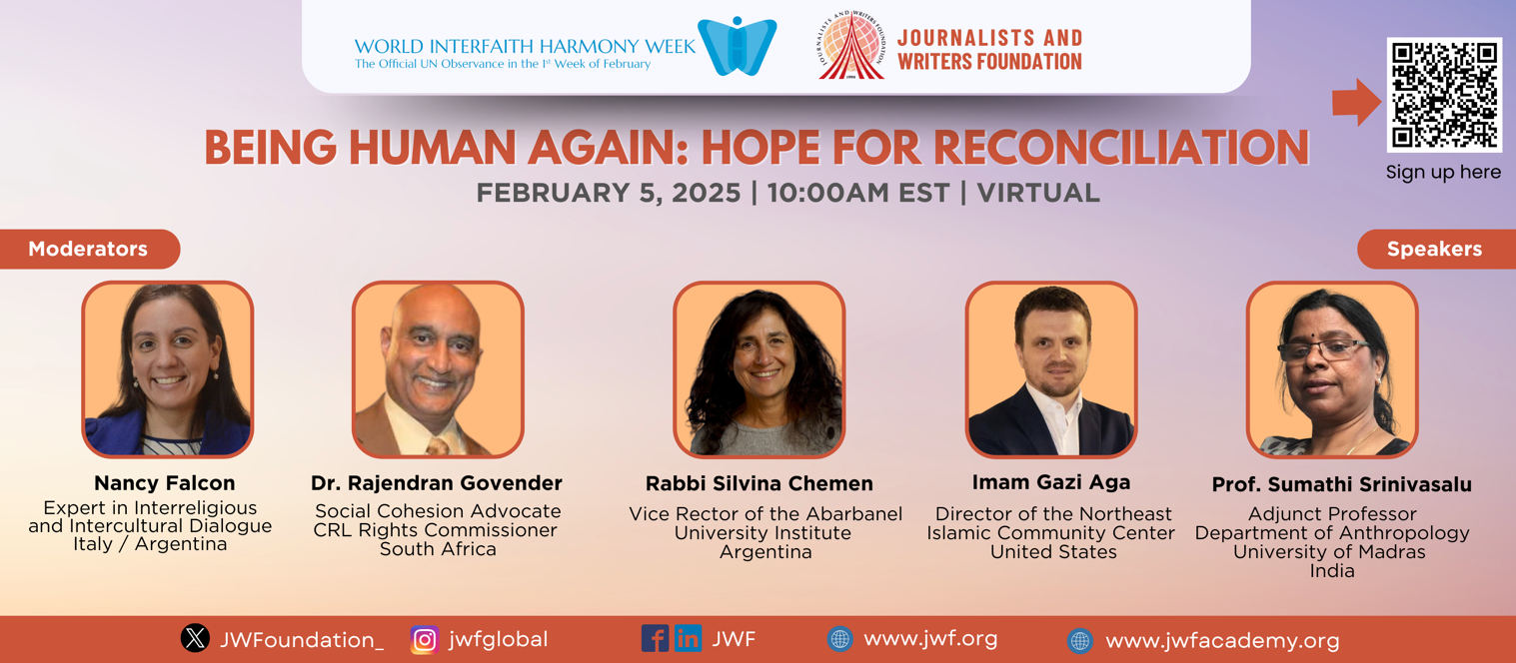

World Interfaith Harmony Week 2025

PANEL DISCUSSION
Being Human Again: Hope for Reconciliation
February 5, 2025 | 10:00am EST | Virtual

Click Here to RSVP

The panel discussion on Being Human Again: Hope for Reconciliation will explore the role of interfaith dialogue in fostering reconciliation, healing, and unity in divided communities. As societies grapple with the aftermath of conflict, inequality, and misunderstanding, the need to rediscover our shared humanity is more pressing than ever. Panelists from diverse faith traditions will reflect on how spiritual teachings, community engagement, and acts of compassion can pave the way for reconciliation. The session will highlight the importance of empathy, forgiveness, and collaborative action in building bridges across cultural and religious divides.

Objectives
- Emphasize the role of faith and spirituality in promoting reconciliation.
- Share practical examples of interfaith initiatives that foster unity.
- Inspire collective action towards creating harmonious and inclusive societies.

Key Topics for Discussion
- How can religious teachings guide reconciliation in divided societies?
- What practical steps can faith communities take to address social injustice and foster unity?
- How do we cultivate hope in the face of past divisions and ongoing conflicts?
- The role of interfaith dialogue in bridging historical and cultural differences.

The discussion aims to leave participants with a renewed sense of hope and practical strategies to implement in their own communities, reinforcing the belief that, at our core, we are all human beings capable of compassion and understanding.

HOSTS

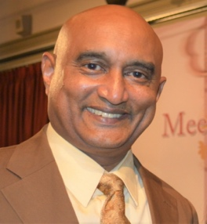
Dr. Rajendran Govender (Host)
Social Cohesion Advocate, CRL Rights Commissioner of South Africa; Executive Director of Mzansi Empowerment Enterprise; Former Senior Manager at KZN Department of Arts and Culture, South Africa; regularly features on National TV and radio as a cultural commentator and a newspaper columnist. Participated at UNGA Conference 2021.

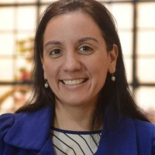
Nancy Falcon (Host)
Former Executive Director of Alba Intercultural Dialogue Center in Argentina; International Fellow at KAICIID 2020; expert in interreligious and intercultural dialogue who facilitates trainings with young leaders and religious actors from various cultures in Argentina and abroad. Promotes dialogue and conflict resolution, interested in the study of gender, transactional femininity and Islam.

SPEAKERS

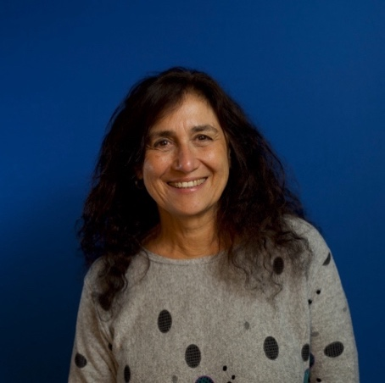
Rabbi Silvina Chemen
Prominent leader in interfaith dialogue and social action; Vice Rector of Abarbanel University Institute, Senior Rabbi at Beth El Congregation, Director of the Center for Dialogue and Social Action of the Marshall T. Meyer Latin American Rabbinical Seminary; holds degrees in Hebrew Language and Hebrew Bible from the Michlelet Shazar Institute, as well as in Social Communication from the University of Buenos Aires; co-founder of the Ana Frank Argentina Center for Latin America and has authored several books on education, human rights, and interreligious coexistence; Advisory Board of the Milstein Center for Interreligious Dialogue at the Jewish Theological Seminary and serves on the executive committee of Global Jewry.

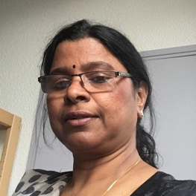
Prof. Sumathi Srinivasalu
Accomplished academic in the field of anthropology, Adjunct Professor in the Department of Anthropology at the University of Madras, India; received numerous awards, including the prestigious Lifetime Achievement in Anthropology awarded by the World Anthropology Congress in 2023; held various research fellowships, including roles at Johannes Gutenberg University in Germany and the University of Tours in France; awarded the Fulbright-Nehru Visiting Lecturer Fellowship for the years 2010-2011.

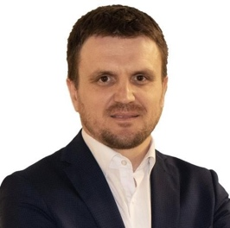
Imam Gazi Aga
Director of the Northeast Islamic Community Center; Imam of the Albanian American Cultural Center in the USA; an experienced interfaith leader who has held prominent leadership roles in various religious organizations and is skilled in religious education, youth engagement, chaplaincy, social affairs, nonprofit work, media relations, and interfaith dialogue; holds a theology degree from Marmara University, a master's degree in interfaith studies from Hartford International University for Religion and Peace, and a PhD candidate in Political Science and Government from Epoka University. Imam Aga was also ordained as a university chaplain at Sacred Heart University.

** This program is prepared and lead by Dr. Rajendran Govender and Ms. Nancy Falcon who serve as JWF’s Interfaith Committee Members and Advisory Board Members at the Journalists and Writers Foundation.

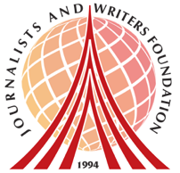
About Us
The Journalists and Writers Foundation (JWF) is an international civil society organization dedicated to the culture of peace, human rights and sustainable development. The JWF promotes diversity and inclusion by creating forums for intellectual and social engagement, generates and shares knowledge with stakeholders, builds partnerships worldwide and develops policy recommendations for positive social change.

Journalists and Writers Foundation
4 West 43rd Street 4th Floor (Suite 419)
New York, NY 10036
www.jwf.org | info@jwf.org

* JWF is a 501(c)3 non-profit organization registered in New York State.
* JWF is associated with the United Nations Department of Global Communications

