05.02.2025 UNESCO's reconstruction of Mosul's landmarks
di UNESCO Headquarters Paris
After 6 years of intense reconstruction, #Mosul’s monuments are rising again.

UNESCO used to resolve CONFLICT & PEACE –without used ARMS

In MEMORY of VICTIM of WAR

Report of the visited by UNESCO PRESIDENT AUDREY AZDULAY in SIRIA then Restoretion

All Religions People PRAYER together for WORLD PEACE

Rosa Dalmiglio CHINA-UNESCO at MEDIA PEACE JOURNALISM CONFERENCE in ROME-JUBILEO 2025

Prayer for POPE FRANCIS in Hospital’ recovery
rdalmiglio@hotmail.com
www.unesco.org

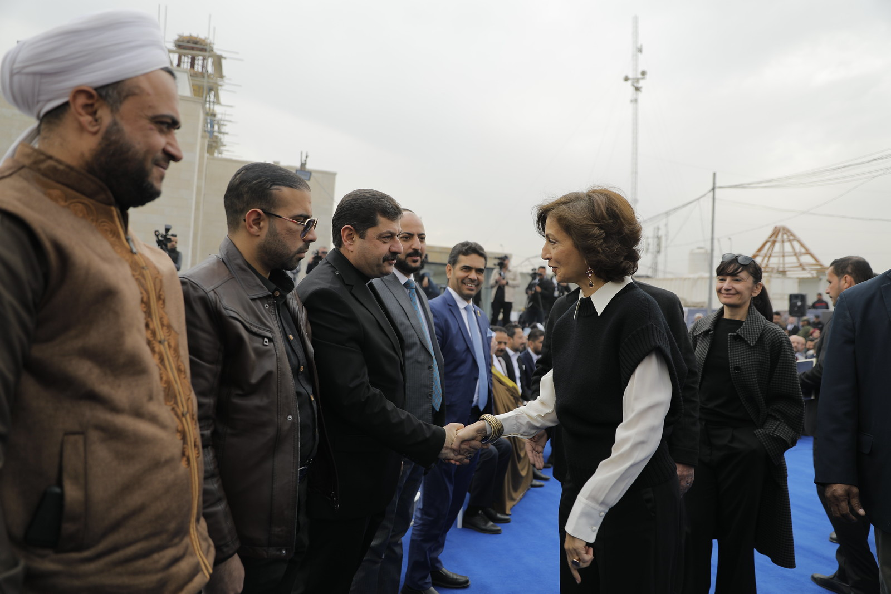
05.02.2025 UNESCO's reconstruction of Mosul's landmarks
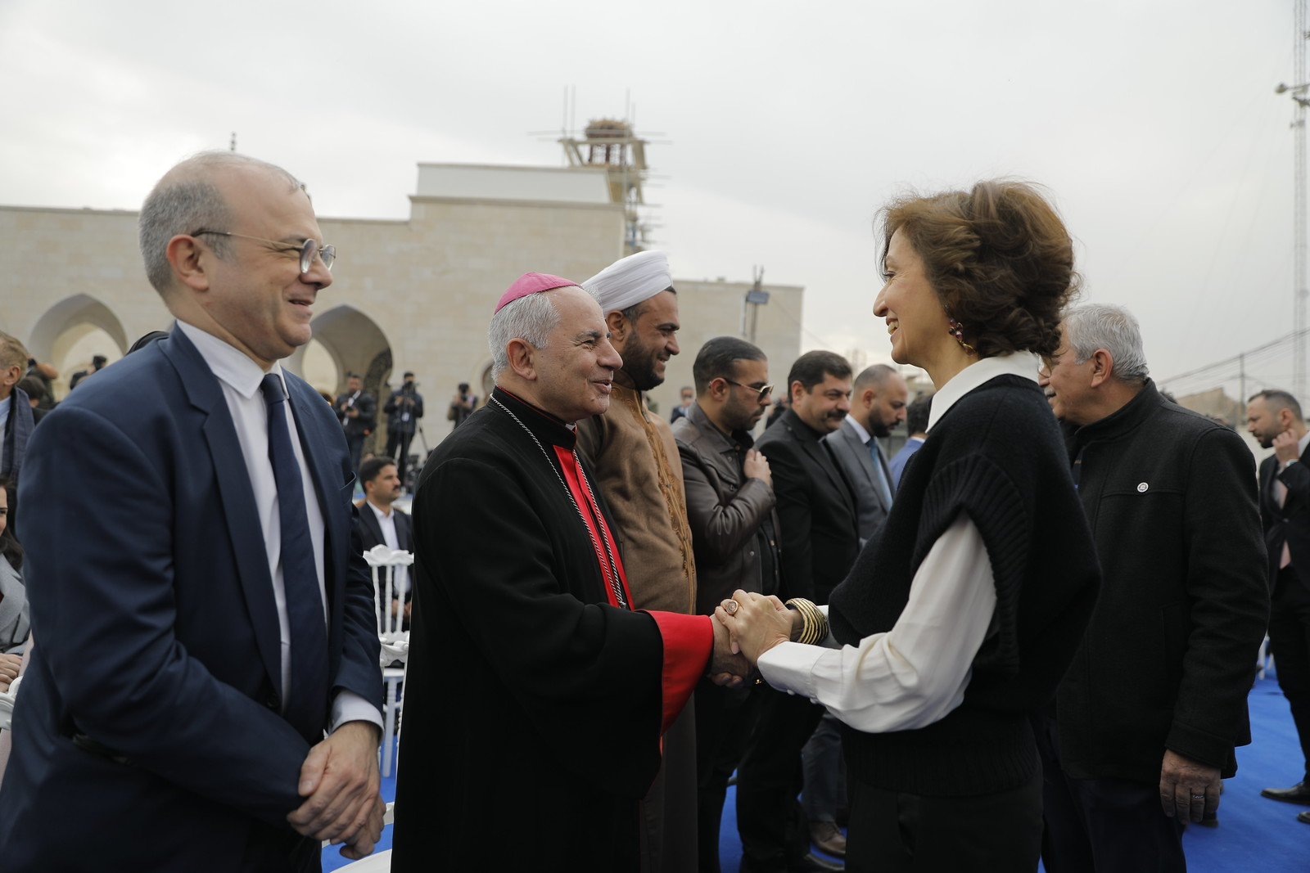
05.02.2025 UNESCO's reconstruction of Mosul's landmarks
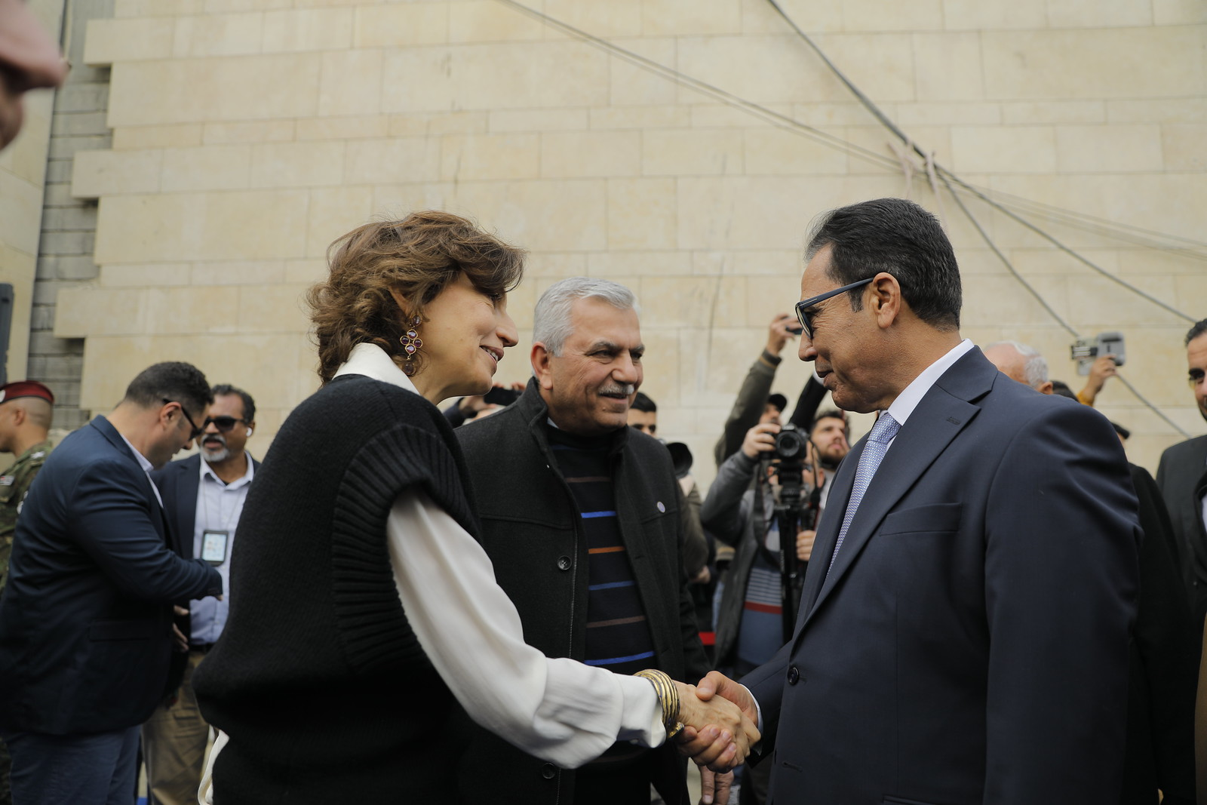
05.02.2025 UNESCO's reconstruction of Mosul's landmarks
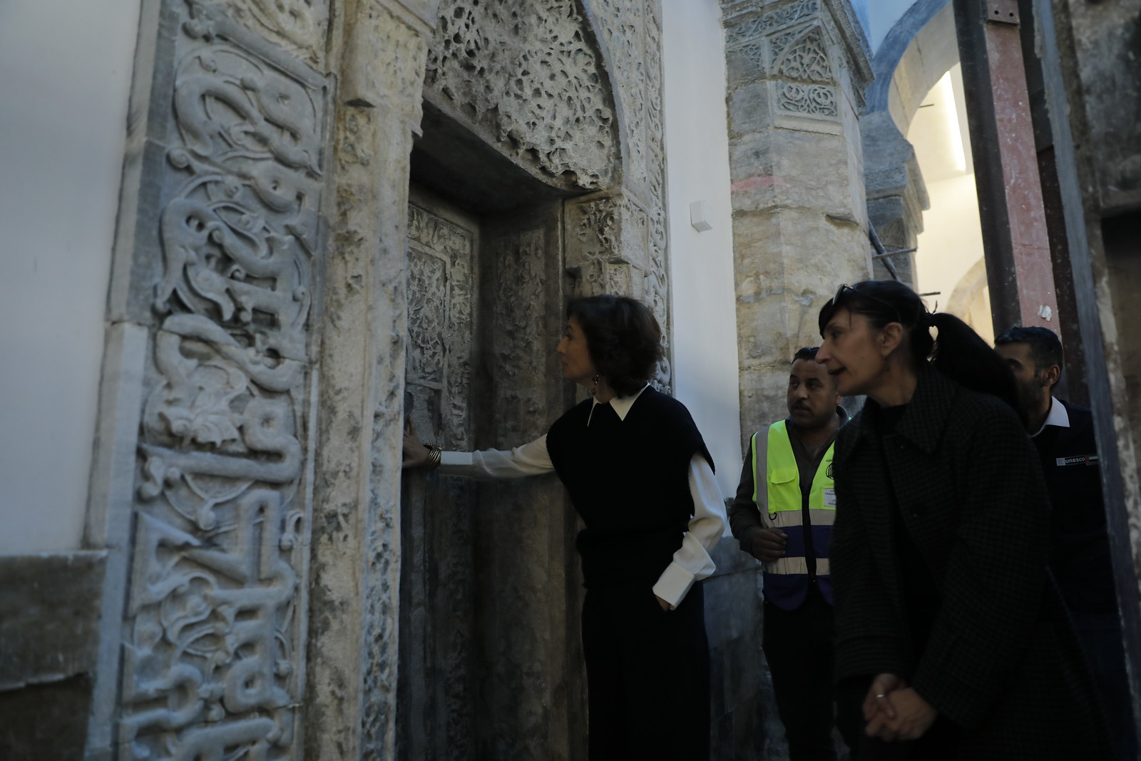
05.02.2025 UNESCO's reconstruction of Mosul's landmarks
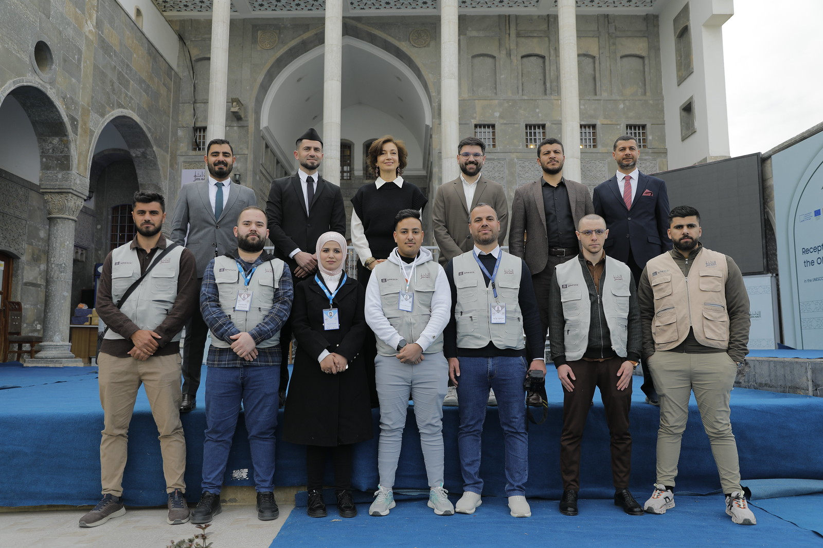
05.02.2025 UNESCO's reconstruction of Mosul's landmarks
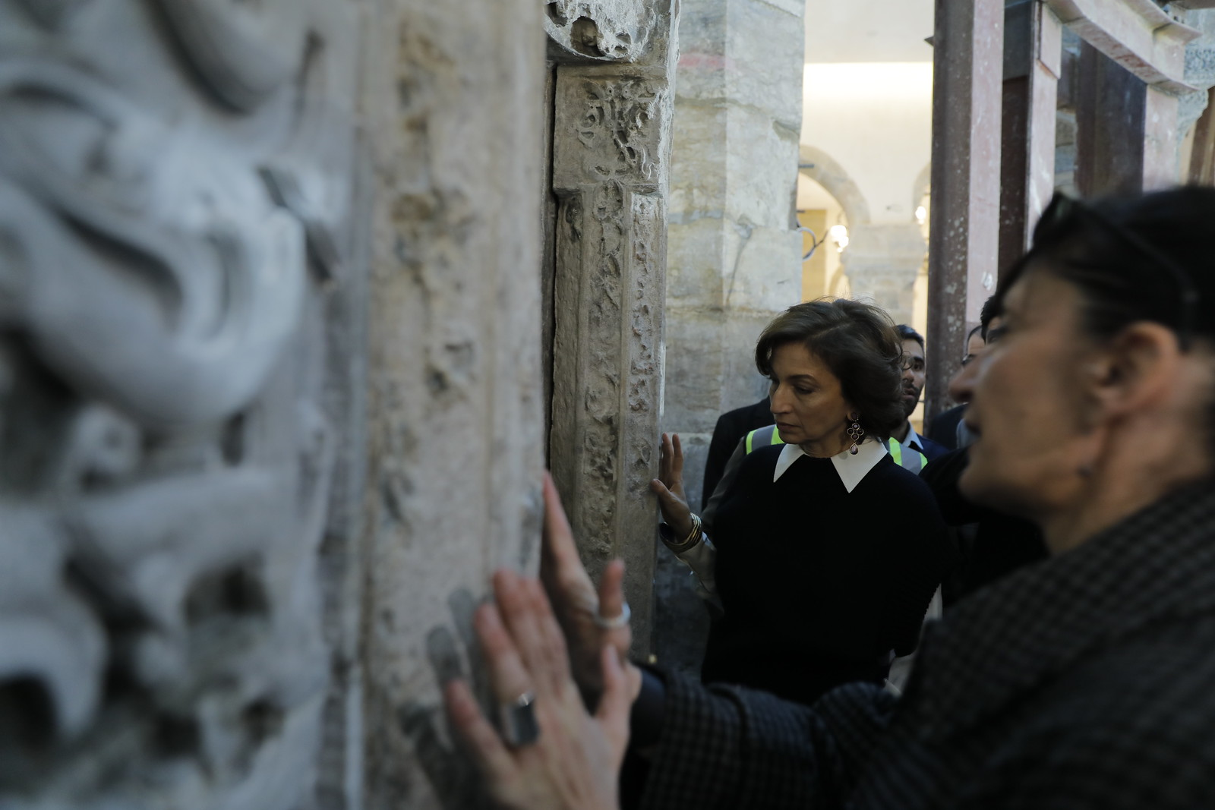
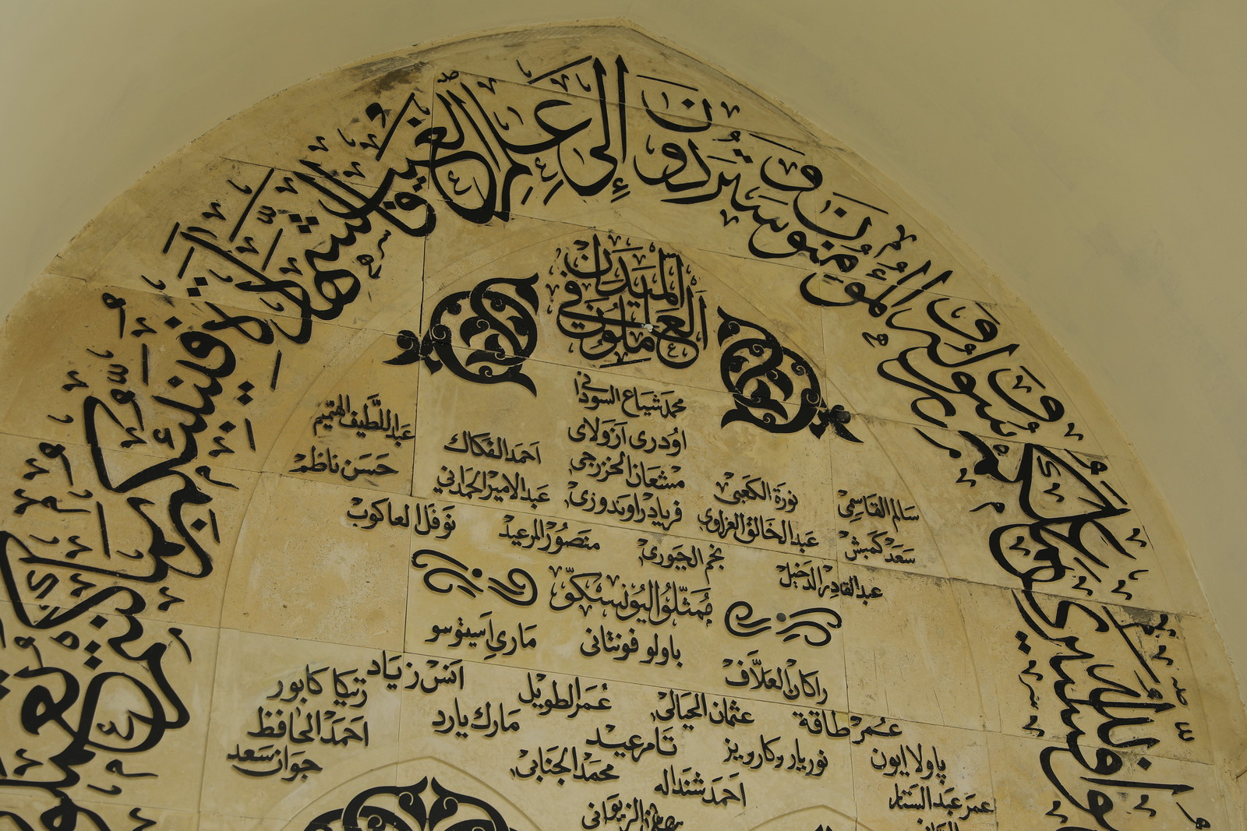
05.02.2025 UNESCO's reconstruction of Mosul's landmarks
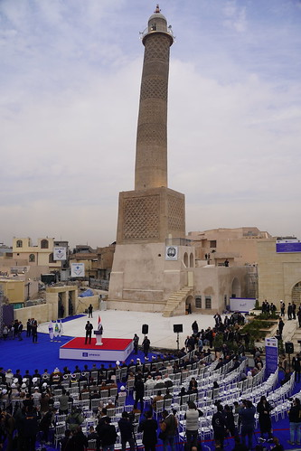
05.02.2025 UNESCO's reconstruction of Mosul's landmarks
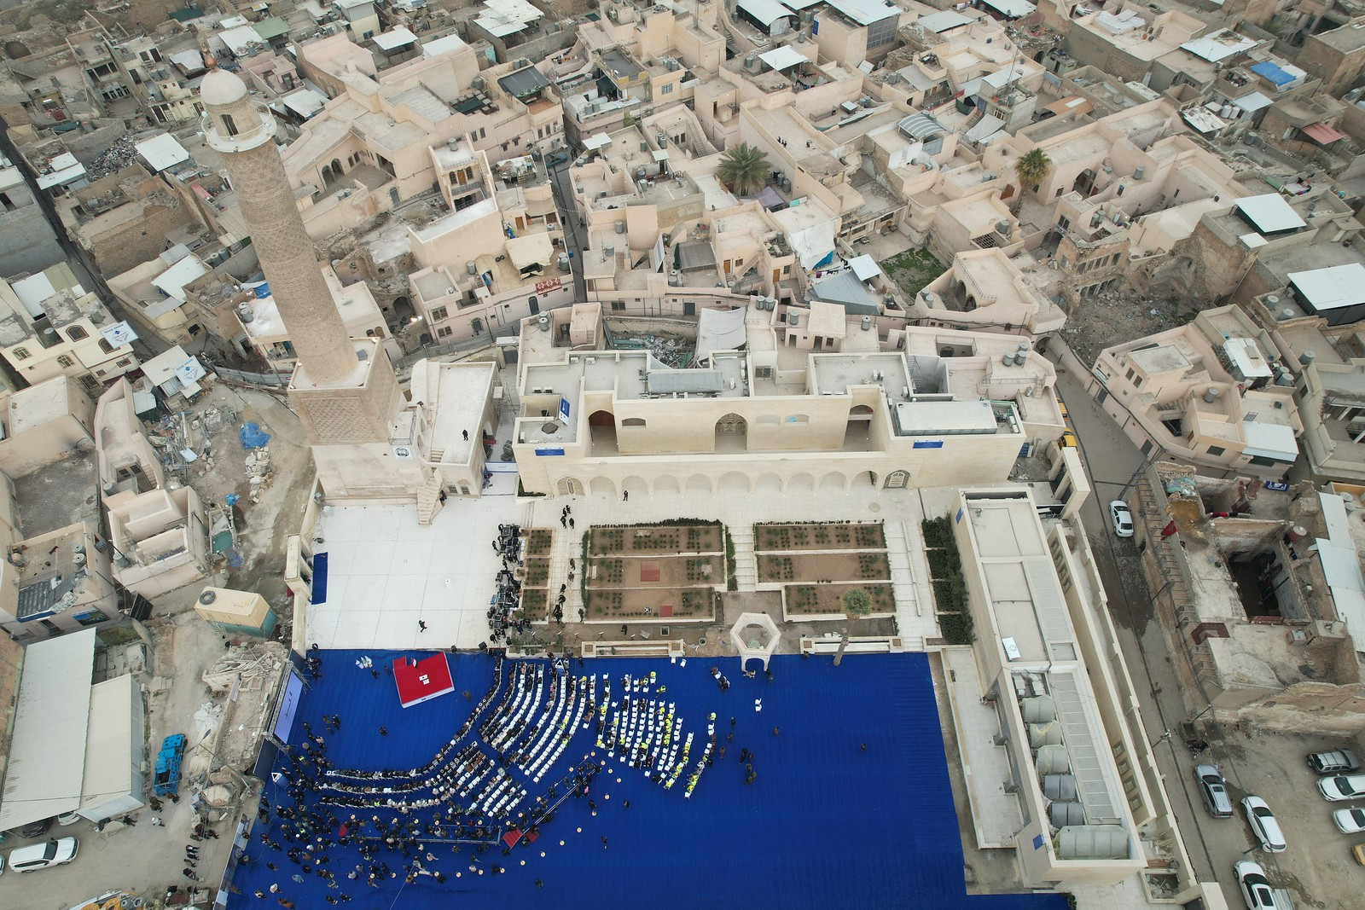
05.02.2025 UNESCO's reconstruction of Mosul's landmarks
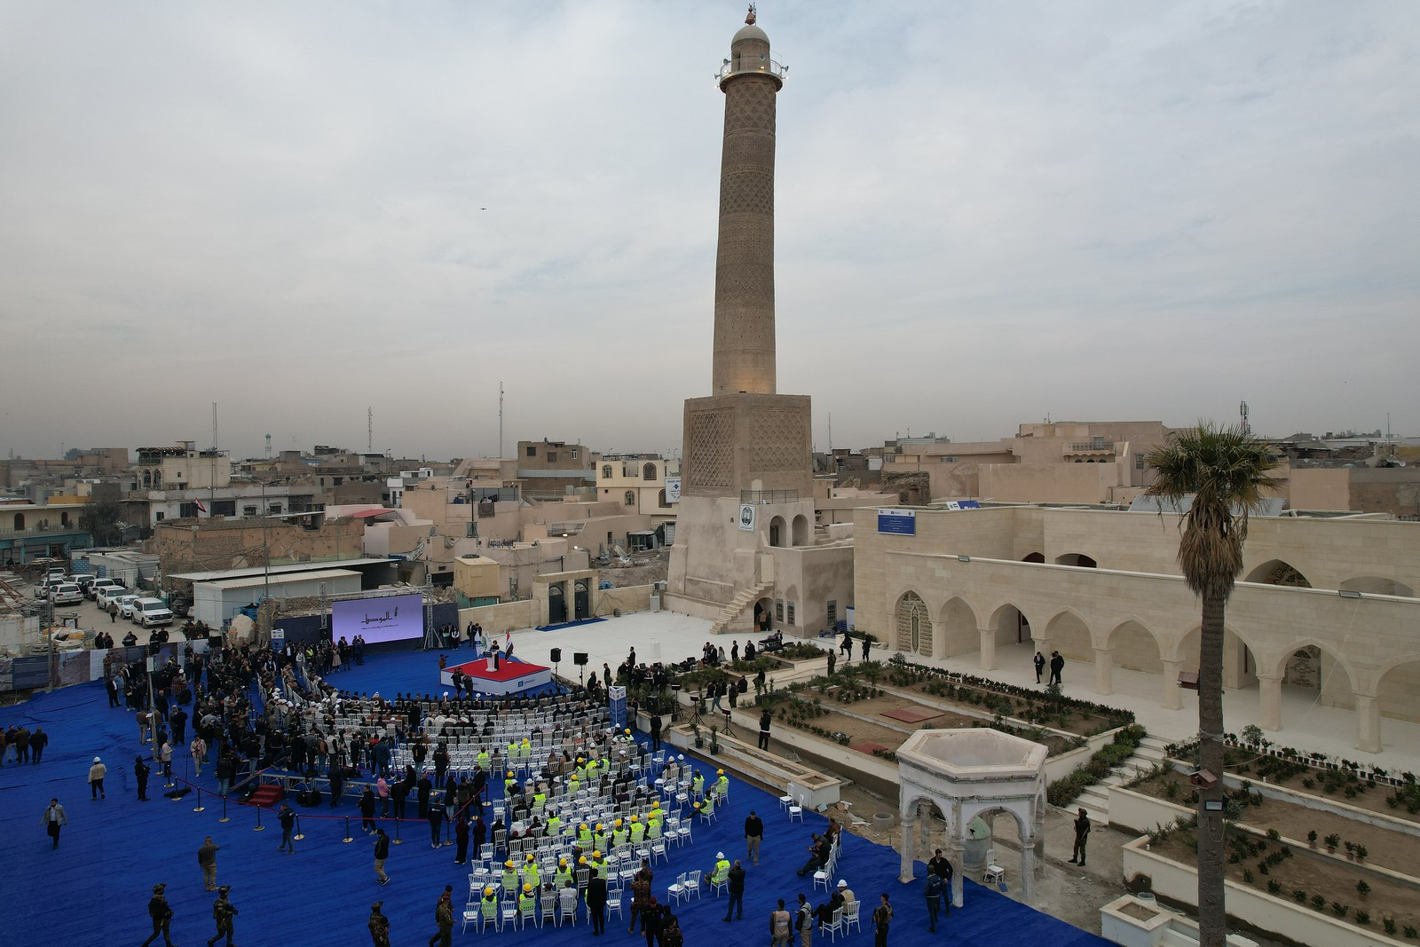
05.02.2025 UNESCO's reconstruction of Mosul's landmarks
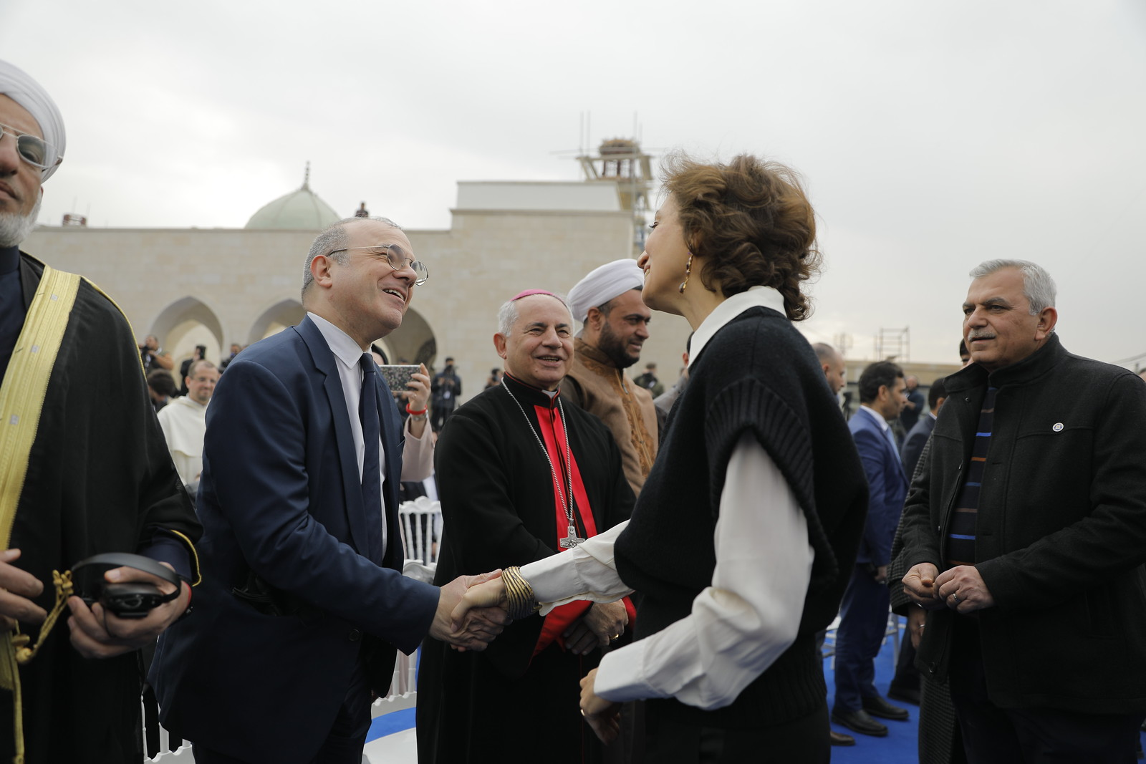
05.02.2025 UNESCO's reconstruction of Mosul's landmarks
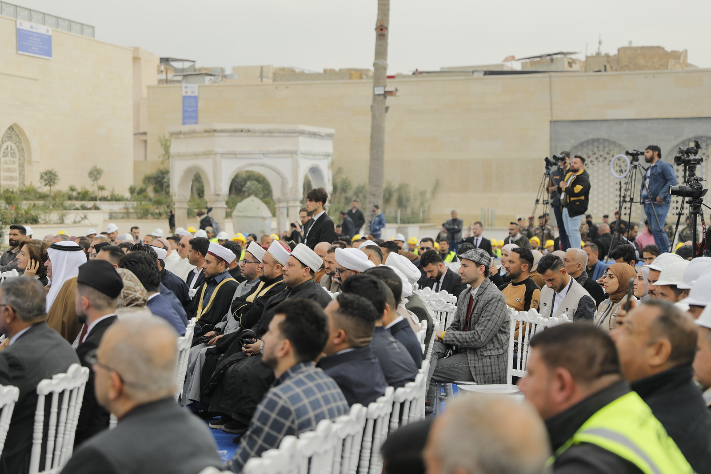
05.02.2025 UNESCO's reconstruction of Mosul's landmarks
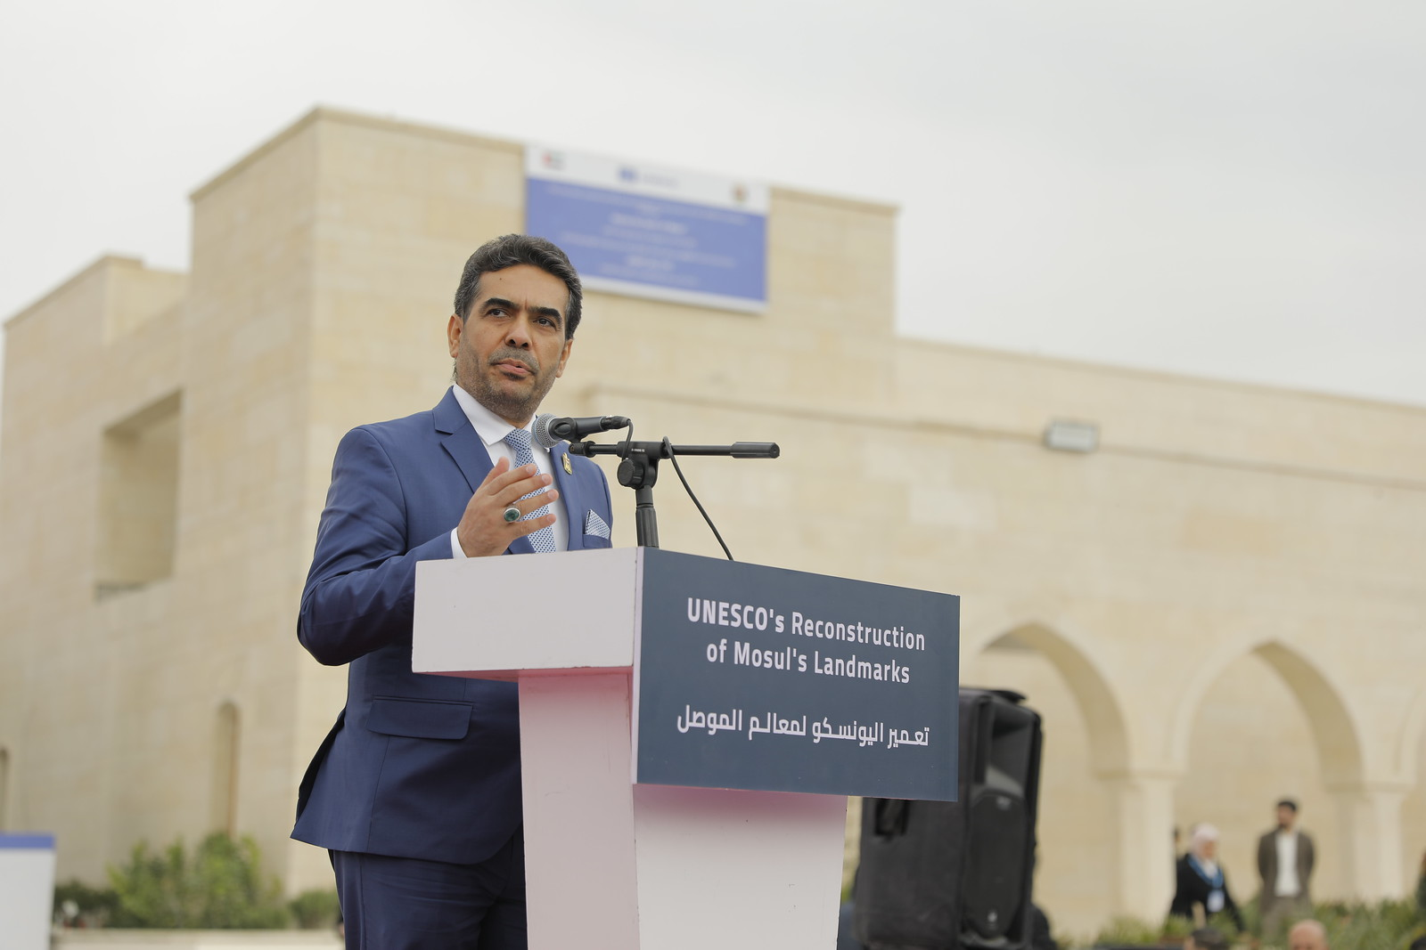
05.02.2025 UNESCO's reconstruction of Mosul's landmarks
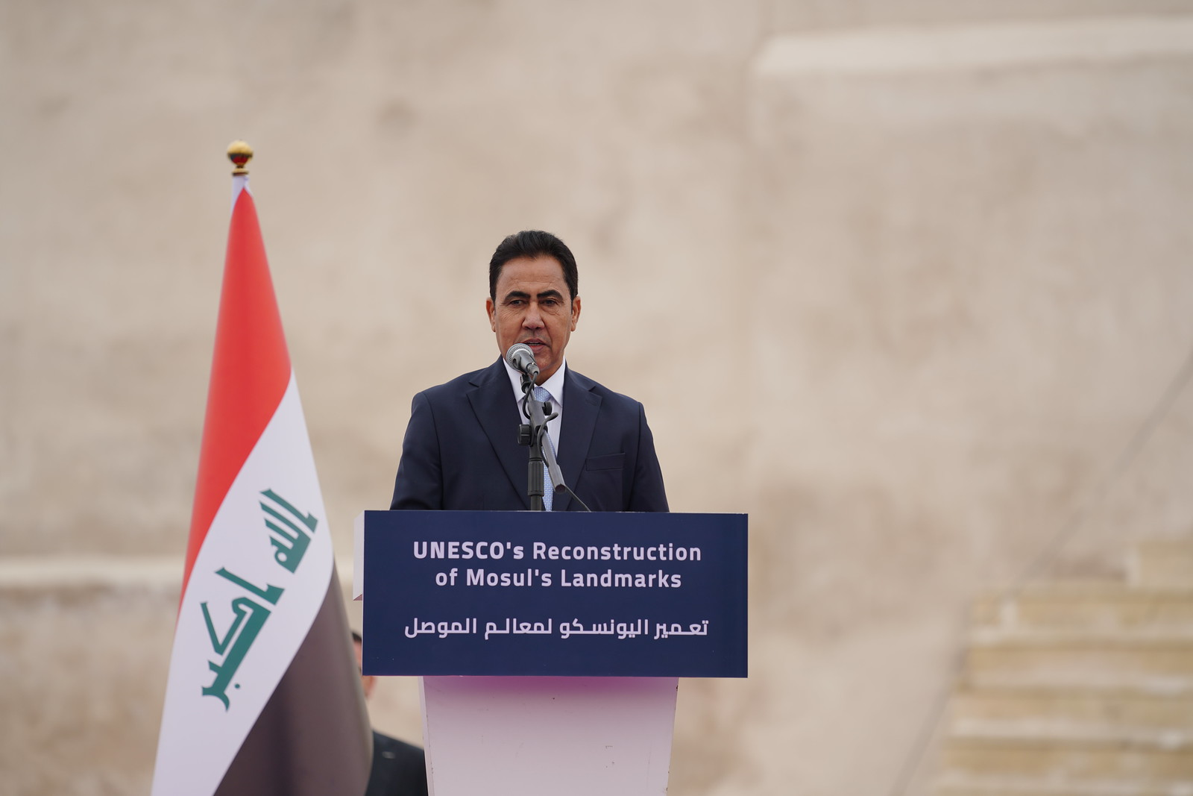
05.02.2025 UNESCO's reconstruction of Mosul's landmarks
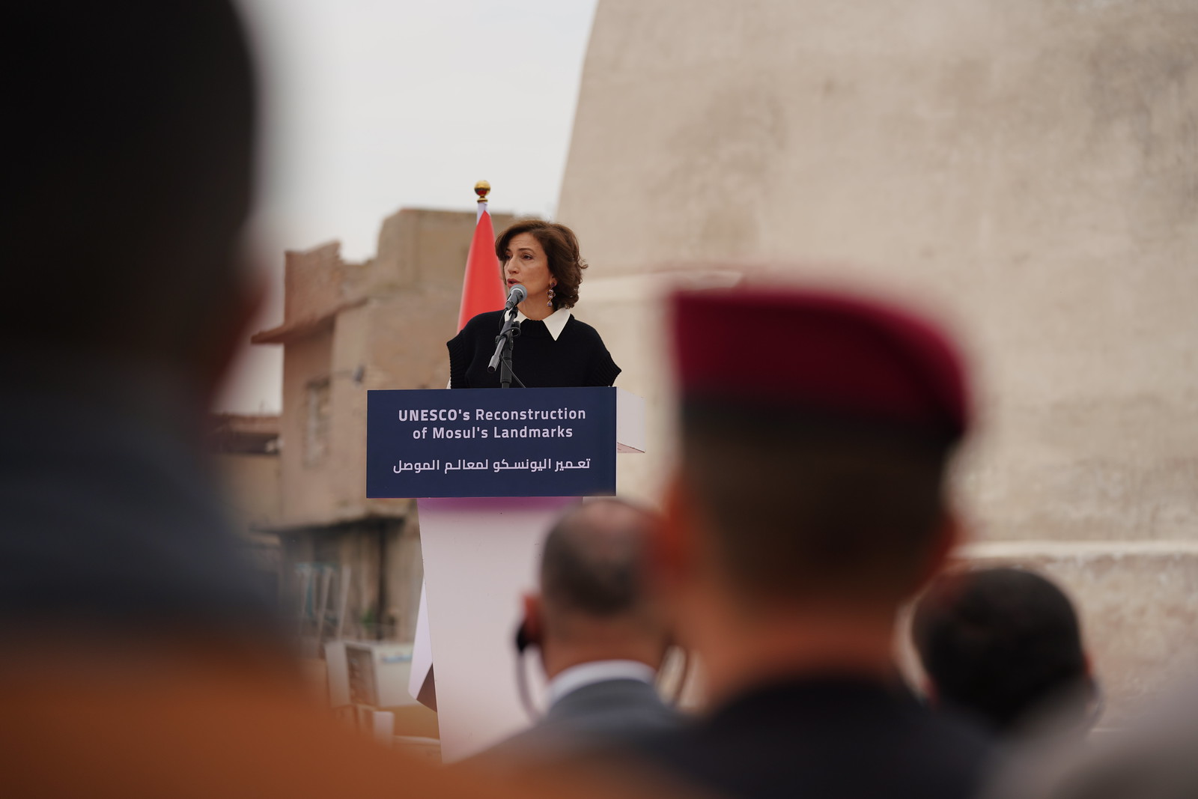
05.02.2025 UNESCO's reconstruction of Mosul's landmarks
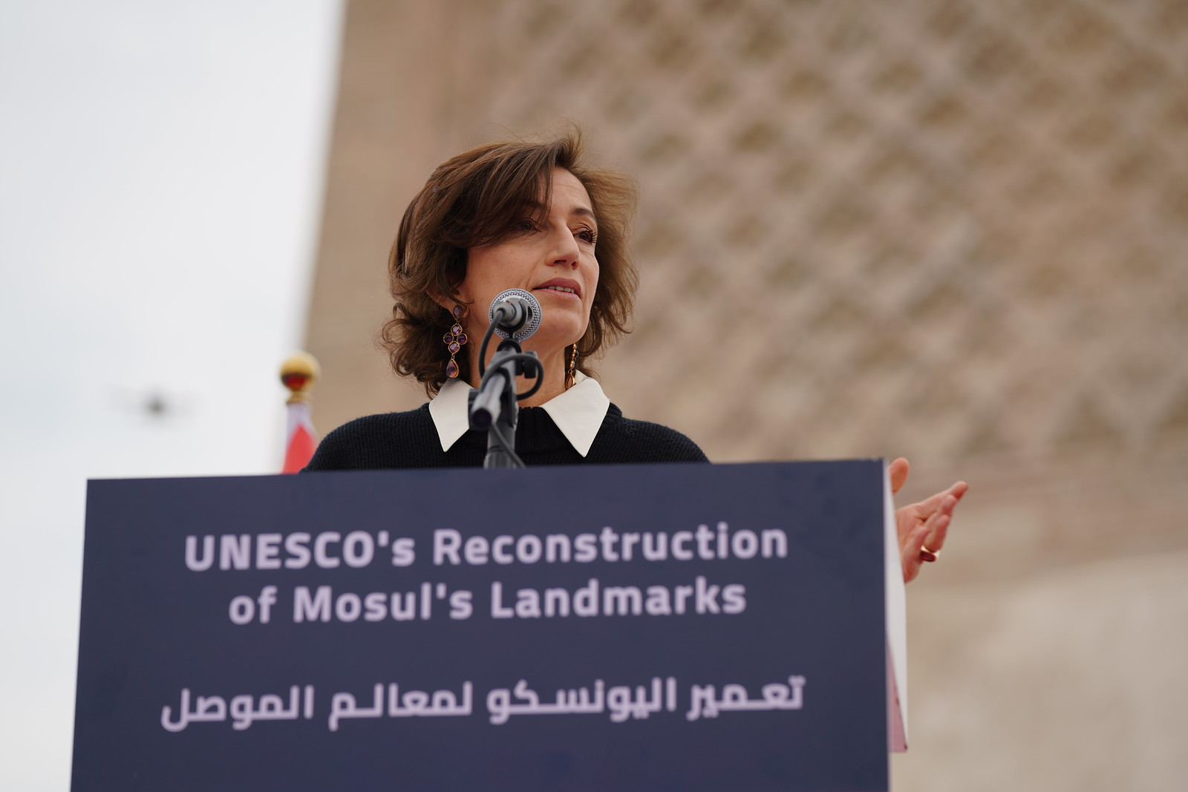
05.02.2025 UNESCO's reconstruction of Mosul's landmarks
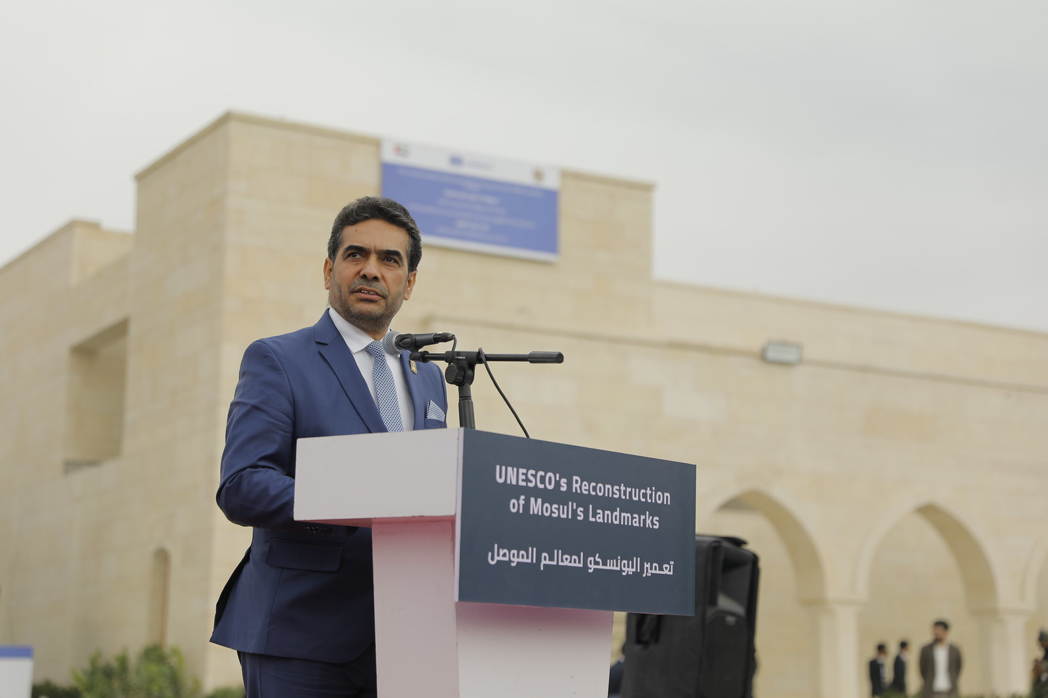
05.02.2025 UNESCO's reconstruction of Mosul's landmarks
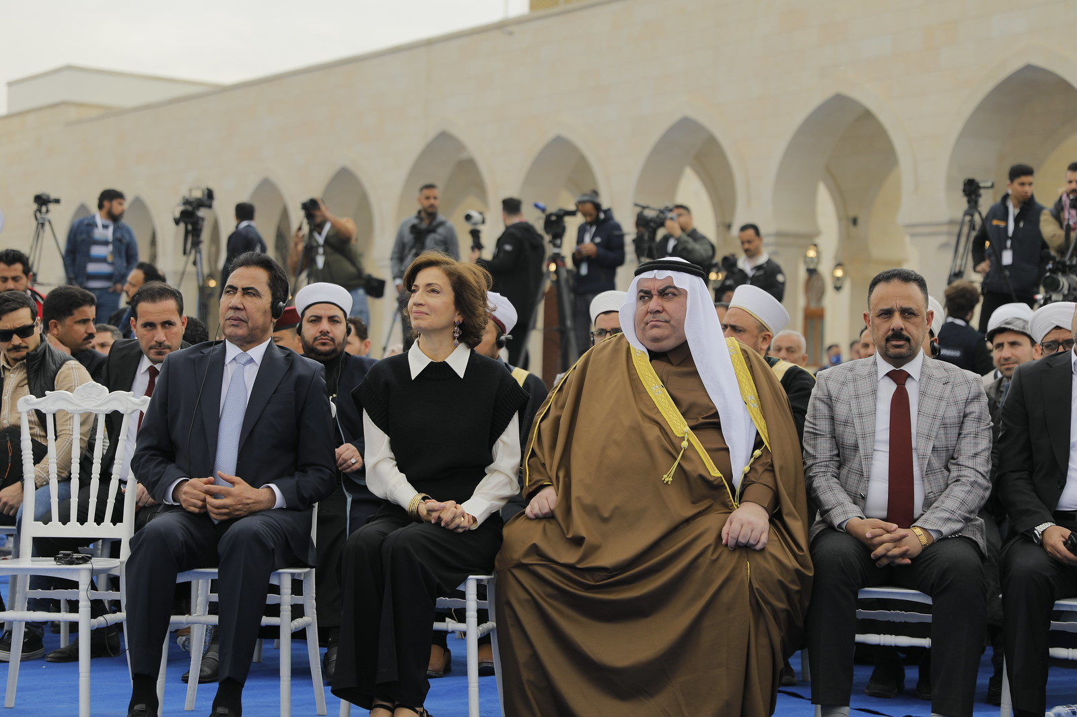
05.02.2025 UNESCO's reconstruction of Mosul's landmarks
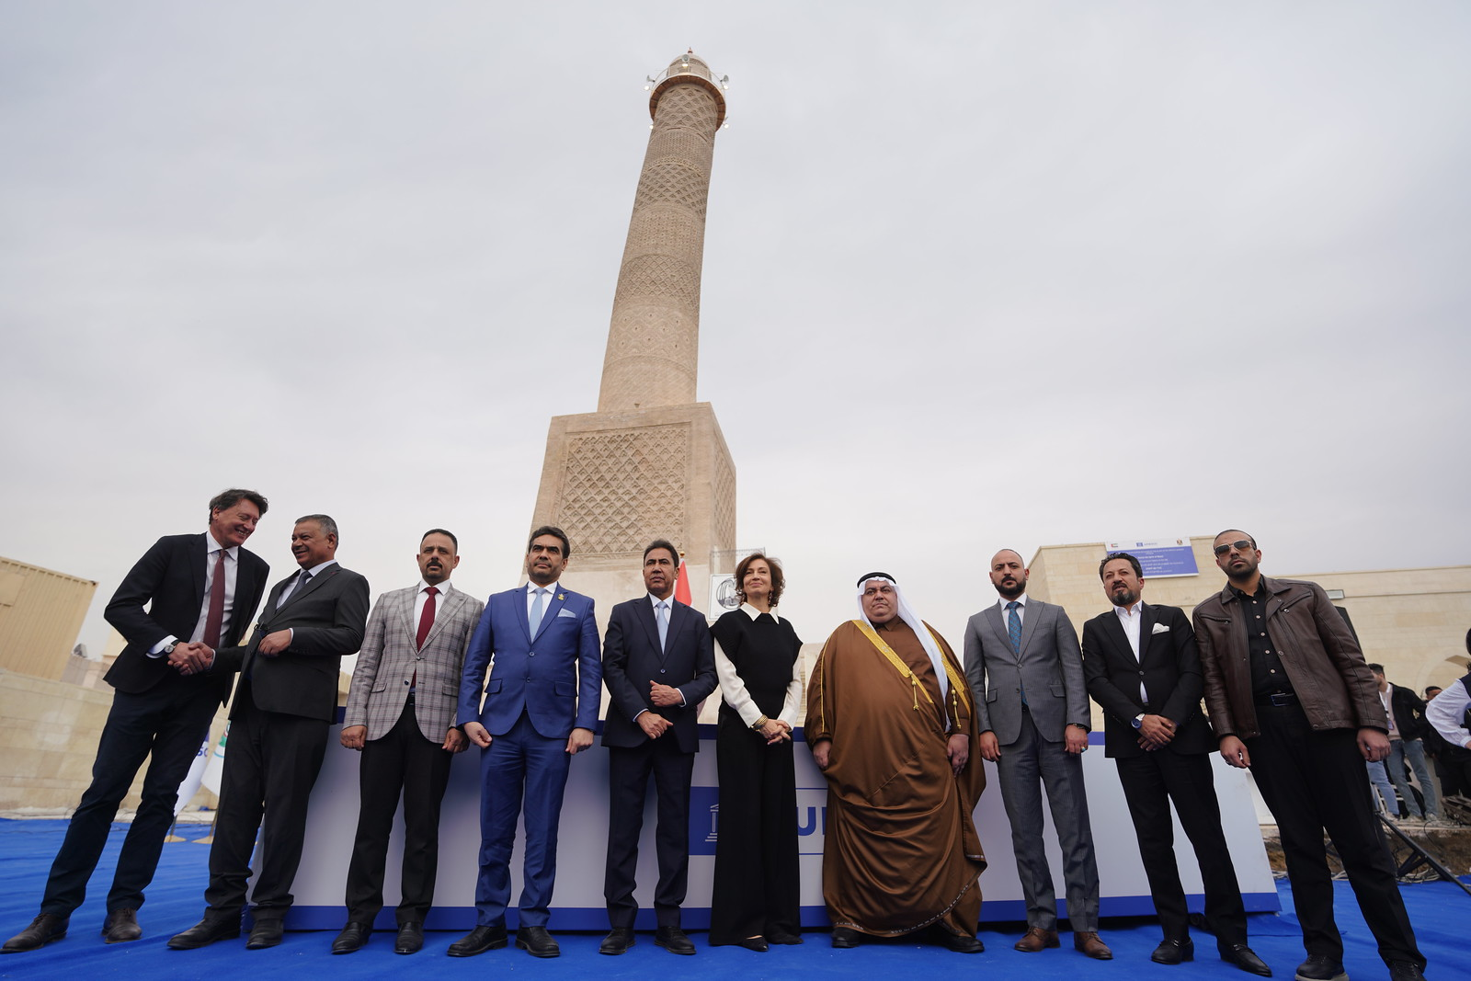
05.02.2025 UNESCO's reconstruction of Mosul's landmarks
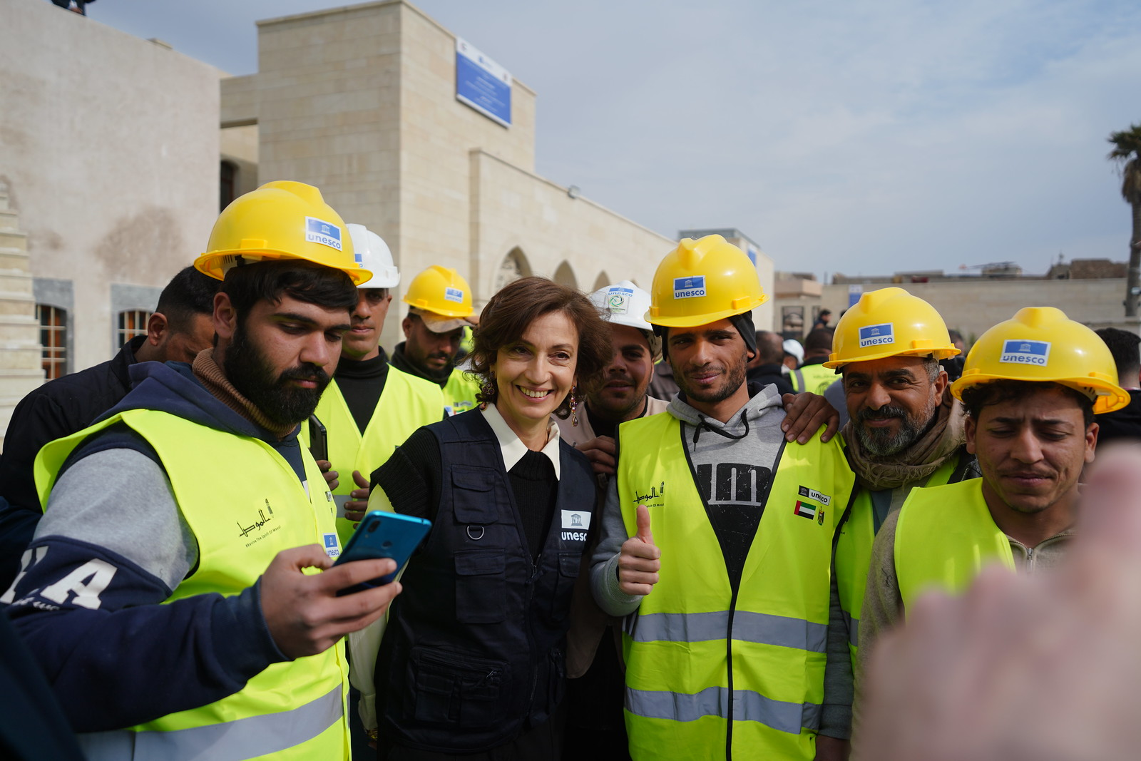
05.02.2025 UNESCO's reconstruction of Mosul's landmarks
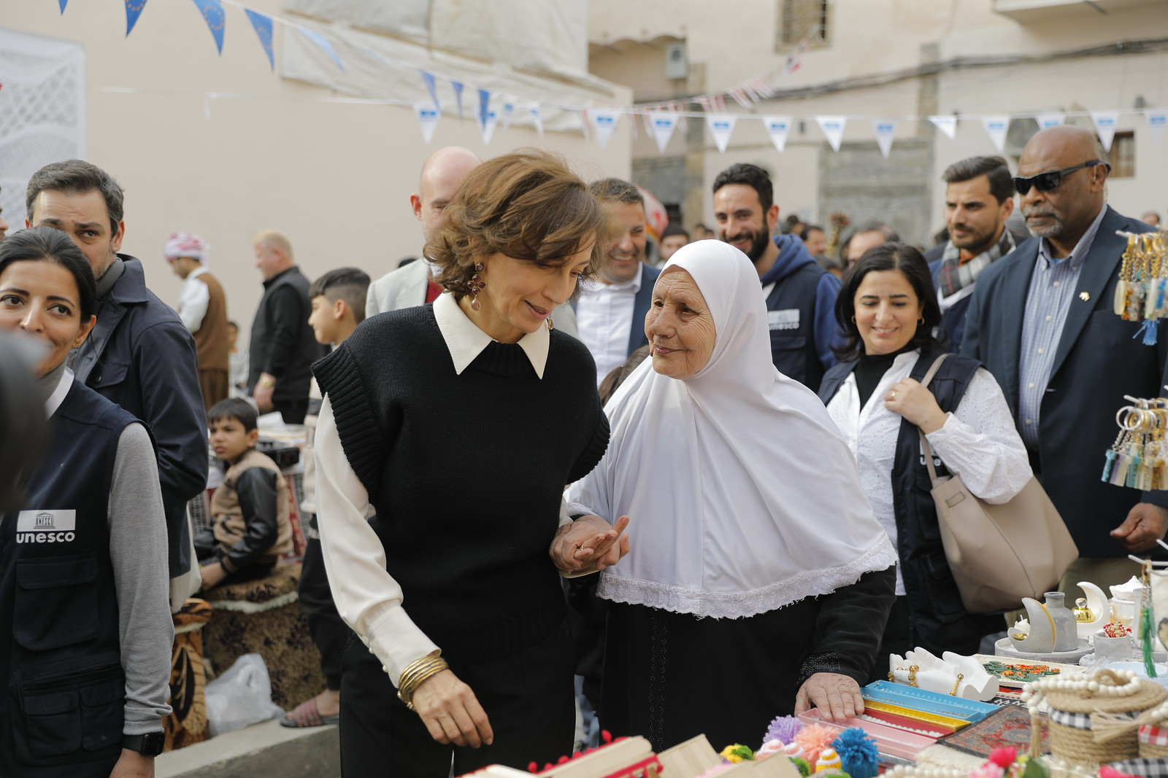
05.02.2025 UNESCO's reconstruction of Mosul's landmarks
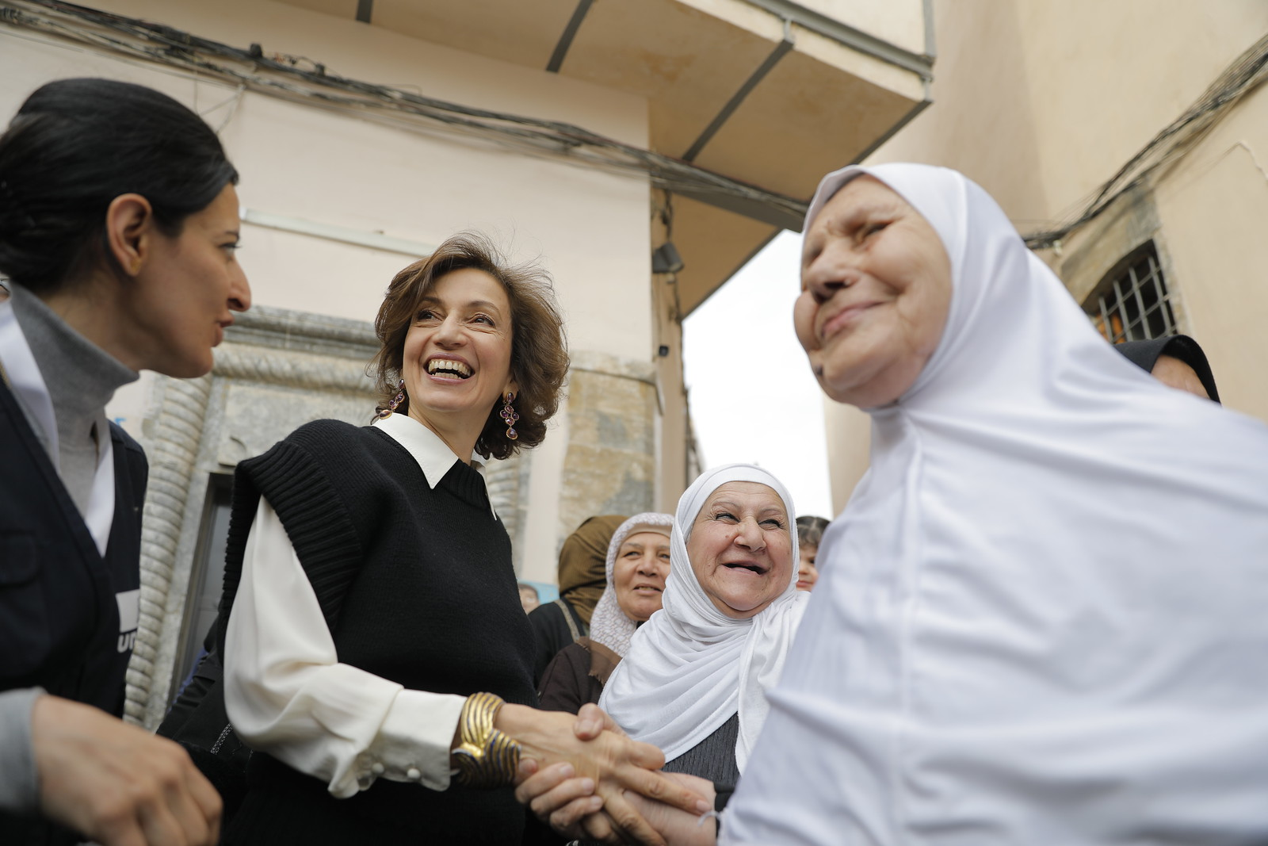
05.02.2025 UNESCO's reconstruction of Mosul's landmarks
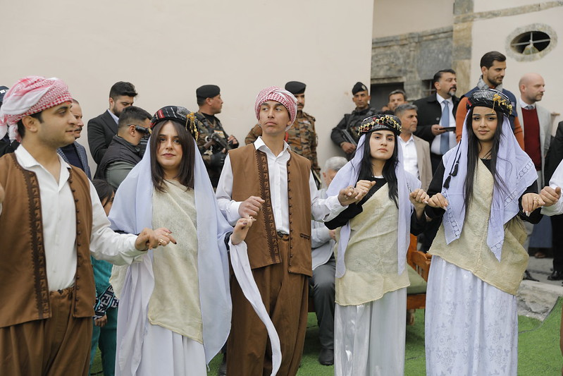
05.02.2025 UNESCO's reconstruction of Mosul's landmarks
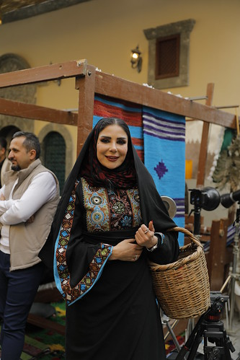
05.02.2025 UNESCO's reconstruction of Mosul's landmarks
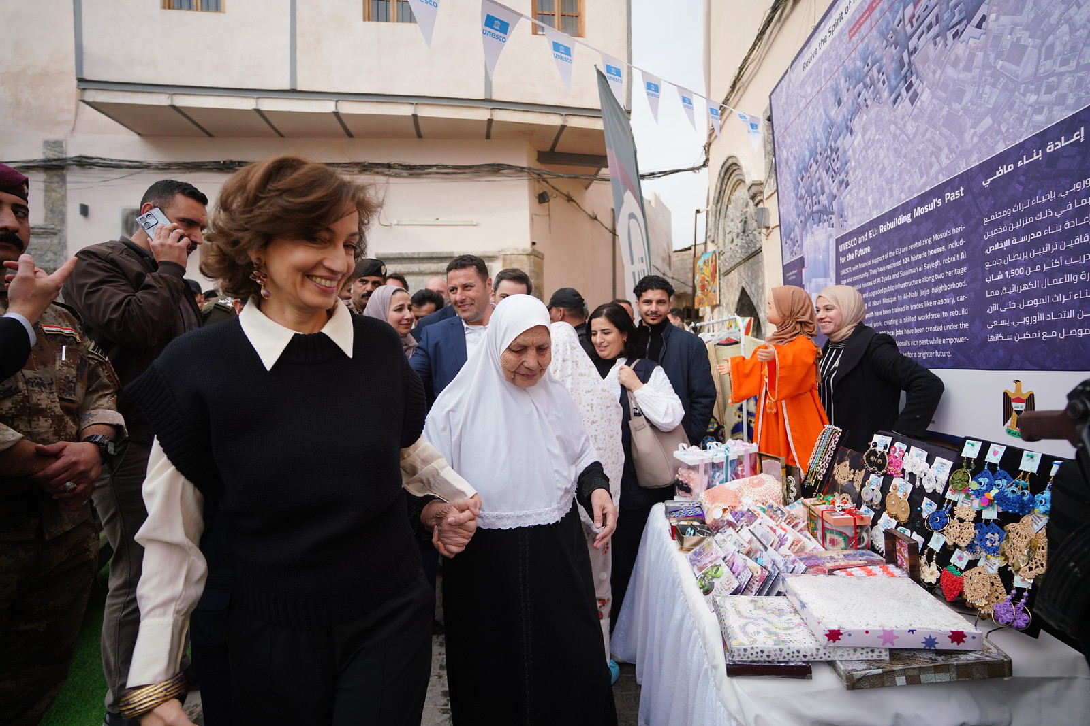
05.02.2025 UNESCO's reconstruction of Mosul's landmarks
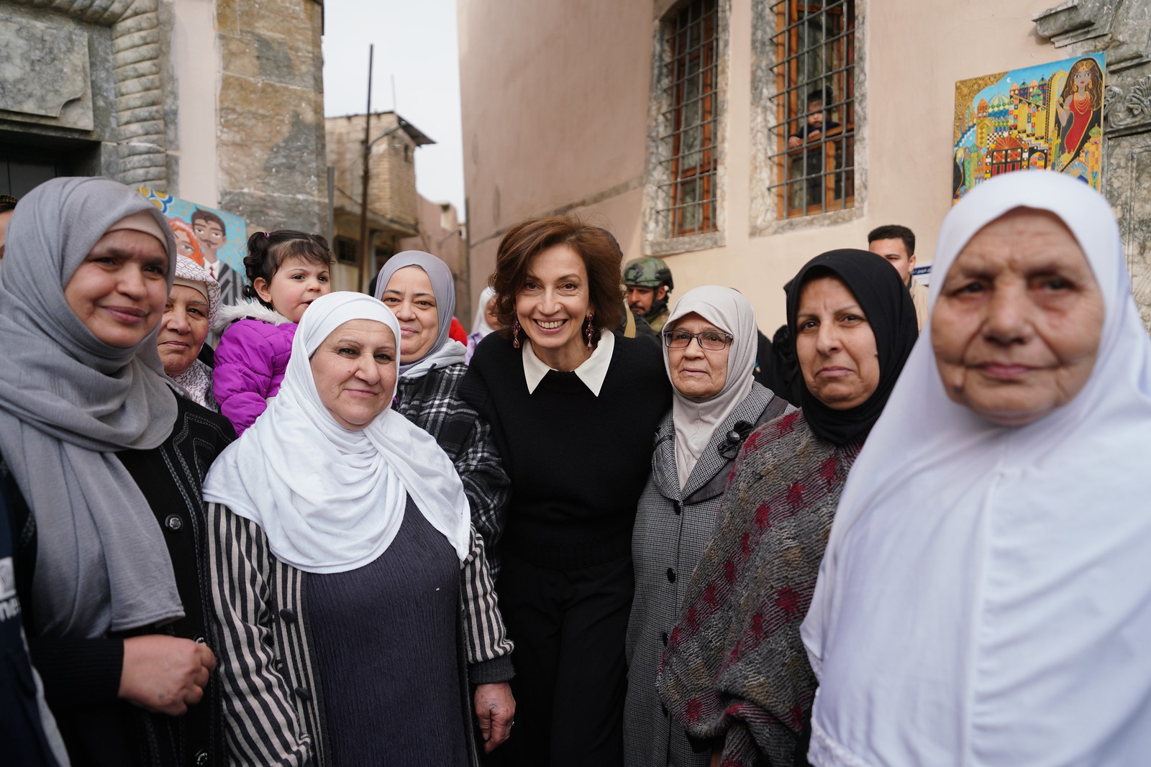
05.02.2025 UNESCO's reconstruction of Mosul's landmarks
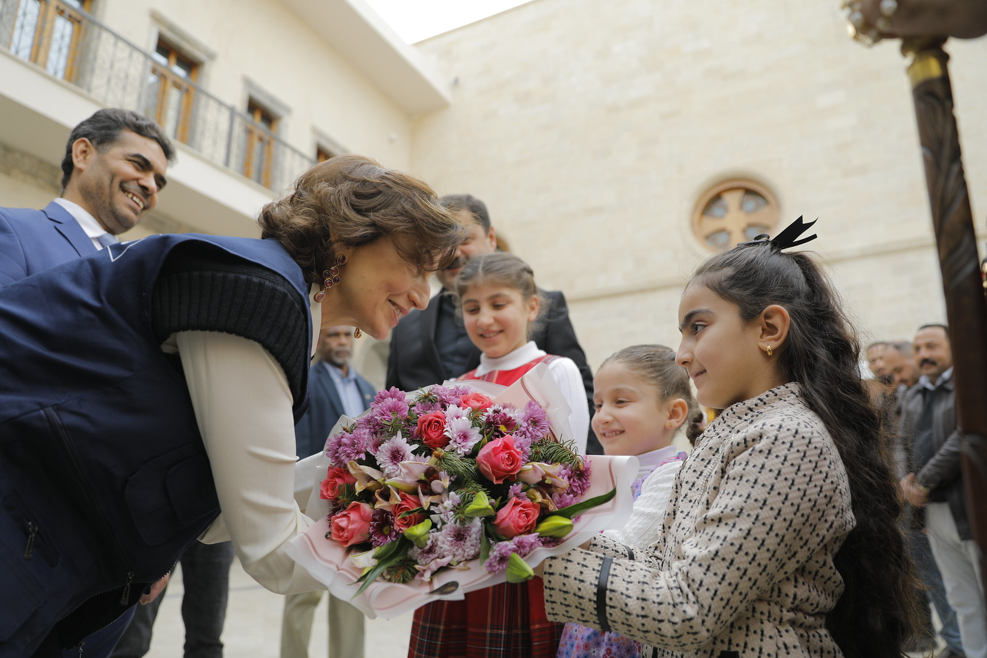
05.02.2025 UNESCO's reconstruction of Mosul's landmarks
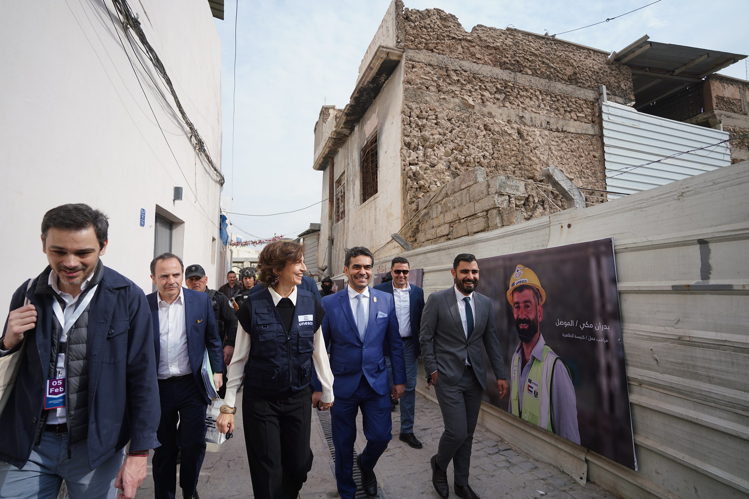
05.02.2025 UNESCO's reconstruction of Mosul's landmarks
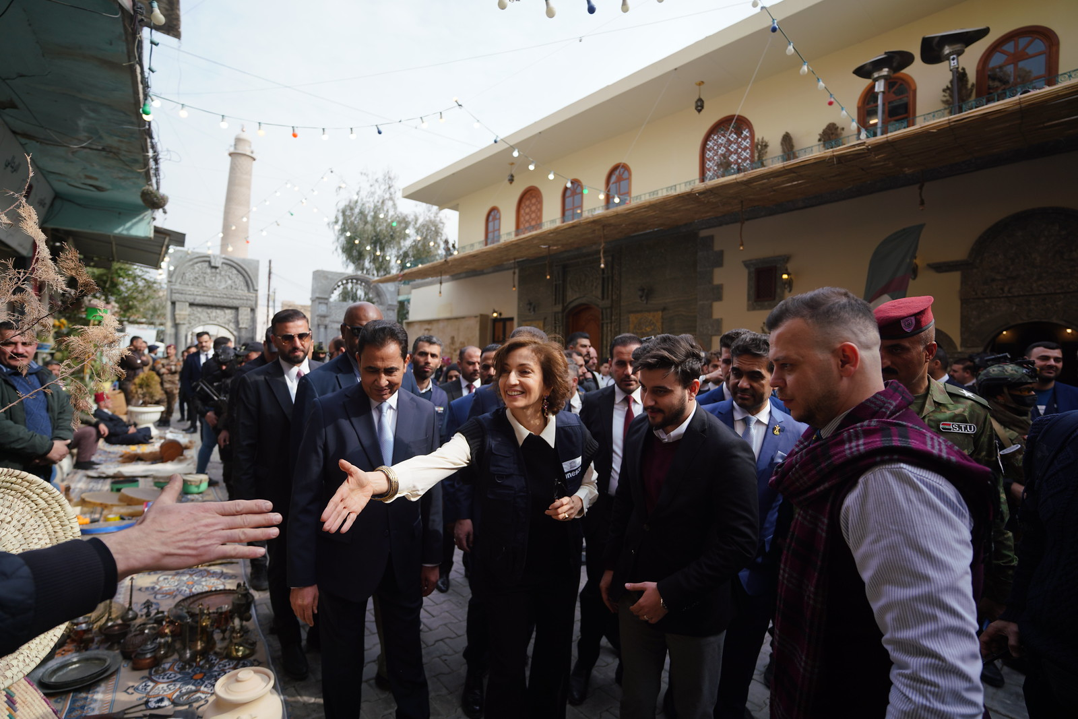
05.02.2025 UNESCO's reconstruction of Mosul's landmarks
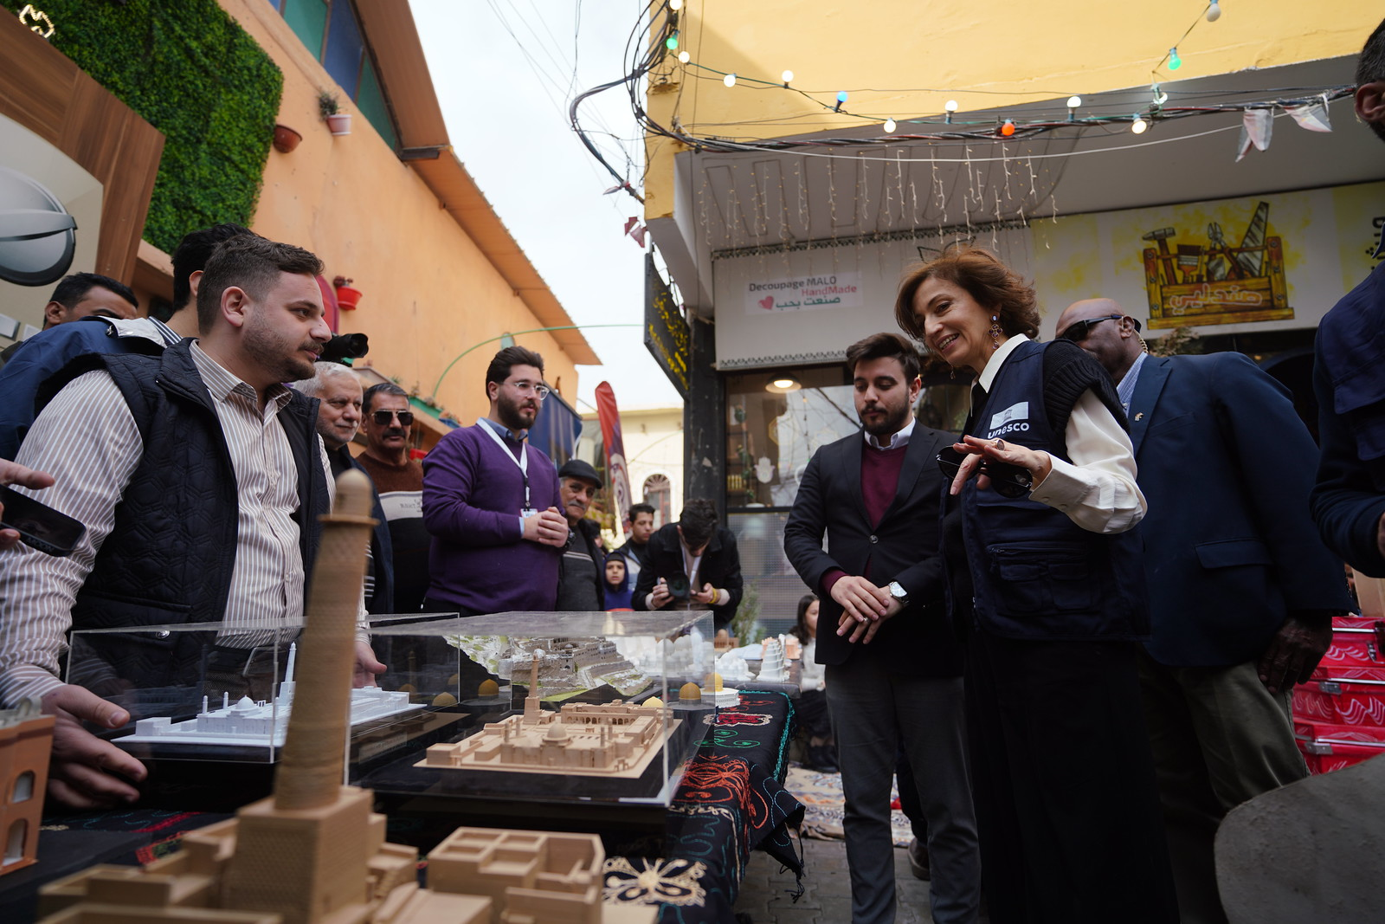
05.02.2025 UNESCO's reconstruction of Mosul's landmarks
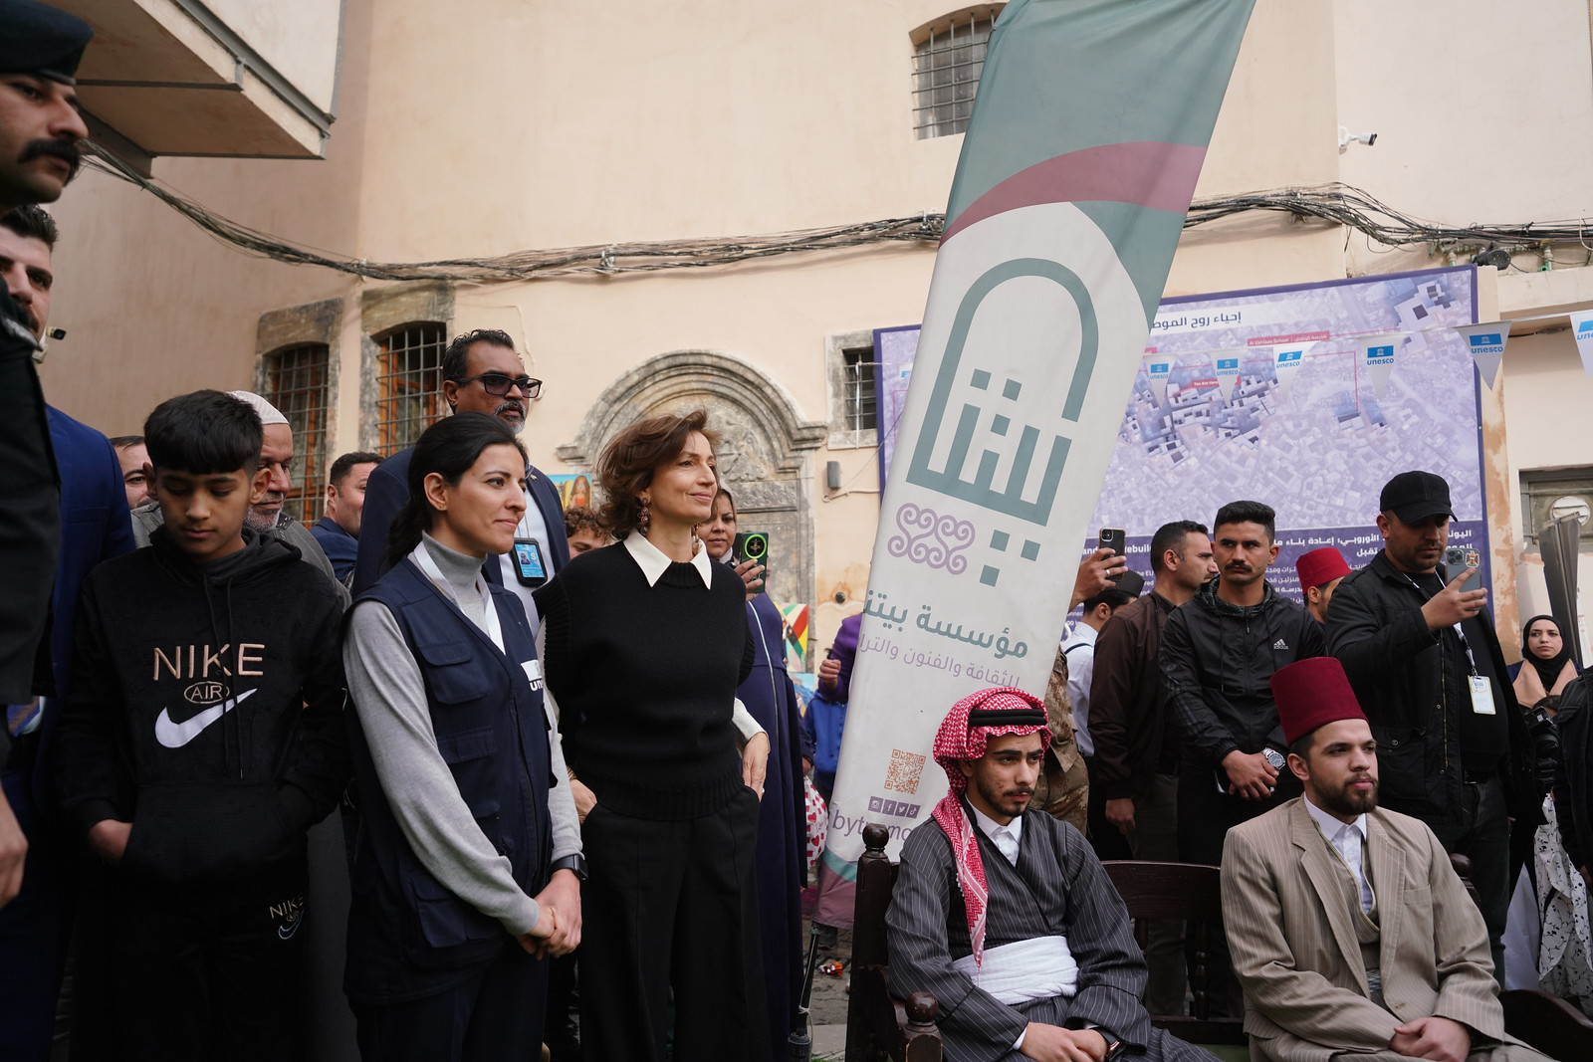
05.02.2025 UNESCO's reconstruction of Mosul's landmarks
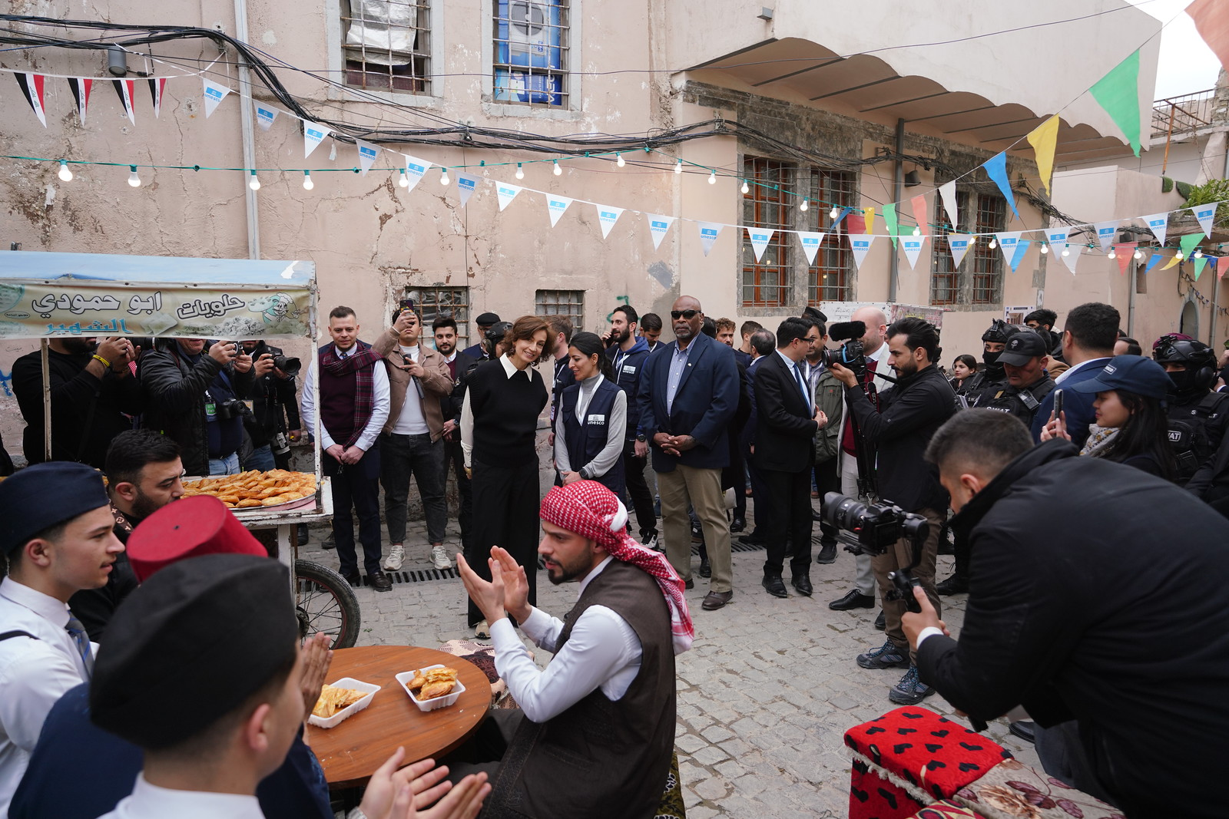
05.02.2025 UNESCO's reconstruction of Mosul's landmarks
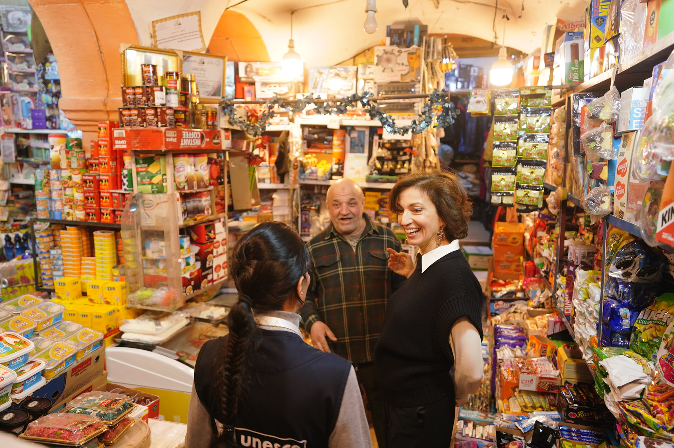
05.02.2025 UNESCO's reconstruction of Mosul's landmarks
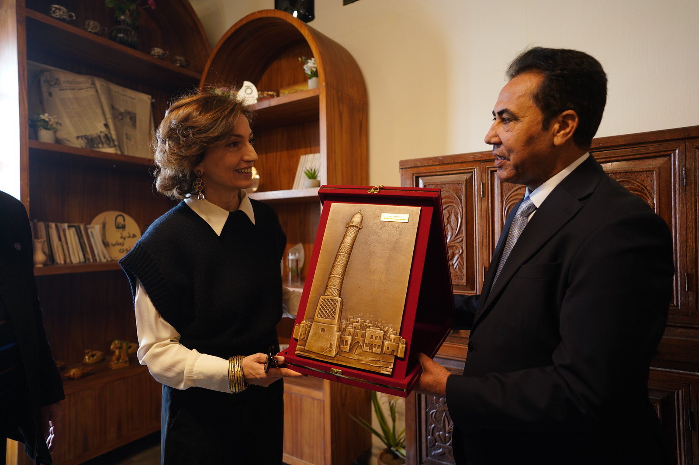
05.02.2025 UNESCO's reconstruction of Mosul's landmarks
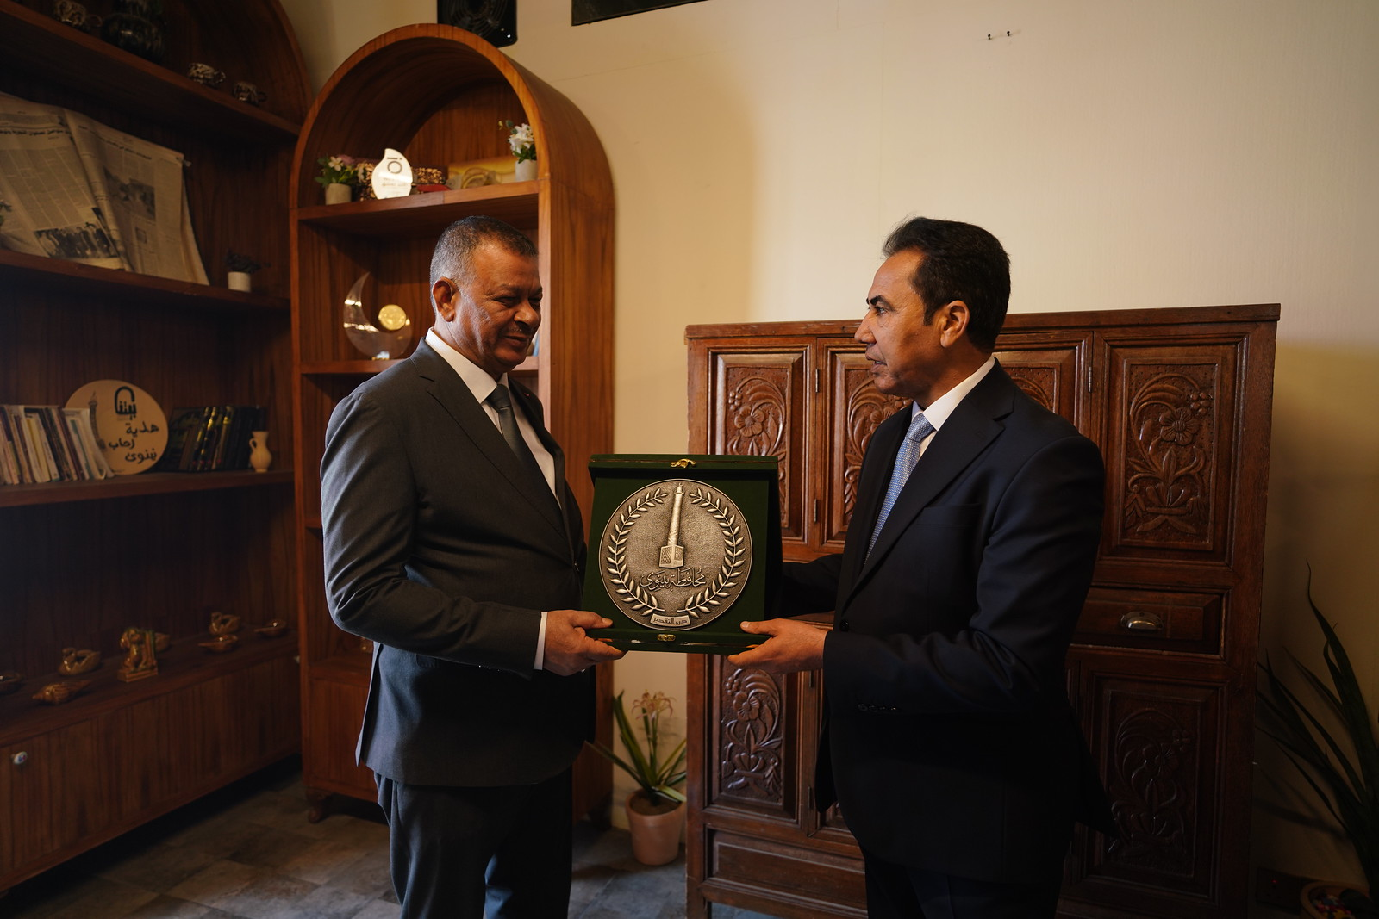
05.02.2025 UNESCO's reconstruction of Mosul's landmarks
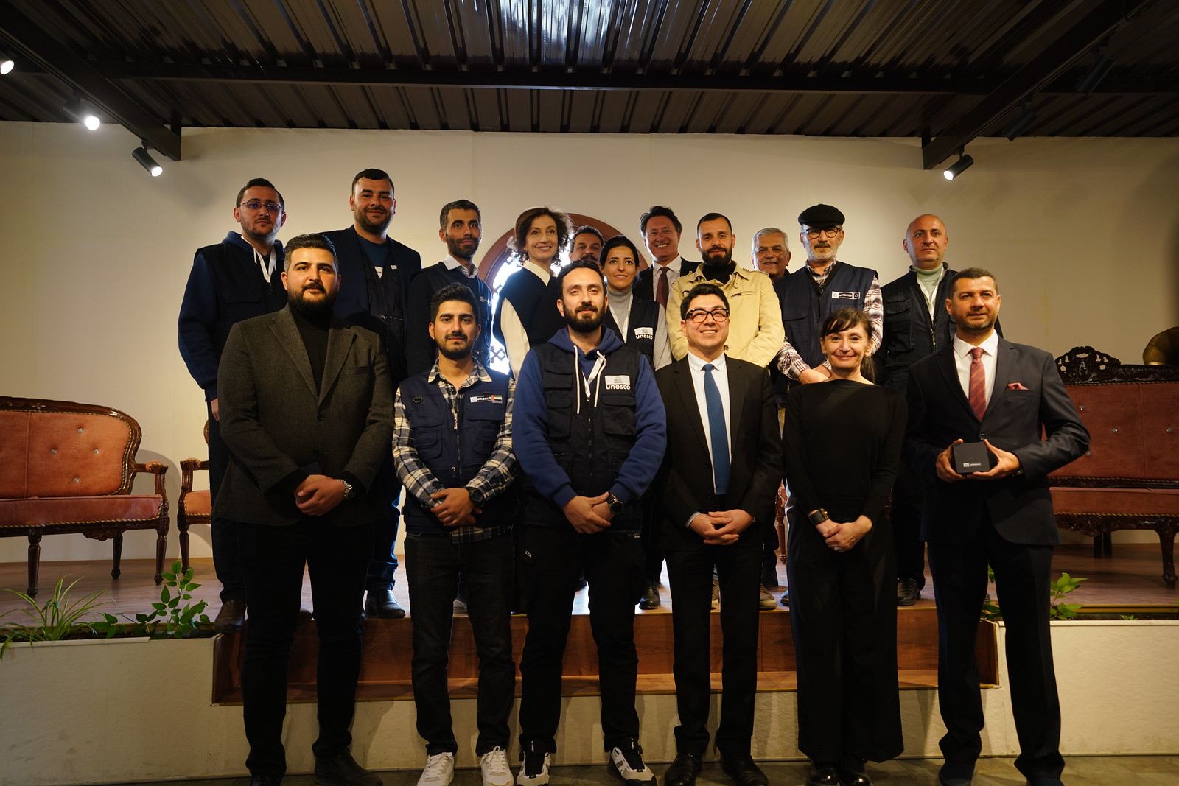
05.02.2025 UNESCO's reconstruction of Mosul's landmarks
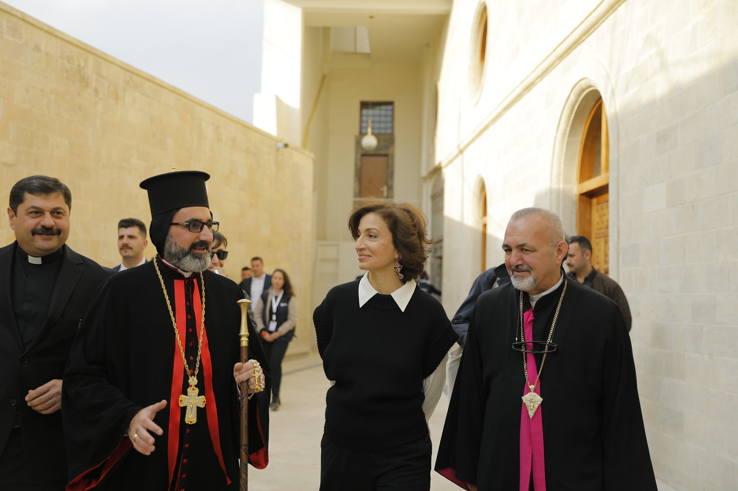
05.02.2025 UNESCO's reconstruction of Mosul's landmarks
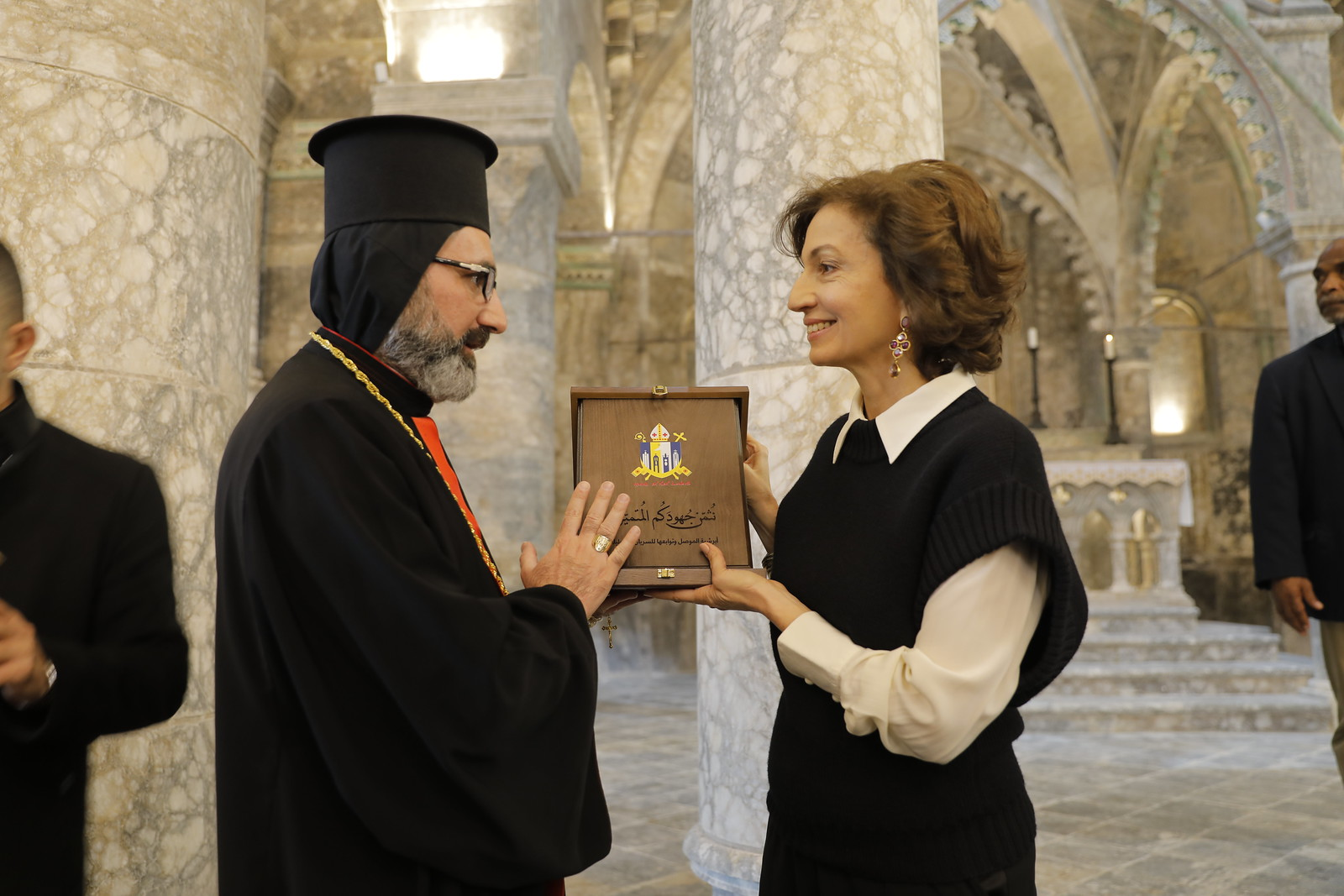
05.02.2025 UNESCO's reconstruction of Mosul's landmarks
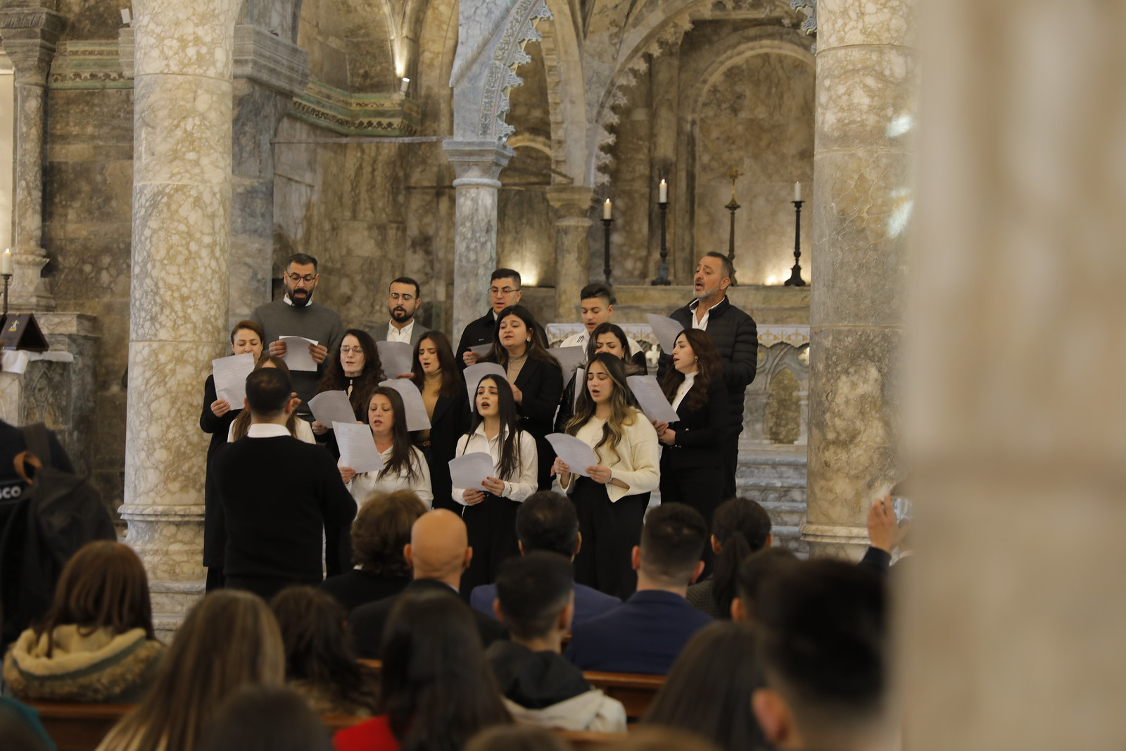
05.02.2025 UNESCO's reconstruction of Mosul's landmarks
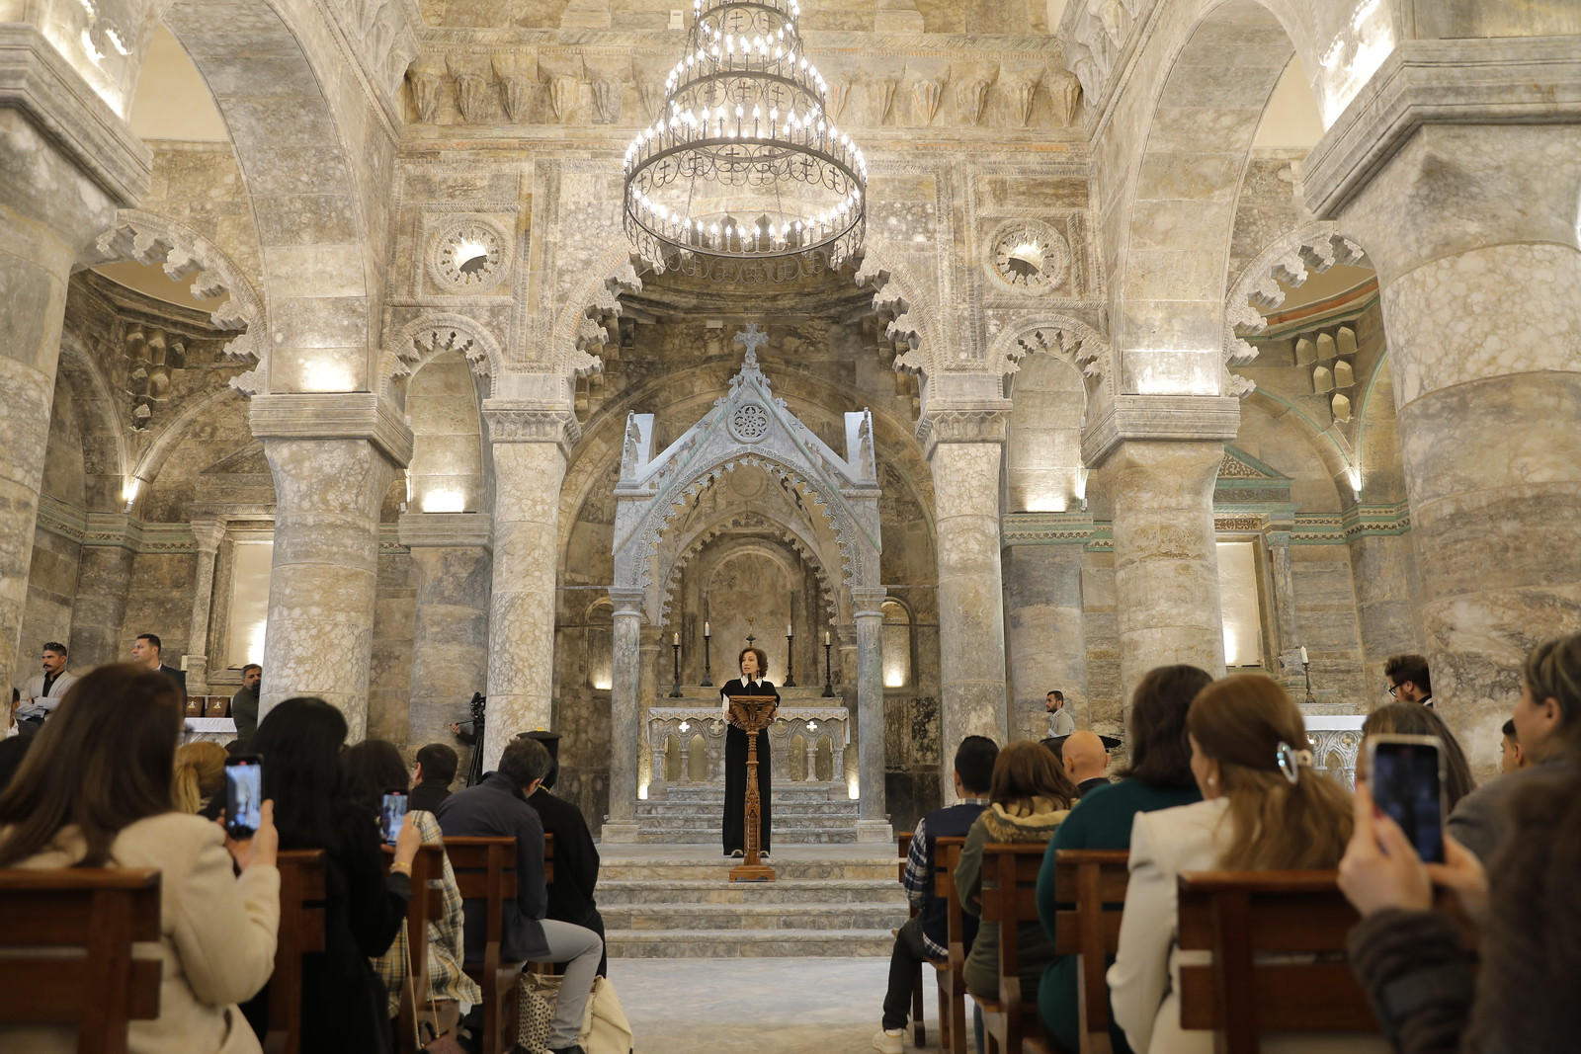
05.02.2025 UNESCO's reconstruction of Mosul's landmarks
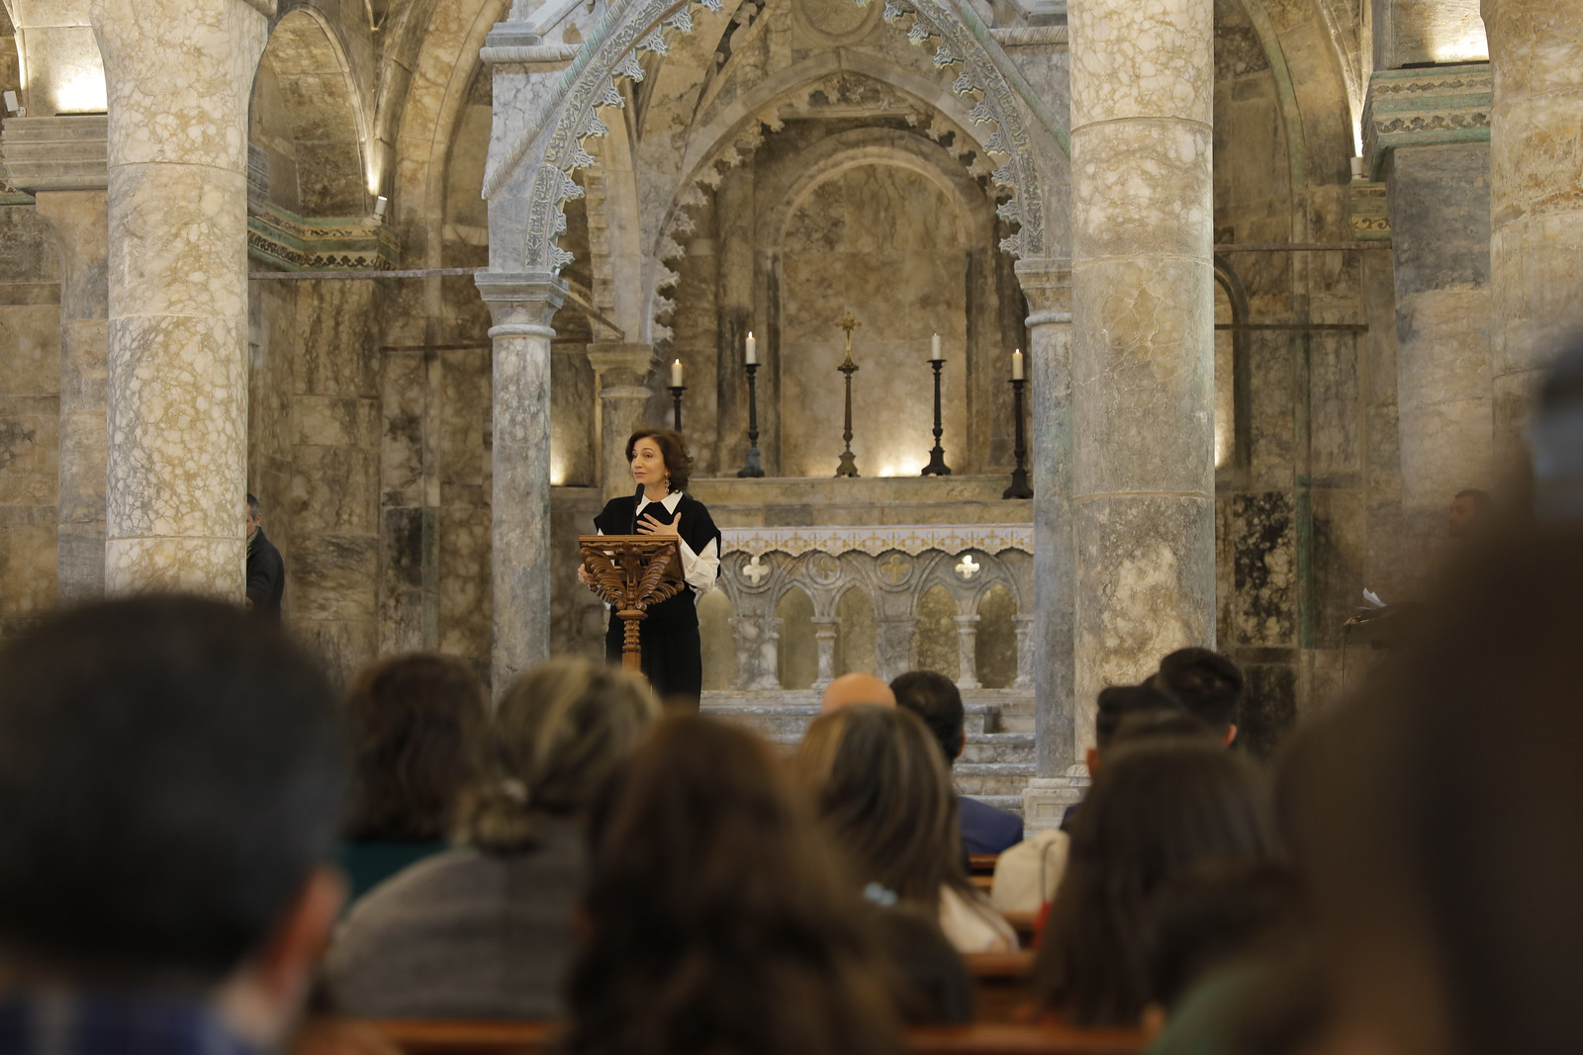
05.02.2025 UNESCO's reconstruction of Mosul's landmarks
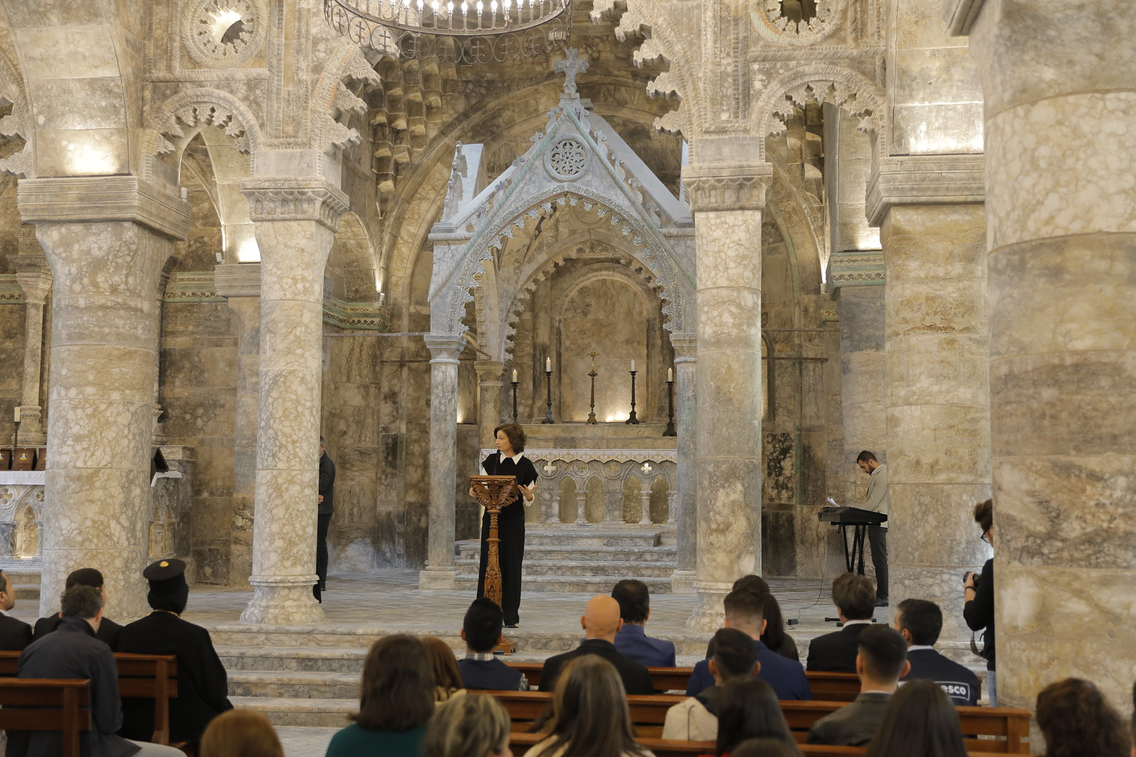
05.02.2025 UNESCO's reconstruction of Mosul's landmarks
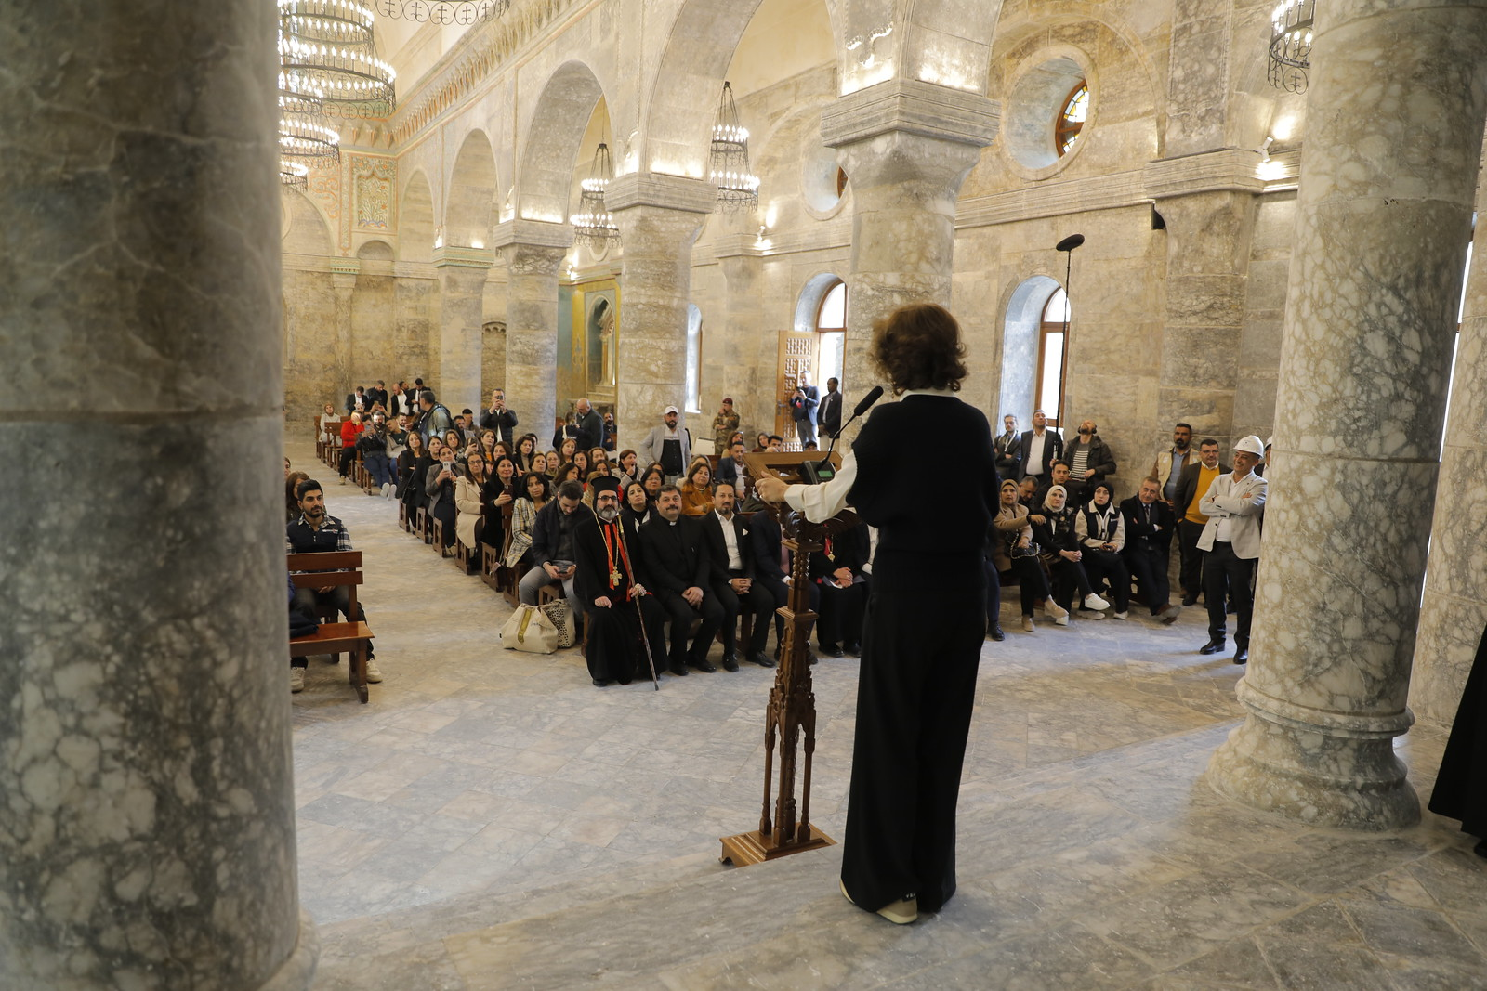
05.02.2025 UNESCO's reconstruction of Mosul's landmarks
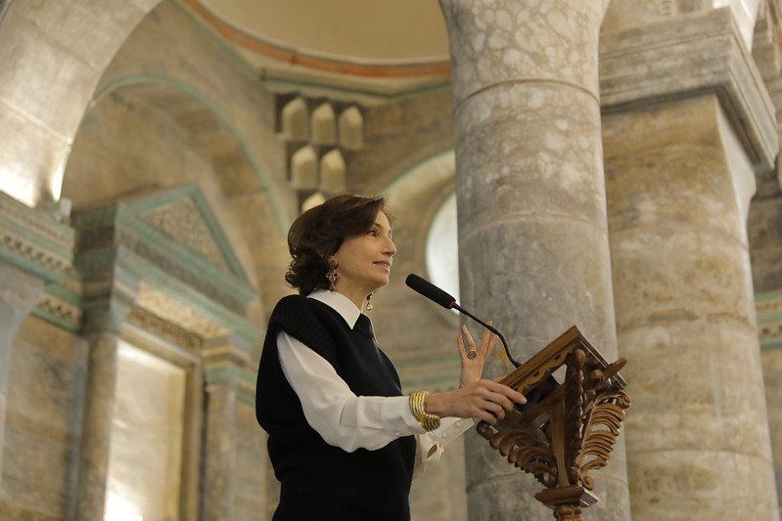
05.02.2025 UNESCO's reconstruction of Mosul's landmarks
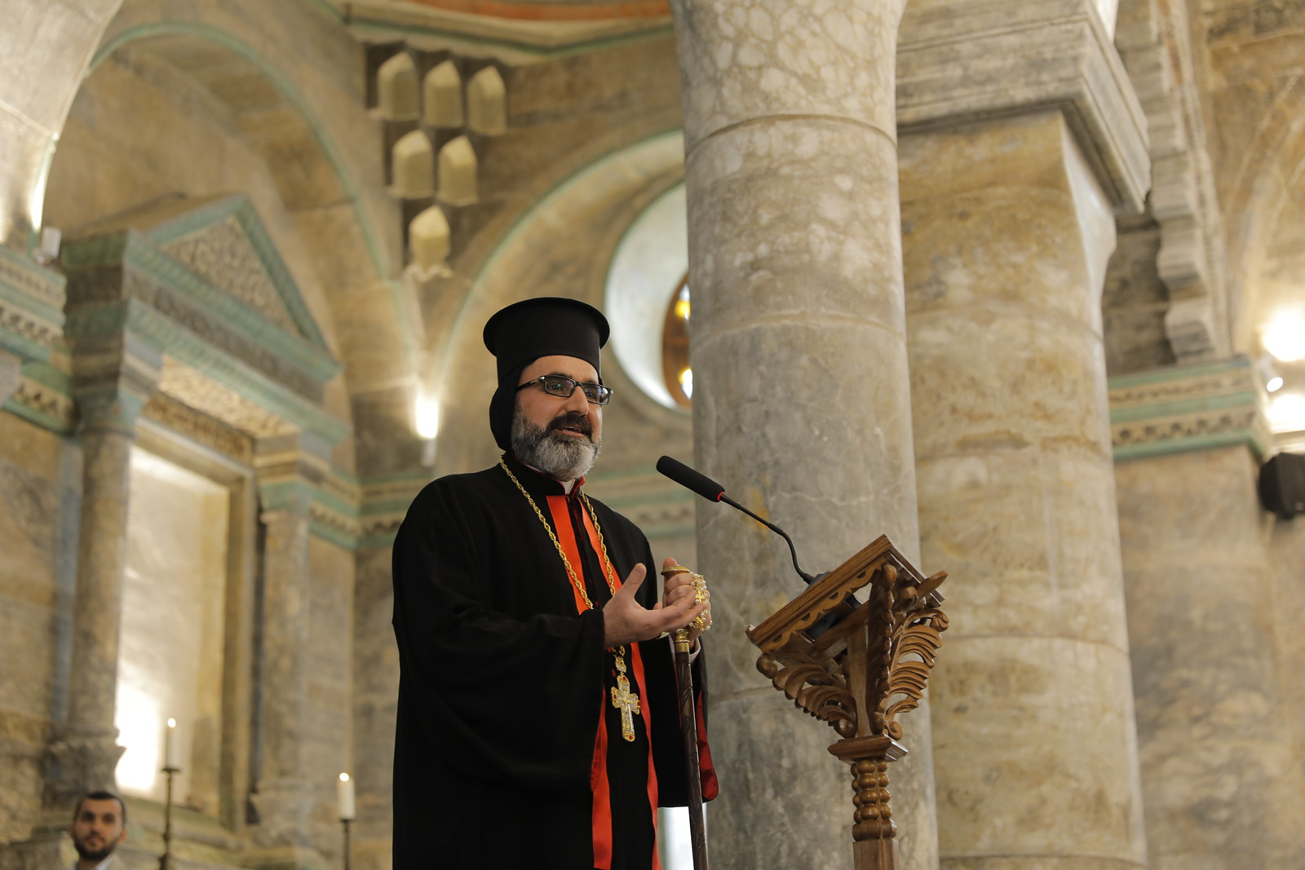
05.02.2025 UNESCO's reconstruction of Mosul's landmarks
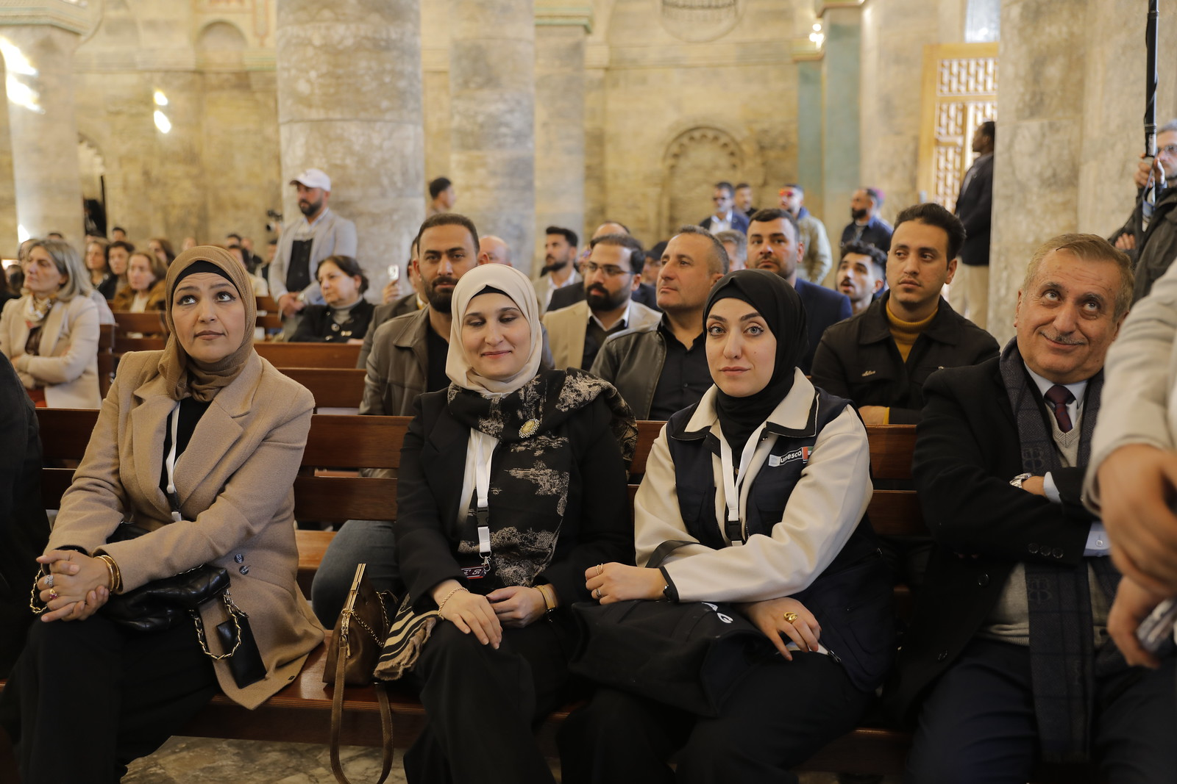
05.02.2025 UNESCO's reconstruction of Mosul's landmarks
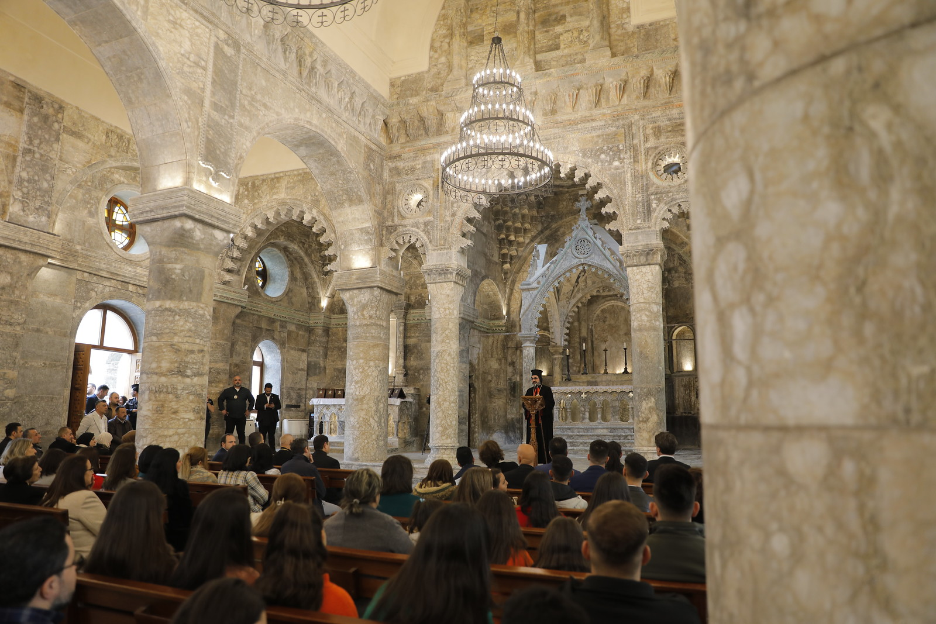
05.02.2025 UNESCO's reconstruction of Mosul's landmarks
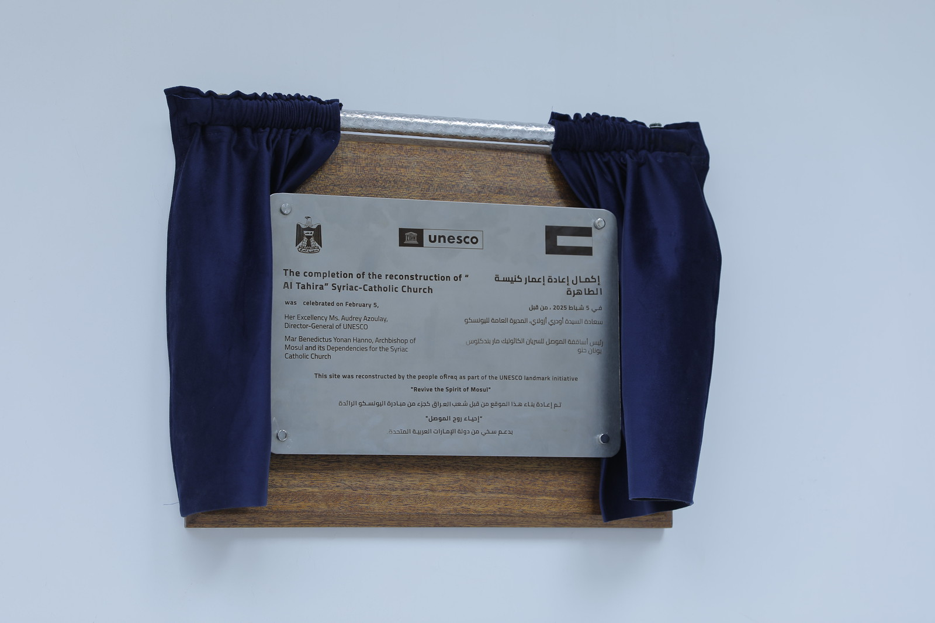
05.02.2025 UNESCO's reconstruction of Mosul's landmarks
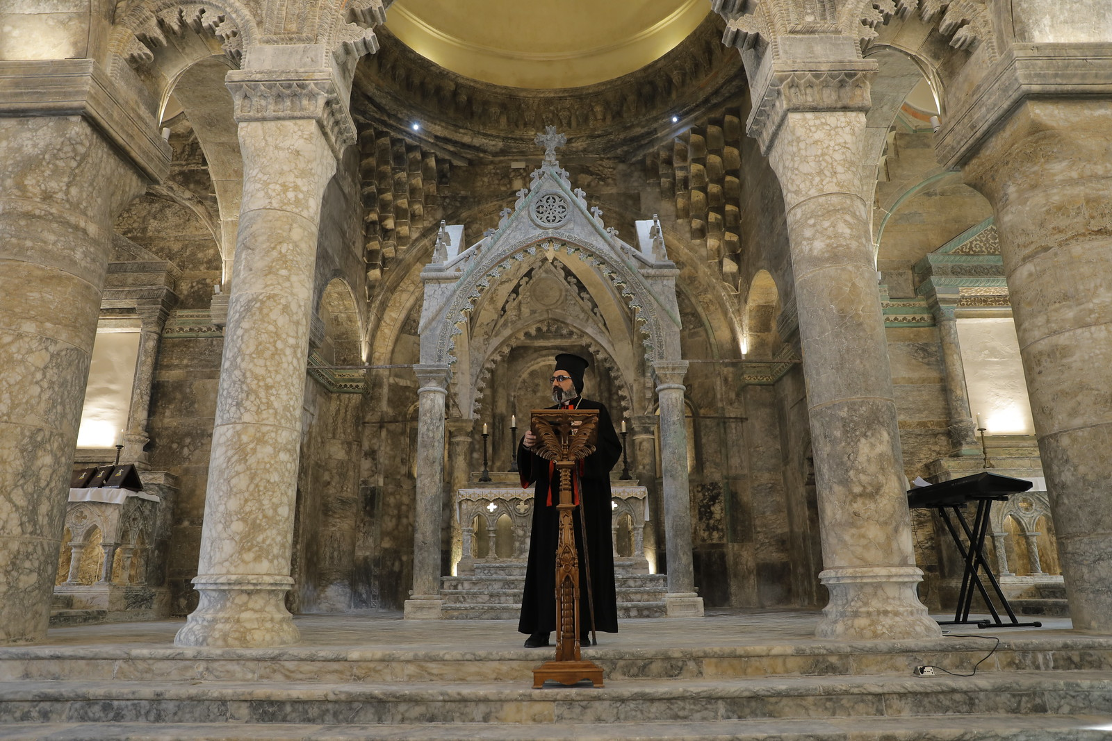
05.02.2025 UNESCO's reconstruction of Mosul's landmarks
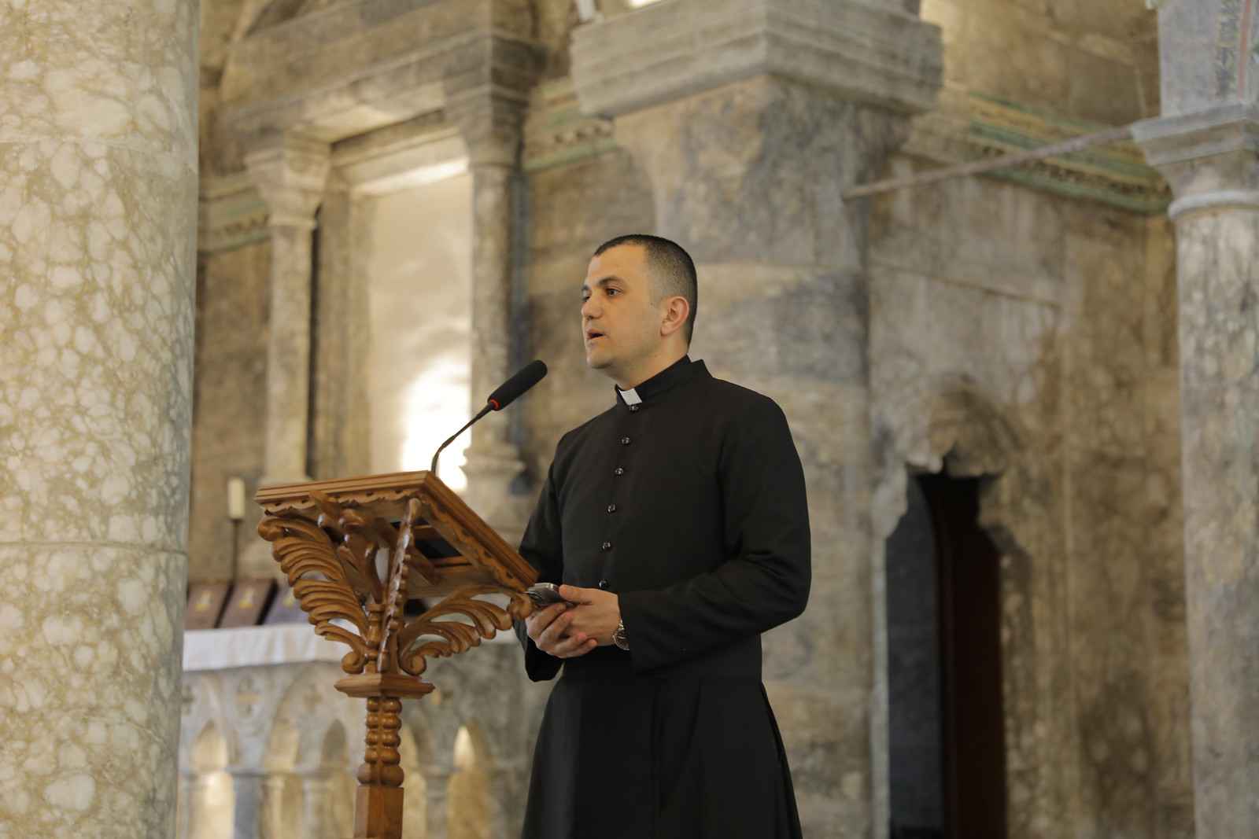
05.02.2025 UNESCO's reconstruction of Mosul's landmarks
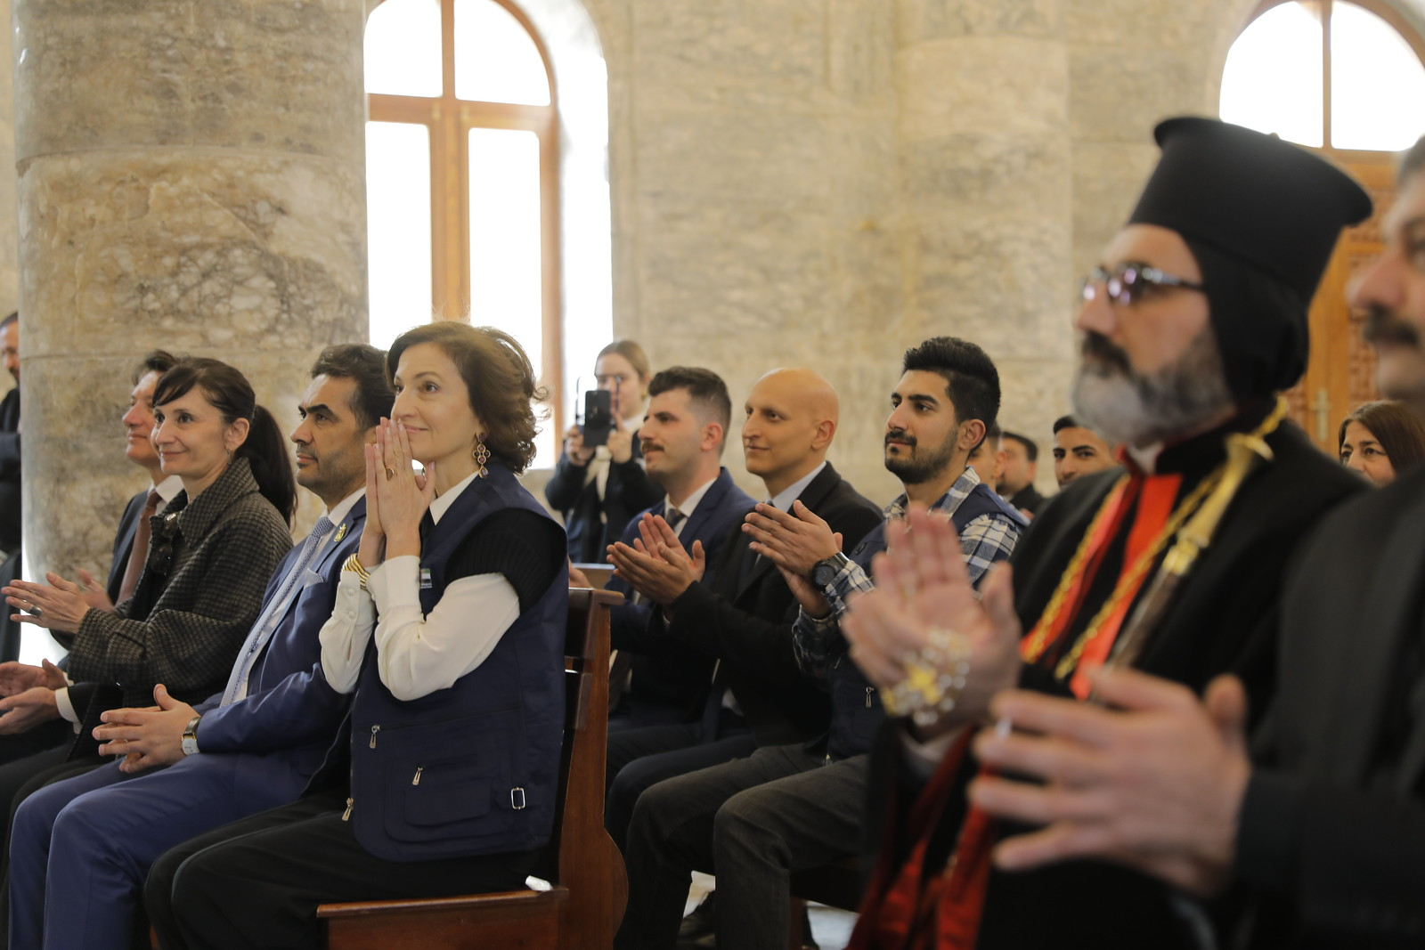
05.02.2025 UNESCO's reconstruction of Mosul's landmarks
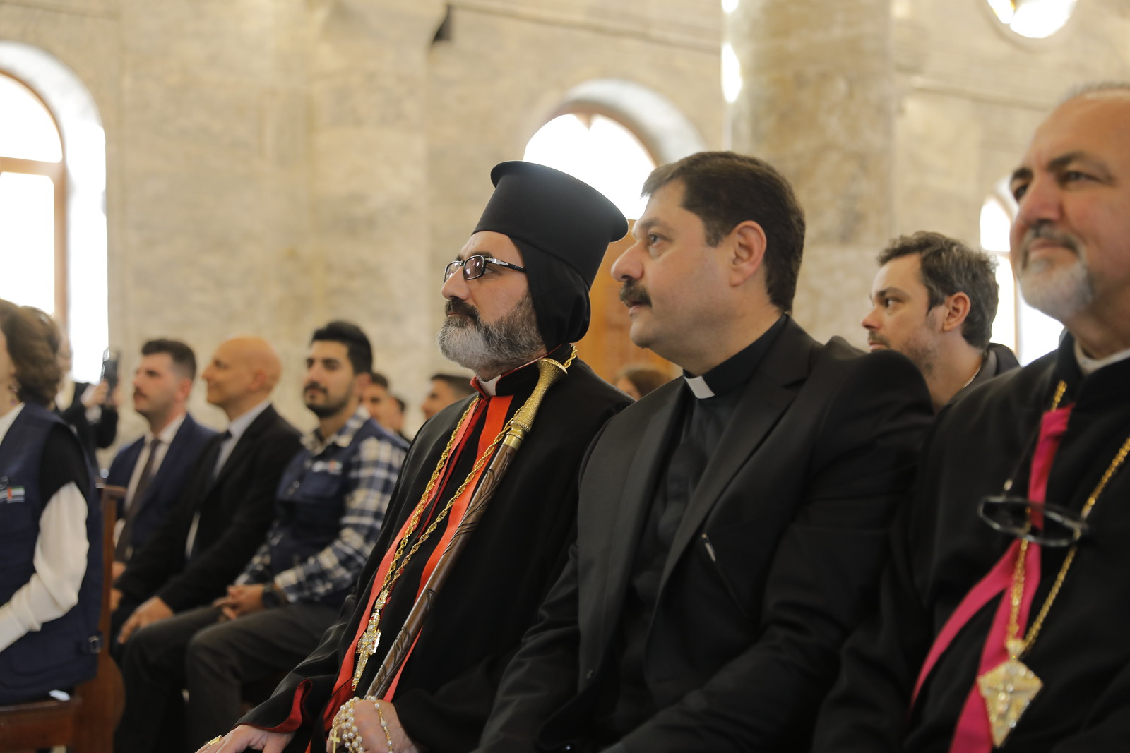
05.02.2025 UNESCO's reconstruction of Mosul's landmarks
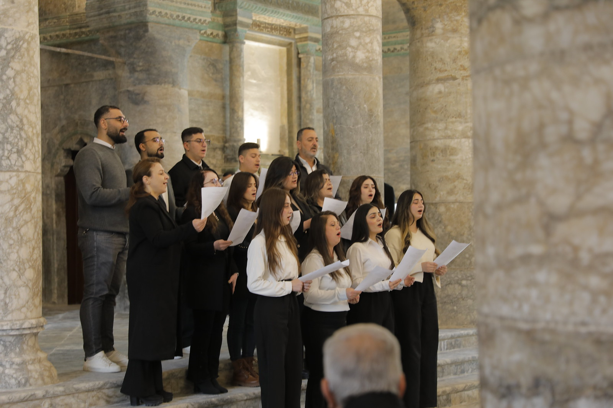
05.02.2025 UNESCO's reconstruction of Mosul's landmarks
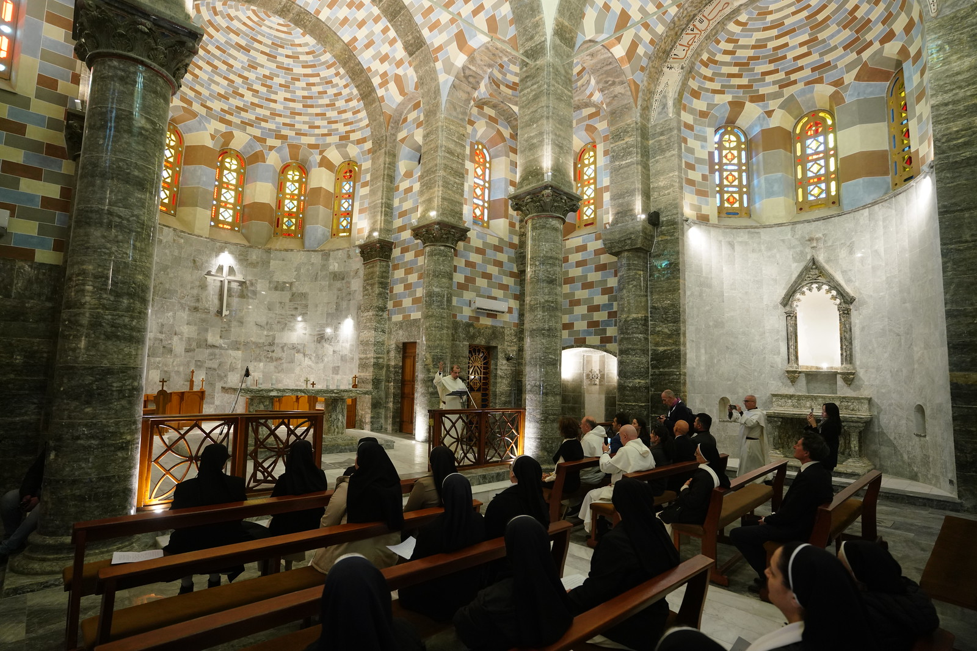
05.02.2025 UNESCO's reconstruction of Mosul's landmarks
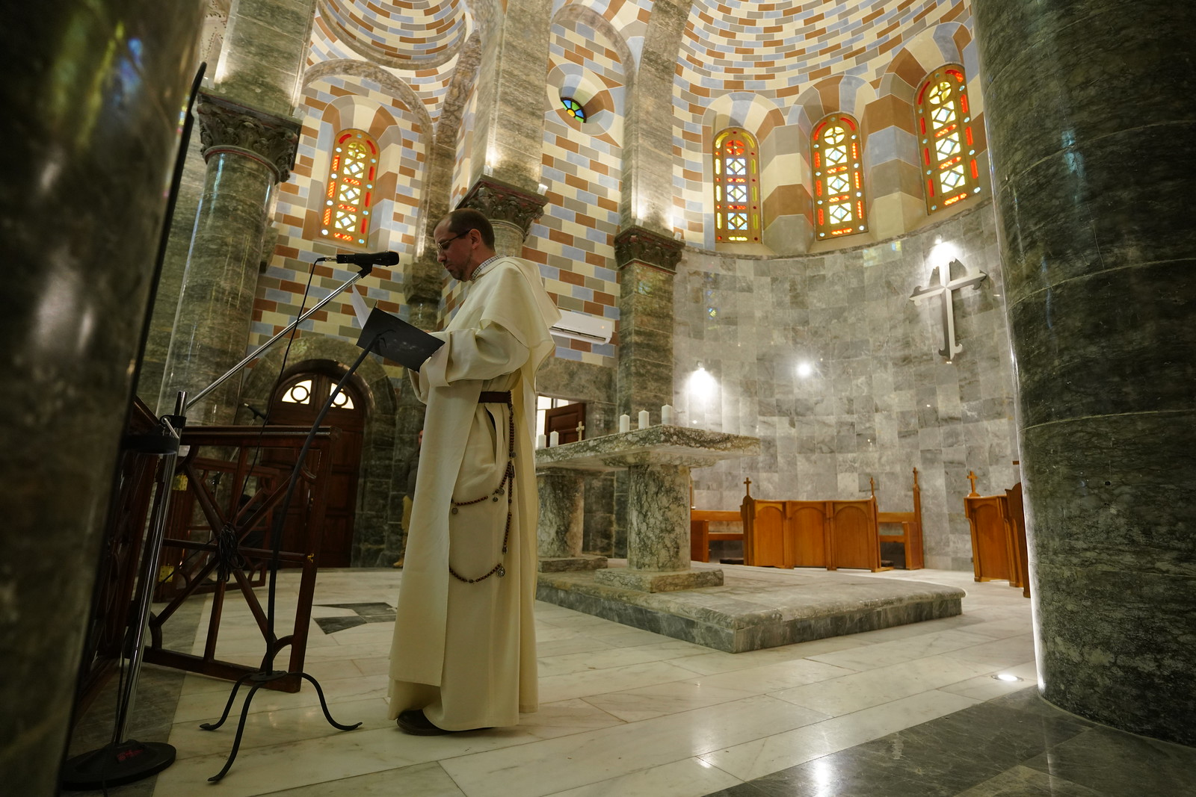
05.02.2025 UNESCO's reconstruction of Mosul's landmarks
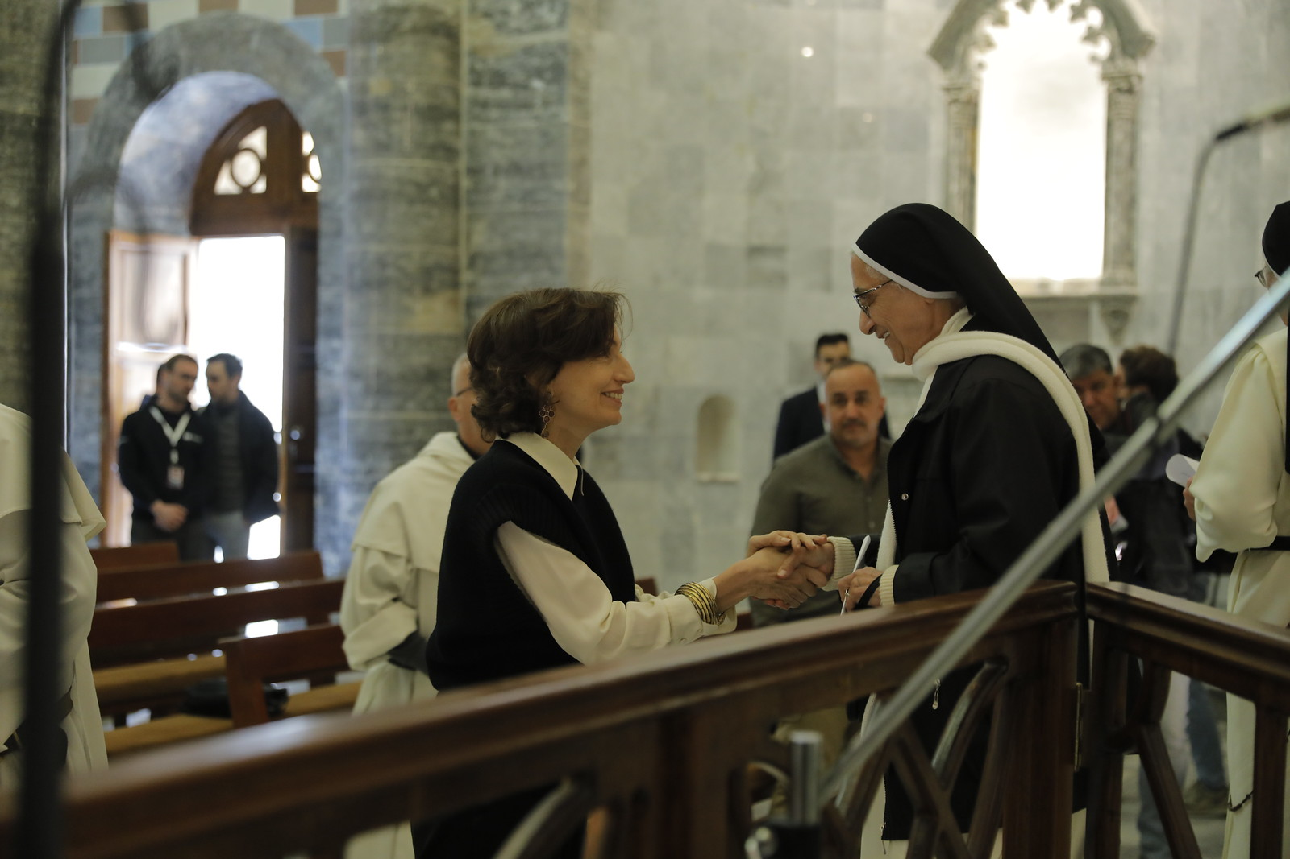
05.02.2025 UNESCO's reconstruction of Mosul's landmarks
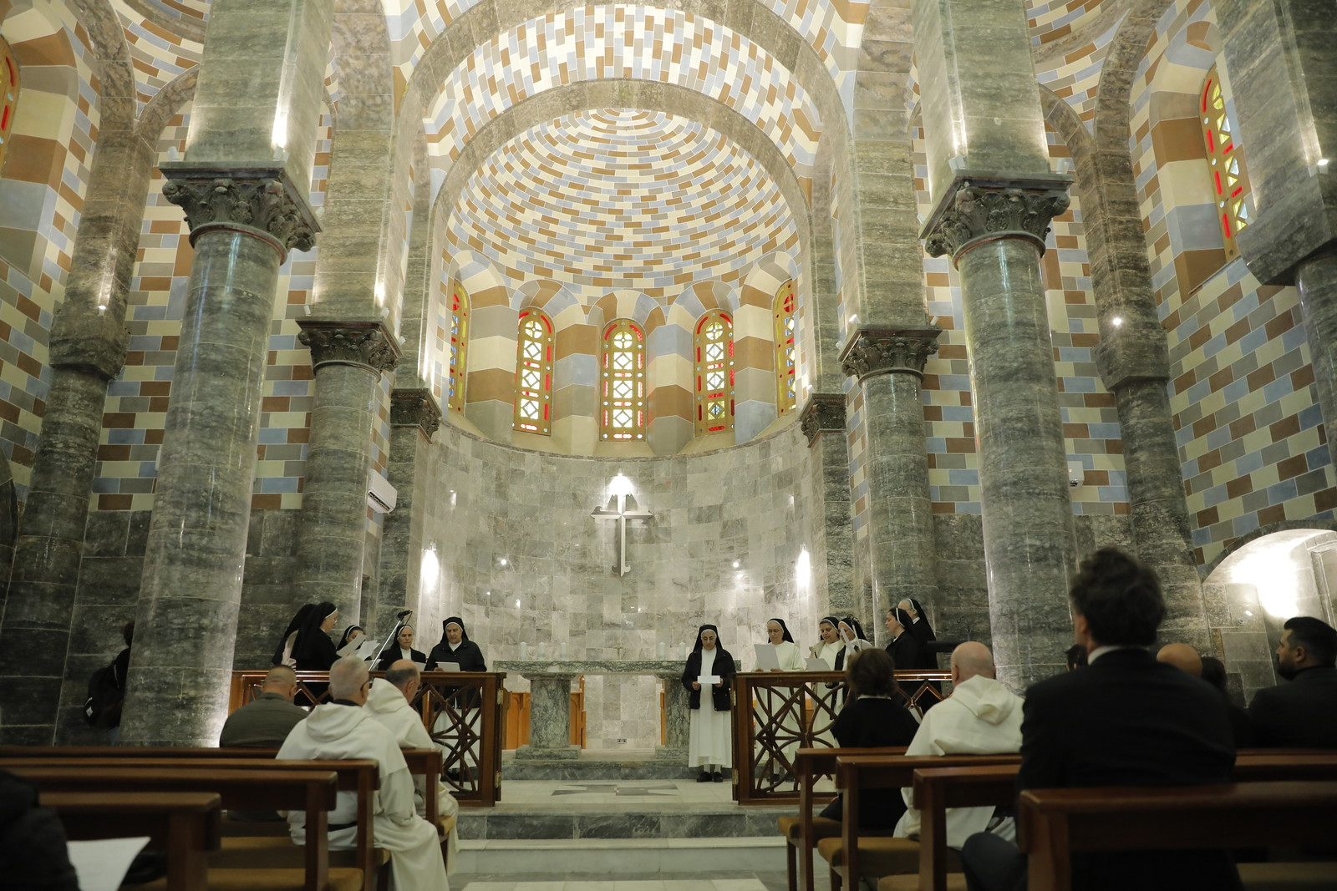
05.02.2025 UNESCO's reconstruction of Mosul's landmarks
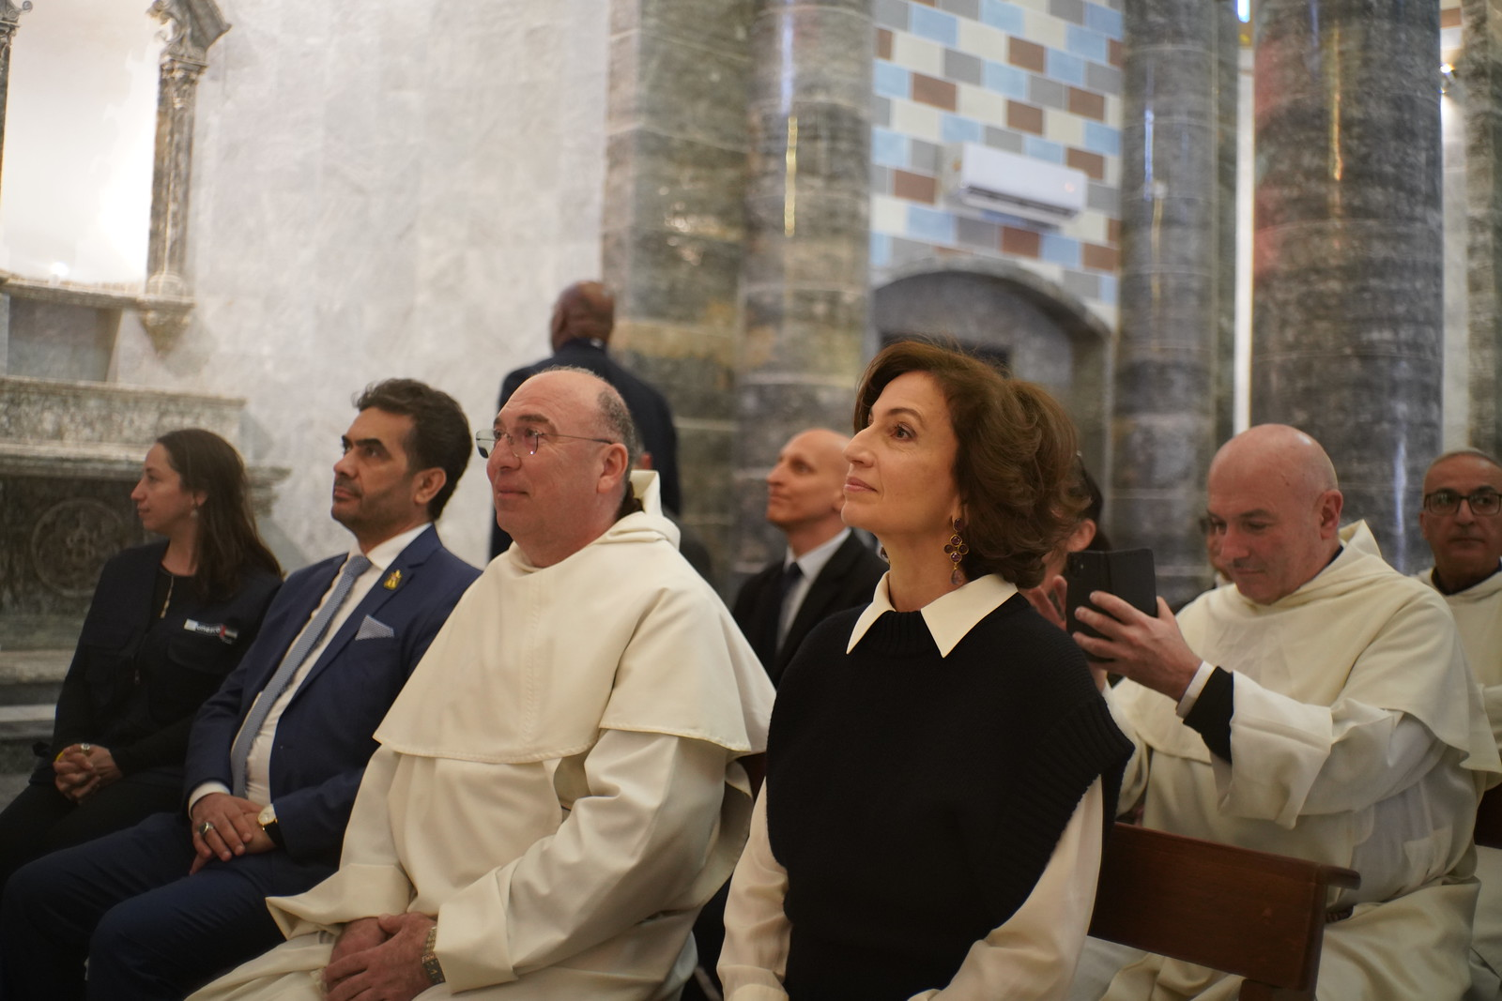
05.02.2025 UNESCO's reconstruction of Mosul's landmarks
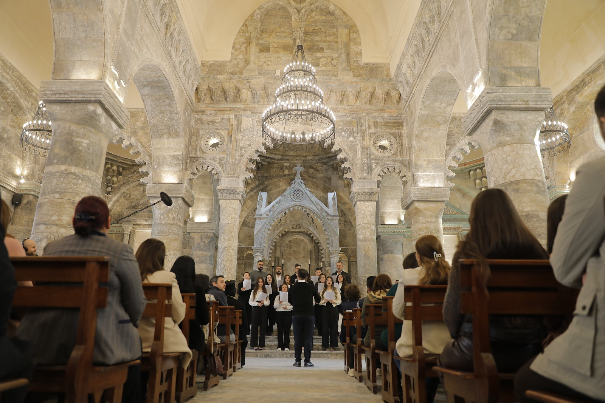
05.02.2025 UNESCO's reconstruction of Mosul's landmarks
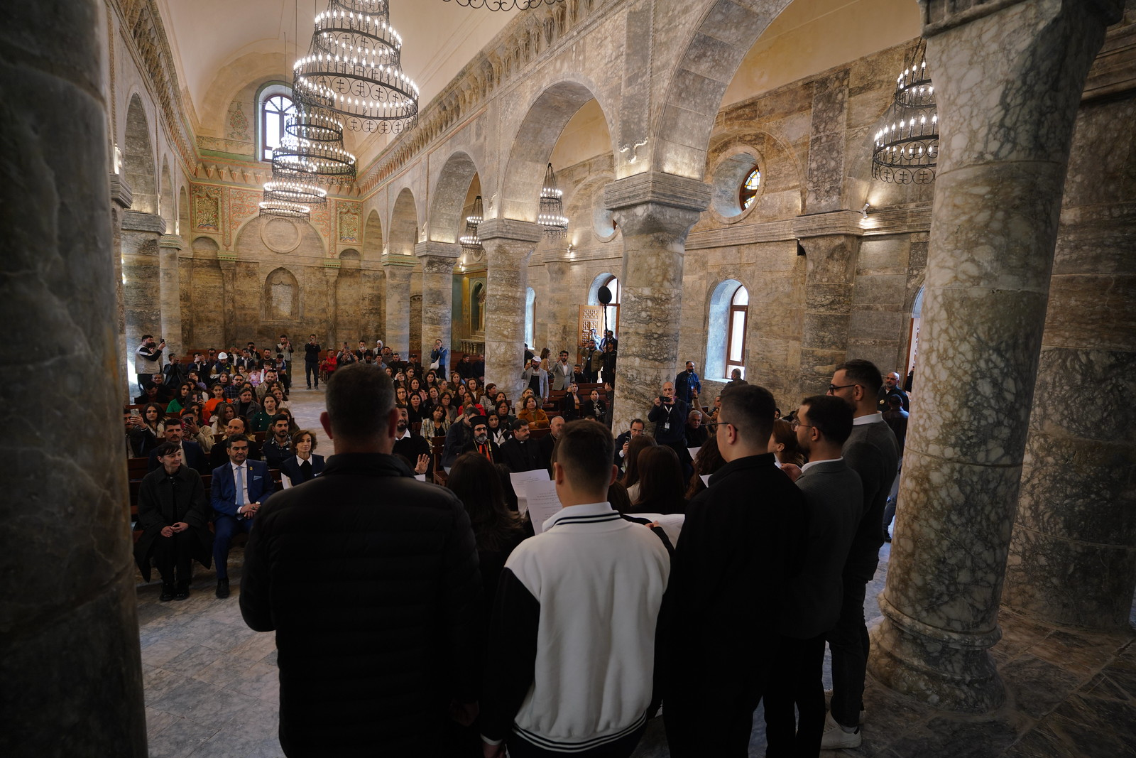
05.02.2025 UNESCO's reconstruction of Mosul's landmarks
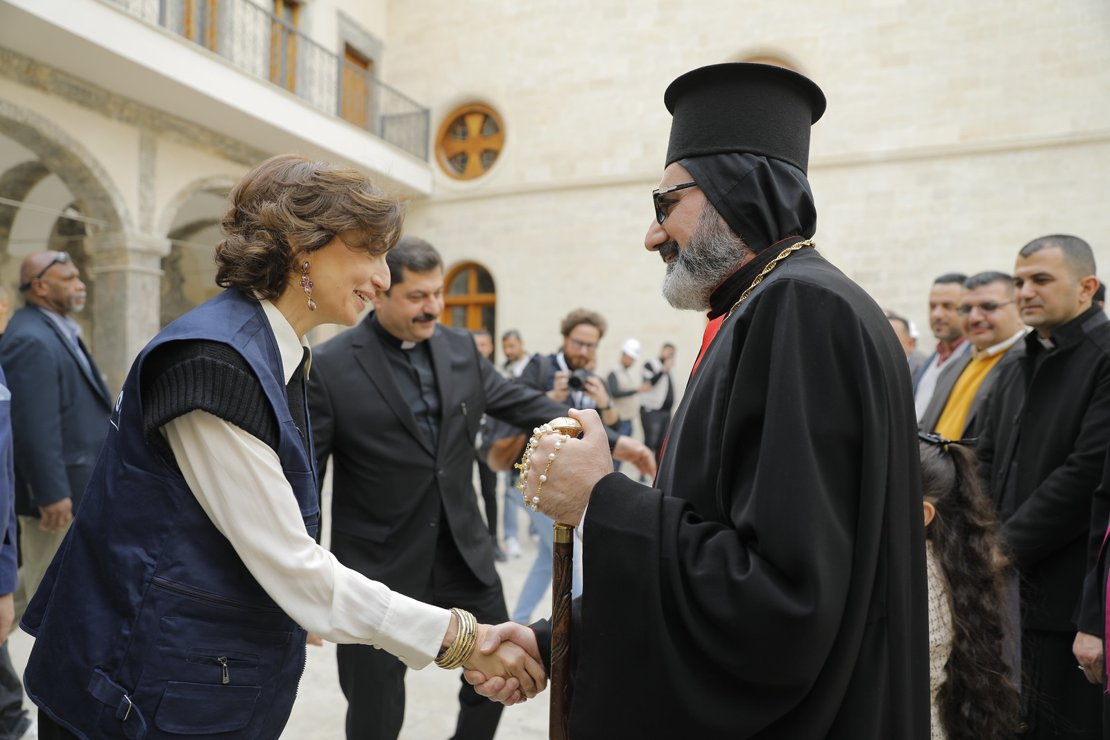
05.02.2025 UNESCO's reconstruction of Mosul's landmarks
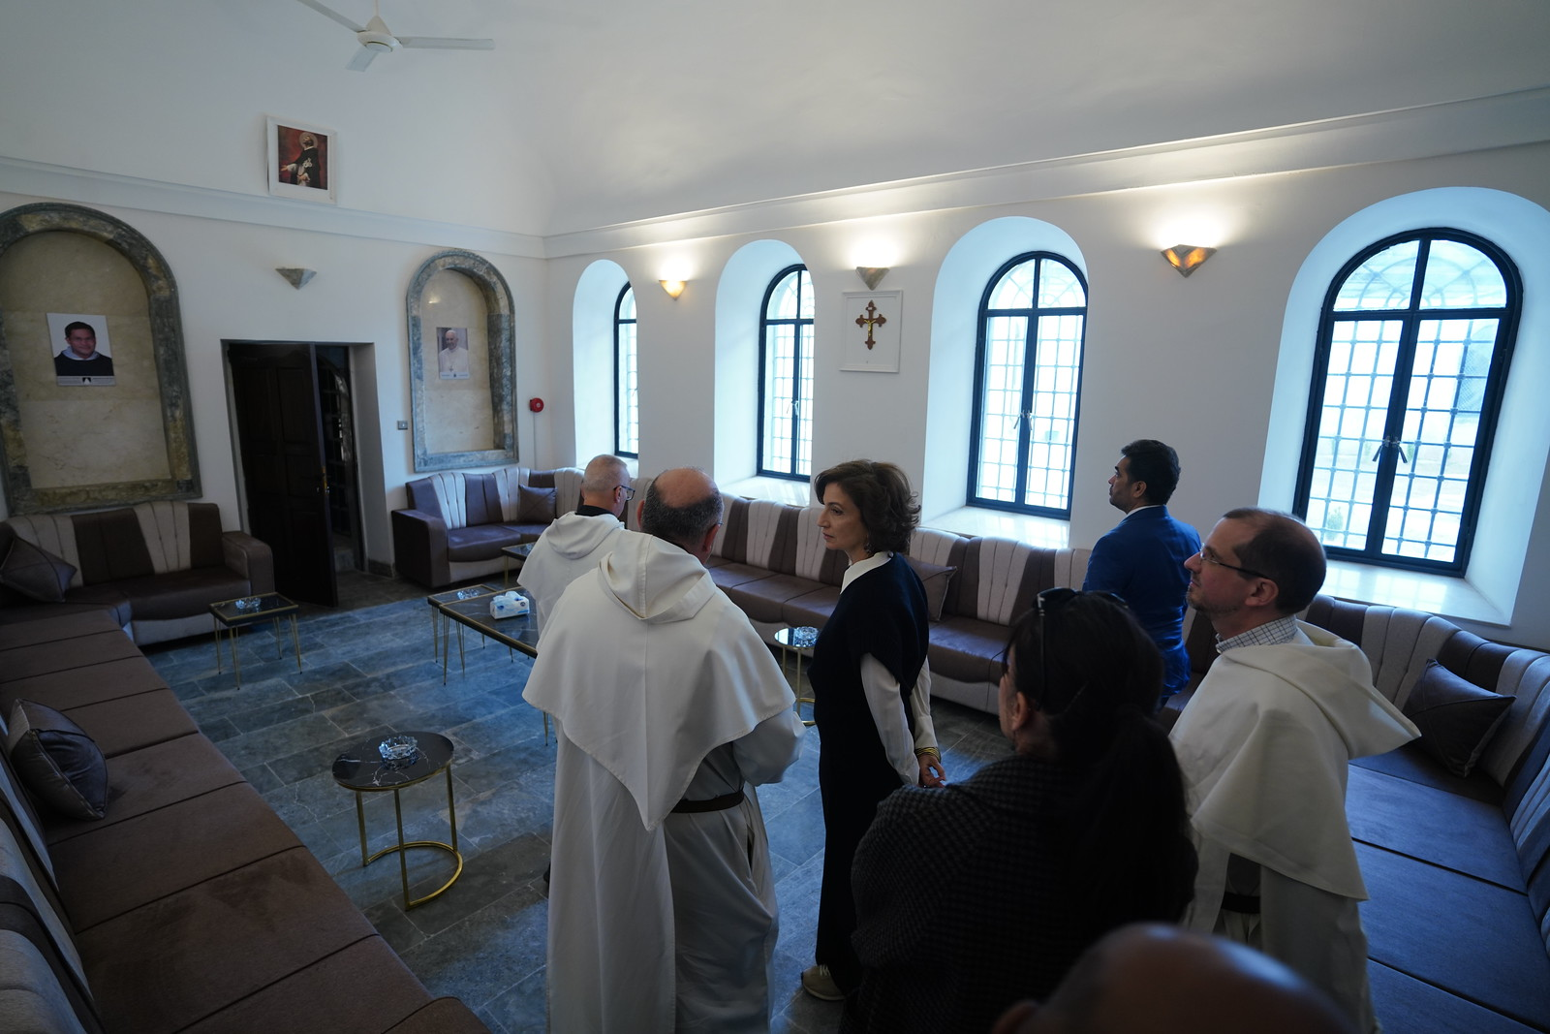
05.02.2025 UNESCO's reconstruction of Mosul's landmarks
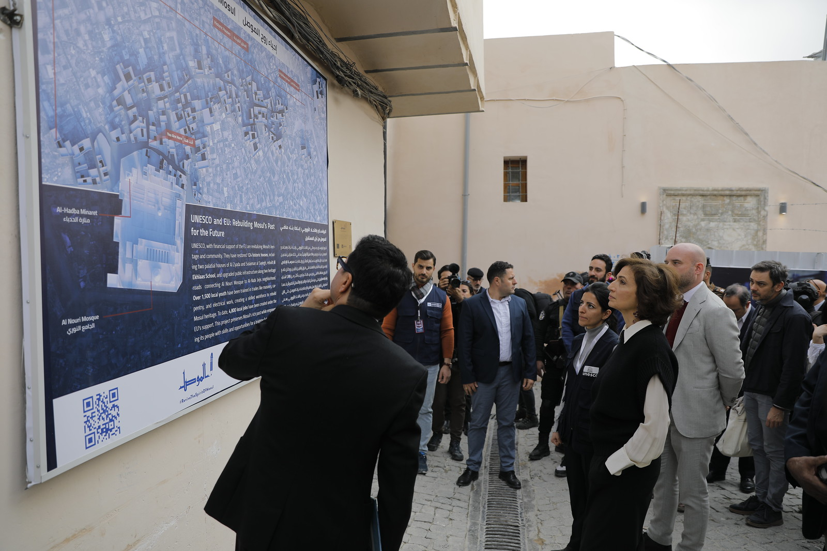
05.02.2025 UNESCO's reconstruction of Mosul's landmarks
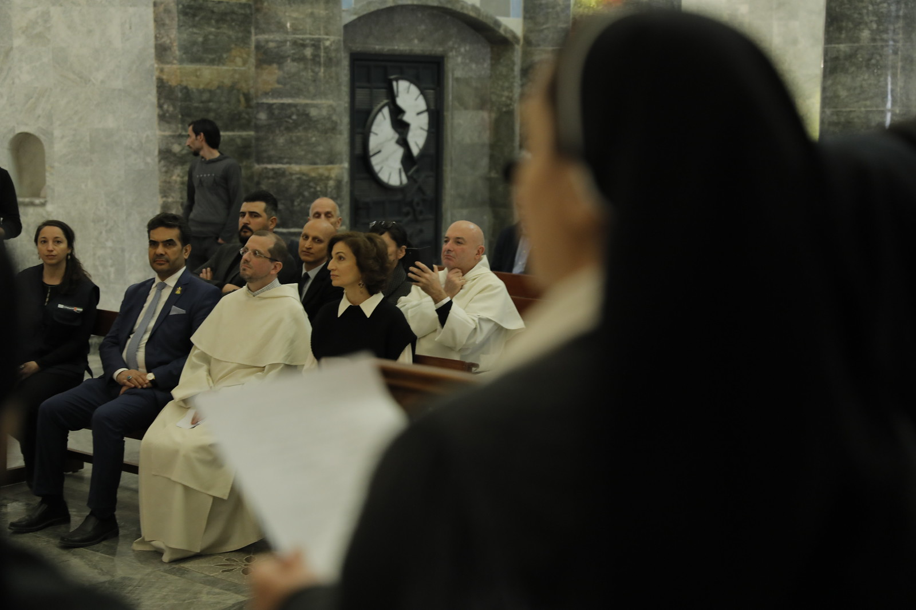
05.02.2025 UNESCO's reconstruction of Mosul's landmarks
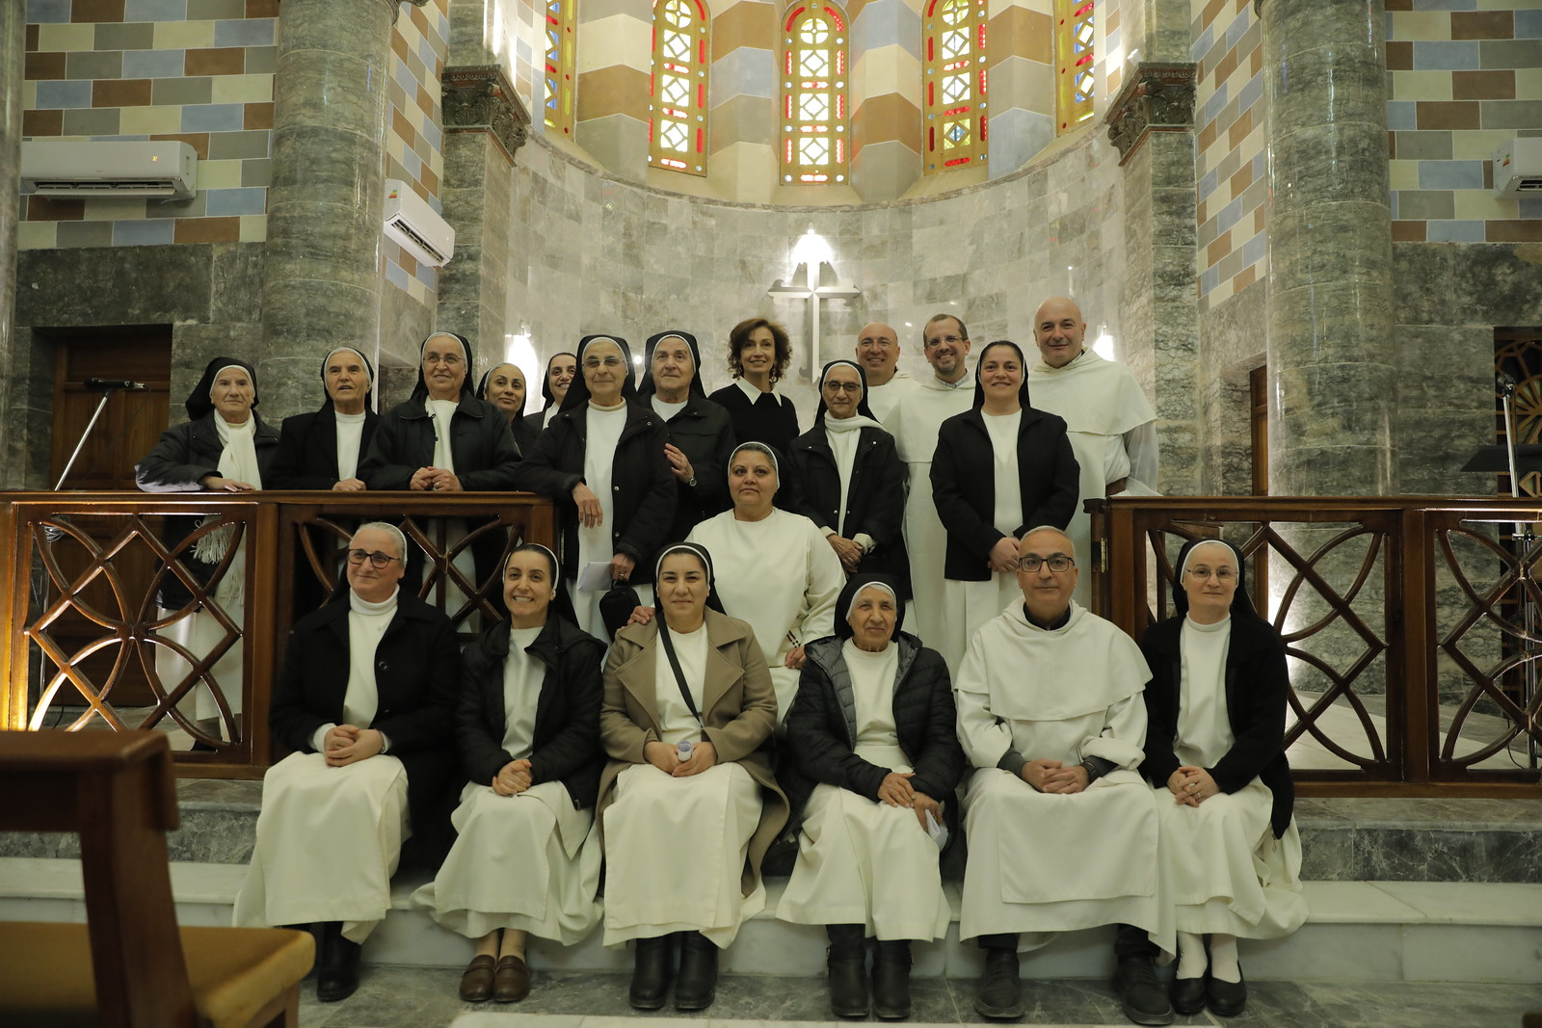
05.02.2025 UNESCO's reconstruction of Mosul's landmarks
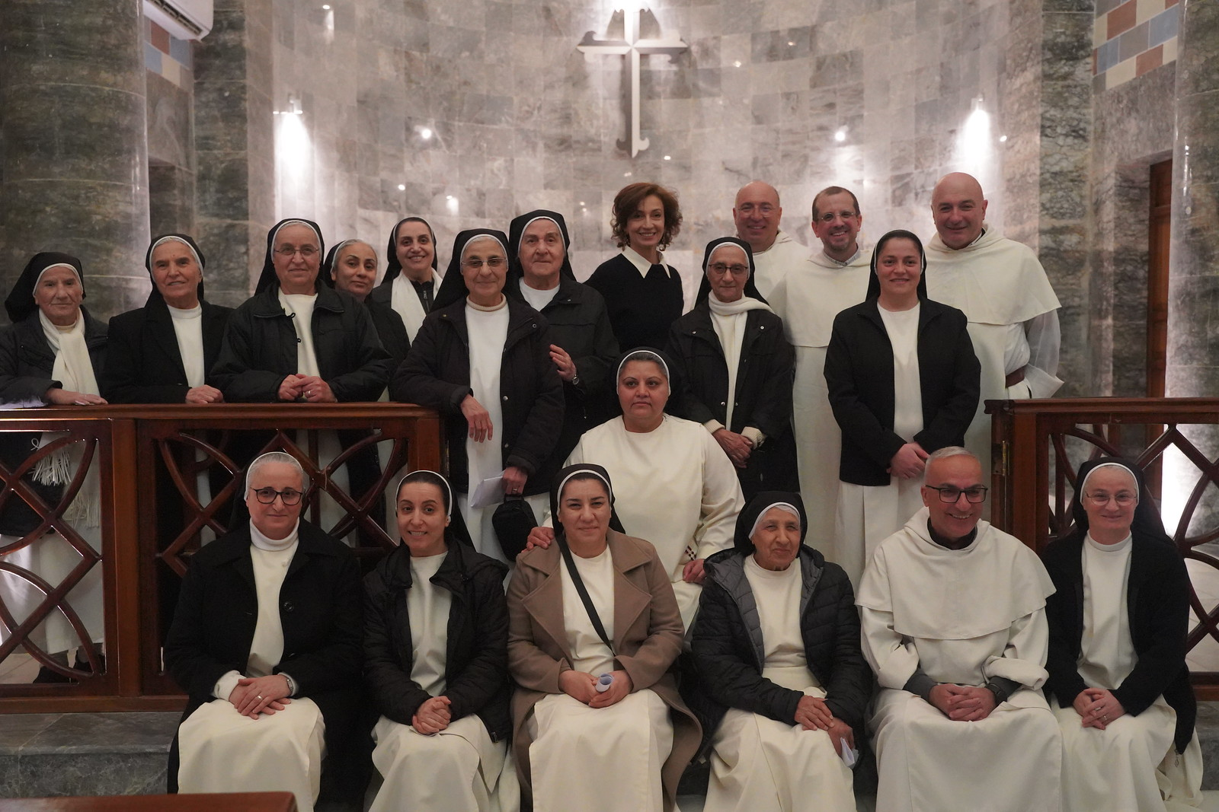
05.02.2025 UNESCO's reconstruction of Mosul's landmarks
