Exhibition Showcases Women's Action for Sci-Tech Innovation

## Rosa Dalmiglio –CHINA-UNESCO promotion a new ACWF-XINHUA e.magazine

[rdalmiglio@hotmail.com](mailto:rdalmiglio@hotmail.com)

# Febrary 2025 at “WORLD INTERFAITH HARMONY WEEK”

### The exhibition on Women's Action for Scientific and Technological Innovation opened November 28, 2024, in the China National Museum of Women and Children. Huang Xiaowei, Vice-President and First Member of the Secretariat of the All-China Women's Federation (ACWF), and Fu Hua, President of Xinhua News Agency, attended. They declared the exhibition open. The exhibition is scheduled to close at the end of March 2025.

|  |
| --- |
| Exhibition Showcases Women's Action for Sci-Tech Innovation |

### During the opening ceremony, Ye Shuhua, an astronomer and academician with the Chinese Academy of Sciences, sent a congratulatory message. Wang Yaping, a heroine taikonaut, and Vice-President of ACWF, shared her story, with her daughter. Sheng Min, a professor with Xidian University, delivered a speech. Sheng's team won the 17th Chinese Young Women in Science Award. Representatives of students and youth paid their respects to women scientists, by performing thematic dances and poetry recitations.

|  |
| --- |
| Exhibition Showcases Women's Action for Sci-Tech Innovation |

### While visiting the exhibition, Huang talked with participants. She noted the exhibition was a showcase of the progress — in the nation's major, strategic industries — achieved since the launch of the project, Women's Action for Scientific and Technological Innovation, in 2021. The exhibition presents the efforts of ACWF, and relevant central government departments, in promoting integration of women's sci-tech innovations with industrial development, and in facilitating the development of new quality productive forces. Huang spoke highly of the research outcomes achieved by women scientists, and their teams, and Huang encouraged the women to enhance their innovation capability, and to work toward greater accomplishments.

### Huang also talked to heads of women's federations and women's associations for science and technology, and she urged them to provide better support and services to women who are working in the science and technology sector, and to work to pool women's strength to make contributions to building China's strength in the sector.

|  |
| --- |
| Exhibition Showcases Women's Action for Sci-Tech Innovation |

|  |
| --- |
| Exhibition Showcases Women's Action for Sci-Tech Innovation |

### Lin Yi, Vice-President and Member of the Secretariat of ACWF, Wang Jiaoping, Member of the Secretariat of the All-China Federation of Trade Unions, heads of relevant agencies involved and some women scientists, also attended.

### The exhibition showcases rare photos, graphs, exhibits and interactive devices to present women's efforts and achievements in the fields of innovation, including digital information technology, new energies, new materials, new services, high-end manufacturing, agricultural science, life science, and resources and the environment. The exhibition also highlights the contributions of more than 100 outstanding women scientists and women academicians, with the Chinese Academy of Sciences and/or the Chinese Academy of Engineering.

|  |
| --- |
| Exhibition Showcases Women's Action for Sci-Tech Innovation |

### The exhibition is being cohosted by ACWF and Xinhua News Agency, and organized by ACWF Department for Women's Development, the China National Museum of Women and Children, China Image Group, Xinhuanet, and China Women's Association for Science and Technology.

### Photos from Yang Rui

### (Source: Women Voice)

### Editor: Cui Rui

[E-Magazines](https://www.womenofchina.cn/html1/culture/20042/1032-1.htm)

[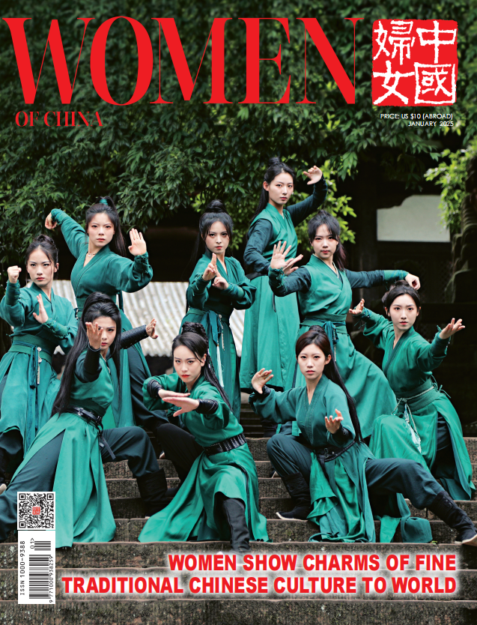](https://www.womenofchina.cn/womenofchina/html1/culture/2502/1356-1.htm)

[Women of China E-Magazine (January 2025)](https://www.womenofchina.cn/womenofchina/html1/culture/2502/1356-1.htm)

[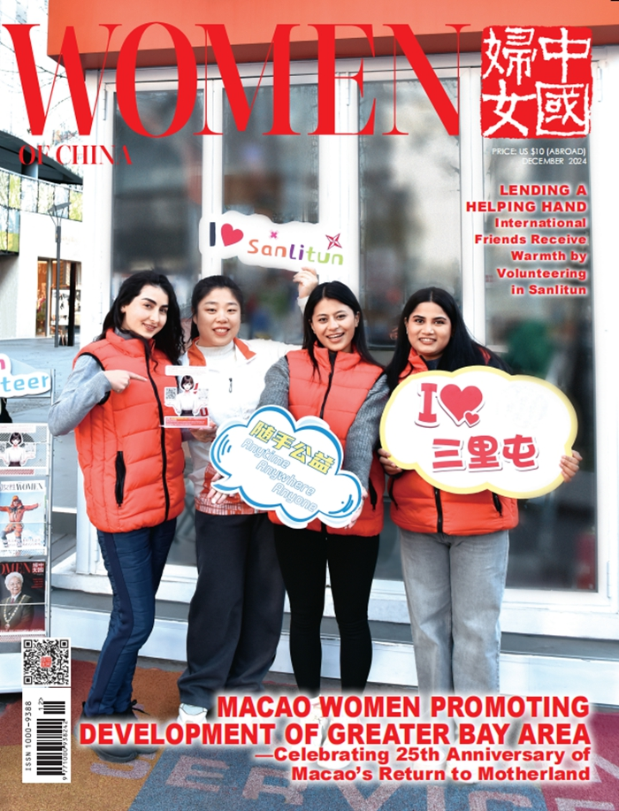](https://www.womenofchina.cn/womenofchina/html1/culture/2502/1355-1.htm)

[Women of China E-Magazine (December 2024)](https://www.womenofchina.cn/womenofchina/html1/culture/2502/1355-1.htm)

[Projects](https://www.womenofchina.cn/womenofchina/html1/projects/0/177-1.htm)

[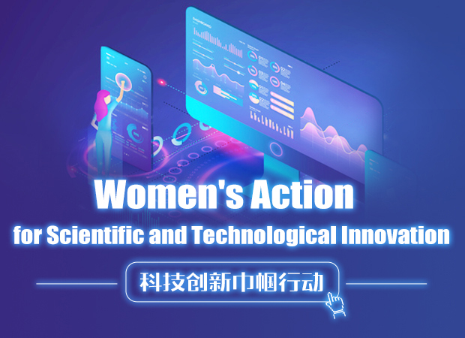](https://www.womenofchina.cn/womenofchina/html1/projects/2111/1295-1.htm)

[Women's Action for Scientific and Technological...](https://www.womenofchina.cn/womenofchina/html1/projects/2111/1295-1.htm)

[Photos](https://www.womenofchina.cn/womenofchina/html1/Photos/1410/1388-1.htm)

[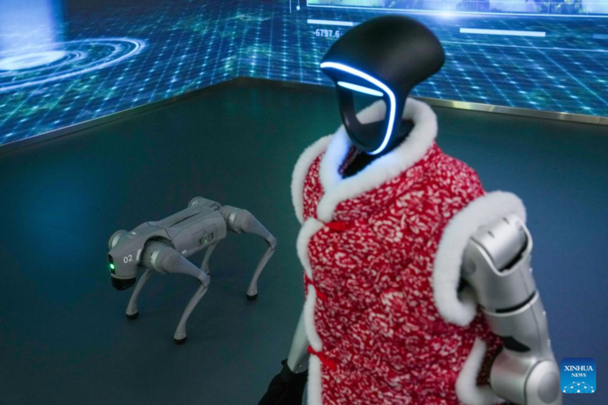](https://www.womenofchina.cn/womenofchina/html1/Photos/2502/1921-1.htm)

[A Glimpse of Beijing World of Robots](https://www.womenofchina.cn/womenofchina/html1/Photos/2502/1921-1.htm)