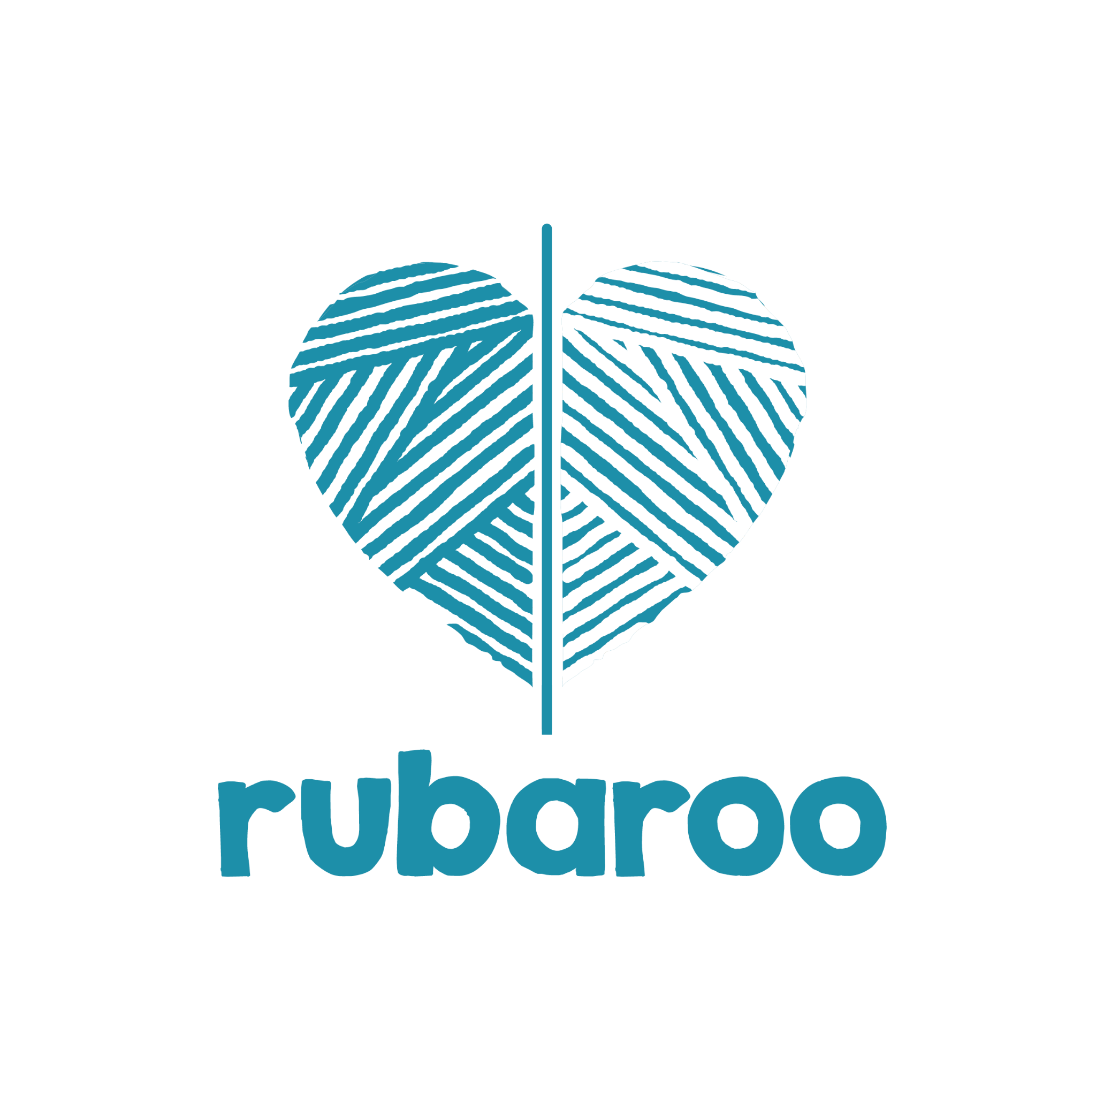

**Interfaith Youth Leadership Programme**

**Social Action Project**

**January-March 2024**

**Name of Fellow**: Urmi Chanda

**Zone**: West

**City**: Mumbai

**UN Sustainable Developmental Goal of choice**: #16 (Peace, Justice, and Strong Institutions)

**Social problem of focus:** Communal/ Religious conflict and violence; disharmony; polarisation

**Solution/ Theme of project:** Social cohesion/ Peace

|  |  |
| --- | --- |
| **Name of Social Action Project or Campaign Idea**  **The main SDG** | Name of (social media) campaign: **At Pluralism’s Altar**  Hashtag: **#pluralismforpeace**  SGD addressed: **SGD #16 Peace, Justice, and Strong Institutions**  *(Promote peaceful and inclusive societies for sustainable development, provide access to justice for all and build effective, accountable and inclusive institutions at all levels)* |
| **Detail of Social Action Project**  Location: (please specify name of community, college, location, etc.)  Date & Timings | **Description**: An umbrella social media campaign, targeting all age groups and communities with access to the internet, and appreciation for India’s pluralist ethos through multifaith sacred objects.  **Date**: Feb 1-7, 2024 [UN World Interfaith Harmony Week]  **Location:** Virtual/ social media |
| **Methodology/ approach that would be used for the SAP**  Rubaroo promotes the idea of inclusive and interactive sessions where participants are able to engage and contribute to the discussion. | Since a lot of religiously divisive ideas are perpetuated through social media, the Pluralism for Peace archives project offers a social media solution. The Fellow will create a photo archive/ repository of crowdsourced images on Instagram, which will showcase the value of pluralism as it is witnessed and expressed in everyday lives of Indians. Images and short descriptions of sacred ‘interfaith’/ multifaith objects will **bear testimony to the inherent pluralism of Indians and reiterate its importance** at a time of growing communal divide. ‘Sacred Interfaith Objects’ (SIO) here refers to (images of) objects such as pictures, amulets, icons, books, flags, etc. that belong to a different religion from those whose shrines and homes they are found in. For example, a copy of a Quran kept with sanctity in a Hindu home would be an SIO. Similarly, a small icon of the Hindu god Krishna in a Christian home would be an SIO. A virtual photo + video repository of such objects (and/or practices) can be of immense value to those viewing and engaging and serve as reminder that it is only through the acceptance of diversity and pluralism in our society that peace can be achieved. If our gods can stand shoulder to shoulder, why can’t we? Since the project is open to public, it will be completely inclusive, while protecting the identity (if requested) of the contributors. Engagement will be through a virtual response form through which contributors will be able to share their stories, and respond to others’ stories through the Instagram page. The Fellow will be responsible for the creation of the page, curation of the content, moderation of comments, and ensuring safe and respectful engagement on the platform. |
| **Who will the Social Action Benefit?**  Example: Youth age group (19-25 years)  **To work with adolescents below the age of 18 years please check the child safeguarding policy** | All age groups active on Instagram, in and beyond India. |
| **Specific Objectives of your project:** At least 3 | **OBJECTIVES**   1. **Documentation** 2. **Awareness creation** 3. **Promoting pluralism and peace**   The three main objectives of the project include documenting, generating awareness, and promoting the idea of pluralism as a pathway to peace. Where there is a deluge of misinformation and hate-filled discourse, it is important to document the pluralistic ethos of this nation and how it manifests in simple ways in our lives. One of the simplest and most visible ways in which this occurs is in our everyday worship. Most Indian homes have an altar, or a space designated as the sacred corner/ spot, where some images of some gods is likely to be found. This space may have one or multiple sacred objects such as icons, lamps, incense holders, copies of sacred books, posters, flowers, bells, flags, etc. And while each altar has a preponderance of objects aligned to the faith of the practitioner(s), there are often objects from other faiths too. These are kept and treated with equal reverence, and this is a tiny but everyday affirmation of the pluralism inherent in our culture. We are more tolerant, respectful, and inclusive that we see or are led to believe. It is important to remind ourselves and others of this little but powerful testament, while documenting a most precious hallmark of Indian society. Because this project will be crowdsourced, it will be inclusive and because it will be virtually conducted, it will be universally accessible. Simple tools such as a Google form (for submissions) and the Instagram page will allow for the Fellow to measure the impact of the campaign on the following parameters:  **Performance:** Measured bynumber of photo entries for the campaign, indicating direct and active engagement  **Specific:** The (expanding) virtual repository will serve as both, the means and the end for promoting peace through pluralism  **Measurable:** Social media amplification of request Number of entries + engagement with posts on Instagram  **Achievable:** 30 crowdsourced posts during Interfaith week to kickstart campaign  **Timebound:** 1**-**weekkickstarter |
| **Activity** - Who - When - Timeline |
| Use the **PSMART** tool: |
| Performance: Evidence of action done by |
| the participants |
| Specific: Clarity of outcome and output |
| Measurable: Ability to calculate the number |
| of participants, sessions, the duration |
| Achievable: Setting targets that impact |
| visible change and activity within that time |
| frame. |
| Timebound: Setting realistic goals and |
| timelines of when the SAP would be |
| completed. |

The more you detail out this sheet, the stronger your Social Action Project would be!

|  |  |  |
| --- | --- | --- |
| **Assessing the Need:**  Why is there a need for this social action project?  What evidence do you have of the need? Are you consulting other members of the community? | Root cause 1  Communal disharmony in present day India – as in the case of the Hindu majority often being at loggerheads with the Muslim and other minority communities – has several reasons, prime among them being ideological and religious differences.  Such societies with internal conflicts are not conducive for sustainable intentions or actions. Where there is inequity and skewed (social) justice, individuals and communities are given to safeguarding self-interests first. Larger interests can be only borne in mind when there is a sense of oneness and peace. There are plenty of instances and evidence of conflict between the said faith communities, starting from hate speech on social media to riots on the streets. It’s a long-standing social issue and needs remedial measures. Interventions aimed at social cohesion are one way of achieving the sustainable development goal of peace. | Root cause 2  Historical rifts are another root cause of contemporary communal conflicts. Right from the advent of Muslim rulers in the Indian subcontinent in the medieval period to the Partition and beyond, Hindus and Muslims have shared a tenuous history. These historical hurts have caused intergenerational trauma, and keep surfacing often, leading to provocations and reactions. |
| **Team Members / Participants Involved:** | Self |  |
| **Monitoring and Evaluation:**  How will you know your Social Action Project or Campaign has been successful?  Ideally through feedback forms and documentations. Rubaroo would need a maximum of 5 photographs only.  Consent of participants should be taken. Photos of adolescents does not need to be taken. | Measurement parameters shared in section above. |  |
| **Resources required:**  We can only support you for INR 5000/- any expense beyond that needs to be incurred by the leader themselves. | List   * Expense towards social media promotion (since it’s a short-duration project and outreach will need some push) | How will you organise?  Step 1: Design social media campaign with text and graphics  Step 2: Create a dedicated Instagram account to serve as the photo archive.  Step 3: Launch campaign during World Interfaith Harmony Week (Feb 1-7, 2024), using all social media platforms.  Step 4: Market the campaign via sustained social media activity  Step 5: Collect, collate, and curate responses via Google forms and publish crowdsourced entries on the Pluralism for Peace Instagram account to start building a repository. |
| **Notes:** | | |