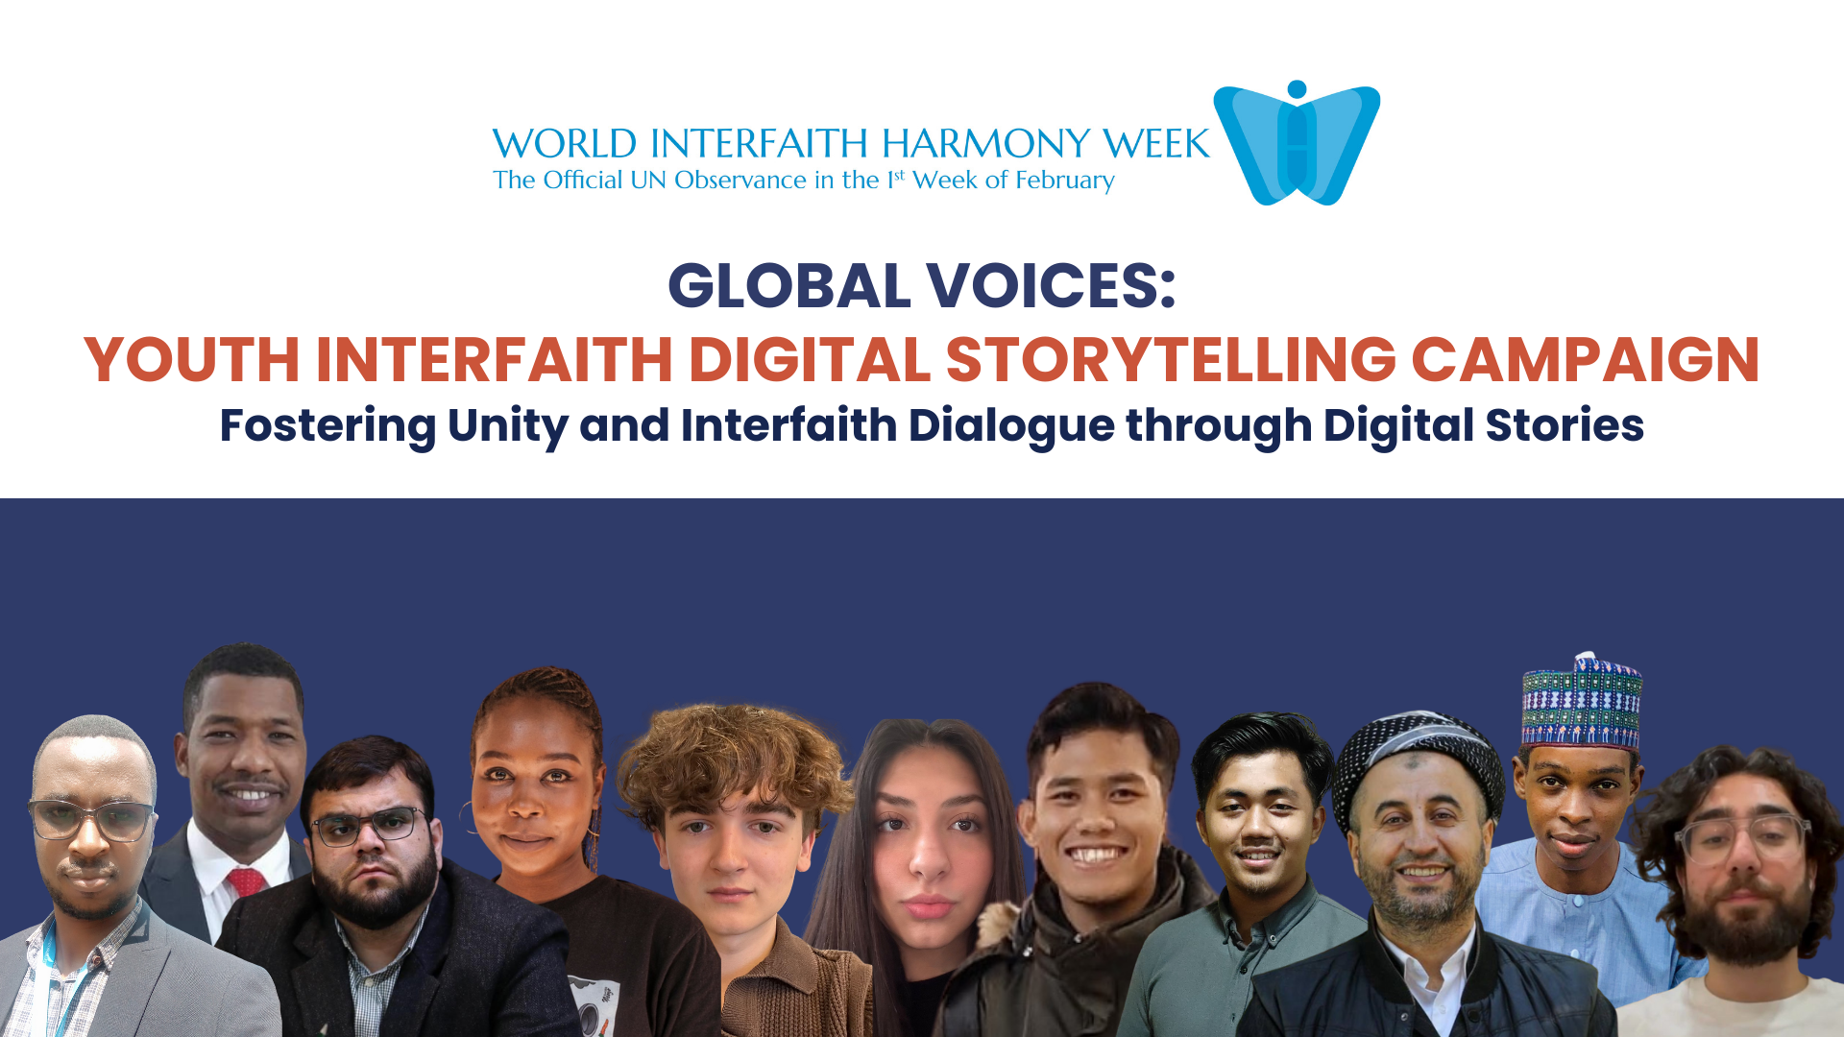

GLOBAL VOICES: Youth Interfaith Digital Storytelling Campaign
February 7, 2024 | 10:00 AM EST

On the occasion of World Interfaith Harmony Week (1-7 February), the Journalists and Writers Foundation organized a digital interfaith storytelling campaign for young people (ages 18-35). As part of this campaign, young people sent us their stories and thoughts on interfaith and intercultural dialogue through 1-2 minute videos.

This campaign aimed to amplify the voices of young people in promoting coexistence sustainable peace, and interfaith/intercultural dialogue. The youth appreciated the opportunity to share their own personal experiences through short video messages and anecdotes. The youth videos were showcased during the World Interfaith Harmony Week program on February 7, 2024. In addition, all videos are available on JWF’s YouTube channels and social media platforms.

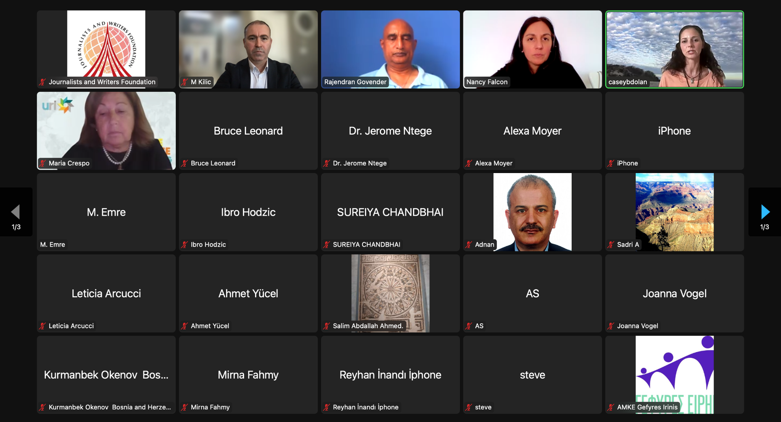

The webinar culminated in a compelling showcase of the Global Voices Youth Interfaith Digital Story Campaign. Through this platform, videos created by young people from various corners of the globe were featured, offering poignant glimpses into their experiences, challenges, and aspirations within their respective faith communities. This initiative stood as a shining example of the transformative power of storytelling to bridge divides and inspire positive change, embodying the spirit of harmony and understanding among diverse faith traditions. Central themes that emerged included the importance of preserving individual identity while fostering mutual respect and understanding, as well as the celebration of diversity as a catalyst for collective growth and enrichment.

By providing a platform for voices from diverse backgrounds to be heard and shared, the webinar underscored the transformative potential of interfaith dialogue in promoting peace and fostering a deeper sense of interconnectedness among all members of the global community. In essence, it served as a testament to the power of dialogue, empathy, and collective action in building bridges of understanding and cooperation across cultural, religious, and geographical divides.

Click here to watch the Global Youth Voices on their interfaith experience
Link:https://youtube.com/playlist?list=PLc_VIzLG2YlpYqjQm5eZakGkfxNo5-IHc&si=HsEXmeO7Ivx8aDjz

Click here to watch the webinar
Link: https://www.youtube.com/watch?v=hmk2-jHyLzM&t=191s

