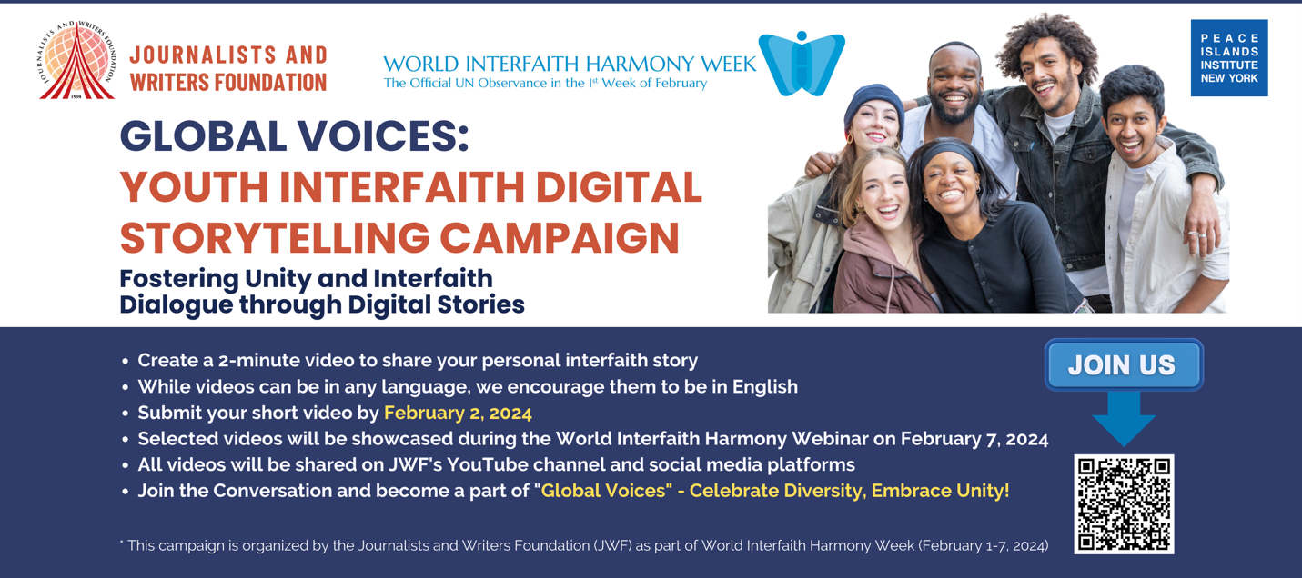

Global Voices: Youth Interfaith Digital Storytelling Campaign
Fostering Unity and Interfaith Dialogue through Digital Stories
[Deadline: February 2, 2024]

Submit Your Video Here
https://docs.google.com/forms/d/e/1FAIpQLSf5qHypAXKHN4k7So8nO6bUPLh-_4Gvy05DL3wASrzMj3lgKQ/viewform

The "Global Voices" Youth Digital Storytelling Campaign aims to empower and amplify the voices of the global youth (ages 18-35) in fostering interfaith dialogue. Through short video messages and anecdotes, participants are welcome to share their personal experiences, promoting understanding, respect, and unity across diverse faith backgrounds.

The purpose of the "Global Voices" campaign is to create a vibrant, inclusive, and youth-led narrative that celebrates the power of interfaith dialogue and foster a sense of unity and harmony among the global community.

Format
- Create a 2-minute video to share your personal interfaith story
- While videos can be in any language, we encourage them to be in English.
- Submit your short video by February 2, 2024
- Selected videos will be showcased during the World Interfaith Harmony Webinar on February 7, 2024.
- All videos will be shared on JWF and PIINY's YouTube channels and social media platforms.
- Join the Conversation and become a part of "Global Voices" - Celebrate Diversity, Embrace Unity!

* This campaign is organized by the Journalists and Writers Foundation (JWF) and Peace Islands Institute (PIINY) as part of World Interfaith Harmony Week (February 1-7, 2024).

