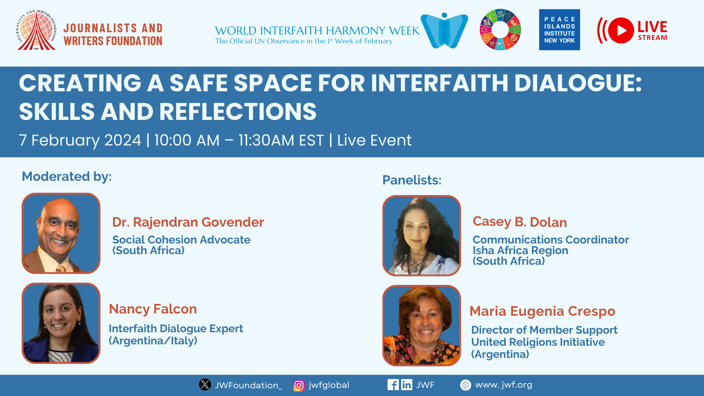

Creating a Safe Space for Interfaith Dialogue: Skills and Reflections
February 7, 2024 | 10:00am EST.

On the occasion of the World Interfaith Harmony Week 2024, the Journalists and Writers Foundation organized an online interfaith event titled: “Creating a Safe Space for Interfaith Dialogue: Skills and Reflections”, held on February 7, 2024 at 10:00am EST. The event focused on the importance of interfaith experiences, knowledge, and skills for fostering interfaith and intercultural dialogue, mutual understanding, appreciating similarities, and respecting differences. Speakers discussed key skills necessary for effective interfaith dialogue and offered advice on how individuals can enhance these skills. Additionally, they recommended essential competencies for young people to engage in interfaith dialogue and understanding through interfaith education, to enhance overall dialogue literacy.

Mehmet Kilic, President of the Journalists and Writers Foundation, welcomed attendees, highlighting the significance of unity, solidarity, and cooperation in addressing common challenges. He stressed the importance of peacebuilding and reconciliation through interfaith and intercultural dialogue.

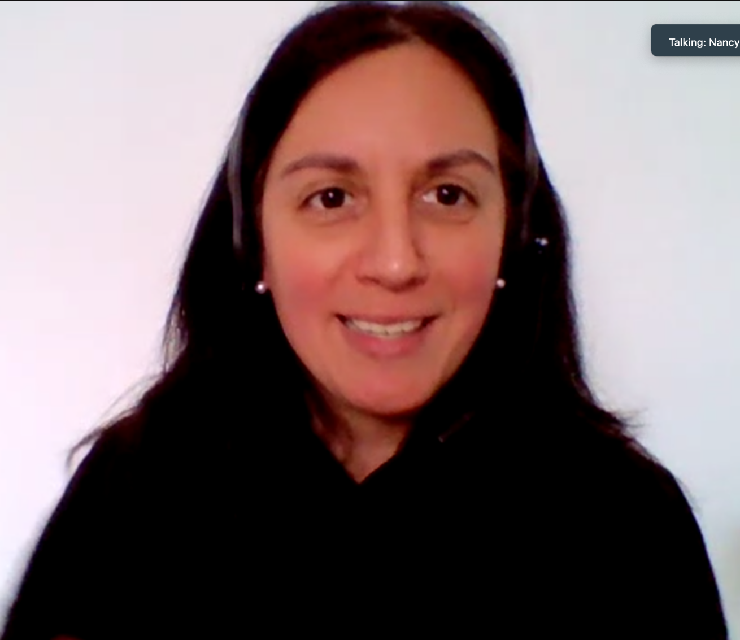
The webinar featured experts who explored essential skills, tools, and knowledge needed for meaningful interfaith dialogue. The event was moderated by Nancy Falcon, an Interfaith Dialogue Expert from Argentina/Italy and Dr. Rajendran Govender, a Social Cohesion Advocate from South Africa. Mr. Kilic introduced the moderators who are members of the JWF's Interfaith Committee and Advisory Board and are close collaborators and friends.

Dr. Rajendran Govender emphasized the critical importance of involving global youth in interfaith dialogue, as it serves to cultivate vibrant and inclusive narratives spearheaded by the younger generation. This proactive engagement not only fosters unity and harmony but also facilitates the development of essential skills necessary for effective interfaith dialogue. By actively involving youth, this approach directly addresses the challenges faced in interfaith interactions and contributes significantly to the promotion of peace within diverse communities.
Casey B. Dolan underscored the significance of prioritizing commonalities over differences and educating the younger generation about the array of diverse beliefs present in our world. This approach serves to promote unity, encourage the celebration of differences, nurture peace, and instill a profound sense of belonging within communities. Casey celebrated the richness inherent in the diversity of faiths and cultures, emphasizing the unity found in the shared wisdom gained from learning from one another while simultaneously embracing the unique differences that exist. Through the exploration of cross-cultural religions, Casey highlighted the discovery of fascinating similarities that serve to deepen our understanding beyond initial perceptions.

The webinar featured two distinguished experts in interreligious and interfaith dialogue: Casey B. Dolan, Africa Coordinator at ISHA Foundation, and Maria Eugenia Crespo, Director of Member Support at United Religion Initiative (URI) in Argentina.
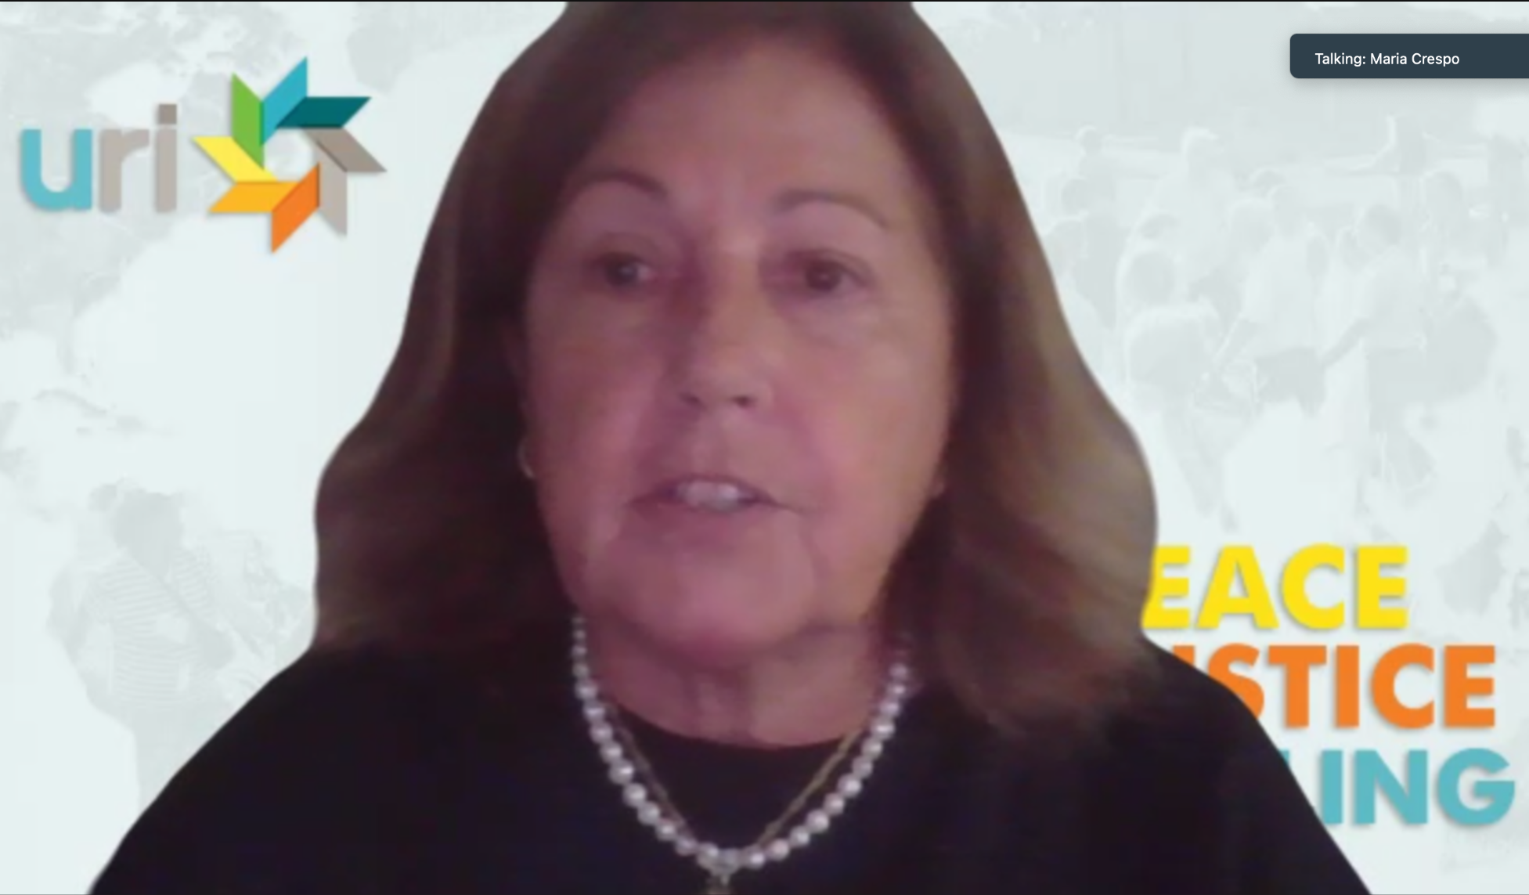
Maria Crespo, representing the United Religions Initiative and specializing in interreligious dialogue coordination, shared insights into her work both in Argentina and globally. She introduced the Bridge Builders program for youth, a project she initiated and successfully replicated in Spain and Brazil. Expressing gratitude for the opportunity to contribute, Maria emphasized her dedication to youth engagement in interfaith dialogue. She highlighted the Bridge Builders project's emphasis on dialogue and action for the collective good, underlining the importance of cooperation and collaboration among diverse faith communities. Maria stressed the essential role of active listening and curiosity in facilitating effective dialogue, advocating for appreciative inquiry as a means to foster deep understanding and collaboration. Additionally, Maria emphasized the transformative power of diverse faiths coming together for the betterment of communities, promoting peace, justice, and healing while actively working to mitigate religious violence. She emphasized the necessity of daily interfaith cooperation, advocating for a dialogue of action focused on defending human rights and building bridges for unity. Maria underscored the importance of embracing multiple perspectives to counter societal fragmentation, emphasizing the value of learning from differences.Furthermore, she acknowledged the significant involvement of youth in interfaith collaboration, recognizing their unique insights and actions as essential contributions to fostering understanding and unity.

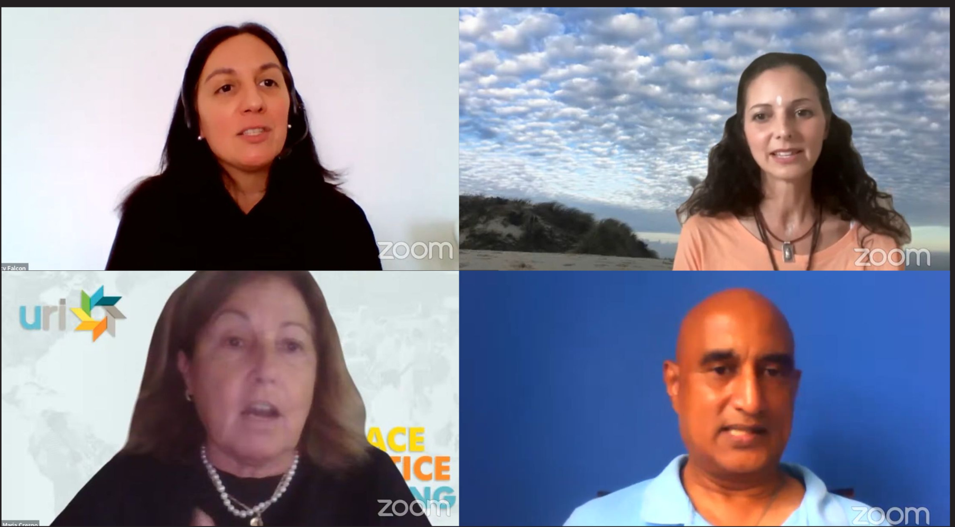

Casey B. Dolan, the Communications Coordinator of the Isha Foundation in Africa, shared her insights and shared her personal journey of embracing diverse traditions, including Jewish, Christian, and Hinduism influences. She described how yoga, in particular, has been transformative for her, emphasizing themes of unity and self-inquiry. At the Isha Yoga Center, Casey highlighted the celebration of diversity, acknowledging the presence of common spiritual threads among various faiths. She pointed out that their temple symbolizes unity amidst religious diversity, emphasizing the importance of uplifting human consciousness to foster dialogue and mutual understanding.

Casey stressed the significant role of education, especially for youth, in promoting interfaith harmony. By nurturing a sense of belonging and pride while embracing unity, she believes we can create a more inclusive and compassionate world. She underscored the importance of focusing on commonalities over differences and teaching the younger generation about diverse beliefs. Casey emphasized that this approach promotes unity, embraces differences, fosters peace, and instills a sense of belonging.

Casey also celebrated the richness of diverse faiths and cultures, highlighting the unity found in learning from each other's wisdom while embracing differences. She pointed out that cross-cultural religions reveal fascinating similarities, deepening our understanding beyond our initial perceptions. Through her remarks, Casey emphasized the transformative potential of recognizing and celebrating diversity in promoting harmony and understanding among communities.

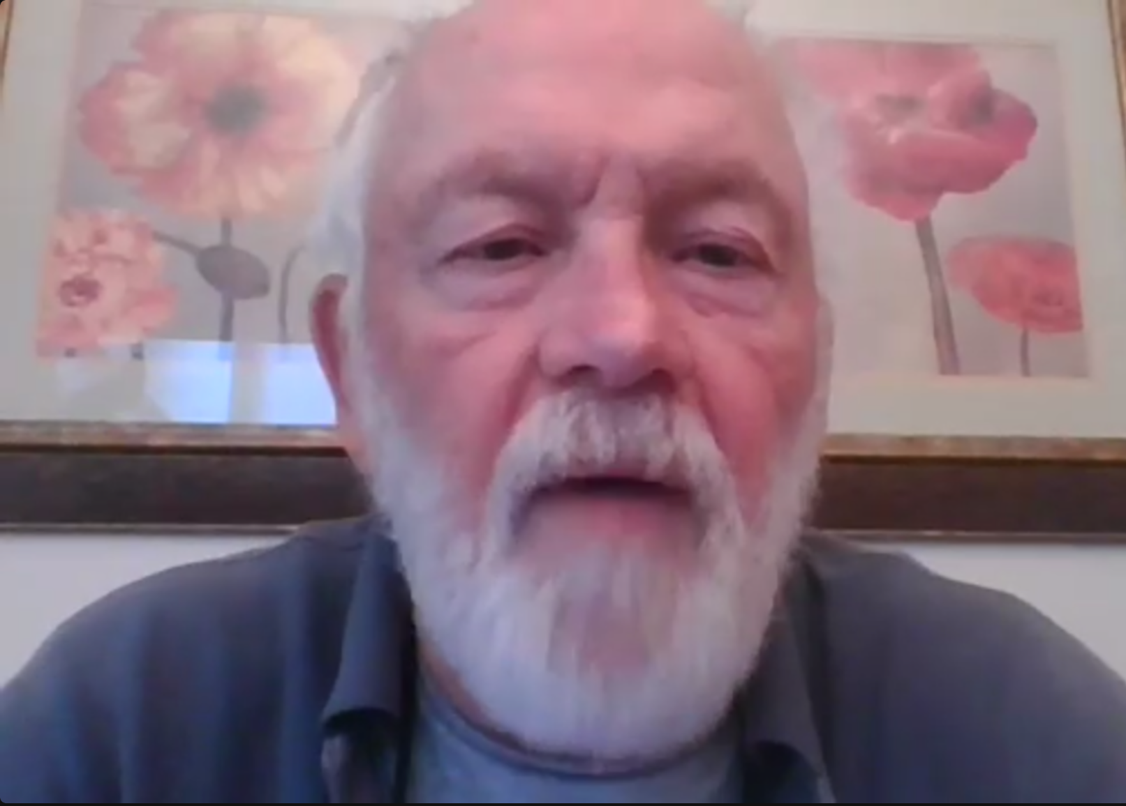

During the Q&A session, a participant from Argentina posed a question about initiating interfaith dialogue in a company with over 20 different cultures. In response, the expert panelists stressed the paramount importance of creating a safe and inclusive space within the company where individuals feel comfortable sharing their diverse perspectives and experiences. They suggested starting small, perhaps with informal gatherings or workshops, as a means to gradually build trust and foster understanding among employees of different cultural backgrounds. Key to successful interfaith dialogue, they emphasized, is encouraging active listening, cultivating curiosity, and promoting respect for diversity in all interactions within the workplace.

Throughout the discussion, panelists underscored the significance of appreciating and respecting diverse beliefs, advocating for careful language use to avoid assumptions and generalizations that might inadvertently perpetuate divisions. Instead, they emphasized the need for sensitivity and a deliberate effort to build bridges between cultures, fostering collaboration and understanding across different faiths and traditions.

Moreover, there was a strong call for greater youth involvement in interfaith dialogue, with suggestions put forth for creating dedicated platforms and programs aimed at engaging young people in meaningful discussions about pressing global issues. Discussion stressed the importance of empathy, compassion, and collective action in addressing the root causes of conflict and promoting reconciliation among diverse communities. Through these concerted efforts, they believed, a more harmonious and inclusive world could be realized.

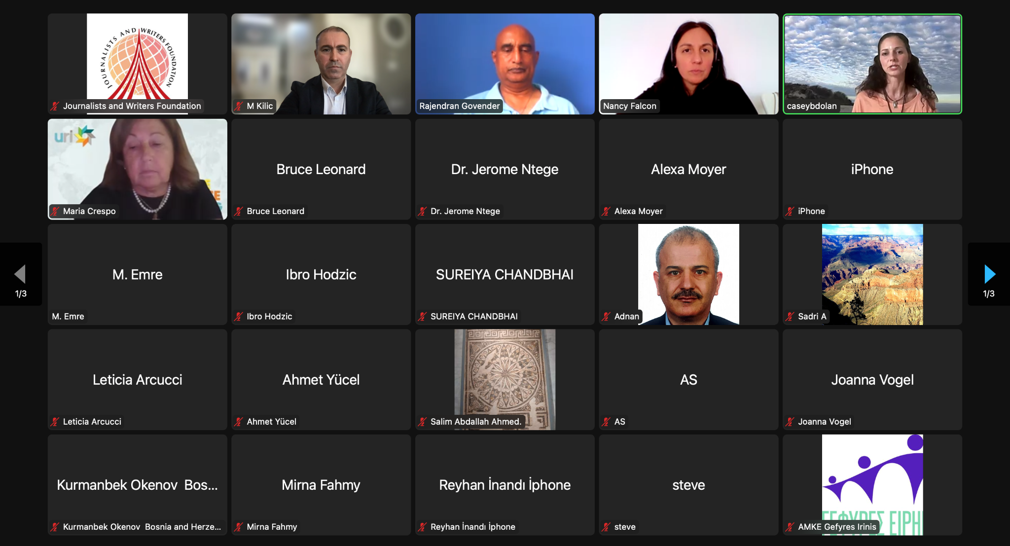

Following the engaging Q&A session, the webinar culminated in a compelling showcase of the Global Voices Youth Interfaith Digital Story Campaign. Through this platform, videos created by young people from various corners of the globe were featured, offering poignant glimpses into their experiences, challenges, and aspirations within their respective faith communities. This initiative stood as a shining example of the transformative power of storytelling to bridge divides and inspire positive change, embodying the spirit of harmony and understanding among diverse faith traditions. Central themes that emerged included the importance of preserving individual identity while fostering mutual respect and understanding, as well as the celebration of diversity as a catalyst for collective growth and enrichment.

By providing a platform for voices from diverse backgrounds to be heard and shared, the webinar underscored the transformative potential of interfaith dialogue in promoting peace and fostering a deeper sense of interconnectedness among all members of the global community. In essence, it served as a testament to the power of dialogue, empathy, and collective action in building bridges of understanding and cooperation across cultural, religious, and geographical divides.

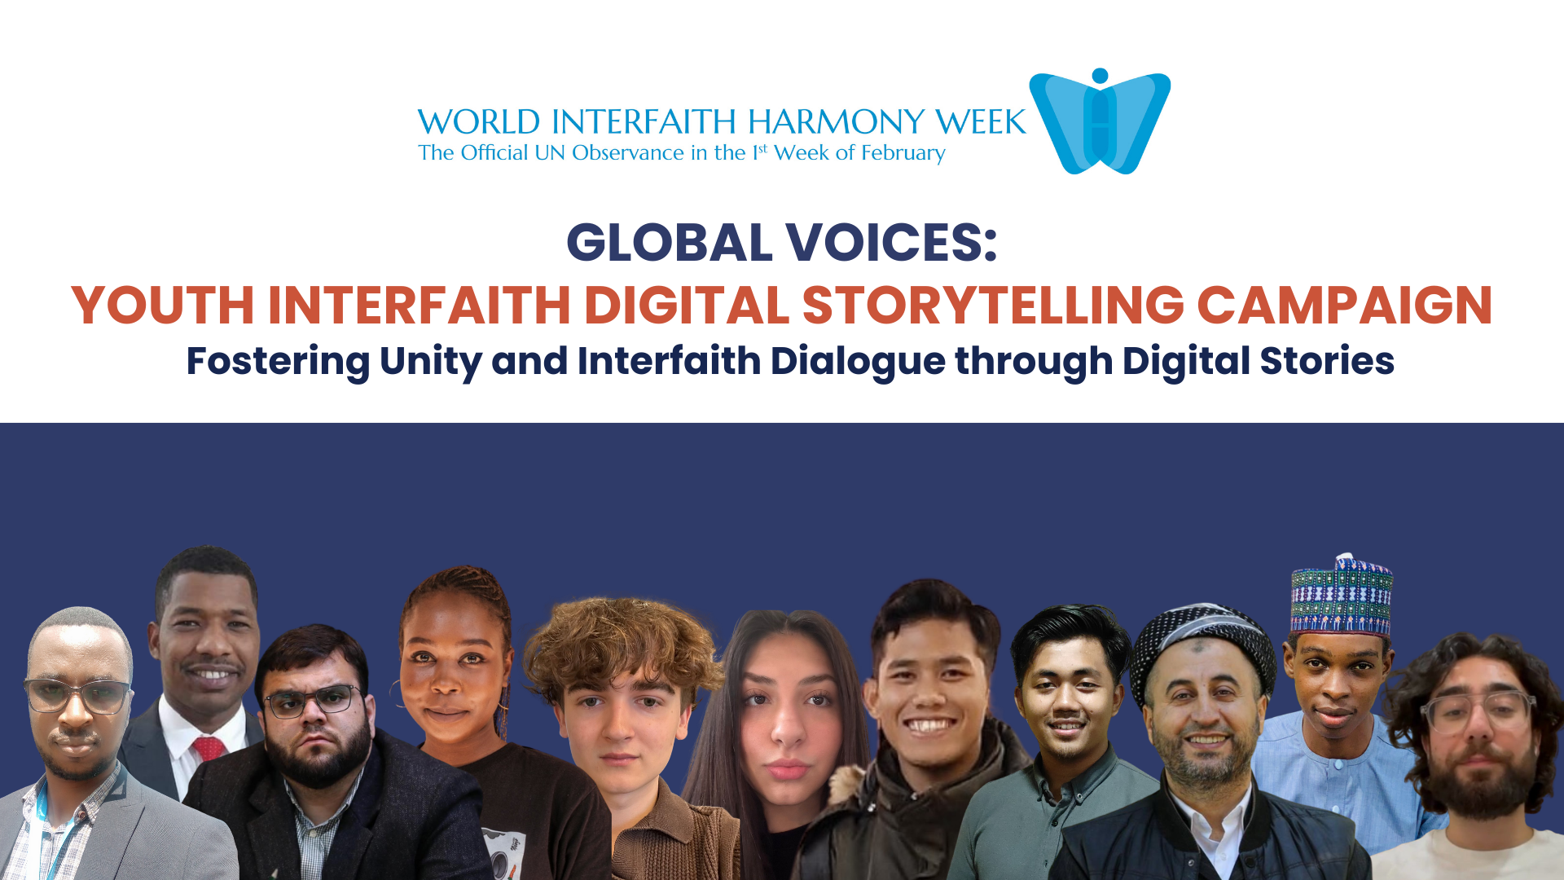

On the occasion of World Interfaith Harmony Week (1-7 February), the Journalists and Writers Foundation organized a digital interfaith storytelling campaign for young people (ages 18-35). As part of this campaign, young people sent us their stories and thoughts on interfaith and intercultural dialogue through 1-2 minute videos.

This campaign aimed to amplify the voices of young people in promoting coexistence, sustainable peace, and interfaith/intercultural dialogue. The youth appreciated the opportunity to share their own personal experiences through short video messages and anecdotes. The youth videos were showcased during the World Interfaith Harmony Week program on February 7, 2024. In addition, all videos are available on JWF’s YouTube channels and social media platforms.

Click here to watch the Global Youth Voices on their interfaith experience
Link:https://youtube.com/playlist?list=PLc_VIzLG2YlpYqjQm5eZakGkfxNo5-IHc&si=HsEXmeO7Ivx8aDjz

Click here to watch the webinar
Link: https://www.youtube.com/watch?v=hmk2-jHyLzM&t=191s

