(SLIDER 1 and Content for JWF & PIINY websites)

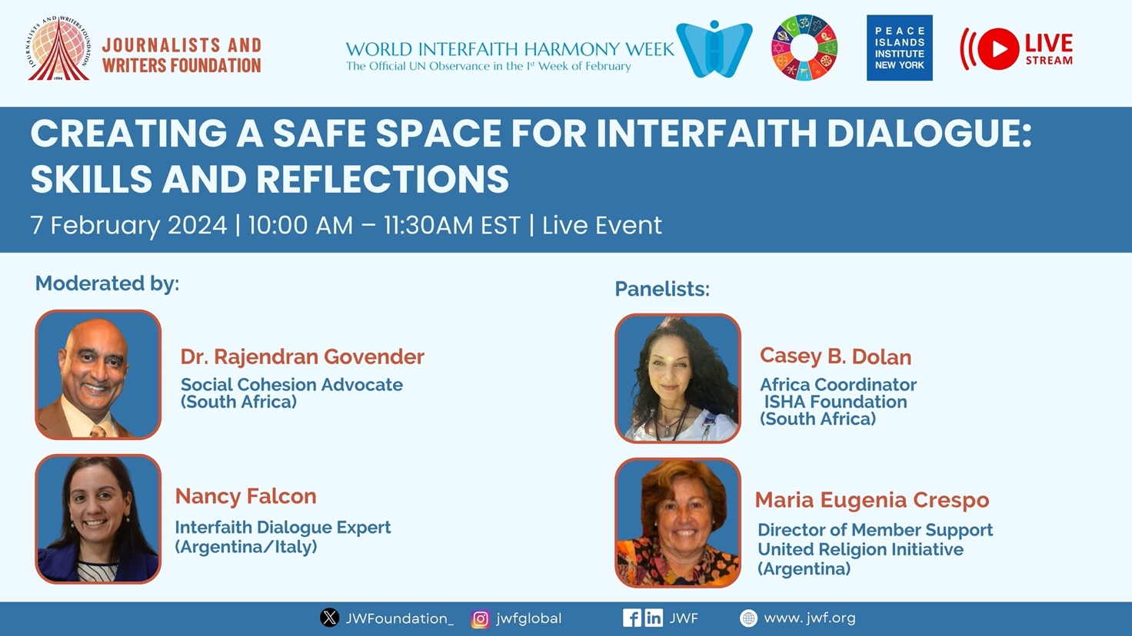

CREATING A SAFE SPACE FOR INTERFAITH DIALOGUE:
SKILLS AND REFLECTIONS
February 7, 2024 | 10:00am – 11:30am | YouTube Live Event

Registration Button
(please make button red color that takes attention)
https://us06web.zoom.us/meeting/register/tZwvcOmsqj8qGNamSHO6T9cshIe-qAFqgSD4

A webinar on cultivating a secure space for interfaith dialogue will feature experts in the field who will delve into the essential skills, tools, and knowledge required for interfaith dialogue. The experts will elaborate on effective strategies for acquiring, nurturing, and teaching the skills relevant to interfaith dialogue. Moreover, they will draw from their own experiences to discuss the challenges encountered in implementing these practices and offer insights on overcoming various barriers. This webinar aims to actively engage the audience by encouraging questions and facilitating reflections.

- What are the most important skills for interfaith dialogue?
- How can individuals engaged in interfaith dialogue enhance their skill set?
- Do young individuals acquire the essential competencies for dialogue and understanding through their general education?
- What steps can be taken to improve overall "dialogue literacy"?

Moderated by:

Dr. Rajendran Govender  Social Cohesion Advocate  (South Africa) | 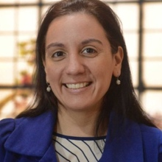  Nancy Falcon  Interfaith Dialogue Expert  (Argentina/Italy)

Speakers:

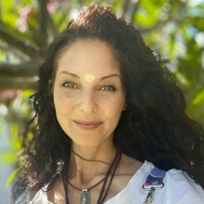  Casey B. Dolan  Africa Coordinator  ISHA Foundation  (South Africa) | Maria Eugenia Crespo  Director of Member Support  United Religion Initiative  (Argentina)

Please note that this webinar format actively promotes and values the participation of attendees. The final 10 minutes will be dedicated to viewing videos from the youth interfaith storytelling campaign, followed by an opportunity for participants to engage in a final reflection on the content.

Registration Button
(please make button red color that takes attention)
https://us06web.zoom.us/meeting/register/tZwvcOmsqj8qGNamSHO6T9cshIe-qAFqgSD4

(SLIDER 2 and Content for JWF & PIINY websites)

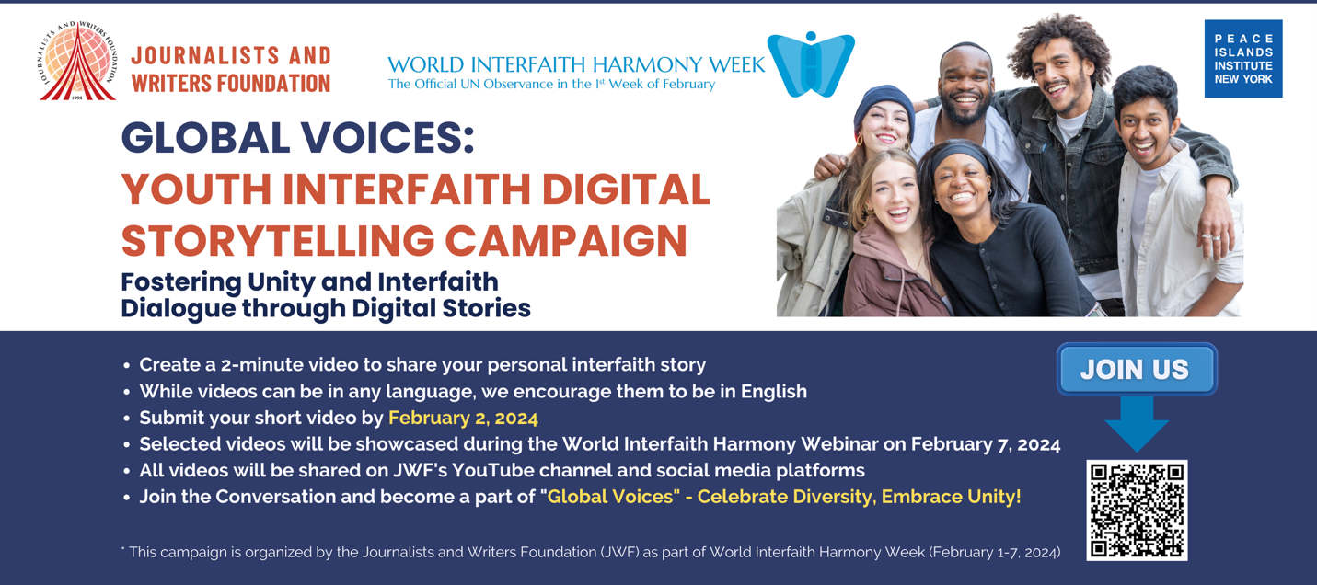

Global Voices: Youth Interfaith Digital Storytelling Campaign
Fostering Unity and Interfaith Dialogue through Digital Stories
[Deadline: February 2, 2024]

Submit Your Video Here
(please make button red color that takes attention)

https://docs.google.com/forms/d/e/1FAIpQLSf5qHypAXKHN4k7So8nO6bUPLh-_4Gvy05DL3wASrzMj3lgKQ/viewform

The "Global Voices" Youth Digital Storytelling Campaign aims to empower and amplify the voices of the global youth (ages 18-35) in fostering interfaith dialogue. Through short video messages and anecdotes, participants are welcome to share their personal experiences, promoting understanding, respect, and unity across diverse faith backgrounds.

The purpose of the "Global Voices" campaign is to create a vibrant, inclusive, and youth-led narrative that celebrates the power of interfaith dialogue and foster a sense of unity and harmony among the global community.

Format
- Create a 2-minute video to share your personal interfaith story
- While videos can be in any language, we encourage them to be in English.
- Submit your short video by February 2, 2024
- Selected videos will be showcased during the World Interfaith Harmony Webinar on February 7, 2024.
- All videos will be shared on JWF and PIINY's YouTube channels and social media platforms.
- Join the Conversation and become a part of "Global Voices" - Celebrate Diversity, Embrace Unity!
Submit Your Video Here
(please make button red color that takes attention)

https://docs.google.com/forms/d/e/1FAIpQLSf5qHypAXKHN4k7So8nO6bUPLh-_4Gvy05DL3wASrzMj3lgKQ/viewform

* This campaign is organized by the Journalists and Writers Foundation (JWF) and Peace Islands Institute (PIINY) as part of World Interfaith Harmony Week (February 1-7, 2024).

