**Rosa Dalmiglio Introduction of the High School Affiliated to China Disabled People’s Performing Art Troupe at 2023 World Interfaith harmony Week**

**Documentary duration 35 minutes**

**Site: Rome-International Women House**

**Date 1 Febrary 2023**

The High School Affiliated to China Disabled People’s Performing Art Troupe was jointly established by China Disabled People’s Performing Art Troupe (CDPPAT) and the government of Yichang. Supported by the rich resource of Yichang Special Education School, the High School is aimed to discover gifted hearing-impaired students and provide compound talents for special arts. Zhang Haidi, the President of China Disabled Persons’ Federation (CDPF) and Ma Xuming, the Mayor of Yichang city are accredited as the Honorary Principals. CDPF takes hands with Yichang City Committee and Government in the unswerving resolution of building a characteristic world-class school that exemplifies special education and expands the channel of international communication.

**Objectives & Goals**

The High School Affiliated to China Disabled People’s Performing Art Troupe is designed to cultivate physically-challenged students into outstanding and professional performers, encouraging them to develop all-round abilities in morality, intelligence, physique and aesthetics, as well as facilitating them to acquire higher education.

**Guiding Principles**

The High School attaches equal importance to moral education, cultural competence and art accomplishment by combining the systematic teaching contents with real practice. Meantime, the shaping process of individual’s custom, style and character has also been highly concerned.

**Working Pattern**

Students will be fostered in the school for 6 years, including fundamental education of middle-school level and systematical art training. After graduation, they will receive the Regular High School Certificate and meet the standard of professional performer.

**Achievements**

In the past five years, under the care and guidance of China Disabled Persons’ Federation and Government of Yichang, fruitful achievements have been made in aspects of school construction, student cultivation, teaching creation and so on. In the ambience of unity, solemnity and liveliness, students develop themselves in a multi-level way. Sharp progress of both knowledge study and professional skills has been clearly made during the process of happily growing.

The Class of 2013 is equipped with a solid mastery of basic dancing skills and artistic accomplishment, therefore, they currently represent the China Disabled People’s Performing Art Troupe to perform the classic show all over the world. Members of CDPPAT have displayed their elegant glamour in Yichang TV, Hunan TV, Chongqing TV, Beijing TV, China Central Television (CCTV) and appeared on the stage of Hong Kong. In 2016, performers proceeded to Cuba and the UK in representation of China, and also attended International Day of Disabled Persons for commonweal.



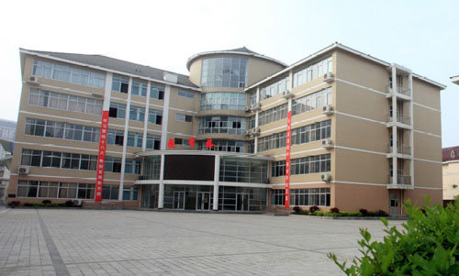

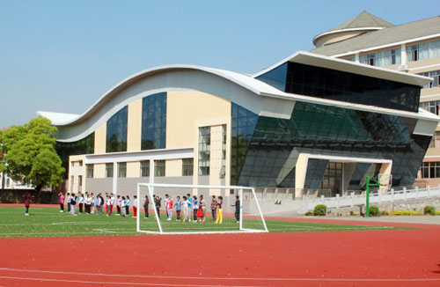

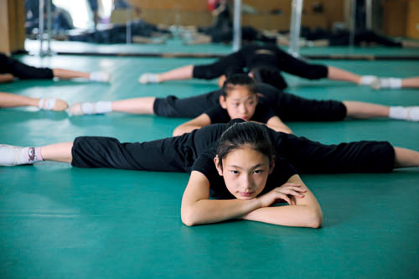



**Contact** [**–rdalmiglio@hotmail.com**](mailto:–rdalmiglio@hotmail.com)

Marketing Dep.:  
TEL : +86(10)-84637907   
FAX : +86(10)-84637919  
Email:  [cdppat@vip.sina.com](mailto:ystwlb@sina.com.cn)

Location : 8A Huixinli Street, Chaoyang District. BeiJing,P.R.China  
Postal code: 100029