Report 7: Faith Meets Faith (Tro møder tro)
UN World InterFaith Harmony Week 2023
Arranged by Cross-cultural Ministry of Kolding Deanery in cooperation with the Office of Migrant Cooperation and Encounter with Other Religions of the Haderslev Diocese
An offer to students in 5 schools , carried out on January 31, February 2, February 9 and February 21, relating these events to UN World Interfaith Harmony Week. It is bringing WIFHW to these following schools: Lyshøj School, Brændkjær School, Vonsild School, Bramdrup School, Søndervang School and Munkevængets School in the Municipality of Kolding in cooperation with Church and School Services. The dialogue visits were done by two religious leaders in Islam and Christianity. Imam Kassem Racheed and Pastor Michael Markussen are good friends. The dialogue forums were with the 8th and 9th grade- students, reaching a total of 649 students in all the sessions of their 4 visitations
Introduction: The program Tro møder tro, which means Faith Meets Faith in English, is our regular offer to 8th and 9th grade students in schools wherein two leaders in Islam and Christianity, who are good friends, visit schools and allow students to dialogue with them on all questions on earth they as students would like to ask. These four visits were intentionally carried out to fall on the dates from January 31 to February 21 to mark the UN World Inter-Faith Harmony Week.
This program is in cooperation with the office of SKIK (Church and School Services) It is this office that arranges the visits with schools and specify the dates of the visits to the teachers in these 8th and 9th graders. Teachers of these classes ask their students to prepare their written questions for the dialogue and they also join with their students in these dialogue sessions. The religious leaders who use their time for this purpose get a little honorarium from our office.
(Note: Schools have strict rules in relation to photo taking. We enclose the photos of the schools, the photos of the Christian priest and the Muslim imam. On the photo is one of the teachers and some of the students.)
This report will include the list of the schools with the number of students in different class sections and put together in the school`s biggest room or hall. Two of our colleagues make a short report of their experience in their visits.
- Schools visited and number of sections put together
and the number of students.

Date | Schools visited | Classes | No. of pupils and students
Tuesday  January 31 | Lyshøj School | 4 class sections | 100 students
Thursday  February 2 | Brændkjær School | 4 class sections | 84 students
Tuesday  February 7 | Vonsild School | 2 class sections | 44 students
Tuesday  February 7 | Bramdrup School | 2 class sections | 44 students
Thursday, February 9 | Søndervang School | 2 class sections | 51 students
Thursday  February 9 | Munkevængets School | 1 class section | 25 students
February 21 (Culture Day: Faith meets Light) | Lyshøj School | 4 class sections  5 class sections  6 class sections | 104 students  96 students  101 students

Total number of students in these visits and encounters: 649

2. Here are reports of our two colleagues who joined in Faith Meets Faith
Report of Camilla Møbjerg Henriksen
Faith meets Faith
Faith meets Faith, a ministry for students in schools to understand the practice of two of the monotheistic religions – Christianity and Islam – towards tolerance and common understanding. This is in cooperation with SKIK or Skole-Kirke Tjeneste of Kolding Deanery. Representatives from these two religions were Imam Kassem Racheed and Rev. Michael Markussen who spoke about their holy scriptures and their faith in praxis as believers. Here they come in dialogue with students who come prepared with their own questions.
Faith meets Faith program is designed to help students talk about religion in real life and in daily practice. It also shows how religious leaders can stand together, talk, and show an interest in each other’s perspectives.
I joined with Pastor Michael and Imam Kassem visiting two schools on the 2nd Of February. They gave a lecture for 84 students that day. The students were curious and wanted to explore many different topics:
- Is Jesus a God?
- Is it allowed to smoke?
- Can you wear gold?
- and questions concerning gender
Faith meets Faith creates a safe space, where the students feel free to ask questions and get the opportunity to hear different perspectives.

2. Report by Jårliny Spence Swanlake
I have participated in Faith Meets Faith event with Michael Markussen and Kazem at Vonsild School in Kolding on February 7. There were about 44 students from the 9th grade. They had had the subject of Islam and Christianity as a subject in some weeks and concluded with the visit of the two religious’ leaders in Christianity and Islam. Many of students in the class were preoccupied with what the two religious leaders did say in their presentations. Each of them got 10 minutes: Michael Markussen presented his daily practice, the Bible, a bit on the history of Christianity, also on role the church in our society. Kasem also presented a bit of the history of Islam, his daily life practice as a Muslim and a bit of Koran.
Some questions which students raised after the 20- minute presentation:
What is the tradition of Easter?
How do you keep it in a national church?
How do you spend Easter in your family?
Why should women wear head cover? (hijab)
Why should you pray in a certain direction when you are a Muslim? ‘
Are you allowed to spend Christmas when you are a Muslim?
Why do you have to pray three times a day as a Muslim?
Why and when should the girls and women wear covers on their head?
When does one become a Muslim?

Enclosures;
- Photos of Imam Kaseem Racheed and the priest Michael Markussen and one teacher
- Photo of the two leaders with some students who followed them up with more questions after the session.
- Photos of the schools being visited from January 28 to February 21
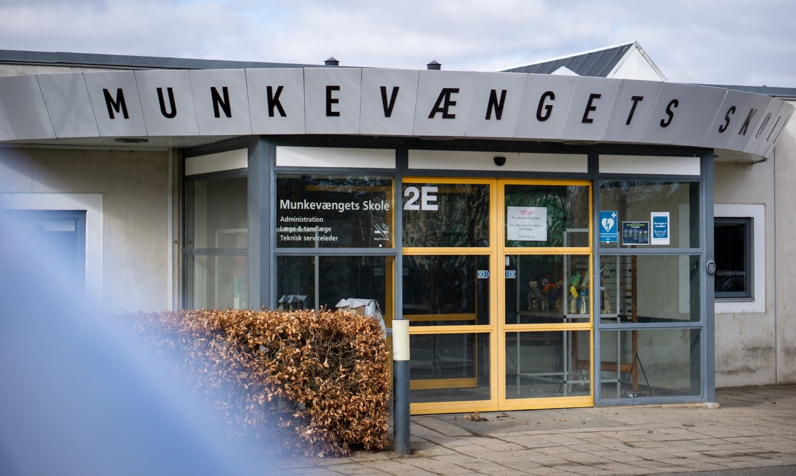
Munkevængets Skole

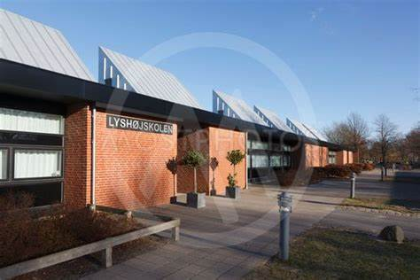
Lyshøjskolen
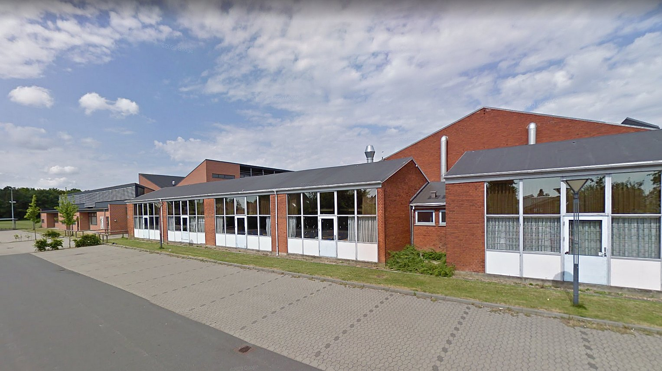
Brændkjærskolen

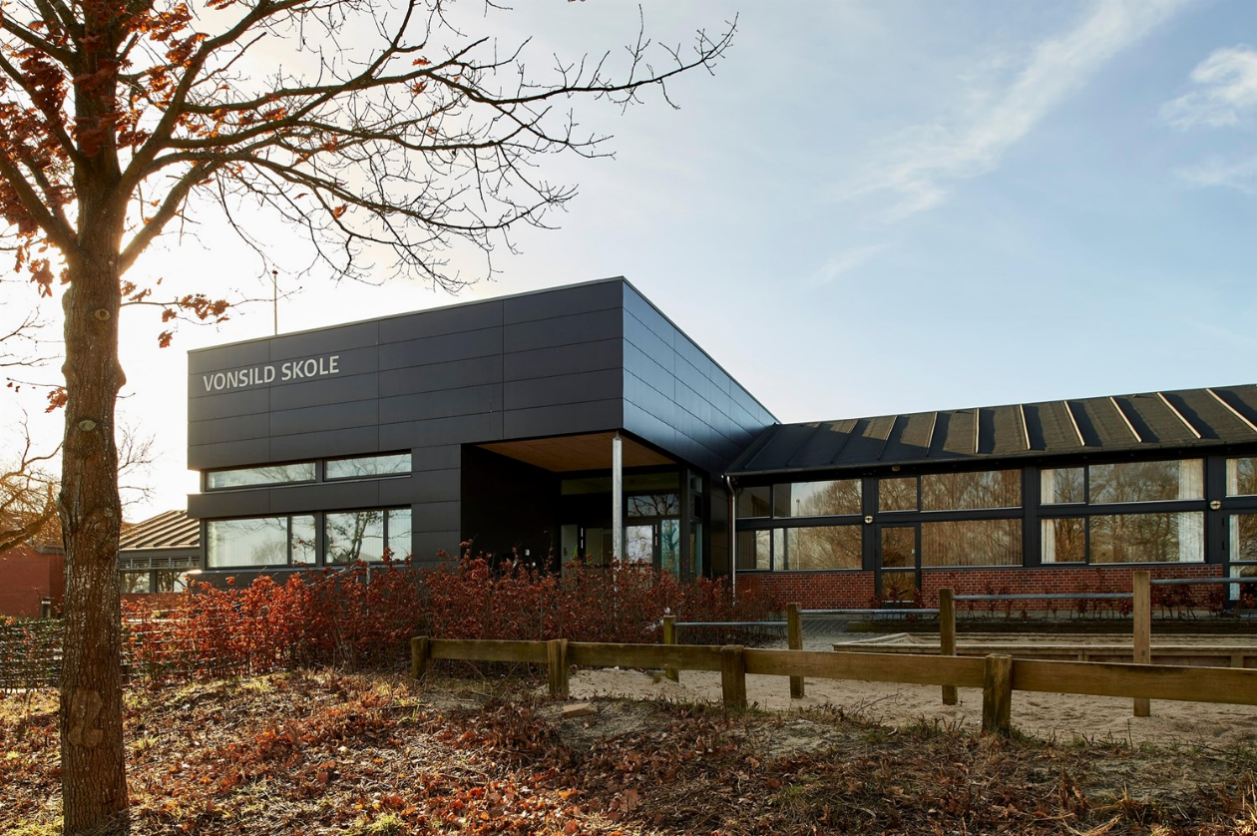
Vonsild Skole

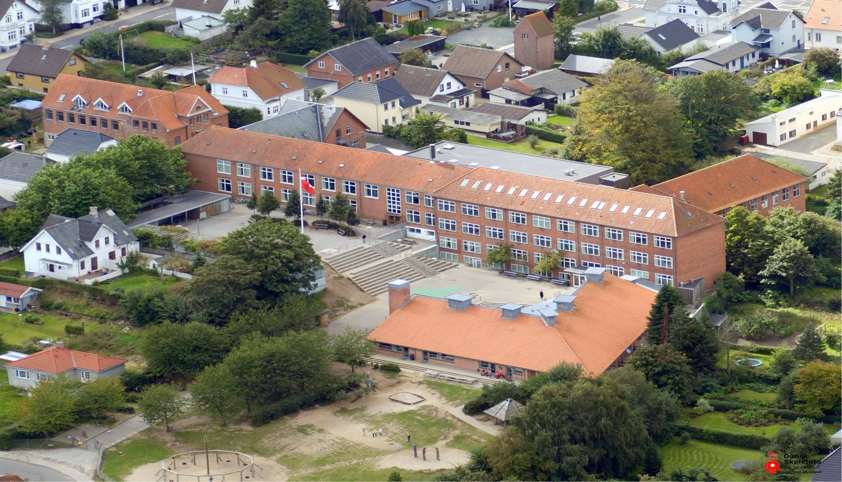
Sondervang Skole (with a flag)

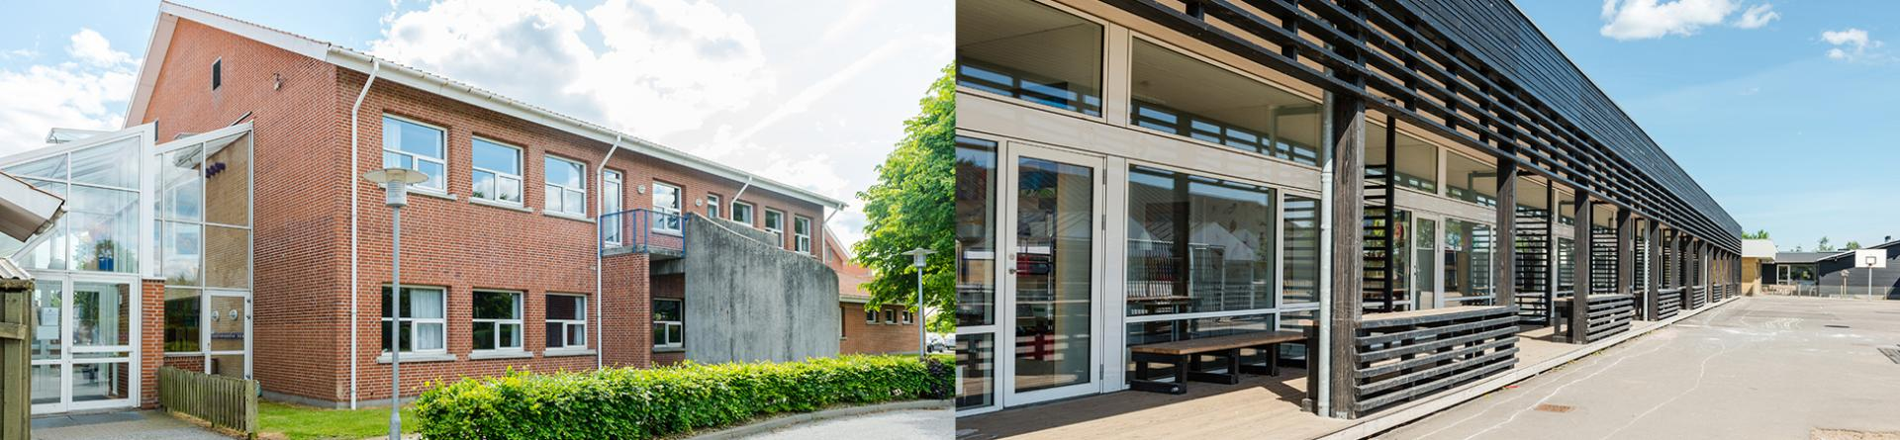
Vamdrup Skole

The Impact of Faith Meets Faith
- Religion is still one of the subjects in Danish schools. The visits of two representatives in religions bring the face of the actual friendship between two religious leaders into the classrooms. Michael and Kassem have been to many dialogue forums in public places to create better understanding that Muslims and Christians can work together for the common good of our country.
- It is allowing students to listen to the praxis in religions in personal daily life- in prayer, in use of holy scriptures and ways of service and students are free to raise their questions in an atmosphere of freedom and friendship.

- It is beautiful that we have a good working relationship with the Kolding Municipality, that owns and runs the schools, and grants permission that this program on Faith Meets Faith comes as good break from the students’ classroom routines, being joined in by co-students from the same grade levels.

- The awareness, that these visits in February are also to mark the UN World Interfaith Harmony Week, affirms the deeper understanding that religions are part of the common pursuit for peace and harmony in our one world.

