**Report 2: Musical Brunch Fellowship**

**UN World Interfaith Harmony Week 2023**

**Arranged by Cross-cultural Ministry of Kolding Deanery in cooperation with Migrant Work and Encounter with Other Religions of Haderslev Diocese**

January 29, 2023 at 12 am to 5 pm

Venue: Simon Peters Church’s Fellowship Hall

**Description of the event:**

Participants of Muslim and Christian families brought their prepared food from their homes to the common table. The committee for Brunch Fellowship received them, and placed them on the table near the entrance hall. All participants were ushered in to the fellowship room.

There was time for introductions, for fellowship brunch, for creative activity and for singing songs of love and faith accompanied by some musical instruments, like guitar, drums, and tambourin.

Number of participants: **55**

**Program:**

**Learning the UN World InterFaith Harmony Week,** learning its history from September 2010 with King Abdullah 11 of Jordan, and to October 2010 as a ratified and adopted resolution of the UN General Assembly, affirming that religions, with their ground principles on Love of God and Love of Neighbor can indeed facilitate peace and harmony among peoples, reiterating the resolution’s invitation to create activities during the first week in February but with the freedom to hold activities from the last days in January to the early days in March.

**Reading of the texts on Love of God and Love of Neighbor** in Koran , Torah and the Bible.

**Learning and identifying symbols in religions,** and their possible meaning, working in pairs.

**Creative activity:** understanding on Tolerance by drawings, writing definitions on Tolerance or writing poems on Tolerance. Their drawings and description and poems were included in the Art Exhibition at the Kolding Library on February 20 to March 1. Children had their own program with games and toys.

**Fellowship Brunch**

Each one picked up food from the common table and tried to be in a new group with a person or persons they do not know. There was kindness among bringers to identify food with pork, otherwise most of the food was eatable to both Christians and Muslims.

Time to sing together short and easy to learn songs of love and faith in English, Philippine, Danish, African languages and singing them with body movements, accompanied by guitar and drums. Elizabeth accompanied the singing by her guitar and Angelo Charles from Ghana played drums. Children played with tambourines for the singing before they went out to their playroom.

**The Impact of the event:**

1. The event further brought awareness on the UN World Interfaith Harmony Week, bringing people of faiths and religions or without faith to eat together. There were Muslims and Christians and a few who expressed they do not have religion.

2. Christians and Muslims and a few, without religious affiliation, could sit together and talk and share the food which they brought to the common table.

3. Children of Christian and Muslim parents got time to play together.

4. Participants spent time to talk on tolerance and express their thoughts on the subject by drawing images or by writing a definition or poem on Tolerance.

5. Participants could test themselves on their knowledge on symbols of religions and what these symbols stand for.

6. It was a happy encounter, giving each one knowledge of each other’s names. It is impossible to know all names, but at least, 2 or 3 persons who are new in their table were persons they could personally talk to and exchanged names or be a Facebook friend.

**Enclosures:** 1. The summarized program as information,

an overview of our FN WIFHW events 2023

2. The Paper used to draw on or write with words on Tolerance

Few chosen English texts. Most had texts in Danish

3. Exercise of testing oneself on symbols in religions

4. Some photos

5. Texts on Love of God and Love of Neighbor from three scriptures.

‘

**Report no. 3: The Official Opening of UN WIFHW**

**within the first week of February**

**UN World Interfaith Harmony Week 2023**

Arranged by Cross-Cultural Ministry of Kolding Deanery in cooperation with the office of Migrant Cooperation and Encounter with other Religions of Haderslev Diocese

***February 5, 2023 at 1 to 5 pm***

***Venue: Simon Peters Church and Fellowship******Hall***

**Reflection:**

Started with a church service with Elizabeth Padillo Olesen giving the reflection on the *Workers on the Vineyard*, relating the parable to the start of UN WIFHW. We are all called to be workers for peace and harmony in our one world.

**Total number of participants 84.**

**Welcome by a toast of fruit drinks:**

**All participants were asked to get hold of a glass of drinks and while holding their glasses, they were welcomed by Rev. Michael Markussen, declaring the opening of the UN World Interfaith Harmony Week 2023 in the first week in February.**

**Table of cakes and fruits:**

12 women participants came with cakes as coordinated by Jårliny Spence Swanlake. The cake bringers with diversity of their cakes represented 14 countries of origin from: Sri Lanka, Liberia, Poland, Congo, Iran, Iraq, Syria, Afghanistan, Ukraine, Bahamas, England, and Zambia, Denmark. Each one was invited each to come forward and present their cake and why such a cake was prepared for the event. It was informative and touching when one of them, Andrua Bank from Sudan, pointed out that she prepared the cake which reminded her of her time at the refugee camp in Sudan. Jårliny Spence Swanlake Petersen thanked them for their labor of love. It was also her intention to put together the recipes of the cakes, and to make it available to families who might want to try them in their own kitchen.

**Historical background, its significance and Reading and Signing of the Declaration of Support for FN World Interfaith Harmony Week.**

Presentation on the historical background of FN World Inter Faith Harmony Week and the reading of the Support of Declaration in Danish and English by Elizabeth Padillo Olesen

Reading of the document on our support declaration of UN World InterFaith Harmony Week, followed by Signing the document as signing of the “covenant”. The document was written both in Danish and English Languages to declare support for UN World Interfaith Harmony Week in February. The local document is in Engligh and Danish languages.

**Conversations in small groups:**

Conversations in small groups: What are concrete expressions of Love of God and love of neighbor. Blank paper on tolerance was also displayed on tables, requesting those ,who had not done it earlier, to draw or write their thoughts on tolerance . There was also given the possibility for others, who were not present during the Musical Brunch Fellowship, to try on sharing symbols of religions they know and their meanings and test themselves how many other religious symbols they know and what the symbols stand for. It was amazing to see people using their telephones or iPhone in making their actual research.

It further gave each one time to ask personal questions. What is your name? Where do you live? How are you? How long have you been in Denmark?

**Reading of the Declaration of Support**

Signing of the covenant, those who joined declared their support for UN WIFHW in two declarations, written in Danish and English languages.

Two songs were chosen to sing together: Steve Wonder’s “Wonderful World” and “If we could consider each other a neighbor a friend or a brother “ accompanied by the musician, Ejvind Amorsen.

The meeting extended even beyond the planned time. People spent time talking with each other.

**The impact of this meeting:**

1. People are open to share their resources, like cakes, and spend time to prepare them when they are invited to do so.
2. Marking an event and making it as opening, joined by groups and peoples throughout the world, makes the day special. During that first week in February, we were not alone but joined in by people all over the world to celebrate the importance and value of this worldwide event to work for peace and harmony.
3. The event enabled people to talk with each other, exchange addresses or telephone numbers.
4. The story behind the ratification of the resolution started by King Abdullah 11 from Jordan was shared during the church service for the Danish congregation and for the International Congregation. It was a proud moment for the Muslim participants that a leader, who share with their Islam religion, has something to do with the UN World Interfaith Harmony Week with the realization of WIFHW.

**Enclosures:**

1. Program of the summarized events to mark the UN WIHW 2023
2. The intro poster as info material, being distributed (What is WIHW)
3. The Document on Declaration of Support in Danish and in English
4. Photos of the cakes and the serving…
5. Photos on the event

**Report 4a : Sprogcafe/ Learning Danish Language**

**Event to mark the UN World InterFaith Harmony Week 2023**

Arranged by Cross-cultural Ministry of Kolding Deanery in cooperation with the Office of Migrant Cooperation and Encounter with Other Religions

of the Haderslev Diocese

**Sprogcafe sessions on February 7 and February 28 (Report 4a and Report 4b)**

**(This report is on Sprogcafe, held on February 7)**

**Description:**

Sprogcafé or Learning the Danish Language is an offer to foreigners: students, refugees, guests, new Danes, immigrants, guest workers as help for their integration in Denmark, taking place every Tuesday at Simon Peters Hus. To have learned the Danish language is a key to integration and to getting a job in Denmark. Two (2) Tuesdays of Sprogcafe sessions in the month of February were set aside to learn about the UN World Interfaith Harmony Week to mark the UN World Interfaith Harmony Week. There was a gap of the chosen dates because of the winter holiday on the second week of February. Sprogcafe takes place in Simon Peters Hus at Islandsvej 4, 6000 Kolding, every Tuesday from 1 to 6 pm. The time span also includes the preparations for coffee and tea and the cleaning up after the session. Students, after the session, often stay for a while to talk with teachers, share other concerns of importance to them.

**A. Sprogcafe or Language Café on February 7:**

**The usual start as students and volunteers enter**

Start with coffee, tea, cakes and fruits, the regular thing as students and volunteer teachers enter. Two volunteers come earlier to cut fruits, make coffee and tea, and put them in two wagons, free for students, volunteer teachers who arrives to help themselves. finds a seat where one feels at home.

**Who avail of Sprogcafe or Danish language study?**

They are foreign students coming from education centers in Kolding. A foreign national. who speaks and understands the Danish language, has much the closer chance to get a job and a longer residence permit. Some are refugees who have been granted asylum; some are foreigners in Denmark by family reunification or by marriage, others as migrant workers employed by some companies; others have stayed in Denmark for quite a while and just simply need to practice speaking the Danish language with a Danish volunteer. Or others come to get help for their forthcoming Danish exams or to get help to understand a letter or document they receive in Danish or help to correct their job applications or formulation of their CVs (Curriculum Vitae)

We have a group of 12- 15 persons who regularly serve as volunteers in Sprogcafe. to help teach the students according to their level of acquisition of the Danish language and according to their needs. Sprogcafe is known in our town as a center to help the foreigners’ integration in their new country, Denmark.

(**Note**: *When in March this year, there came the influx of Ukrainian refugees to Denmark, many of them joined in our Sprogcafe or Learning Danish Language. We witnessed also the rise of Danish volunteers to 25 persons, added to our group of teachers offering their help. We could be 60 persons- volunteer teachers and students from 12 to 15 countries. As more Ukrainian refugees get their official residence permit, which give them the chance to enroll in Language schools and find work, we find lesser number of them in the Sprogcafe. At present there are 6 to 10 of them who regularly join in Sprogcafe together with those from other countries, making a present regular total of attendance: 20-25 students from 12 to 15 countries, and 10-15 volunteers, weekly reporting to help us with great joy. Among our volunteers there is one from Argentina, the Philippines and Lithuania. They have been in DK in many years and have Danish citizenship.)*

**Program on Sprogcafe on February 7** within the global week of World Interfaith Harmony Week

**Words of Welcome** by Járliny Spence Swanlake. She also gave announcements via Power point presentation on the screen about other coming events related to UN World Interfaith Harmony Week like Art exhibition, Women’s event with focus on women’s human rights, Faith meets Faith in different schools with a Christian priest and a Muslim Imam.

**Information on the United Nations and WIFHW,** its history and purpose and introduction of lesson materials by Elizabeth Padillo Olesen. She also introduced the song, “Dream for a Wonderful World” sung in English with provided translation into Danish language.

**Introductory speaking Danish session** in tables where students sipped their coffee and tea. The introductory session gives each one the chance to try to speak simple sentences in Danish. Some guide questions to help the personal conversation: (see the paper) that enables each one to speak simple Danish sentences. A teacher or teachers are assigned in each table.

**Group session with assigned teacher according to students’ level of acquisition in the Danish language.**

And assigning each group a teacher. The teacher chooses and picks up materials from the table.

The one-hour session sees to it that students go through an exercise in reading a text, speaking and writing.

**Lesson materials: On the United Nations and FN World Interfaith Harmony Week**

On Mother Therese

On Mahatma Gandhi

And the lesson on the Good Samaritan (to be read in dialogue)

With an activity for dialogue and writing.

**Impact of the Lesson and Sprogcafe:**

1. Mother Therese’s love and compassion for the poor, and Mahama Gandhi’s movement of protest with non-violence are also ways or models for peace and harmony in our one world. Christians, Hindus, Muslims and Buddhists see the value of these expressions of commitment as concrete actions of love.
2. Most of our new students know about the United Nations but not of the World Interfaith Harmony Week. Some of them took time in attending other events, related to WIFHW.
3. Sprogcafe is an offer to help foreigners’ integration in their new country Denmark. The presence and participation of the Danish volunteers mean a lot, that they find Danish nationals who voluntarily give their time to help them and be their friends. Our volunteers often share their great joy to be in this work.
4. The text of the Good Samaritan was given as an assignment to read and understand and to look forward to dramatize it in the next session. It is a biblical story of compassion to a stranger in need, performed by a Good Samaritan. The use of drama in language lesson, performed by students, is also our creative way of learning in Sprogcafe. It makes our students more actively involved and happy. Not all are brave enough to do so, but there are always those who love to volunteer to do it. Singing songs, acting in short role plays, and engaging in lessons in Danish grammar and stories also provide a happy learning experience for our students.

**Report 4b: Sprogcafe/ Learning Danish Language**

**Event to mark the UN World InterFaith Harmony Week 2023**

Arranged by Cross-cultural Ministry of Kolding Deanery in cooperation with the Office of Migrant Cooperation and Encounter with Other Religions of the Haderslev Diocese

**Sprogcafe on February 28 at 3-6 pm**

**Attended by 25 students, 5 guests from Syddansk Universitet, and 12 teacher volunteers. Venue: Simon Peters Hus at Islandsvej 4, 6000 Kolding**

**Coffee and tea** with cakes and fruits and juices for children

**Words of welcome** by Jårliny Spence Swanlake and power point presentation of the song on love and friendship in Danish language with borrowed melodies. Elizabeth wrote the Danish texts. (enclose the page)

**Introduction of the lesson materials** as prepared by Elizabeth Padillo Olesen

1. On learning new vocabulary related to work for peace and harmony
2. The articles on Human rights in Danish language with provided copy of the English texts to those who need.
3. The story of Nelson Mandela
4. The Story of Martin Luther King
5. The dialogue form of the Story of the Good Samaritan aimed at to be acted out as drama in the class.

**Singing two songs:** Singing together is often a supplement in learning the Danish language. There is no Sprogcafe without singing together about songs on seasons and history, Danish children’s songs in schools, or Danish pop songs. This time we sang songs of love and friendship. Most of our singing together is accompanied by piano. We have 3 volunteer teachers- Kirsten Nørgaard, Johannes Jørgensen, and Else Boisen who can play piano, and they take turns in accompanying the singing during the start of Sprogcafe. Since the songs, which Elizabeth prepared was without written notes, she had to teach and accompany the singing with her guitar.

Time to sing songs is a good learning supplement. The song contains sentence structures which a student can build up according to one’s own situation.

**See the simple songs used, using the popular melody**. The song in Danish, with new text prepared by Elizabeth, indicates how the use of Adverbs of time are seen in the sentence structure in the Danish language. And how students can make their own sentences out of the model of sentences in the songs. What happens in the structure of a sentence in Danish when the sentence starts with an adverb of time or what happens in the Danish sentence structure when the sentence ends with an adverb of time?

At the back of the song page, are more ***adverbs of time*** to be used in students` making of their own Danish sentences.

**Dramatization of the Good Samaritan story on Love of God and Love of Neighbor** with the roles of the Narrator, the wise man, the one who was victimized on the road, the robbers that took all the victims’ carried belongings, the priest, the Levite, who simply passed by and turned away to help the victim, and the Good Samaritan who took time to help and took the victimized to a lodging place for medication and rest, and he came back to pay for it The drama was done by some of the volunteer teachers and some of the students. The drama left a question: Who is it that loves in the drama/role play that demonstrates love? It is person, who helps a person in need.

It was great fun for everyone. Never before, we used drama in Sprogcafe, and it went well. There was much attention given how the drama was played though given a very short time to practice. It was a spontaneous act out of the material that rewritten in dialogue form.

**Regrouping of students according** to their need and level of the Danish Language and assigning a teacher to take care of the students. Some of the visitors helped the teaching in groups. Teachers get materials for learning grammar, the use of adjectives to describe persons like Nelson Mandela, Mother Theresa, Martin Luther King or The Universal declaration of Human rights in short and simple form or the 30 articles of the Human rights in Danish language or readings of the life of front figures for love, compassion and freedom for peace and harmony.

Note: Materials not fully covered will be used in the coming other sessions even after the marking of UN WIFHW in the month of February.

**Impact of the 2nd Sprogcafe session:**

1. Combining learning experiences in grammar, learning adverbs that describe verbs and adjectives that describe nouns, learning new vocabulary terms related to the observance of UN World InterFaith harmony Week which most of our new students have not heard of it, has provided a space for actual learning.
2. Using drama, played by students and volunteers to touch on the very basic principle of love, bounded on the religious principle - Love of God and Love of Neighbor is something unforgettable.
3. Bringing to mind the contributions of some world figures that have shown acts of compassion or have worked for peace, justice and equality and non-violence.
4. Keeping in mind the basic statements of every human right that must be safeguarded and upheld by every government and every local authority in a village, town, city and country.
5. The focus, taking place in Sprogcafe session, dedicated to mark the FN World INterFaith Harmony Week

**Enclosures:** Sprogcafe

Photos of the Sprogcafe session

Coffee table

Lessons in two sessions

Facebook profil: Sprog-café Kolding

https://www.facebook.com/groups/140575326627992

**Report 7: Faith Meets Faith (Tro møder tro)**

**Event to mark the UN World InterFaith Harmony Week 2023**

**Arranged by Cross-cultural Ministry of Kolding Deanery in cooperation with the Office of Migrant Cooperation and Encounter with Other Religions of the Haderslev Diocese**

An offer to students in 5 schools , carried out on January 31, February 2, February 9 and February 21 and relate these events to UN World Interfaith Harmony Week. It is bringing WIFHW to these following schools: Lyshøj School, Brændkjær School, Vonsild School, Bramdrup School, Søndervang School and Munkevængets School in the Municipality of Kolding in cooperation with Church and School Services. The dialogue visits was done by two religious leaders in Islam and Christianity. Imam Kassem Racheed and Pastor Michael Markussen are good friends. The dialogue forums were with the 8th and 9th grade- students, reaching a total of 649 students in all the sessions of their 4 visitations

**Introduction:** The program *Tro møder tro*, which means Faith Meets Faith in English, is our regular offer to 8th and 9th grade students in schools wherein two leaders in Islam and Christianity, who are good friends, visit schools and allow students to dialogue with them on all questions on earth they as students would like to ask. These four visits were intentionally carried out to fall on the dates from January 31 to February 21 to mark the UN World Inter-Faith Harmony Week.

This program is in cooperation with the office of SKIK (Church and School Services) It is this office that arranges the visits with schools and specify the dates of the visits to the teachers in these 8th and 9th graders. Teachers of these classes ask their students to prepare their written questions for the dialogue and they also join with their students in these dialogue sessions. The religious leaders who use their time for this purpose get a little honorarium from our office.

*(Note: Schools have strict rules in relation to photo taking. We enclose the photos of the schools, the photos of the Christian priest and the Muslim imam. On the photo is one of the teachers and some of the students.)*

*This report will include the list of the schools with the number of students in different class sections and put together in the school`s biggest room or hall. Two of our colleagues make a short report of their experience in their visits.*

**1.Schools visited and number of sections put together and the number of students.**

|  |  |  |  |
| --- | --- | --- | --- |
| **Date** | **Schools visited** | **Classes** | **No. of pupils and students** |
| **Tuesday**  **January 31** | **Lyshøj School** | **4 class sections** | **100 students** |
| **Thursday**  **February 2** | **Brændkjær School** | **4 class sections** | **84 students** |
| **Tuesday**  **February 7** | **Vonsild School** | **2 class sections** | **44 students** |
| **Tuesday**  **February 7** | **Bramdrup School** | **2 class sections** | **44 students** |
| **Thursday, February 9** | **Søndervang School** | **2 class sections** | **51 students** |
| **Thursday**  **February 9** | **Munkevængets School** | **1 class section** | **25 students** |
| **February 21 (Culture Day: Faith meets Light)** | **Lyshøj School** | **4 class sections**  **5 class sections**  **6 class sections** | **104 students**  **96 students**  **101 students** |

**Total number of students in these visits and encounters: 649**

**2. Here are reports of our two colleagues who joined in some of these events.**

**Report of Camilla Henriksen Møberg**

**Faith meets Faith**

Faith meets Faith, a ministry for students in schools to understand the practice of two of the monotheistic religions – Christianity and Islam – towards tolerance and common understanding. This is in cooperation with SKIK or Skole-Kirke Tjeneste of Kolding Deanery. Representatives from these two religions were Imam Kassem Racheed and Rev. Michael Markussen who spoke about their holy scriptures and their faith in praxis as believers. Here they come in dialogue with students who come prepared with their own questions.

**Faith meets Faith** program is designed to help students talk about religion in real life and in daily practice. It also shows how religious leaders can stand together, talk, and show an interest in each other’s perspectives.

I joined with Pastor Michael and Imam Kassem visiting two schools on the 2nd Of February. They gave a lecture for 84 students that day. The students were curious and wanted to explore many different topics:

- Is Jesus a God?

- Is it allowed to smoke?

- Can you wear gold?

- and questions concerning gender

**Faith meets Faith** creates a safe space, where the students feel free to ask questions and get the opportunity to hear different perspectives.

**2. Report by Jårliny Spence Swanlake**

I have participated in Faith Meets Faith event with Michael Markussen and Kazem at Vonsild School in Kolding on February 7. There were about 44 students from the 9th grade. They had had the subject of Islam and Christianity as a subject in some weeks and concluded with the visit of the two religious’ leaders in Christianity and Islam. Many of students in the class were preoccupied with what the two religious leaders did say in their presentations. Each of them got 10 minutes: Michael Markussen presented his daily practice, the Bible, a bit on the history of Christianity, also on role the church in our society. Kasem also presented a bit of the history of Islam, his daily life practice as a Muslim and a bit of Koran.

**Some questions which students raised after the 20- minute presentation**:

What *is the tradition of Easter?*

*How do you keep it in a national church?*

*How do you spend Easter in your family?*

Why should women wear head cover? (hijab)

Why should you pray in a certain direction when you are a Muslim? ‘

Are you allowed to spend Christmas when you are a Muslim?

Why do you have to pray three times a day as a Muslim?

Why and when should the girls and women wear covers on their head?

When does one become a Muslim?

Describe the ritual for one who wants to be a Muslim?

**Enclosures;**

1. SKIK homepage
2. Photos of Imam Kaseem Racheed and the priest Michael Markussen and one teacher
3. Photo of the two leaders with some students who followed them up with more questions after the session.
4. Photos of the schools being visited from January 28 to February 21

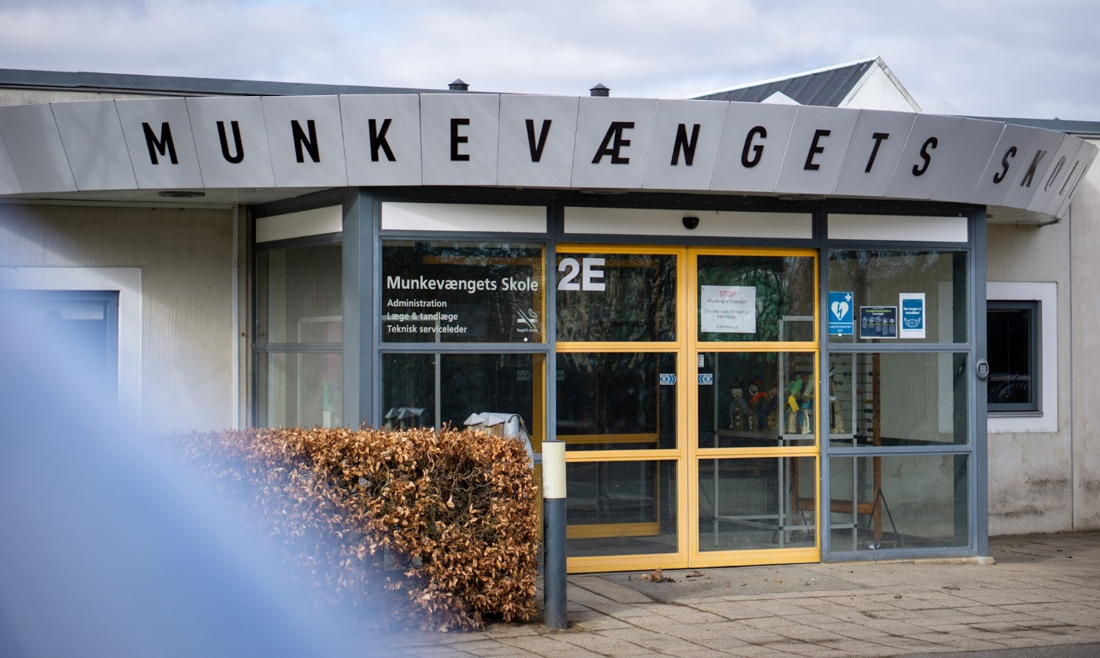

**Munkevængets Skole**

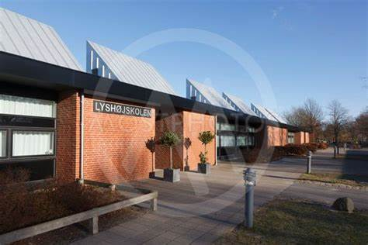

**Lyshøjskolen**

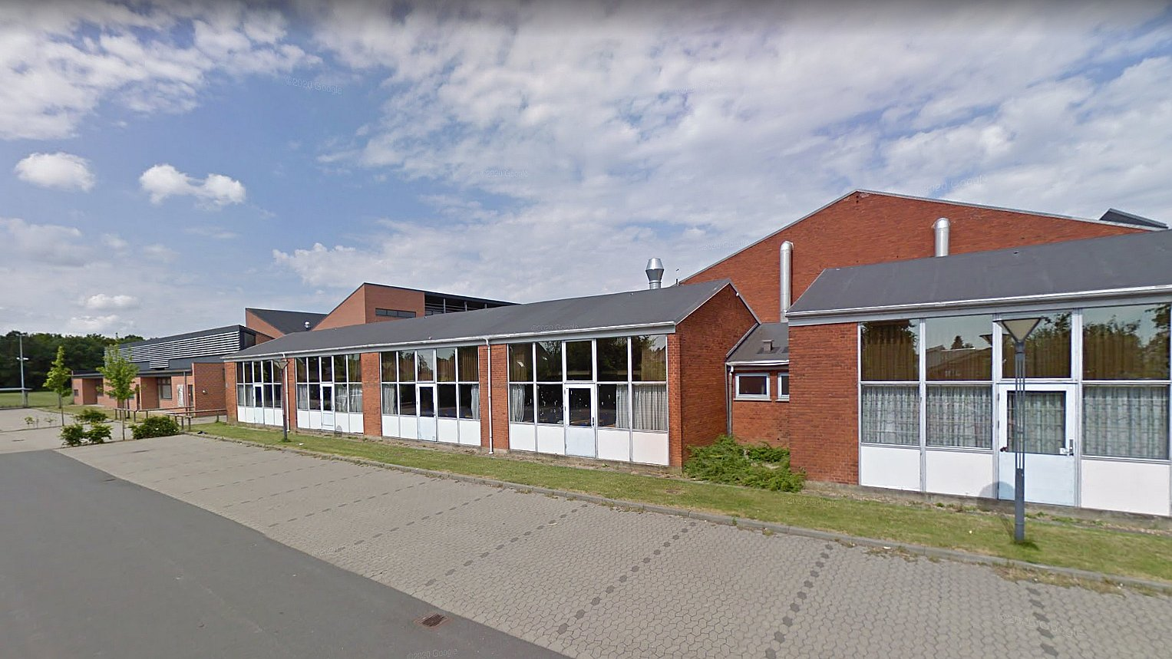

**Brændkjærskolen**

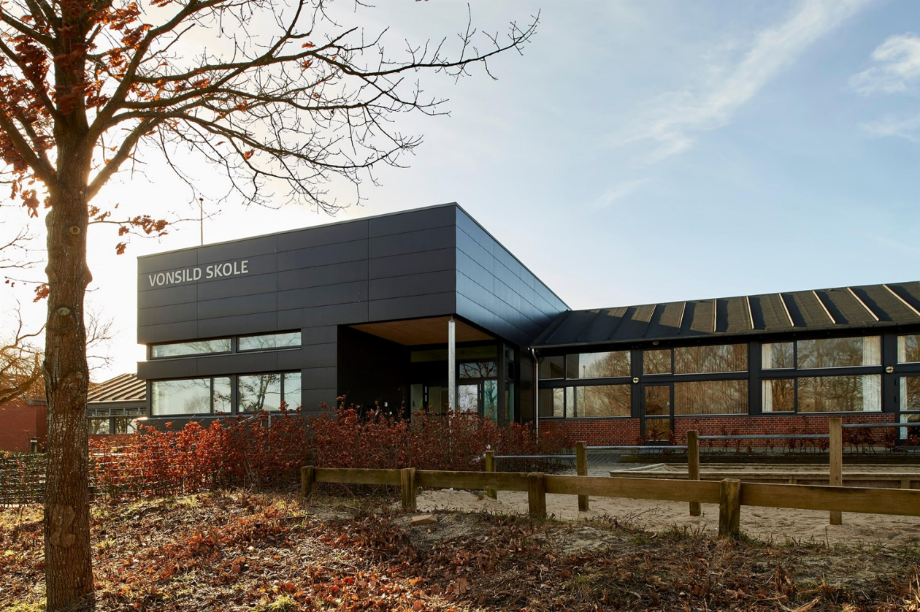

**Vonsild Skole**

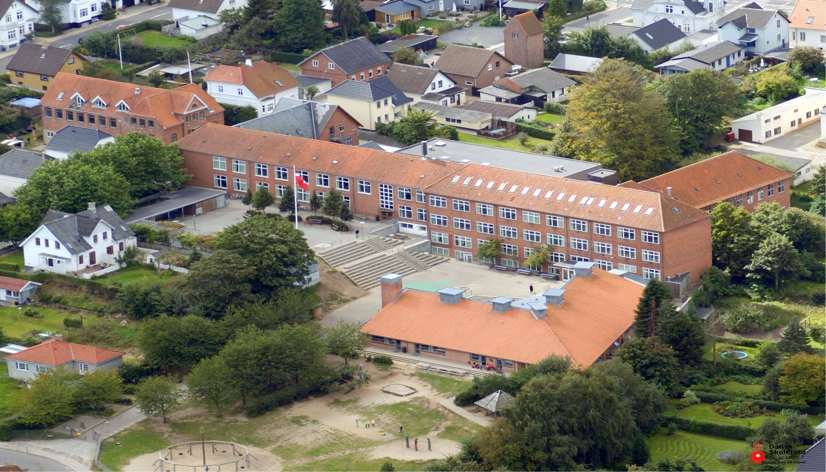

**Sondervang Skole (with a flag)**

**The Impact of the**