Youth Engagement report IHH 2023

As the first in person event of the Youth Engagement Program, after 2 years of pandemic projects, the program this year consisted of two parts: The 2023 Interfaith Exploration of Sound and Silence, and an Exhibition of the painting and film created over the last two years.

Our youth theme for 2023 was Sound and Spirit. All communities were sent the same message.
Song is a powerful tool for sending spirits high. Silence is a powerful tool for deep reflection, meditation, and growth.
How do our spiritual traditions express silence and sound? What meanings do songs, prayers, dances, music, rhythms, and melodies convey? When do we take time for silence, and why?
How does the use of music or sound (or silence) affect you and how you feel about your tradition?
Each community discussed the theme individually from their tradition’s perspective, and then selected youth presenters to share with the group.

This was the first time that the teens were able to meet each other in person, and we chose a Halifax Public Library space as a neutral venue for the event. Three communities sent youth presenters for the event, Hindu, Jewish and Christian. Teens and children shared prayers, chanting, expressions of faith and inspirational music. Families were invited to watch, and we were able to have an intergenerational conversation about the theme and had a chance to discuss with and support our youth. About 45 people were in attendance.

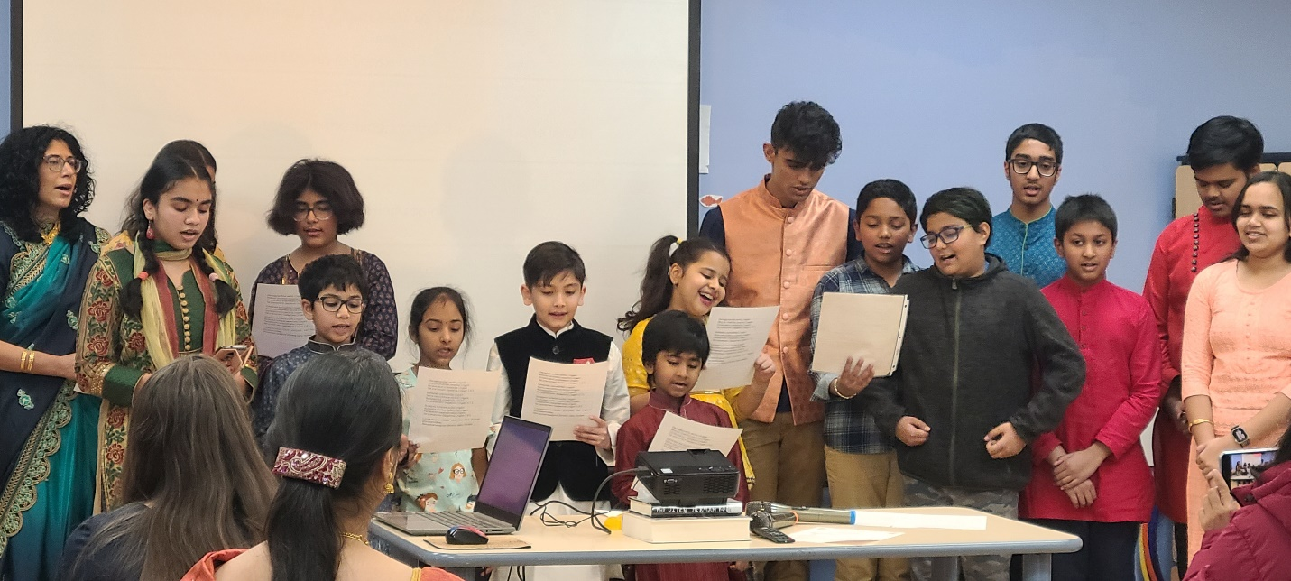

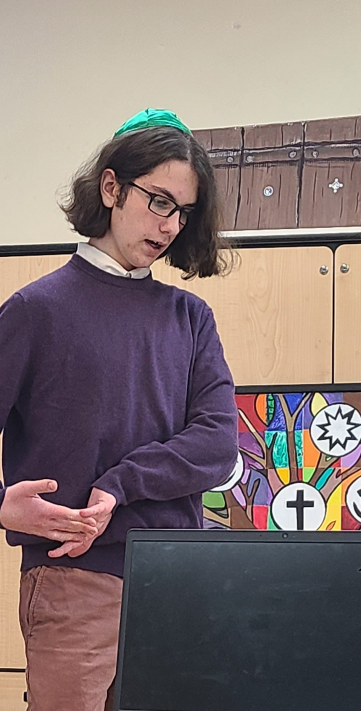
We also took time to exhibit the works created during the last two years for the first time.

Over the last three years, ten faith communities participated from the Halifax area: Hindu, Muslim, Jewish, Sikh, Universalist Unitarian, Church of Jesus Christ of Latter Day Saints, United Church, New Horizons Baptist Church, Pagan, and Shambala Buddhist, with more than 100 youth involved in the projects.

The 2021 Youth project was a mosaic painting “Tree of Harmony” designed and put together by Youth artist Calla Quist. 96 individual canvasses were sent out to the communities and were put back together to show a tree holding all the symbols of the participating faith traditions.

The 2022 project was a film compilation of video footage and photographs submitted from the communities about significant milestones and coming of age practices within our communities. The 12 minute film, presented by young filmmaker Boaz Wexler, was screened for the first time during the event, and many of the children previously had participated. This was a wonderful opportunity for the youth to see how they have already worked together to create beautiful things.

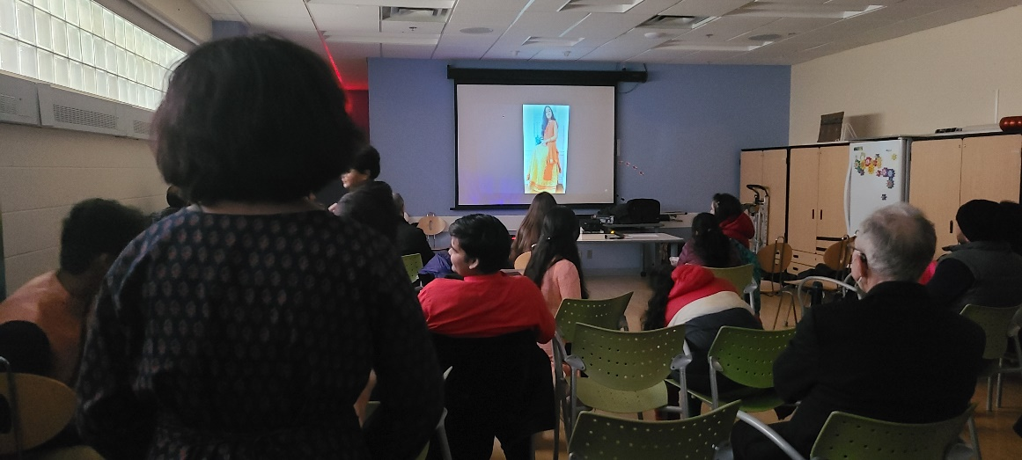

The pride and care the youth took in preparing these presentations was very heartwarming and an inspiration to all who attended.

Youth Project of Painting a Mosiac
https://drive.google.com/file/d/1EtWjDy2FPvDERzh1pBdn-TS-uTBvwLWt/view?usp=drivesdk
The Big Sing Video celebration on February 12th 2023 in Halifax
https://www.dropbox.com/s/6xar4v84moi9nh3/The%20Big%20Sing%20-%20%22One%20Day%22.mov?dl=0

Respectfully submitted,
Joanna Mirsky Wexler
Chair, Youth Engagement Committee
Interfaith Harmony Halifax

