Interfaith Scotland World Interfaith Harmony Week Report 2023
Interfaith Youth Leaders: Envisioning the Future

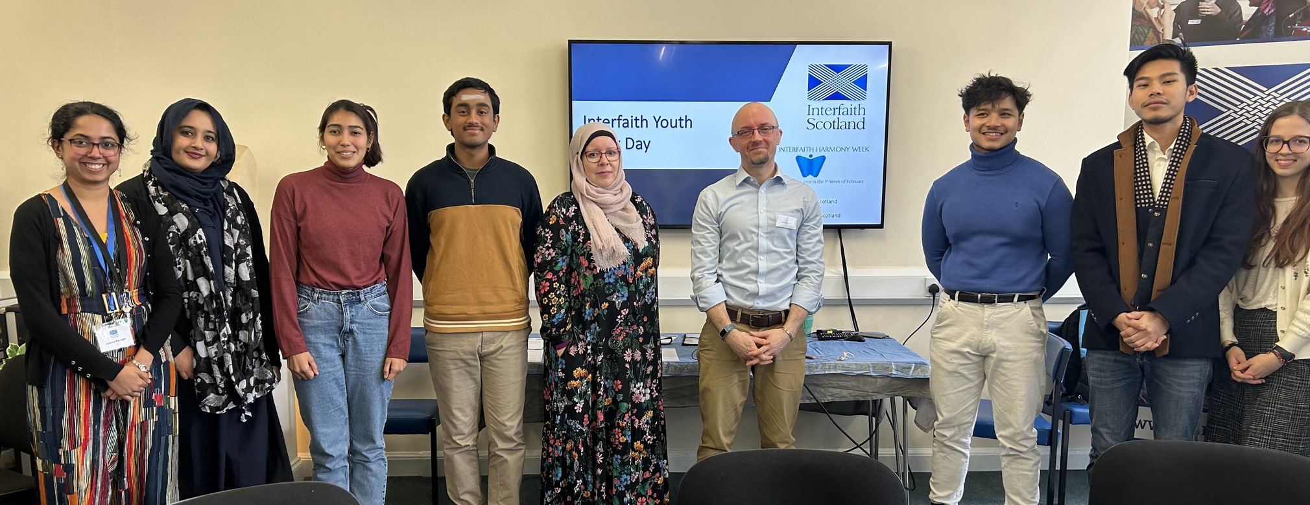

In preparation for World Interfaith Harmony Week 2023, Interfaith Scotland advertised for young people from the diverse faiths of Scotland to apply to become a team of Interfaith Youth Leaders to galvanise the young people of faith in Scotland to work together for Interfaith harmony and understanding.

Many young people applied to become members of the World Interfaith Harmony Week Youth Leadership Team and Interfaith Scotland held 3 on-line training sessions on how to work inclusively with people from all faiths and backgrounds and then an away day on the 11th of February was held where an Interfaith Youth Advisory Board for Scotland was solidified and many plans made for engaging young people in dialogue, understanding and building a harmonious society in Scotland including;

- Hosting an Intergenerational Interfaith Buddies Event in partnership with Faith and Belief Dundee (25 March)
- Supporting interfaith panel discussions in schools across Scotland (4 school events in the planning) (March, April and May)
- Co-hosting an Intergenerational Interfaith Retreat on Holy Isle Arran (August)
- Meeting together as an Interfaith Youth Advisory Board for Scotland on a regular basis

Throughout the World Interfaith Harmony Away Day on the 11th of February the young people used social media to get the message of harmony and understanding sent across Scotland and they continue to connect with each other on a regular basis and are reaching out to others. Below is a selection of quotes from some of the young people involved in the Away Day;
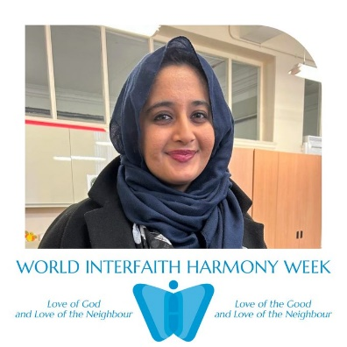
"Interfaith harmony and understanding are important because we need a safe space for young people to come together to share their faiths and beliefs." – Shailaa
"Interfaith harmony is important because communities thrive on the breadth of different perspectives and religious identities, especially when incorporating them in the development of a multicultural landscape" – Haikal
Interfaith harmony and understanding is important because it gives us the opportunity to bring young people of faith together and build diverse friendships. Maria
"Interfaith harmony and understanding is important because it helps develop acceptance & understanding of different cultures and religions. According to Hindu texts, our whole world is one single family - Vasudhaiva Kutumbakam – Anish
"Creating a dialogue is important because it helps us understand different faiths in communities." – Felix
Facebook link: https://www.facebook.com/interfaithscotland
Twitter link: https://twitter.com/InterfaithScot
Website link: www.interfaithscotland.org
Instagram link: https://www.instagram.com/interfaith_scotland/

