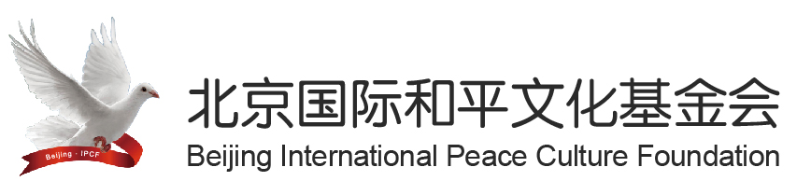
中文 English
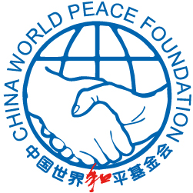
chinese NGO cooperates with UNESCO to lead a delegation of Shaolin martial arts to Africa
Source：BJIPCF Count：12589-
ROSA DALMIGLIO
rdalmiglio@hotmail.com

Promotion a TV Documentary at 2023 –FEBRARY 1 in ROME INTERNATIONAL SCHOOL
AFRICAN ACROBATIC STUDENTS in CHINA
TANZANIAN STUDENT DURING THEIR LIVES IN CHINA an UNFORGETTABLE PERIOD

Duration:30 minutes
PRODUCER: DING WEI, LI XIN
EXECUTIVE producer: ZHANG LIXIAO,XIE FEI,SHU JIANPING
DIRECTOR:JIN TIEMU
PRODUCED by BEIJING ZHONGRUN XINGYE ART DEVELOPMENT CO, Ltd
PRODUCTION SUPERVISED by CENTER of INTERNATIONAL CULTURAL EXCHANGE
PRESENTED by the BUREAU for EXTERNALCULTURAL RELATIONS
MINISTRY of CULTURE P.R.CHINA

LANGUAGES: CHINESE-ENGLISH-FRENCH-SPANISH-ARABIC-JAPANESE-RUSSIAN.-GERMAN-ITALIAN-PORTUGESE

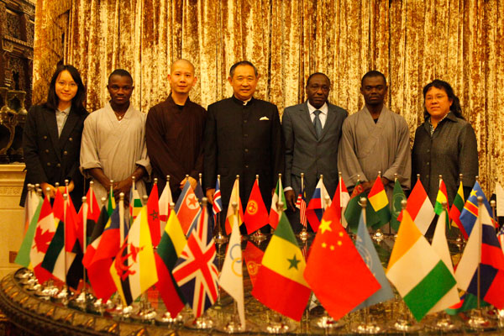
Group Photo of Ambassador of Mali,Mr. Li ruohong and the delegation
event report “ WORLD INTERFAITH HARMONY WEEK” 2023 –Febrary 1
China World Peace Foundation, Beijing International Peace Culture Foundation launched a cultural exchange program together with UNESCO: "Chinese Shaolin monks into Africa". The project aims at inculcating African youth with martial arts and self-discipline; to sensitize them about peace and non-violence in order to assume their responsibility of peace; to transmit the message of peace and reconciliation and promote the formation of an intercultural dialogue mechanism.
Mali and the Ivory Coast were identified as the two destination countries, this partially because of the reality of reconstruction after turbulent conditions, and also due to the object of developing the friendly relationships with these two countries, The delegation will stay one month in Africa for this mission.
Before delegation’s departure, President Li Ruohong and His Excellency Ambassador of Mali Mr. Lansina Kone exchanged ideas in Peace Garden Museum about beliefs, diplomatic etiquette, customs and security issues. It is reported that political leaders and senior government officials including the President, the Prime Minister will be meeting with the delegation. Likewise, the schedule of the delegation will be carefully arranged by UNESCO representatives and the Chinese Embassies in the two countries.

