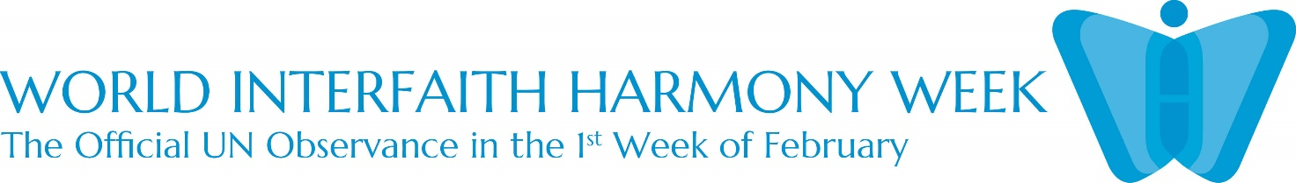
WORLD INTERFAITH HARMONY WEEK, February 1-7, 2023
United Nations’ endorsed event since 2010
Observed with activities from January 28 - March 1, 2023 Organized by Cross-Cultural Ministry of Kolding Deanery and Haderslev Diocese’s
Office for Migrant Cooperation and Encounters with other Religions

January 29 at 12:15: Musical Brunch Fellowship
Eating together home-made food from people of different cultures, singing together songs of love, faith and hope; listening to the songs by some ethnic groups and to the readings on Love of God, Love of Neighbor and Love of the Good from the holy scriptures of different religions. Discussion in groups on the history and relevance of World InterFaith Harmony Week in our own time and context.

February 5 at 1pm to 5 pm: International Church Service, Fellowship Meal and Signing of the Covenant
The international community has its regular church service at 1 pm and holds reception after the church service to mark the global opening of the World InterFaith Harmony Week within the first week of February. There will signing of the Declaration of Support for the WIFHW, information on the history of UN resolution, the principles behind, and an update on our activities which we submit to support the WIFWH observance 2023. There will be served cakes and drinks.

February 7, February 21 at 1-6 pm: Sprogcafe Lessons / Learning around tables of trust (Note: February 14 is winter holiday, no Sprogcafe)
Sprogcafe is where people of different cultures and religions meet to learn the Danish language, as help for their integration in the new country. Two lessons in February will focus on the history behind World Interfaith Harmony Week and stories of people who dedicate their lives to work for peace, freedom, and service. Lesson materials will include life story of Mother Therese, Nelson Mandela, and Martin Luther King. Students in cultural and religious diversity share about their personal experiences on love, friendship, compassion, and generosity with people of other faiths and religions.

February 20-Marts 1: Art Exhibition at Kolding Library by 22 artists
February 22 at 3 pm: formal opening of the art Exhibition with invited political and religious leaders in town and other cultural groups
It is displaying works of art by artists from Denmark, Poland, Iran, Iraq, Romania, Syria and Philippines at the Main Library. Kolding Library receives more than a thousand visitors every day and the exhibition will inform the public about WIFHW and get a glimpse of the virtues of love, compassion, solidarity, harmony, care for natural environment, and symbols in religions from displayed paintings and other art forms.

January 28 and February 25 at 1-6 pm: Women’s Feast, and Solidarity and Women’s Rights
Women Encounter is an event we regularly hold during the last Saturday of the month. We usually gather women of 12-15 nationalities. On this day in February, after a presentation on
FNs WIFHW, we ask our women friends from different countries to give us an update on the plight of women and girls in their countries. We therefore work in groups to plan ways of solidarity… We have time to eat, sing and dance together. We expect children of women to join in this event. We also provide play activities for the small children.

January 31, February 2 and February 21: Faith Meets Faith: Religious Dialogue in Schools
It is an offer to 8th and 9th graders in schools. Religious leaders or representatives from Islam and Christianity meet with students in schools in Kolding, and dialogue with students on scriptures, symbols, rituals, and praxis in daily life. After the presentations of the religious leaders as guests, students raise their questions and comments in a free forum and dialogue. Students are made aware that these religions also have things in common for the pursuit of peace and harmony.

