Universal Healing: Awakening the Heart of Humanity: Day 1 - February 1
This year to celebrate World Interfaith Harmony Week (2023) Charter for Compassion and the RISE Team -Religion, Interfaith and Spirituality for Everyone- have created a special experience for you: a daily offering of healing from different traditions of the world.
Day 1 – Root Chakra with Steve Kramer representing Earth Based Spirituality
Delving deeper into our connection to Mother Earth
To find peace in today's chaotic world it is helpful to come from a place of being centered, being grounded. This opens us up to the pathway of healing. Today, we will be working with the ROOT CHAKRA to purify and heal our connection with Gaia, Mother Earth, Pachamama. The root chakra, an energy center located on the pelvic floor, is the lowest of the seven main chakras. When we get in touch with its energy, we can engage in a more loving union with Mother Earth through grounding.
Land acknowledgment:
In recognition of all land, air, water, our human and non-human relations, and our sacred planet earth:
And in honor, reverence, and gratitude, we come to you as kin, remembering the sacred relationship between us, remembering we are interdependent.
And in honor, reverence and gratitude for our global ancestors who have stewarded this land before us, we pledge to live in reciprocity with this living land; devoted to harmonizing past, present, and future generations. In healing ourselves, we heal our world.

YouTube recording of the Session: https://youtu.be/hnfGdq_xBrg

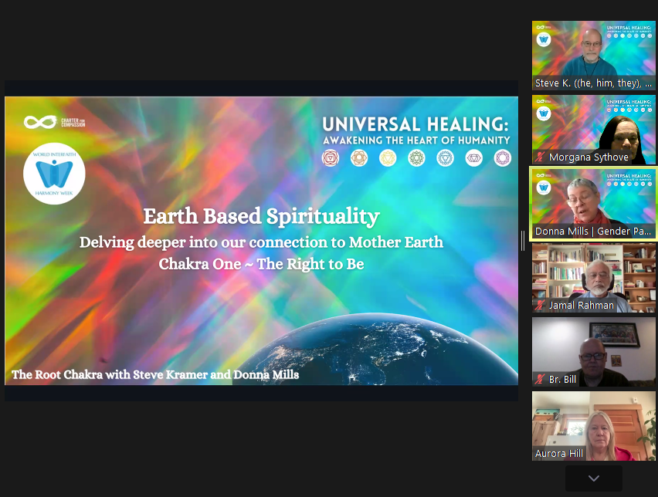
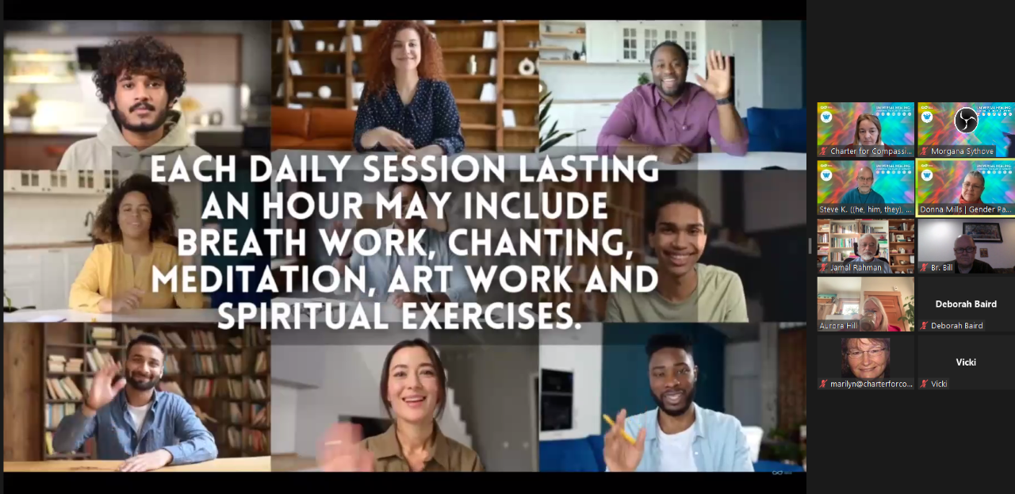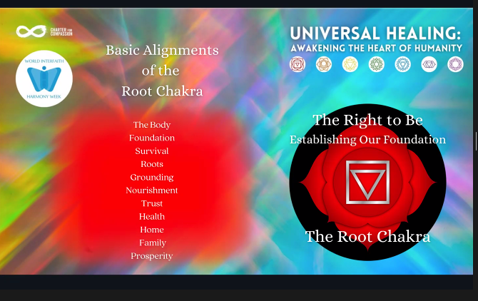
Email sent to participants

Subject: |  | Registration Confirmation - World Interfaith Harmony Week 2023 - Universal Healing: Awakening the Heart of Humanity - Morgana Sythove
Date: |  | Mon, 23 Jan 2023 07:41:36 -0800
From: |  | Charter for Compassion <contact@charterforcompassion.org>
To: |  | morgana@paganfederation.org
CC: |  | merida@charterforcompassion.org

Dear XXX,

Thank you for registering for World Interfaith Harmony Week, starting daily from February 1 to February 7, 2023, at 9am PT.
Please find Zoom information below and save for your records. It's the same link every day, and we'll send a reminder 1 hour before each one.
Join Zoom Meeting
https://charterforcompassion.zoom.us/j/89804113364
Please schedule the dates on your calendar:
Session 1 - Wednesday Feb 1 with Steve Kramer- Delving Deeper into our connection to Mother Earth - Root Chakra
Session 2 - Thursday Feb 2 with Merida McCarthy- Delving Deeper into our relationships and creativity - Sacral Chakra
Session 3 - Friday Feb 3 with Jamal Rahman - Delving deeper into our emotions - Solar Chakra
Session 4 - Saturday Feb 4 with Donna Mills - Delving Deeper into unconditional love - Heart Chakra
Session 5 - Sunday Feb 5 with Jan Chase & Richard Rose - Delving deeper into communication, breath and prayer - Throat Chakra
Session 6 - Monday Feb 6 with Kiran Bali- Delving Deeper into our knowledge, wisdom and intuition - Brow Chakra
Session 7 - Tuesday Feb 7 with Morgana Sythove & Donna Mills- Delving deeper into the Spiritual connection - Crown Chakra
You may check the time in your area here: https://www.worldtimebuddy.com/
We look forward to seeing you there!
RISE Team - Charter for Compassion

