REPORT ON WORLD INTERFAITH HARMONY WEEK CELEBRATIONS
On 6th February, 2023 Nile Dialogue Platform (NDP) celebrated the World Interfaith Harmony Week with the Kampala Capital City Authority (KCCA) youth council under the theme, “Working together to achieve peace, gender equality, mental health & wellbeing, and environmental preservation”.
The first to the venue was the KCCA youth council led by Mr. Dickson who arrived and set the venue for the arrival of guests. They erected the tent set up the sound system as well as arranging the chairs and tables.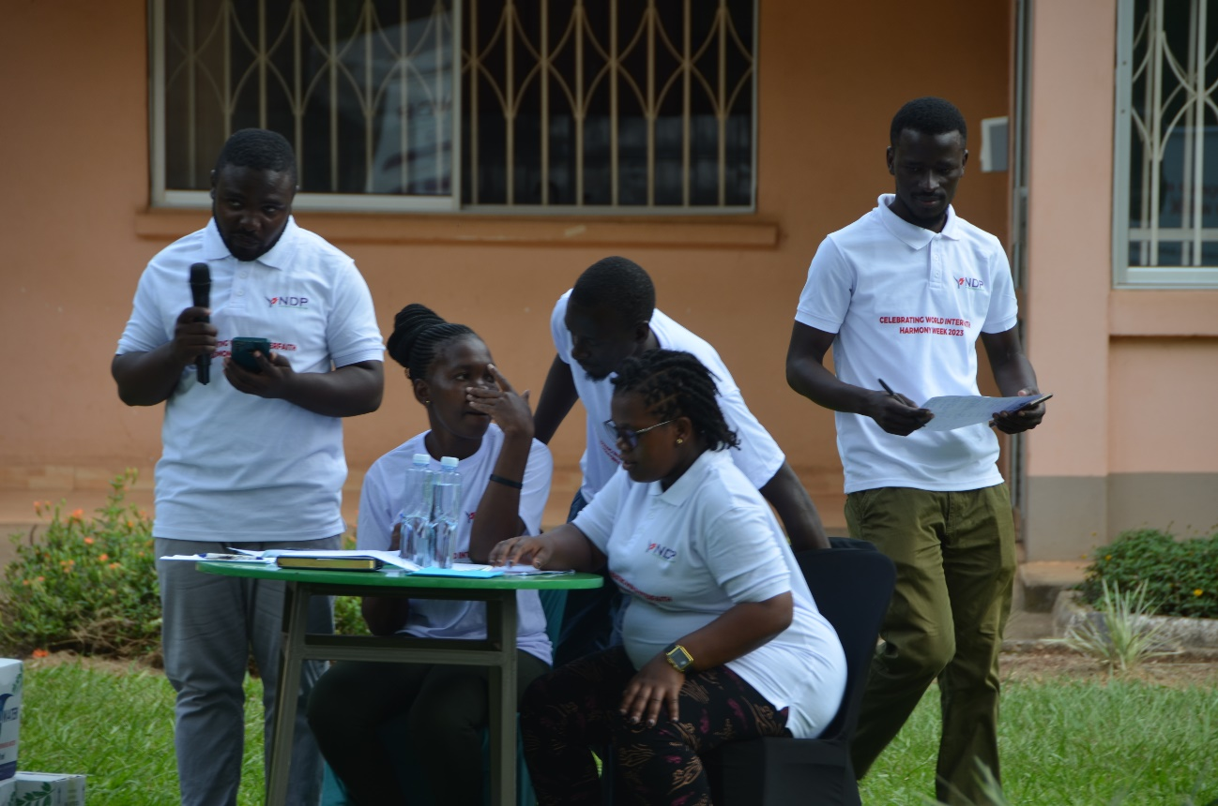
The masters of the ceremony were Mr. Grace Mugonero from NDP and Mrs. Josephine from KCCA youth council.
The arrival of guests was a little late because of the fact that the ceremony was put on a Monday which also made it difficult for some of our invited guests to attend. Despite those difficulties, the number of attendees rose to more than a hundred which was a good number. The function was scheduled to start at 10 AM with the arrival of guests but it started at around 10:15 AM.
At 10:20 AM, Mr. Issa Kirarira the Secretary General, NDP, opened the ceremony and asked one of the KCCA youth members to sing the National Anthem and give an opening prayer. He then reminded the audience that the Uganda People’s Defense Force (UPDF) was also celebrating ‘tarehe sita’.
After the National Anthem was sung and prayer was concluded, Mr. Issa gave his speech and this is what he said, “Let’s talk, let’s listen to each other, and let’s have conversations, for the greater good of living in peace with one another. One of the challenges is poverty. Without acquiring an Education, conflicts without dialogue, how do we expect to eliminate poverty? It’s really a challenge, why don’t we pay attention through skilling programs, educate, running activities in the churches and mosques, be available for one another, advice one another and be creative and reason. The moment we start that, we will achieve more”.
“Where there’s no poverty, no conflict and no ignorance, the sky is the limit”. 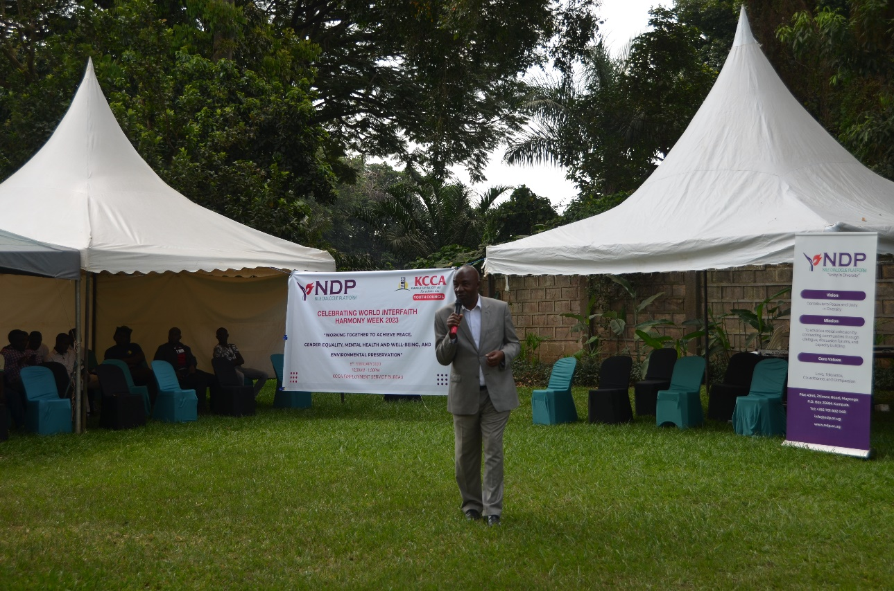
“I call upon the citizens of this country to embrace diversity, promote pluralism and sectarianism shouldn’t be amongst us. Ours should be to work together for the greater good to make the world a better place”.
Mr. Issa Kirarira then called upon one of NDPs community connectors, Rev. Otto to give his speech and also requested him to read out NDPs message to the audience and this is the message,
“Uganda is one of the most religiously diverse countries in the world – and continues to embrace people of all faith backgrounds. This tremendous success can be attributed to the hard work of various institutions and individuals who have dedicated their energy and resources to promote religious harmony.
The religious diversity in Uganda has been a great strength that continues to bring with it a whole host of opportunities to harness for the good of all. It has helped communities to work on various development agendas and fighting against discrimination based on religion.
During this ‘Harmony Week' –NDP builds on these gains and works to recognize the diversity among Ugandans through various activities that involve different stakeholders including women and youth. It is hoped that the initiatives that NDP undertakes with support from the government and other stakeholders can provide a platform from which all Ugandans can recognize that the common values they hold far outweigh the differences they have, and thus provide a strong dosage of peace and harmony to their communities.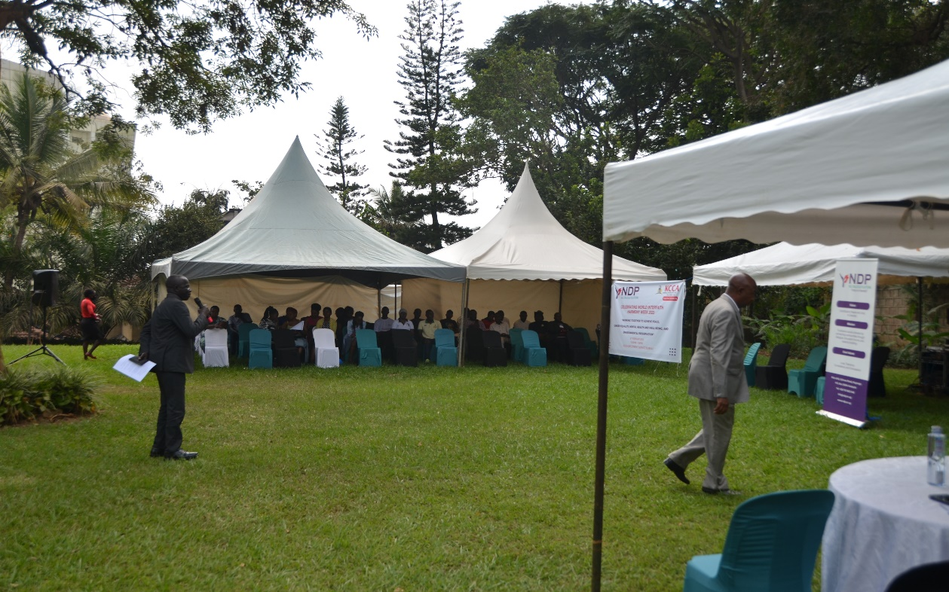
It is my great pleasure to address you today on celebration of World Harmony Week with Nile Dialogue Platform, a registered NGO established in 2013 with the aim of advancing social cohesion through dialogue”.
Mr. Joshua Makawa was the next speaker and he started by putting forth the problem of unemployment. “I here statistics say we have over 70% of grandaunts without jobs so there’s something that we need to work on. I was happy with the theme where youth and the environment preservation were emphasized. We have a common Earth as our home so we need to take care of it. Things we need to take care of the Earth;
- The cry of Earth
- The cry of the poor
- Ecological economics
- Simple lifestyles
- Ecological education
- Ecological spirituality
- Community involvement and participation
At St Edigio community, we consider the message from the Pope where he talks about the Earth to the world and how we can be people that support the environment. We are also looking at the idea that NDP is having to skill the younger population.
Sheikh Abubakar was introduced and he had this to say;
“I am very happy with what I saw in the program especially with the last item where lunch was allocated. Food brings people together so, it’s another way of bridging gaps in humanity. The prophet talked about establishment of peace as a way to get into paradise. Can one really dine with his or her enemy? At Nile Dialogue Platform, we advocate for peaceful and harmonious living amongst all peoples.
From the bottom of my heart, I respect everyone here as well as all religious leaders because I can’t be a good Muslim if I don’t respect you. We all have our ways and beliefs so, let’s leave the rest to God. God the Almighty be glorified. We are all human beings and each has the right to thought and belief and that’s what differentiates us from animals. “Oluganda kulya” that’s why I really liked the last item”.
The Principal Assistant Secretary, Ministry of Internal Affairs, Mr. Munyambabazi Adrian also gave his educational speech saying “I am Adrian and I am from the west, the Reverend, my brother comes from the east, some else is from the central and some others from different areas but you will not expect all of us to understand each other 100%, so if I have my own thinking and you also have your own thinking, then we have to look for a common ground in order to pass our different ideologies and this can be done through dialogue.
Only when we fail to listen to each other, that’s when there’s no peace. At every situation where you happen to be you need to tolerate one another because even I a lecture room, the lecturer will have his or her own view and the students too may have their own so tolerance would be the way forward. The most important thing is that we must always find a way to live in harmony with each other.
I thank Nile Dialogue Platform because there’s something I learnt from the last 15 to 16 years I’ve been with them. When I attended one of the first events, I found catholic priests, Muslims, born agains, and I said, this is a place to belong. Actually, previously, the late Father Lukoda used to preside over so this shows that we have to live together despite the differences between us and what we believe in”.
Madam Eunice, the General Manager KCCA youth council was present and she also gave her message to the audience.
She gave a brief introduction of KCCA and its roles and activities aimed at eradicating violent tendencies in the capital city. KCCA does this by engaging and bringing the youth together and equipping them with skills and responsibilities. It then tasks the trained youth to engage other youth thus creating a bond and connection and molding responsible and peace-loving youthful citizens.
She also thanked NDP for the work it does in bringing diverse people together in peace and harmony through meaningful dialogue.
Madam Eunice then called upon the KCCA youth chairperson to say something to the guests.
The representative of the Guest of honor was introduced, Mr. Justus Rubarema, Ministry of Ethics and Integrity who was representing the Minister for Ethics and Integrity, Hon. Rose Lilly Akello.
Mr. Justus Rubarema spoke generally about human behavior between different groups such as parent-child, teacher-student, government-citizen, etc. He argued that when one fails to respect the other, there will always be friction which later may turn into hatred and violence e.g. when a child disobeys his or her mother or father, they’ll be punished and in a case where the child is grown up, he/she will have the urge to hit back. A good example is between citizens and a government they feel is oppressing them. If they fail to use their words to (communicate) their concerns, they’ll end up using violence and they’ll also be greeted with more violence from the authorities.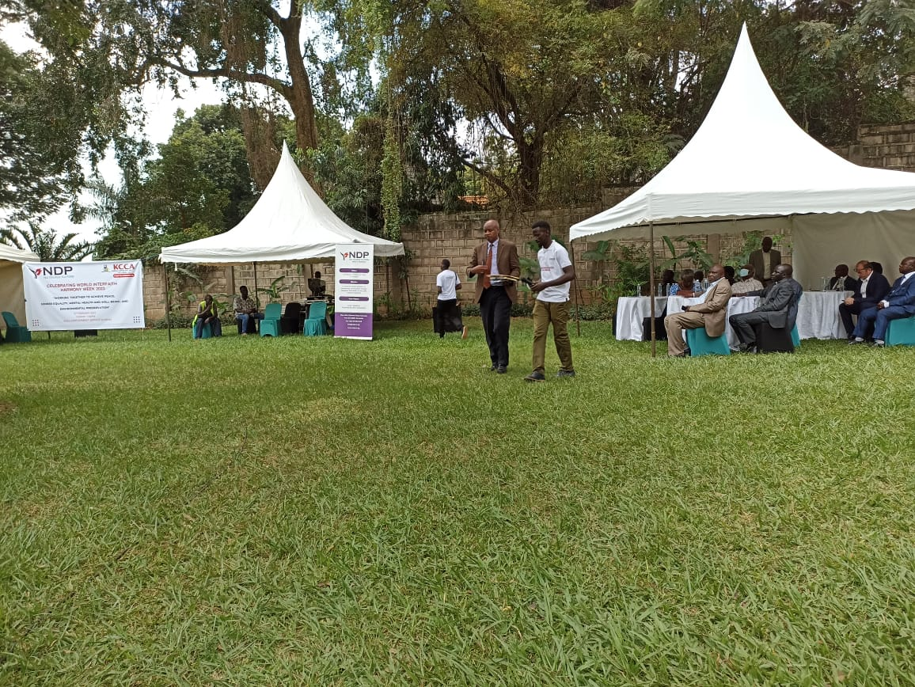
He narrated a scenario between a student and lecturer where the student, a girl, dressed indecently and sat at the front of the class and then the lecturer had to ask her to change seats and at least go to the back because she may distract him. The girl refused and this tension grew even bigger. The failure to understand each other would bring such and sometimes becomes ugly like being thrown out of a class by a security personnel.
First of all, if the student was dressed decently, all this trouble would have been avoided. So, it starts with discipline. Secondly if she had understood and respected the lecturer’s point of view, this would have been avoided.
Social media has been another tool used to decay our culture and instill in our young ones the wrong traits of disrespect to elders, indecency, violence, extremism and radicalism. We therefore have to fight back harder to get our youth back and on track to live in peace and harmony for a better world for all.
Mr. Issa Kirarira was called to give a vote of thanks and he in turn also called upon all the youth to give thanks to the Guest of Honor and all other speakers for the words of advice and encouragement they gave. They complied all stood up and walked to the VIP tent and then made a circle and clapped in a way to give thanks.
At 12:45 PM, photos were taken. VIP guests alone, KCCA youth council alone, all youth and then a group photo.
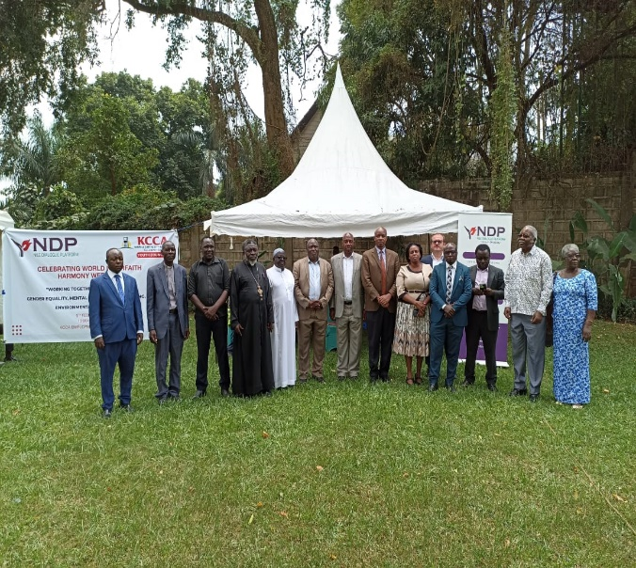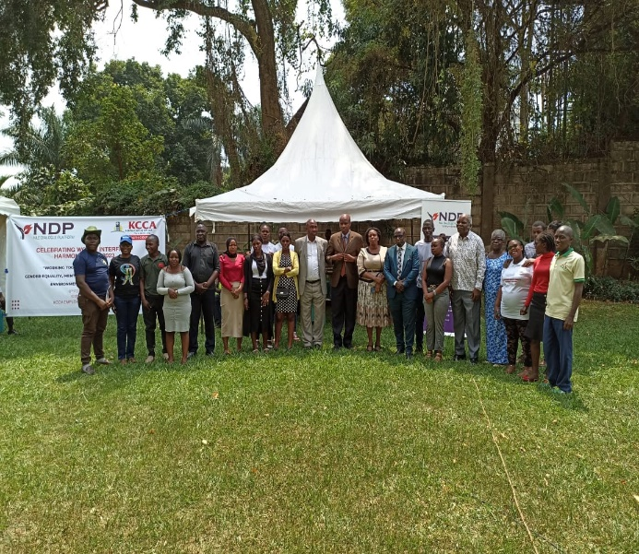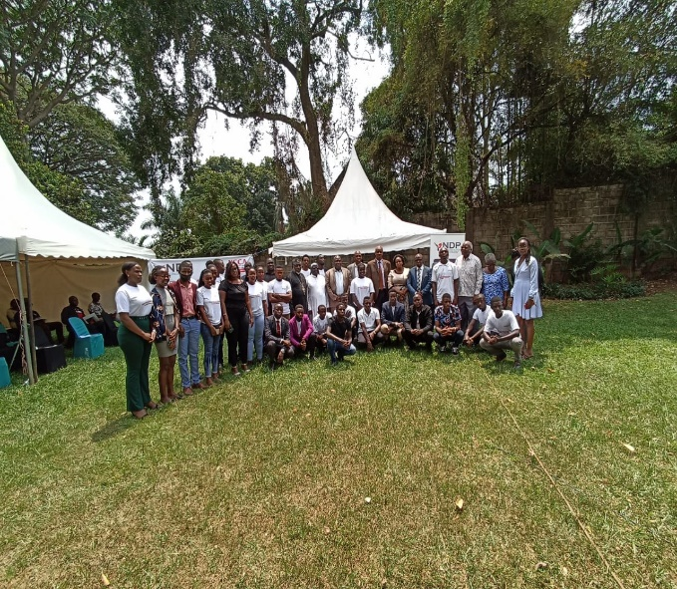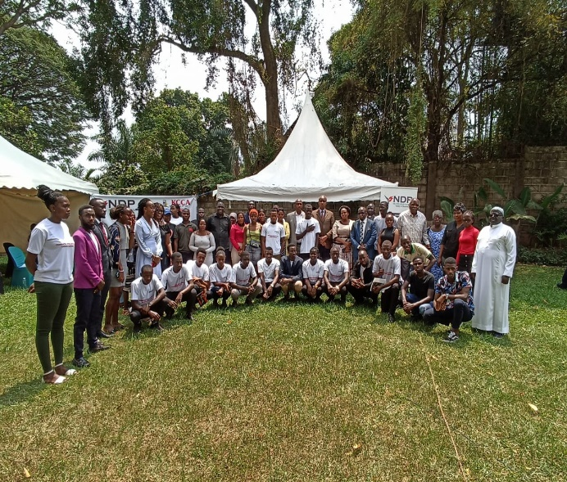

Lunch was served at around 1:05 PM. The VIPs first and then all guests got in line to get their food. The food was delicious and wholesome since there were different kinds available.
The Deputy RCC Makindye (name) division arrived and was given the floor to pass on her message.
She mostly spoke about peace saying with peace everything else falls into place automatically because, with a peaceful country, you can educate, develop schools, infrastructure, the economy, etc. while without it, nothing can be done easily. She thanked the Uganda government for fighting and advocating for peace in the entire country and then she also hinted on the ‘Tarehe sita’ celebration of UPDF. 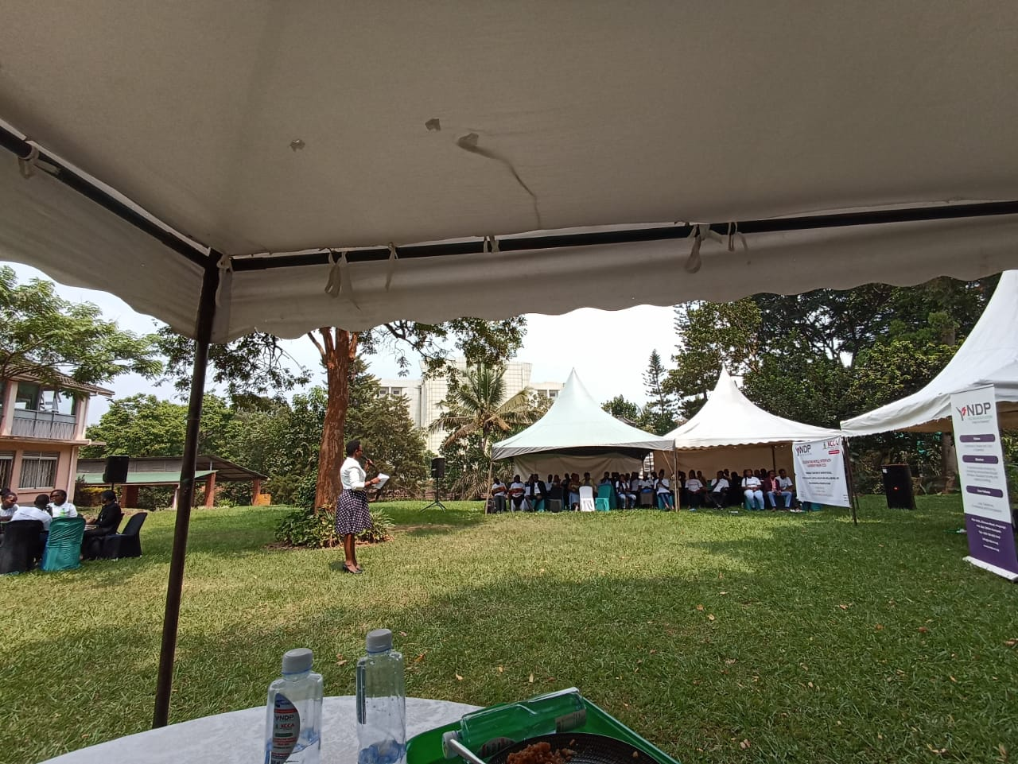
She then also thanked Nile Dialogue Platform and other NGOs that are working toward creating a peaceful and harmonious environment for us all to live in. She said, no matter your religion, race, ethnicity, political affiliation, you have to respect and understand other people’s differences, even in ideas.
At 1:40 PM, the event was closed with a prayer from one of the members of the KCCA youth council.

