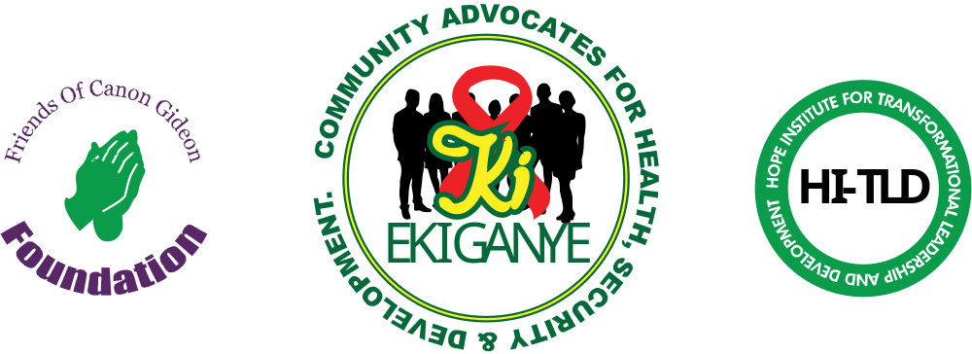 3RD MARCH 2022
FRIENDS OF CANON GIDEON FOUNDATION (FOCAGIFO), COMMUNITY ADVOCATES FOR HEALTH, SECURITY & DEVELOPMENT (CA4HSD) & FOCAGIFO HOPE INSTITUTE (HI –TLD) WAMALA WARD- REPORT ON PRAYERS TO MARK THE 2022 WORLD INTERFAITH HARMONY WEEK
Date: SUNDAY 27th FEB 2022 Venue : SHEIKH ZAIDI MAGNANITY CENTER, KATOOKE A LC1
Theme: LOVE GOD. LOVE YOUR NEIGHBOR AS SELF
Sub-theme: Breaking Barriers , Achieving Equity in Youth Empowerment & Skilling to End AIDS & Stigma, GBV& Teen Pregnancies, Household Level Poverty& Youth Unemployment Faster.

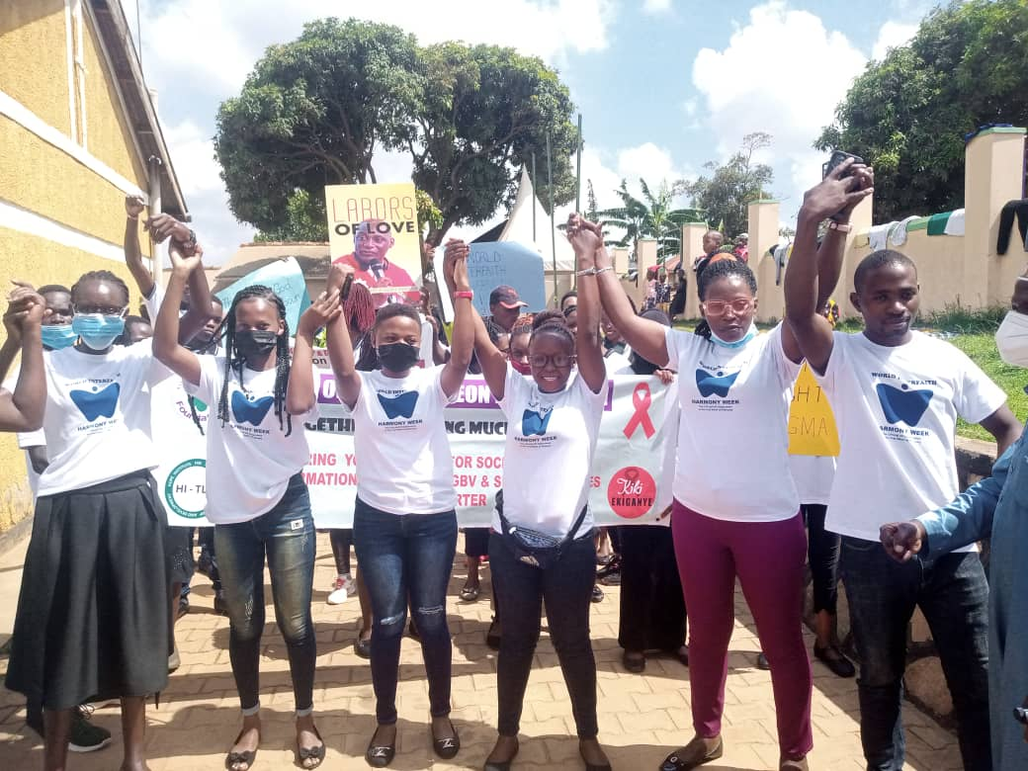
1.1 INTRODUCTION
Since the 14th of December 2019; both FOCAGIFO Secretariat and FOCAGIFO Hope Institute for Transformational Leadership & Development ( in Jinja-Kalori LC 1 , Wamala Parish, Nabweru Division- Nansana Municipality) have been working with youths in the area , their educators and trainers, their local community leaders and societal governors , their spiritual mentors and cultural gatekeepers etc. to mount a community response that is task- focused , results- oriented, inclusive, participatory and sustainable enough in : (a) Addressing youth, family and local community level vulnerabilities /challenges around AIDS & Stigma, Gender Based Violence and Teen Pregnancies; Household level Poverty & Youth Unemployment ; (b) Providing types of accessible, affordable and good quality ‘Youth Empowerment & Skilling’(YES) activities and courses aimed at equipping targeted youths with the type of knowledge and attitudes, beliefs and values as well as the skills and practices that enable the YES graduates to:

- Excel in supporting local community and local government efforts against individual, family and societal level challenges that compromise/ frustrate better community level health , deeper community level security and more equitable, holistic and sustainable community level development;
- Overcome their personal risks, community and family level vulnerabilities as well as societal injustices and inequities slowing the end of AIDS & stigma, GBV & Teen Pregnancies , Household level poverty and Youth Unemployment .

On Sunday 5th December, 2021- with objective of achieving the two aims above; FOCAGIFO entered into and launched a formal partnership with Wamala Ward Community leaders and members plus those of the neighboring Wards of Maganjo, Nakyesanja and Kawanda under a Comumunity –Self- Mobilization Forum Called COMMUNITY ADVOCATES FOR HEALTH, SECURITY &DEVELOPMENT (CA4HSD) coordinated by the Office of the LC2 Chairman, Wamala with Coordination Support from the Rev Canon Prof Gideon B Byamugisha

- OBJECTIVE OF THE INTERFAITH SERVICE
Since 2019; We plan and hold interfaith prayer services the last Sunday of every month (except during COVID-19 Lockdown). The keep purpose is to engage in hymns and prayers, read scriptures, preach sermons, make community speeches and mobilize resources for Youth Empowerment and Skilling Courses and Programs that work in combination to help contribute to (a) Overcoming Barriers in (i) Bettering Adolescent & Youths’ health and (ii) Deepening Youth safety & security against anything that robs them of their life and health, peace and human dignity.
(b) Achieving Equity and Quality in Youth Empowerment & skilling (YES)
(c) Ending AIDS & Stigma, Gender Based Violence & Teen pregnancies, Household Level Poverty& Youth Unemployment Faster .

These objectives were maintained for the Sunday 27.02 2022 interfaith prayers to mark the 2022World Interfaith Harmony Week

- ATTENDANCE
Number of registered participants leading the interfaith prayers | Figure
Female | 61
Male | 73
TOTAL | 134
Estimated Number of The General Public Reached (Through The Public March In Town With the Band , The Two Public Sermons Preached and the Brochures Distributed) | 600

- ACTIVITIES ACCOMPLISHED
4.1 2022 World Interfaith Harmony Week Public Awareness Raising March through Katooke Town
We started commemorating the day with an awareness raising march in town with the Alfred William M Brass Band. The youths dressed in t-shirts (and had banners) talking about the interfaith harmony week theme and subtheme. They interacted with people individually and stopped to pass on messages urging the community to address and overcome youth empowerment and skilling barriers to equitable access.
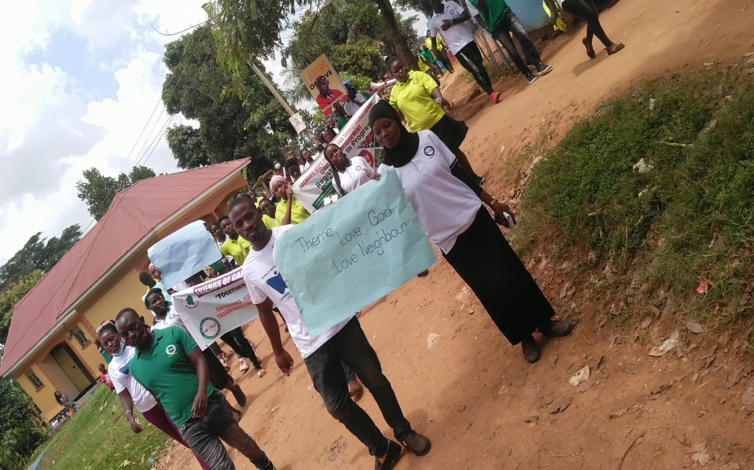
Love To God, Love To Neighbor : Youths matching alongside the band in Katooke Town to create awareness on the theme and subtheme of the 2022 World Interfaith Harmony Week

4.2 Interfaith Prayer Service
Our interfaith prayer service was led by The Most Rev Archbishop & Patriarch Lwanga Tusuubira of the Worldwide Anglican Church, the Rev Canon Prof Gideon Byamugisha, Sheikh Muhammad Musa Lubega , Mubuliizi Daniel Kyakonyi and Young People from FOCAGIFO Hope Institute, Curious Youths Uganda , Single Youth Mothers Association Uganda, and Community Advocates for Health, Security and Development (CA4HSD)
Sheikh Muhammad Musa Lubega and Mubuliizi Daniel delivered sermons on the role of deep faith, genuine love and grounded hope (as virtues of religious belief) in helping persons of faith, their families and communities to address the community health, community security and community development challenges driven by inequality and now made worse ( in manifestation and impact ) by COVID-19, AIDS & stigma, Gender based Violence & Teen Pregnancies , Household Level Poverty and Youth Unemployment.
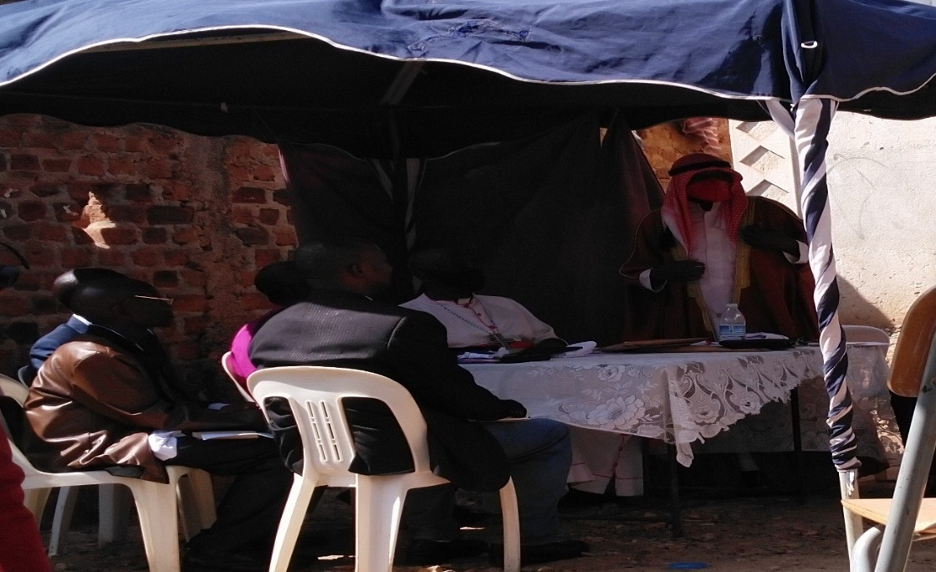
Sheikh Muhammad Musa Lubega: With Allah’s Guidance- We Can (and We Will) Defeat Stigma. End AIDS. On his Right is: Canon Prof Gideon B Byamugisha (Coordinator CA4HSD), Archbishop Lwanga Christopher Tusuubira (also Patron of CA4HSD), Mr William B Sekatwe Chairman (Wamala LC2 Ward & Chief Mobilizer , CA4HSD) , the Guest of Honor for the Day Pastor Moses Muwanguzi and one of the two guests that came with Abp Lwanga.
Both the preachers of the day and the hymns selected for the interfaith prayers urged participants to (a) Not forget their Lord God and to (b) Follow His commandments on the religious, social and economic subjects of faith- inspired LOVE faith- informed UNITY & faith-richened HARMONY.
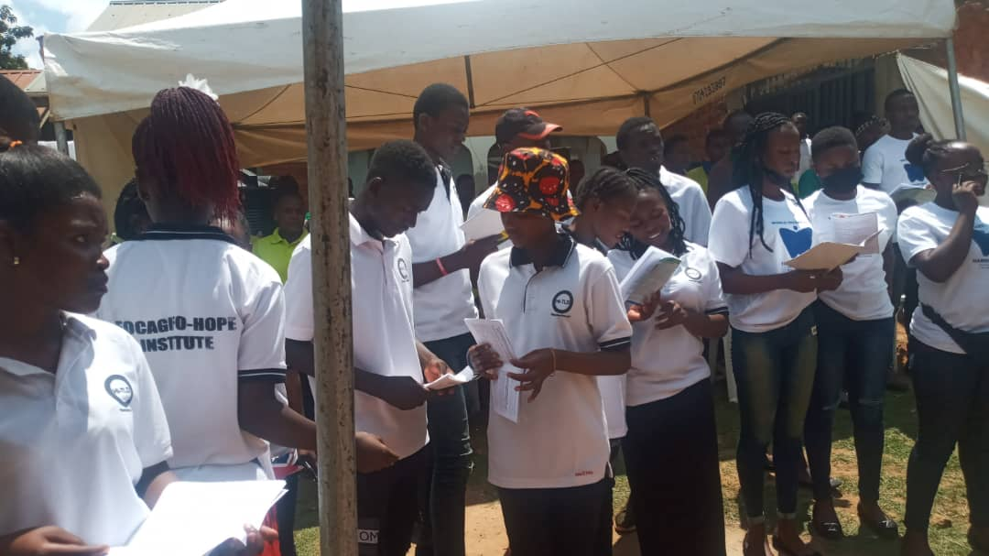
CA4HSD Interfaith Prayers’ Youth Choir: Singing ‘UNITED AGAINST AIDS!
4.3 Demonstrating Community Solidarity With Youths & Transformative Love- In- Action: The next activity in the program was to introduce to the audience the Previously NEET Youths (i.e. Not in Education, not in Employment and Not in Training) that are being Sponsored by the 15 villages that make up Nabweru Division ( in collaboration and partnership with FOCAGIFO & Nabweru friends and well-wishers in and outside of Uganda) to skill & get empowered Against AIDS & Stigma, GBV & Teen Pregnancies, Household level Poverty & Youth Unemployment.
Under (Community Advocates for Health, Security & Development (CA4HSD) ; A total of 3-4 young people from the most disadvantaged families are selected @ admission term (i.e. three times a year) by the Chairman , Council Members and Focal Point Persons of each village LC1 for youth empowerment and skilling at the FOCAGIFO Hope Institute KISOBOKA YES `program . Resources are mobilized by the community led by young people themselves under the Community Resource Mobilization drive called the 2KYES FUND . In the locally innovated mechanisms to raise money to prevent and mitigate impact of AIDS, its drivers and facilitators, sustainers and impacts in Uganda; the 2KYES Fund is the second known one after the One Dollar Initiative. Under the 2KYES FUND, each community member contributes 2000 Uganda Shs (or its equivalent in other currencies) as a Youth Empowerment & Skilling (YES) Gift to the YES partnership between FOCAGIFO, FOCAGIFO Hope Institute and Community Advocates for Health, Security & Development (CA4HSD). 2000 Uganda shs (or its equivalent is the minimum gift one can give . There is no ceiling to maximum number of gifts one can give.
Representatives of the first 50 young people to benefit from this “Community Self-Mobilization Effort” were introduced to the audience as a way of : (a) Showing fruits that come from community collaboration and partnership, harmony and unity ; (b) Galvanizing more involvement and contributions from youths, their faith communities and individual congregations and from their places of residence, education, work and or business
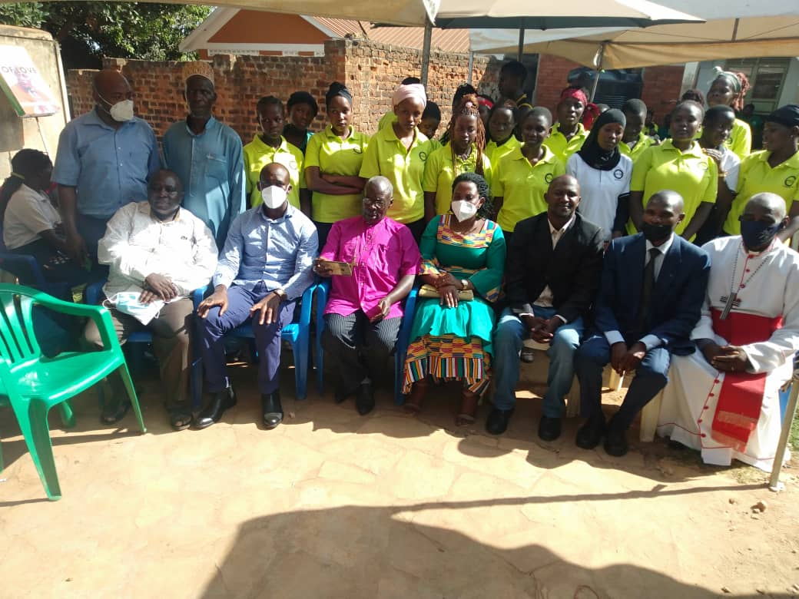
United With Vulnerable Youths Against AIDS, Its Drivers & Facilitators, Sustainers & Impacts: CA4HSD Leaders in the Interfaith Prayer Service with some of the youths under Youth Empowerment &Skilling Program called –‘KISOBOKA YES’ being piloted at the FOCAGIFO HOPE Institute
4.4 Declaration Of Committment
This was the climax of our 27th February 2022 Interfaith Prayer Service to commemorate the 2022 World Interfaith Harmony Week
We the audience committed ourselves to lead Our Wamala &Nabweru Community to join other Stakeholders focused on young people and on AIDS & stigma, GBV & Teen Pregnancies , Household Level Poverty and Youth Unemployment in :
4.41 Strengthening the FOCAGIFO Hope institute in Wamala Ward to make it better able to handle the youth empowerment and skilling (YES) aspects of the Parish Development Model, the ‘Emyooga’ Presidential Initiatives and our “Kisoboka” YES Programs;
4.42 Resourcing our 2K YES FUND so as to raise the necessary resources to sponsor, enroll and skill young people to become parents and guardians, spiritual mentors and cultural custodians, community leaders and societal governors, youth educators and trainers, service providers and professionals that are: (a) Conscious (b) Competent and(c) Resilient against all forms, types and faces of poverty, security risk and health vulnerability.
In the Declaration, we rallied all youths, men and women of faith in various places of worship and residence, schools and colleges, institutes and universities, places of work and business, entertainment and sport together with other well-wishers to join us in championing a type of youth empowerment and skilling that is effective in ending:
AIDS & Stigma; & Gender Based Violence & Teen Pregnancies & HIV, Household Level Poverty & Youth Unemployment ; Community Level Insecurity & Crime.
To implement this Declaration forward; we pledged to form three steering committees Youths of Faith, Women of Faith & Men of Faith (respectively).
The committees will be meeting every last week of month starting from 27th March 2022. Their role will be to make sure that all what is described in the declaration is implemented.

Ps: See Attachment: for The Declaration in Full

