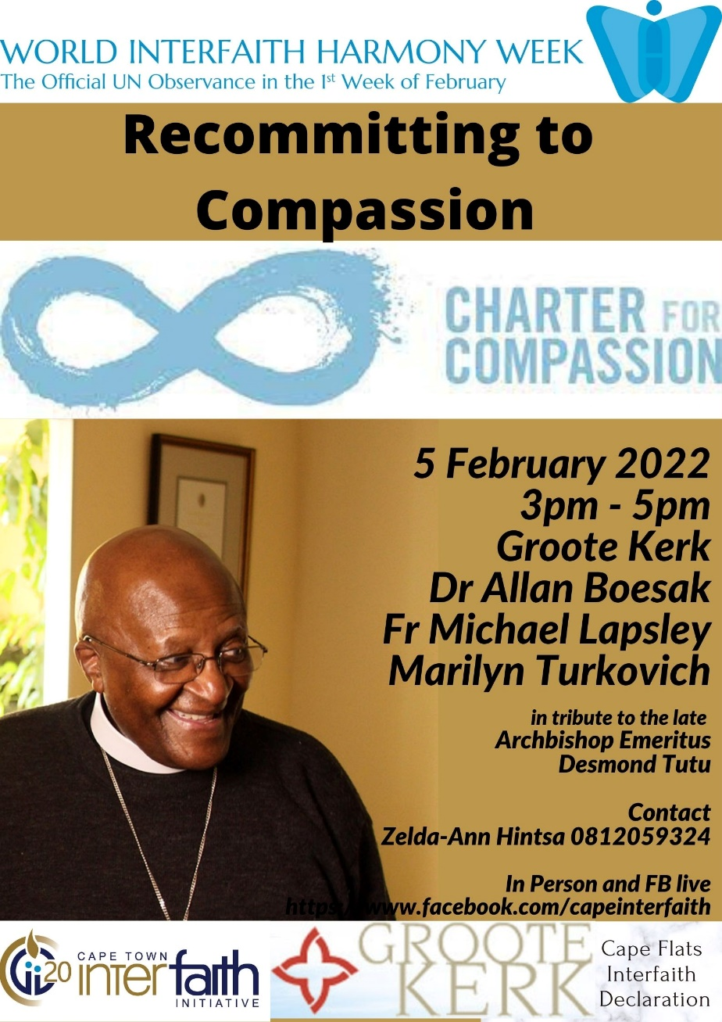

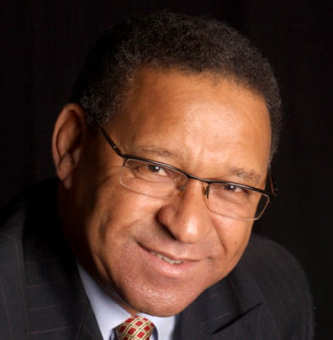
Dr Allan Boesak is a Dutch Reformed minister who was one of South Africa’s leading spokespersons against the country’s policy of apartheid. He was also the keynote speaker at the historical Cape Flats meeting on 25 August 2019, at which the Cape Flats Declaration was adopted. He remains a dedicated voice for social justice.

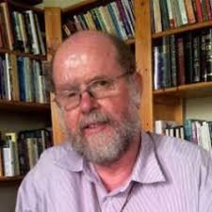
Father Michael Lapsley spoke out on behalf of schoolchildren who were being shot, detained and tortured during the 1970s. In 1990 a security force’s letter bomb cost him both hands and the sight in one eye. He later worked with victims of violence and torture, and in 1998 established the Institute for the Healing of Memories in Cape Town.

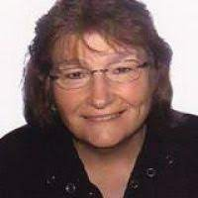
Marilyn Turkovich is the Executive Director of the Charter for Compassion. Her work has been primarily in areas of global awareness, international education, race and social justice and in instructional design including the authoring or co-authoring of more than twenty-five training and curriculum books.
Recommitment to Compassion
Saturday 5 February 2022 – Groote Kerk – 3pm
Programme
Master of Ceremonies: Rev Dr Llewellyn McMaster
Welcome: Ds Riaan de Villiers
Acknowledgement of Land : Zebada January
Prayers: Shaykh Ismail Keraan (Muslim)
Rev Dorothea Gopie (Christian)
Cecil Plaatjies (Buddhist)
Introduction: Rev Berry Behr, CTII Chair
Speaker: Marilyn Turkovich
The Impact of a Compassionate City
Speaker: Father Michael Lapsley
The Healing Power of Compassion
Speaker: Bishop Thembekile Gqwaka
Introducing the Cape Flats Memories video
Speaker: Dr Allan Boesak
Compassion as Sacred Practice

Engaging Compassion – You are invited to turn to someone you don't know and discuss how compassion shows up for you. Where do you want to create more compassion in your life? Feel free to open that conversation with others - we will have 15 minutes and during that time, Rev Berry will invite people to speak to her on camera for the facebook live feed.
Our FB listeners will have a chance to contribute too by typing your comments which we will read to the room later.
Feedback Session: Plenary
Thanks and closing: Zelda-Ann Hintsa, Cape Town Interfaith Board member and Cape Flats Interfaith representative
Call to Action: Please sign our Charter for Compassion commitment book while you enjoy refreshments with us, and the music of Dizu Plaaties.

Thank you to Dizu Plaatjies for permission to use his music.

