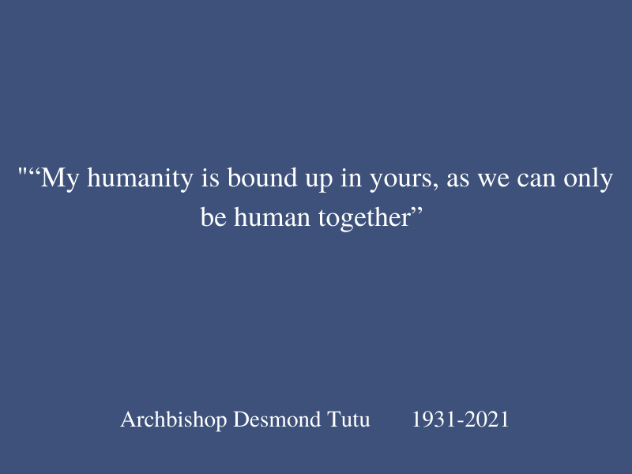
Introduction
“My humanity is bound up in yours, as we can only be human together”
- Archbishop Desmond Tutu (1931-2021)

February 3, 2022 marked the tenth anniversary of an interfaith dialogue for the cultivation of culture of peace as a part of World Interfaith Harmony Week, in honor of the 1984 Nobel Prize recipient and Anglican theologian, Archbishop Desmond Tutu. By bringing together multi-stakeholders, performers, spiritual and faith leaders in community dialogue, the event entitled Faith and Spiritual Leadership to Combat Stigma and Conflict During Pandemic Recovery invites reflection, harmonious connection and an orientation towards ‘sustainable happiness’. The dialogue challenges its participants to unite in solidarity and cooperation with the recognition of our interdependence and shared humanity for the purpose of developing a culture of peace and harmony worldwide.

History of World Interfaith Harmony Week
Proposed in 2010 by King Abdullah II of Jordan at the United Nations, World Interfaith Harmony Week (WIHW) was adopted by the UN General Assembly’s resolution A/RES/65/5 and was declared to be observed annually during the first week of February to promote a culture of peace through programming inclusive of the public and private sectors. By building bridges across boundaries with representatives from government, institutions, and civil society; the UN General Assembly’s support of WIHW recognizes the importance of promoting healthy and harmonious relationships among individuals and systems representing a diversity of cultures, faiths and ethnicities.

In 2012, The United African Congress and Give Them a Hand Foundation organized the first interfaith dialogue among spiritual and faith leaders who centered basic human values such as love and compassion as essential aspects of our common humanity. The common ground established by this interfaith forum established a strong foundation of shared aspirations essential to the cultivation of a more just, peaceful and harmonious global landscape. The United African Congress and Give Them a Hand Foundation have participated each subsequent year with this year being no exception. The event has expanded each year to invite more diverse lenses to build awareness of the shared human experience beginning with the 2013 inclusion of indigenous perspectives to highlight our interconnection with the natural world; themes of the importance of tolerance, reconciliation and forgiveness embodied by the late Nelson Mandela in 2014; the power of Interfaith Prayer and Healing in 2015; amplified interconnectedness brought on by the Ebola pandemic and response in 2016 and the importance of intentional bridge building with the recognition that we are in this together and are stronger together in subsequent years leading up to WIHW 2022.

Stigma and Conflict During the Pandemic
Observance of the annual World Interfaith Harmony Week was interrupted during times in which urgent global needs demanded the attention of organizing partners causing them to turn to action and mobilization. Coincidentally, the year 2015 called for collaborative support in response to the raging Ebola pandemic in the form of a mobilization effort to secure resources for the public health emergency faced by the affected West African countries.

This year, we are in the midst of a different yet devastating pandemic with complex conditions, growing inequity and a myriad of related physical, psychological, economic and humanitarian needs. The COVID-19 virus has infected and claimed lives around the globe and shows no sign of subsiding with its subsequent adaptive variants and much of the world’s lack of access to effective life saving vaccines. To date, Johns Hopkins Coronavirus Resource Center data shows over 5.7 million lives have been claimed across the globe, however access to the vaccine and recovery resources remain inaccessible to millions, perhaps billions worldwide which is leaving increasing numbers of individuals vulnerable and new variants propagating more deaths globally. “Moreover, an unequal distribution of vaccines will deepen inequality and exaggerate the gap between rich and poor and will reverse decades of hard-won progress on human development” (UN, 2022). With increased polarization, politicizing, misinformation, inconsistent strategies and increased isolation due to safety protocols, leaders are increasingly challenged to manage what is clearly a global enemy set within the context of national systems.

The shared common feature in the worlds’ religions identifies the undeniable coming together as human beings to help one another which may be considered a compassionate response as an outcome of the shared experience of the pandemic. The flip side of this coin is the increased conflict, violence, loss of security and racially charged acts of hatred rooted in a concurrent crisis of ideology. The on-the-ground commitment of the worlds’ spiritual and faith leaders roles to console, anchor, share information, bring hope and lift up through face to face and virtual interactions with individuals and communities is paramount to build resilience and contribute to healing in the face of immense and ongoing loss.

Virtual Event Overview
This year’s World Interfaith Harmony Week event was sponsored with multilateral representation by the Main Sponsor by the Permanent Mission of Sierra Leone and Member State co-sponsors, the Missions of Canada, the Kingdoms of Morocco and Bahrain, and the Holy See to the United Nations and was moderated by Dr. Judy Kuriansky, Representative of the International Association of Applied Psychology. Civil society partner co-sponsors were represented by the dialogue’s guest speakers including Imam Shamsi Ali of Nusantara Foundation, Rabbi Jill Huasman of The Actors Temple, Swami Tyagananda of the Ramakrishna Vedanta Society, Venerable Hui Dong of Buddha’s Light International Association, Reverend Dr. Craig Rubano of Unitarian Universalist, Thalia Mintz of Yaqui Nation, Mohammed Nurhussein of United African Congress and Felipe Queipo of the Department of Global Communications, United Nations. Additional speakers included New York Assemblywoman, Jenifer Rajkumar and Sepideh Behzadpour of the Spiritual Assembly of Bahá'ís of the City of New York. Mr. Gordon Tapper of the United African Congress and President and Founder of Give Them a Hand Foundation provided the Closing Remarks.

Musical interludes interspersed throughout the program expressed diverse musical styles and formats whilst shining the light on the power of one love, one faith and peaceful coexistence. Performers included Menace da General of Sierra Leone’s “One Love” whose video depicted images of the complexity of life during the pandemic and hopeful images of support for those on the frontlines; Angelo and Veronica’s emotive contemporary Gospel song, “The Prayer”; Russell Daisey’s compelling live performance of an original song, “One in Faith” (written in collaboration with Dr. Judy Kuriansky); and a popular song “Bismillah Cinta” by Indonesian stars Pasha, founder of the group Ungu, and Lesti Kejora with a religious message about the happiness of welcoming Ramadan and love during the pandemic. The culmination of the event was marked by revisiting the initial message of Menace da General’s video, “One Love”. For the second time, the impact was enhanced by the speakers’ insightful call for collective action on behalf of the greater good.

Opening Remarks and Prayer
Although not in attendance, the United Nations Secretary General, Antonio Guterres’ warm wishes were conveyed by moderator Dr. Judy Kuriansky who shared a video of Guterres as he was received by Pope Francis in December, 2021. At this event, he expressed his deep gratitude to Pope Frances for his promotion of interfaith dialogue. The declaration co-signed by Pope Francis and the Grand Imam of Al-Azhar Ahmed Al-Tayyed entitled “Human Fraternity for World Peace and Living Together” is of particular significance “in a world that sees dramatic attacks on religious freedom and the lives of believers” and goes hand in hand with the United Nations Plan of Action to Safeguard Religious Sites and strategy to combat hate speech. The UN Secretary General stressed “We must stand together for peace and harmony” (Guterres, 2021).

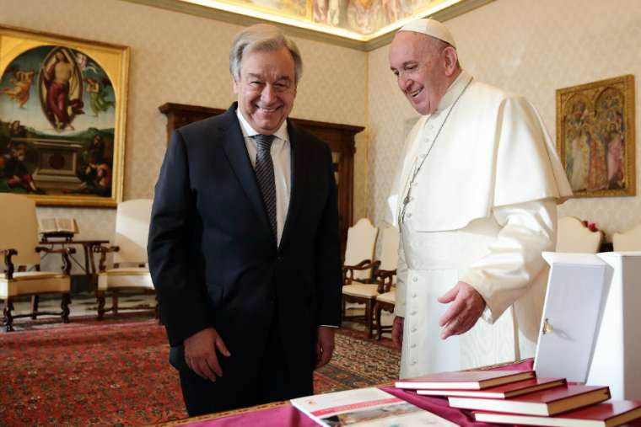
Copyright © 2015-2021 The Permanent Observer Mission of the Holy See to the United Nations

Interfaith minister, Reverend Zoe Chang, Board Member of the United Nations Women's Guild and Vice President Emeritus of the United Nations Staff Recreation Counselor, and Advisor to the UNSRC Enlightened Society, offered a prayer of solidarity and call to action. “May we become the bridges between all faiths. We ask for divine intervention and guidance to build connection and fellowship together. We will be the agents of change for a more equitable and peaceful world” (Chang, 2022).

Main Sponsor - Mission of Sierra Leone
H.E. Ambassador Fanday Turay, the Permanent Representative of Sierra Leone to the United Nations. welcomes honored guests and attendees with the recognition that the United Nations’ charter objective is dedicated to ensure that peace and security will prevail worldwide. However, the harsh reality is that conflict is flourishing in the world.

The role of spiritual and faith leaders is paramount to this effort and urgently needed in a world that seeks to contain and reconcile conflict as well as the challenges of equal access to effective vaccines, heightened poverty and the impact of climate change. H.E. Ambassador Turay is encouraged by the gathering and considers it progress. He imagines another world is possible, and suggest the expansion the vision of New York City’s mayor, David Dinkins, ''I see New York as a gorgeous mosaic of race and religious faith, of national origin and sexual orientation,'' (Dinkins, 1990) to be actualized on a larger scale so that the collective work may “exemplify the model for harmonious societies, countries, and the world at large”. (Turay, 2022) He states,
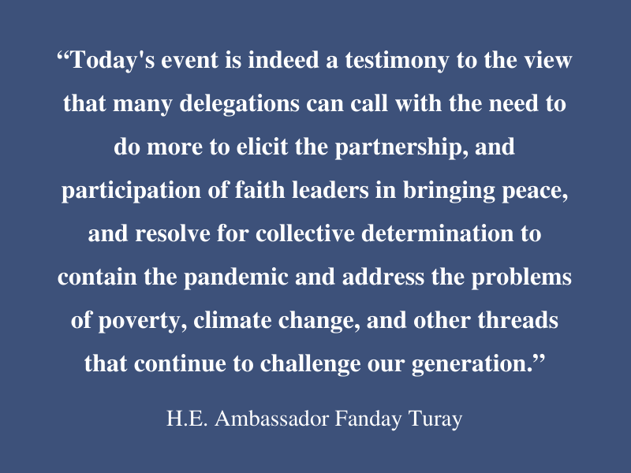

Dedication Honoring Archbishop Desmond Tutu
Dr. Muhammed Nurhussein, national chairman of the United African Congress and co-founder of the WIHW events, dedicated the event to his personal hero and international archetype of peacebuilding and unification, the late Archbishop emeritus of the Anglican Church of South Africa, Reverend Desmond Tutu.

Respected friend of fellow Nobel Peace Prize laureates, His Holiness XIV Dalai Lama and Nelson Mandela, Archbishop Tutu’s recent death as a hero’s hero generated ripples worldwide. inspired compassionate action in his honor.

Dr. Nurhussein shared tributes that poured in from across the globe in honor of the beloved spiritual leader’s extraordinary intellect, invincibility against the forces of aparteid, moral compass, a giant, modern faith leader for modern times, conscious keeper, abounding love for humanity, embodiment of the philosophy of ubuntu. And known to be the best kind of troublemaker, a fearlessly compassionate one. Dr. Nurhussein, a native of Ethiopia, dedicates the event to his idol,
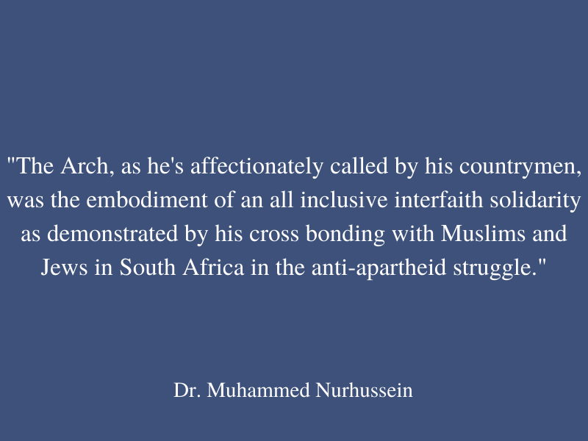
“And so, we dedicate this session to keep his memory alive, that personified the true spirit of interfaith harmony in promoting a culture of peace. Long live the Arch!” (Nurhussein, 2022).

Felipe Queipo, the Communications Officer at the UN NGO Relations & Advocacy Section of the United Nations Department of Global Communications shines the light on the UN’s seventy six year history with the recognition that the UN definition of peace has evolved over time. Mr. Queipo recognizes the shift from a focus on responding to the global atrocities that sparked the creation of the United Nations to its current focus which includes the well being of each and every individual on the planet and articulates a constructive path forward is not made so military intervention, but rather quality diplomacy. The UN definition of peace has evolved over time from a lack of aggression to embracing wellbeing. He shares that as a person of faith, that faith traditions teach that happiness can be eternal and concurrently, he says that his time as a civil servant has taught me that the UN is in the business of making happiness sustainable. The event marks an occasion of coming together to learn at the feet of those who carry the thread of faith and spiritual traditions that have stayed the course for thousands of years. We have much to learn from them on the quest for sustainable happiness. (Queipo, 2022)
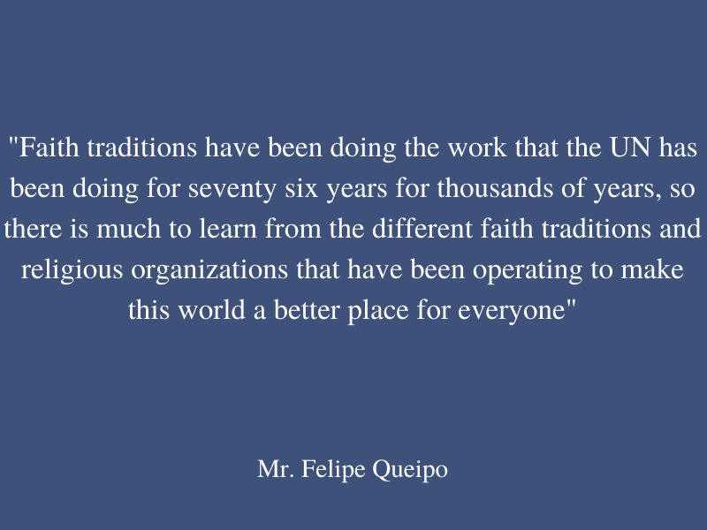

Representatives of Missions of Member States Co-Sponsors
In this high level section of the program, the speakers included Permanent Representatives of Missions of Member States and co-sponsors of the event. Beginning with H.E. Ambassador Omar Hilale, Permanent Representative of the Kingdom of Morocco to the UN who articulated the pivotal role that faith based leaders and organizations play in response to needs amplified by the COVID 19 pandemic,
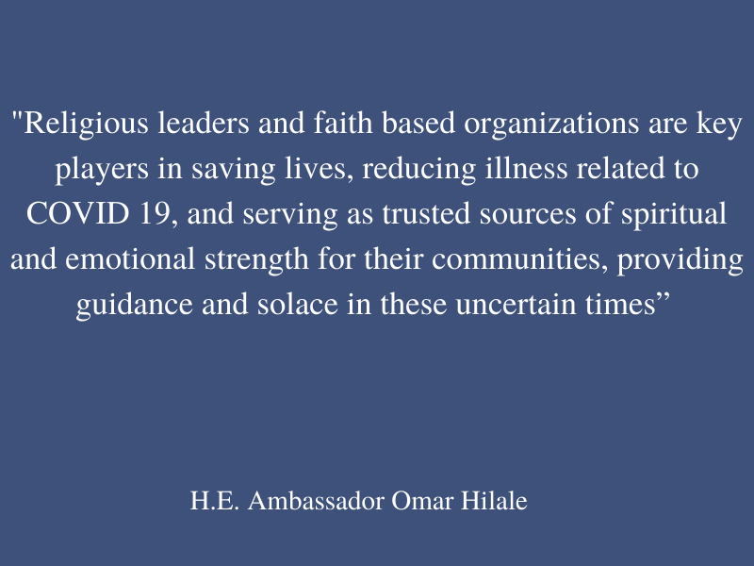
Ambassador Hilale emphasized coming together with an integrated approach to promote mental health and psychosociality in response to the COVID 19 pandemic, our common global conflict.

H.E. Ambassador Jamal Alrowaiei of the UN Mission of the Kingdom of Bahrain, a multicultural and inclusive society acknowledged the commitment of King Hamad bin Isa bin Salman Al Khalifa to combat ignorance, the enemy of peace, with the establishment of the King Hamad Global Centre for Peaceful Coexistence. Ambassador Alrowaiei stressed the importance of education as a vehicle for strengthening peace and commitment to international collaboration.
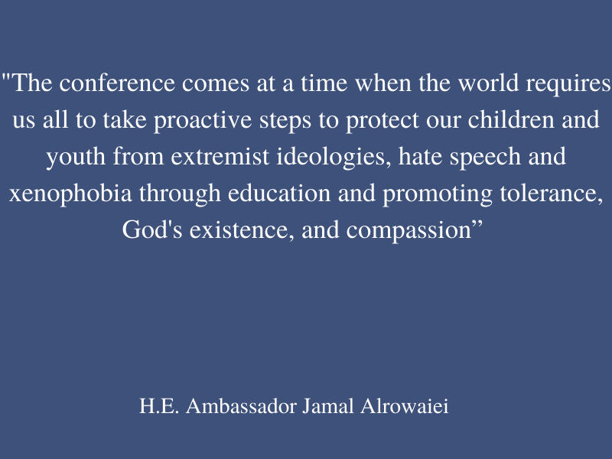
H.E. Ambassador Richard Arbeiter, Deputy Permanent Representative of the Mission of
Canada to the UN, recognizes Canada’s deep commitment to oppose discrimination of all forms whilst acknolwledging that the current conditions in his country are indicative of a startling rise of police reported religious hate crimes (Moreau, G., 2021). He encouraged deliberate adjustment of language by and encouraged calling out hate as the root condition to be condemned with appropriate anti-hate responses.
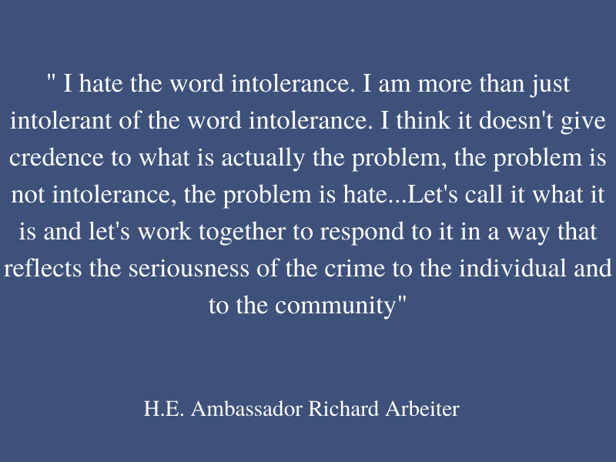
Apostolic Nuncio and Permanent Observer Mission to the UN of the Holy See. H.E. Archbishop Gabriele Giordano Caccia’s message was notably more somber in tone. He emphasized the power of faith based traditions’ capacity to impact cultural change beyond the service based contributions to include the moral responsibility of its leaders to revive moral awareness and spiritual values in the younger generation. In his statement, Archbishop Caccia noted the landmark interreligious declaration called the Document on Human Fraternity for World Peace and Living Together was signed three years ago by Pope Francis and Grand Imam of Al-Azhar, Ahmad al-Tayeb established an International Day of Human Fraternity to be observed annually on February 4 (Francis, P., & Al-Tayyeb, A., 2019). It is by cultivating awareness of what Pope Francis refers to as the transcendent truth or recognizing transcendent reality as a key aspect of cultivating the conditions to support loving concern for others (Caccia, 2022).
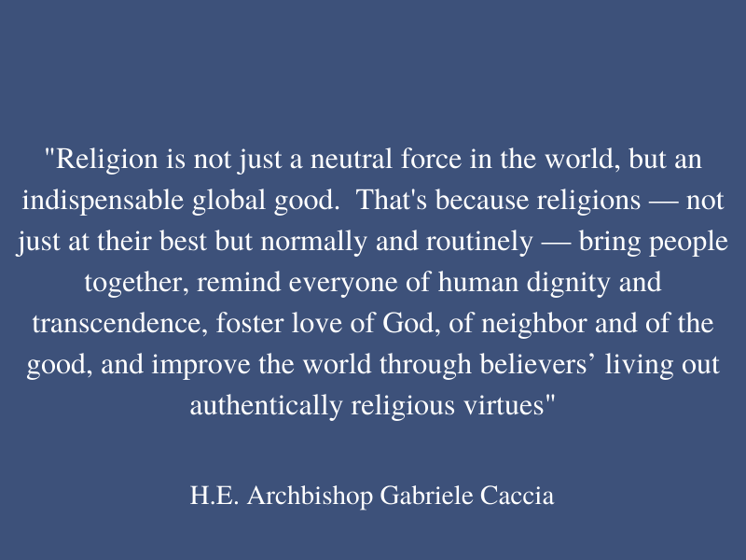

H.E. Sidique Wai, the Ambassador of Sierra Leone to the United States at the Embassy in Washington, former President of the United African Congress, and a co-founder of World Interfaith Harmony Week events acknowledges the growth of the event in its ten year history as being both a clear sign of God’s power to bring participants together for common purpose. “Ten years later, God Almighty has made it even bigger. I see the Holy See participating, I see different countries, I see Canada” (Wai, 2022). He further emphasizes that our challenge with COVID is one of the shared human experience and by joining one another, we can defeat it.
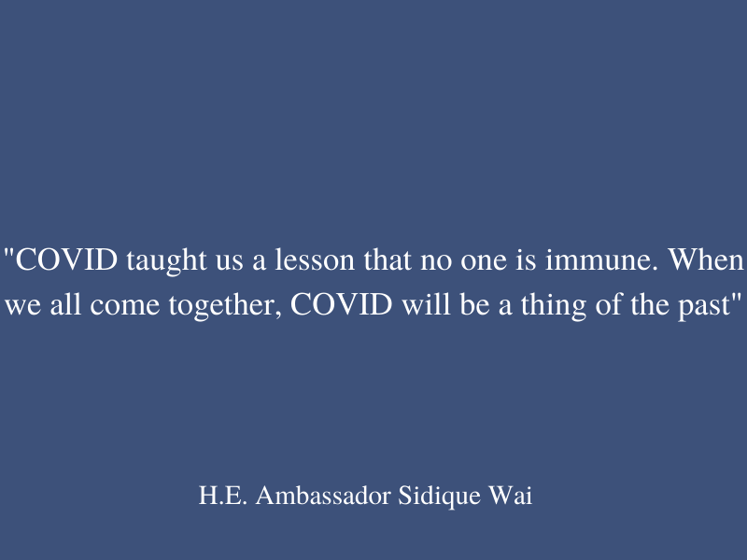

Representatives of Civil Society Partner Co-Sponsors
In the next portion of the event, the civil society co-sponsors shared their perspectives and echoed the themes of common humanity and interdependence through their unique lenses. The first, Imam Shamsi Ali, acknowledged the deep and shared suffering related to the pandemic. In his view, the challenges presented by COVID 19 reminds us of our common solidarity, common humanity, and shared aspirations for collective well being.
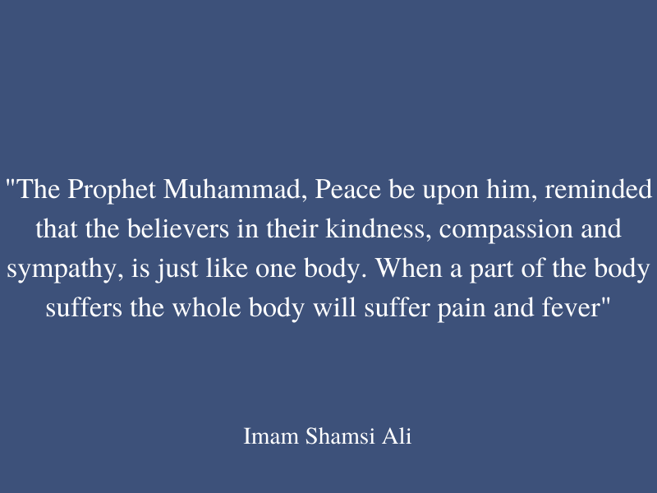
He encourages a path to equity and justice for all with a challenge to rise beyond aggressive divisiveness and to instead, use religious conviction for the common good; to build awareness and appreciation of our interdependence through collective responsibility for all; to courageously hold those in authority to share responsibility for those most vulnerable to ensure basic rights and social justice for all; and to reject superiority of any human. In his view, God himself is the only superior (Shamsi Ali, 2022)

In my view, the most transformative message of the program was offered by Tahila Mintz, Water Protector, Land Guardian and Medicine Carrier representing the Yaqui community of Sonora, New York. She used the opportunity to bring awareness of the interconnectedness of human beings and the natural world which predates the faith perspectives shared at the gathering. For the Yaqui people, separation with the elements is illusory, and as such, water’s life regenerative properties are fundamental to survival. The sacred appreciation of this resources reinforces the intolerable loss of the Yaqui river access due to corporate greed.
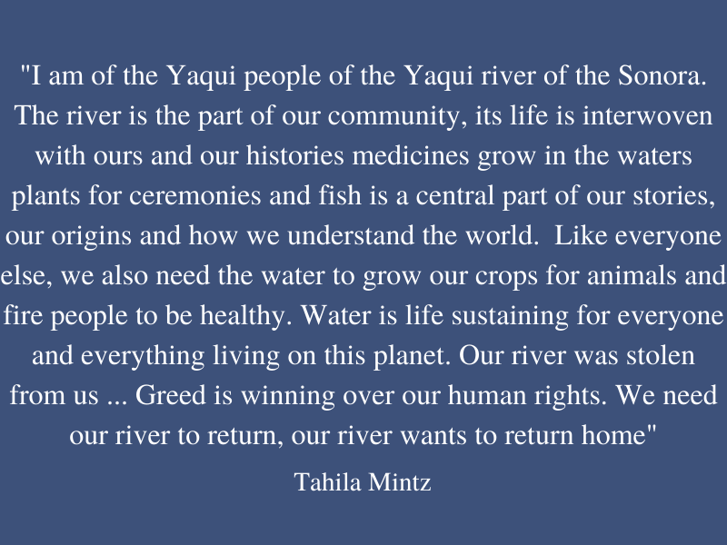
Tahila Mintz shares that her community has received pandemic assistance, not from the country, but from a network of strangers organized and united in acts of love. An act selflessness was offered to attendees in the form of a healing practice. The simple act of prayer over a cup of water is based on the recognition of the power of intention to transform water particles as evidenced by the work of Japanese scientist, Masaru Emoto. Dr. Emoto’s experiments suggest how the influence of our thoughts, words and feelings on molecules of water can positively impact the earth and our personal health (Emoto, 2011).
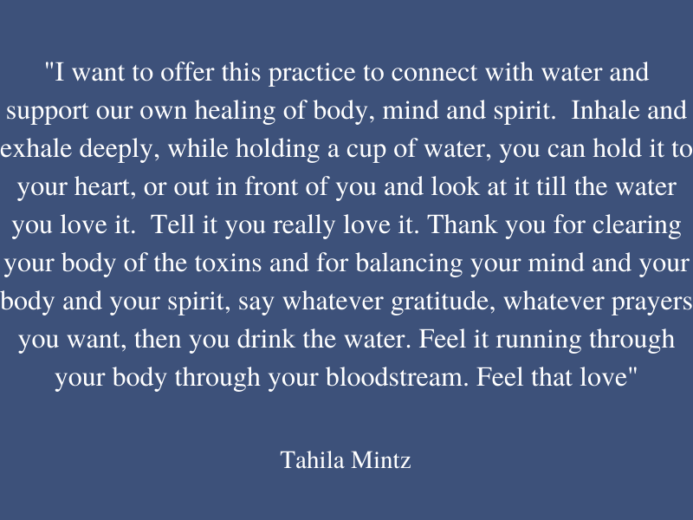
Tahlia Mintz asks attendees to consider the sentient nature of water and its significant presence within our biological makeup. “The practice of loving and respecting water is the practice of loving and respecting ourselves. May we all live with kindness and love and respect and honor the water” (Mintz, 2022). Those who engaged in the practice openly will likely view water differently as a result of the cognitive embodiment and skill building invited by the exercise.

Rabbi Jill Hausman is the Rabbi and Cantor of the Actors’ Temple, Congregation Ezrath Israel, in Manhattan, and is the Assistant Dean of the Rabbinical Seminary International where she was ordained. Rabbi Hausman’s statement illuminated the connection of all humans to the spiritual realm thus bridging the faithful with those who do not ascribe to a religious lineage. She stated, “We have come together in a community of faith to express our love for each other, our gratitude and appreciation for each other and to point the way to a future where we will all be at peace. We are all part of each other in the spiritual realm, there are no separations.” (Hausman, 2022). She encouraged acceptance and pointed to the failure of helping others as the obstacle to equitable access to resources. For her, differing perspectives are enriching and the path towards greater empathy and compassion lies in personal transformation not in attempting to change others. (Hausman, 2022). She ended with a powerful image inviting the dissolution of the illusion of our separateness.
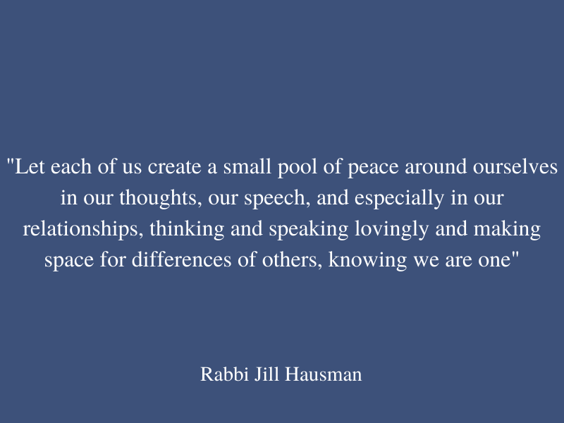

Venerable Hui Dong represented the Buddha’s Light International Association encouraged the examination of stigma and acts of hate to be rooted in the mind in the form of bitterness, aversion and other destructive emotions. As such, one can choose to focus on the cultivation of antidotes such as compassion and equity to eventually eliminate them.
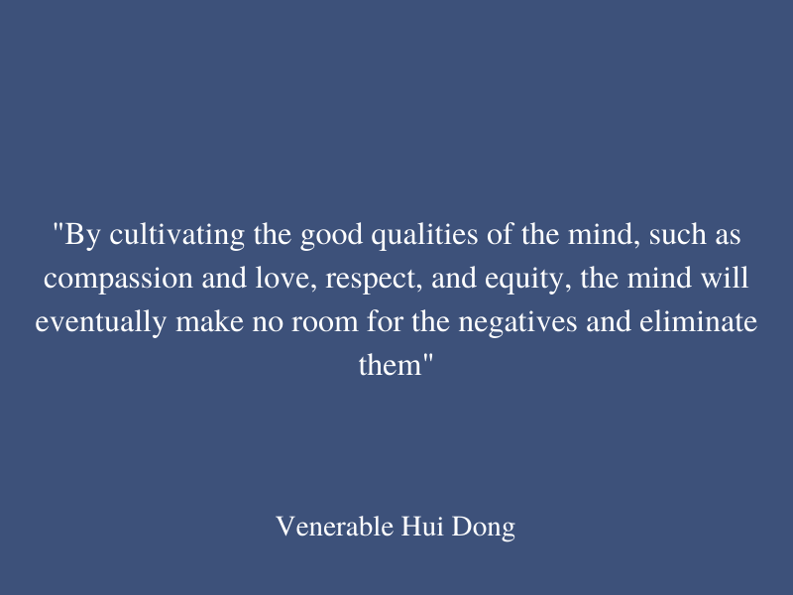

Swami Tyagananda is a Hindu monk of the Rama-krishna Order for nearly 50 years, head of the Vedanta Society in Boston and the Hindu Chaplain at Harvard and MIT. Swami Tyagananda’s courage was revealed through his capacity to speak directly to the suffering of those greatly impacted by the lives lost and glaring inequities of the pandemic. He illuminated the resilience of those on the front lines and generosity of helpers who heeded the call to support others as the selfless capacity inspired by circumstance. Similarly, the more destructive capacities of humankind have manifested in the forms of exploitation, violence, and political opportunism disrupting individual and collective peace. His call for inward transformation as a strategy mirrors that of his fellow spiritual and faith leaders. External peace and harmony are reliant on the cultivation of inner peace and harmony. One must begin there, in our own hearts for this is the path to transform the self, relationship and eventually the global systems, our whole world. (Tyagananda, 2022).
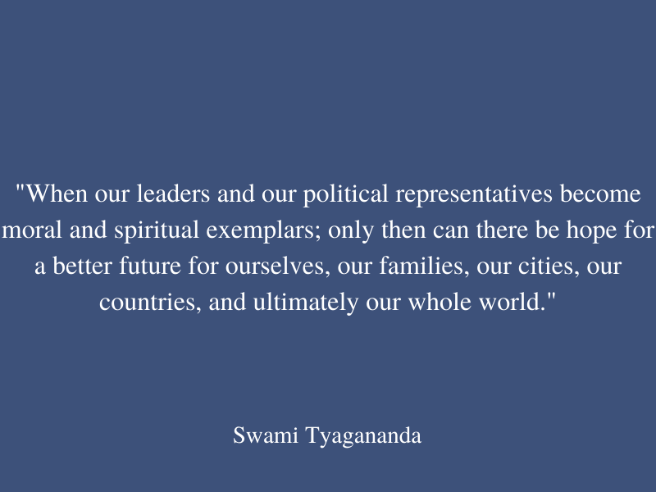
The final speakers, Reverend Dr. Craig Rubano, Minister of the Unitarian Universalist Congregation of Monmouth County in New Jersey; Jenifer Rajkumar, New York Assemblywoman and Sepideh Behzadpour, Community Relations Manager for the Spiritual Assembly of the Bahá'ís of New York City each spoke to the need for an integrated, community based model necessary to address our capacity to transcend the current challenges we face related to the pandemic and the opportunity that we have as a collective to realize our common aspiration for individual and collective wellbeing.

Mr. Gordon Tapper, President of the United Africa Congress and founder of Give Them a Hand Foundation offered closing remarks of gratitude for all participants and contributors to make the event possible and an invitation to continue to work together on a plan of action to keep the spirit of peace and interfaith “really alive each and every day” (Tapper, 2022).

Conclusion
Archbishop Tutu’s opposed aparteid in his native South Africa whilst calling upon the concept of ubuntu, the recognition of the interrelated nature of all humanity. Similarly, this event invites participating spiritual and faith leaders to engage a multilateral and proactive response to combat stigma and conflict during the pandemic recovery process. By focusing on what can be done individually and collectively to address our common antagonist, the Covid 19 pandemic, speakers from diverse traditions and perspectives promoted equitable access to resources and inner-focused inquiry to cultivate the values and dispositions necessary to combat the ideological barriers amplified by the pandemic. The promotion of the cultivation of basic human values as articulated by each of the speakers calls for compassionate integrity at the levels of the self, interpersonal and systems. As an individual committed to the process of cultivating the skills of compassion and ethical discernment in the educational sphere, the connection is direct and clear. What I bring to the world is intentional education of both the head and the heart so that the collective aspirations for sustained happiness are considered essential to individual and collective flourishing. By integrating interfaith alignment into the experiences of the young generations, they may come to embody the aspirational qualities expressed during this session and integral to the vision of His Holiness the Dalai Lama, visionary and beloved friend to the late Archbishop Desmond Tutu.

“Just as we take for granted the need to acquire proficiency in the basic academic subjects, I am hopeful that a time will come when we can take it for granted that children will learn, as part of their school curriculum, the indispensability of inner values such as love, compassion, justice, and forgiveness.” The Dalai Lama, Beyond Religion

Title: Faith and Spiritual Leadership to Combat Stigma and Conflict During Pandemic Recovery

Event: World Interfaith Harmony Week Observance at the United Nations

Date: 03 February 2022 , 3:00PM-5:30PM

Location: Zoom

Moderator: Dr. Judy Kuriansky, Representative of the International Association of Applied Psychology

Panelist: Main Sponsor by the Permanent Mission of Sierra Leone and Member State co-sponsors, the Missions of Canada, the Kingdoms of Morocco and Bahrain, and the Holy See to the United Nations. Civil society partner co-sponsors were represented by the dialogue’s guest speakers including Imam Shamsi Ali of Nusantara Foundation, Rabbi Jill Huasman of The Actors Temple, Swami Tyagananda of the Ramakrishna Vedanta Society, Venerable Hui Dong of Buddha’s Light International Association, Reverend Dr. Craig Rubano of Unitarian Universalist, Thalia Mintz of Yaqui Nation, Mohammed Nurhussein of United African Congress and Felipe Queipo of the Department of Global Communications, United Nations. Additional speakers included New York Assemblywoman, Jenifer Rajkumar and Sepideh Behzadpour of the Spiritual Assembly of Bahá'ís of the City of New York. Mr. Gordon Tapper of the United African Congress and President and Founder of Give Them a Hand Foundation provided the Closing Remarks.

Contact Sheet: link
UN Web TV Production: view full event here
UN Instant Alert: Guterres ‘Let us build bridges between the faiths” link

Flyer:
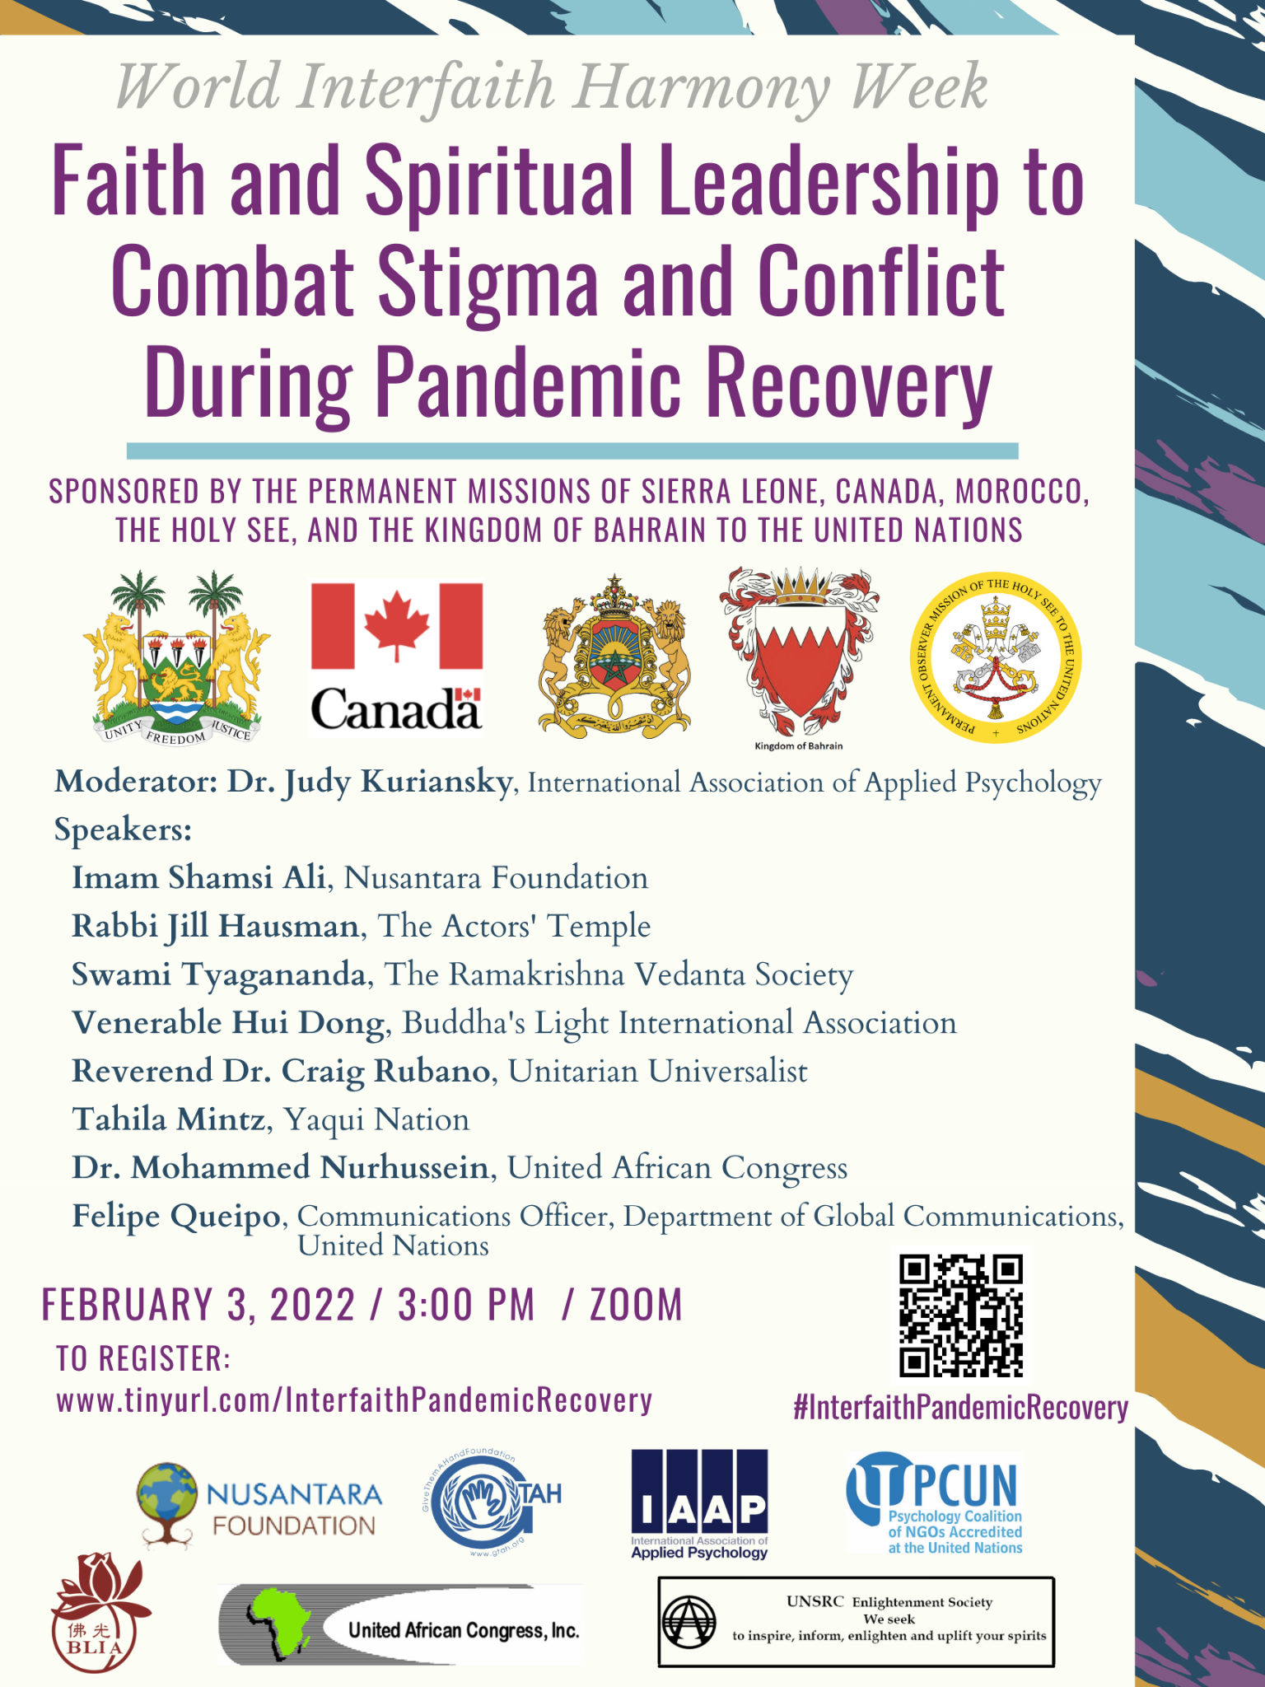
Citations

Lama, D. (2012). Beyond Religion: Ethics for a Whole World. Random House.
Dinkins, D. (1990). Mayor Dinkins: A Pledge to All the People; Text of Dinkins Speech: “We are All Foot Soldiers on the March to Freedom.” The New York Times. https://www.nytimes.com/1990/01/02/nyregion/mayor-dinkins-pledge-all-people-text-dinkins-speech-we-are-all-foot-soldiers.html
Emoto, M. (2011). The Hidden Messages in Water. Simon and Schuster.
Francis, P., & Al-Tayyeb, A. (2019). Human Fraternity for World Peace and Living Together. Libreria Editrice Vaticana, Abu Dhabi.
Hopkins, J. (2020). Johns Hopkins Coronavirus Resource Center. COVID-19 Case Tracker.
Institute, M. & L. (2020, March 24). The Dalai Lama's Education of the Heart. Education of the Heart. Retrieved February 10, 2022, from https://educationoftheheartdialogue.org/dalai-lama-education-of-the-heart/
Moreau, G. (2021). Police-reported hate crime in Canada, 2019. Juristat: Canadian Centre for Justice Statistics, 4-38.
Mission of the Holy See (2021, December). Pope Francis and secretary-general Guterres meet in the Vatican. The Permanent Observer Mission of the Holy See to the United Nations. Retrieved February 10, 2022, from https://holyseemission.org/contents/mission/5dfd12447dbfb.php
United Nations. (2021). Covid vaccines: Widening inequality and millions vulnerable | | UN news. United Nations. Retrieved February 10, 2022, from https://news.un.org/en/story/2021/09/1100192
United Nations. (2022). World interfaith harmony week observance at the United Nations - theme: Faith and spiritual leadership to combat stigma and conflict during Pandemic recovery | un web tv. United Nations. Retrieved February 10, 2022, from https://media.un.org/asset/k13/k133gqa9pn

Bio: Reported by Jennifer Knox, a member of the Student Division of the International Association of Applied Psychology pursuing a masters at Columbia University Teachers College, and a student in Professor Judy Kuriansky’s class on “Psychology and the United Nations.” In addition to my scholastic work, I have over 20 years of experience working nationally and internationally to support education as a vehicle for personal, relational and collective wellbeing with a focus on the arts, secular ethics and the cultivation of basic human values to promote a more compassionate world. My contributions to the Social, Emotional and Ethical Learning (SEE Learning™) program as a facilitator, content designer and educator have far reaching impacts in North America, Europe, and the Indian Subcontinent. I am currently serving as the Director of Character Education and the Ron M. Brill Chair for Ethical Leadership Development at Woodward Academy, the largest independent school in the continental United States.
