Sprogcafe or Learning Danish Language as Key to Integration
Sprogcafe or Teaching Danish Language is something that happens every week. It is an offer to refugees, to guest workers, to foreign students, and to all those who are in need to learn or improve their spoken and written Danish language. Learning Danish is one of the keys to integration in the new country, Denmark. Often it has proven to be a good help in finding a job in Denmark. This is one of the services of the Cross- Cultural Ministry of Kolding Deanery, which consists of 31 local Lutheran churches in town, supported by a group of faithful volunteers.
It is every Tuesday at 4-6 pm. And we do this in the Activity House called Simon Peters Hus at Islandsvej 4 in the municipality of Kolding. This is free service, without cost from our students.
We have a group of volunteers, many of whom are retired teachers from schools, and others who are simply happy to use their time to be of help. We have a group of 12 to 15 volunteers from different local churches, giving time to help students learn and exercise the use of the Danish language. Those who use this free service are of different levels in the acquisition of the Danish language. There are those who come as beginners, that is, they have not learned to say sentences in Danish yet, or those who have learned the language but need a Dane to talk with, those who have been in the country for many years but did not manage to get Danish lessons, and those who are taking studies in Danish schools and would like to get help with their Danish assignments. Otherwise, there are also the lonely ones who simply want to be in the fellowship of learners and volunteers.
In observance of the United Nation’s World Interfaith Harmony Week 2022, we have chosen to have 2 Tuesdays for our students to learn about the United Nations and the significance of World Interfaith Harmony Week.
We have reused our teaching materials as we used last time:
- A text for reading about the United Nations with questions to answer that measure how much a student has understood from the reading. It is also learning new vocabulary and enabling the student to enter into simple conversation with the volunteer teacher, taking up what the student has learned earlier.
- A text on the history of the World InterFaith Harmony Week in Danish, and allows the student to be able to spot the mistakes in sentences and correct them: the grammar, the structure of sentences, the use of verbs and adjectives
- An exercise in finding nouns as many as one can from the given text or from the song being sung, and conjugate every noun word/ or substantive into 4 forms in the Danish language: as singular and plural and as undetermined and specific nouns.
- A page of vocabulary words in Danish in relation to the observance of WIFHW, for example. Cooperation (Samarbejde) harmony (harmoni), love(kærlighed) retfærdighed (justice), fred (peace), pligter (duties), faith (tro), etc. Let the student find the meaning of these words in his/her own language and use the word in own sentences or in personal conversation with the volunteer teacher.
- Some of the exercises serve also as assignment to work further at home.
Sprogcafe lessons start with coffee and tea, fruits and biscuits, giving time for students and teacher volunteers to start the Danish lesson by simple informal talks around tables. Then there is time for everyone to introduce himself/herself and state the country of origin. The introduction often ends with a student’s answer to a given question, which gives the understanding how a Danish sentence is said or formulated. One particular question or questions related to this observance : What can I do to work for peace or harmony? What is peace to me? Or what is it that makes me happy?
Then there is time to sing together as songs are also a help in learning,These are songs, sung by children in Danish schools, or songs about the seasons, friendship, love and peace. Then the students are divided into small groups. Often every group is by 2’s, that is, one teacher and one student after an hour of being together in a big group.
One hour is spent for concentrated teaching and learning and with the use of teaching materials and taking into consideration the level of Danish acquisition a student has.
During two Tuesdays on February 22 and March 1, we have used the teaching materials related to UN World Inter-Faith Harmony Week and shared the information about it as a global event, also extending invitation to our students to other events we have in celebrating the United Nations’ World InterFaith Harmony Week.

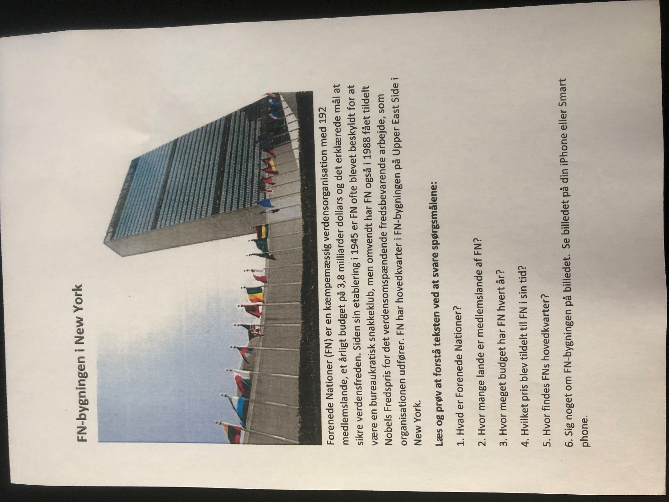

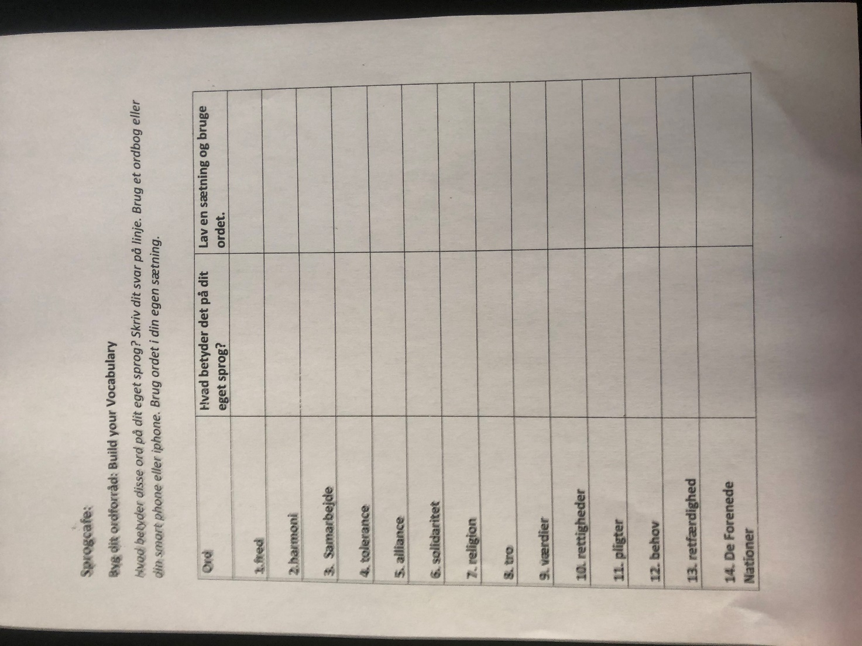

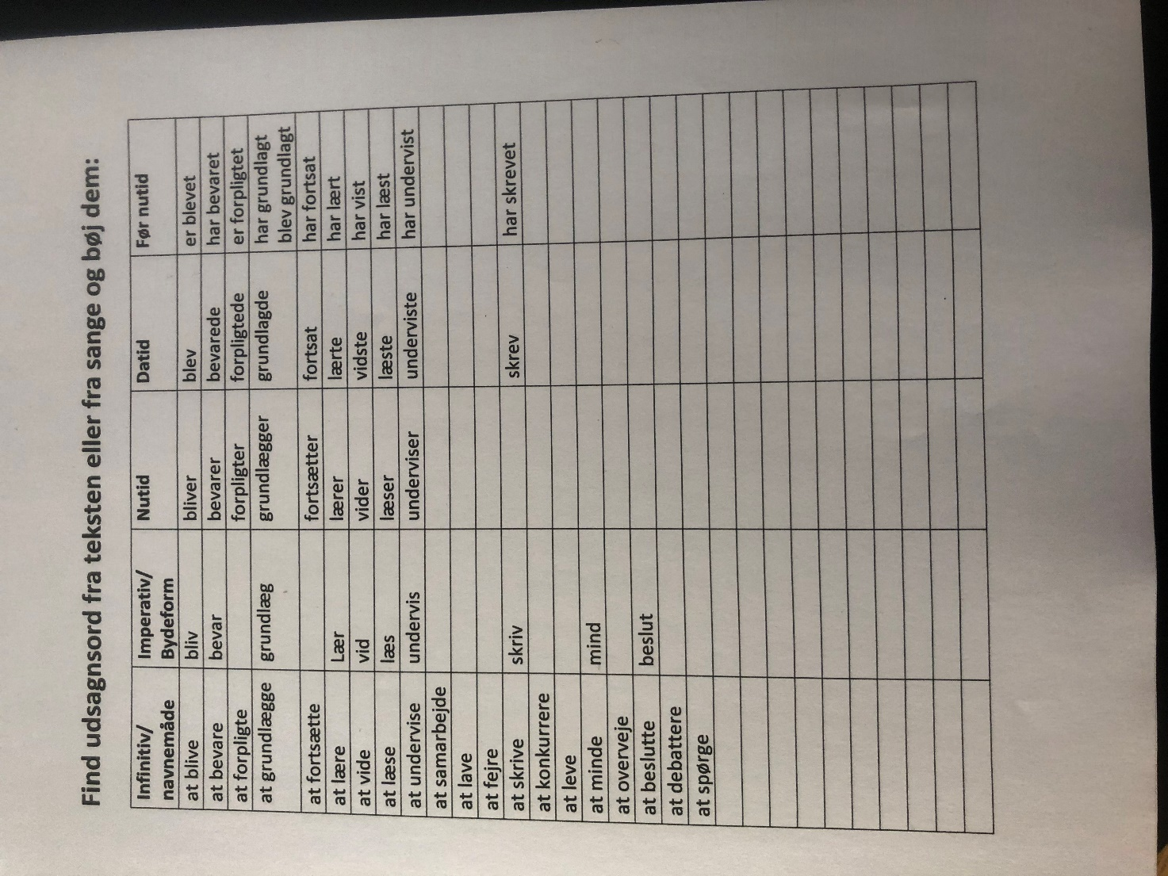

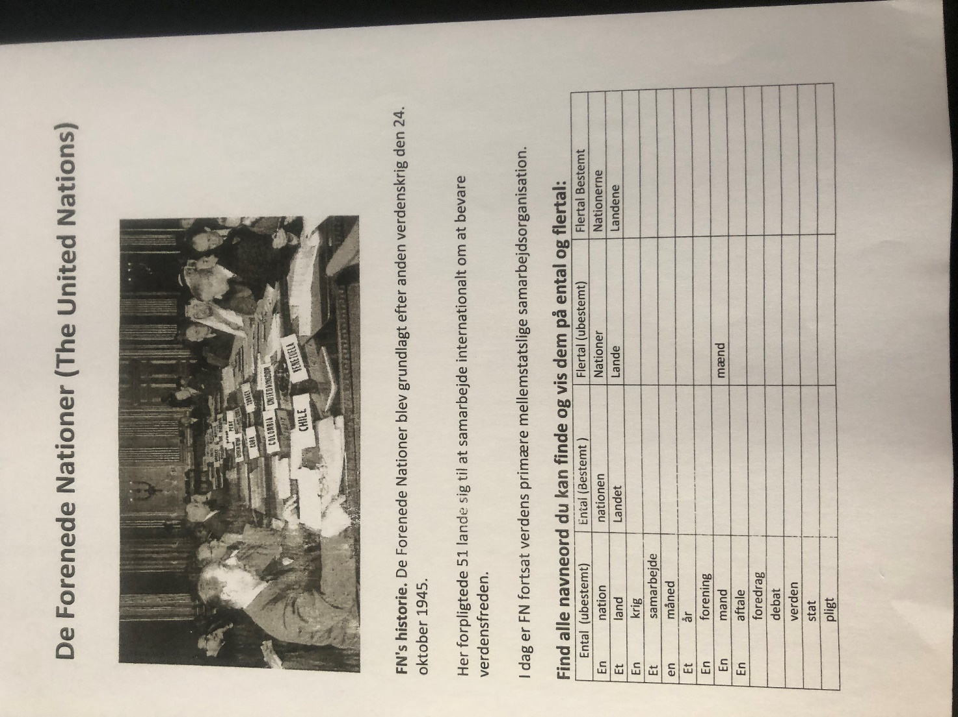

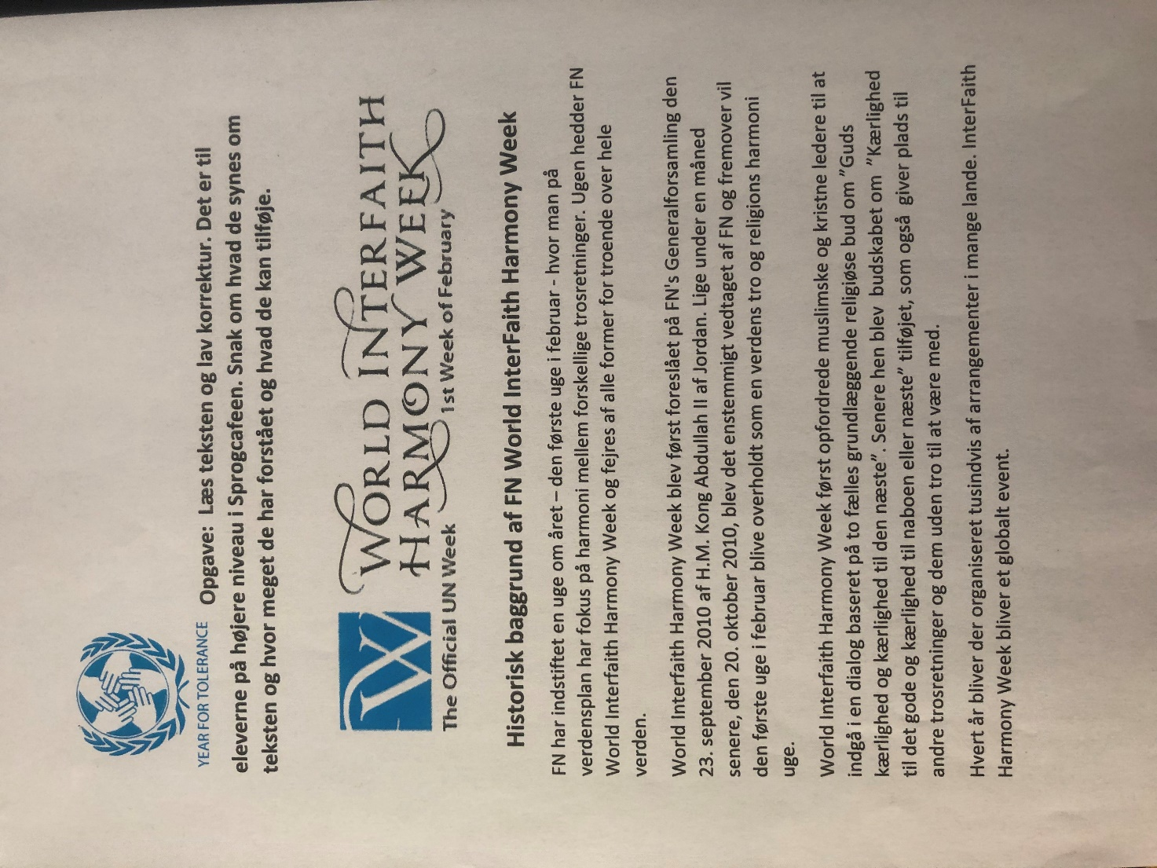

Report submitted: Elizabeth Padillo Olesen, March 3, 2022
Cross-Cultural Ministry of Kolding Deanery in Denmark

