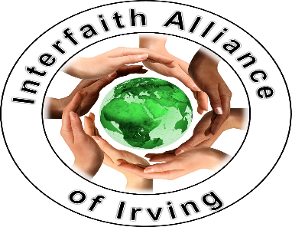
IAOI Celebration of WIHW, held Feb 5, 2022, from 2-3pm CST via Zoom
REPORT
Without a doubt, today’s observance of World Interfaith Harmony Week (WIHW) organized by the Interfaith Alliance of Irving (Irving, TX) to further the practice of “Love of God and Love of the Neighbor” was a great success. Our organization is almost two years old, and this was our first marking of WIHW, though actually almost a year ago (Feb. 3, 2021), we had gathered at a municipal building to offer interfaith prayers for Irving’s Covid-19 victims and their surviving loved ones. At that time the City of Irving had set up in the Jack D Huffman Building a wall display of caricatures of the deceased with their names and ages. Six faith groups were represented then, with ten prayer givers.
This week in North Texas we experienced prolonged subfreezing temperatures and snow that caused us to move our planned gathering for WIHW from outside at an Irving Park to the Huffman Building again. Lingering ice, though, made us reconsider that and we switched to a virtual-only gathering.
It was a captivating and inspired convergence of prayers and uplifting songs - some in their native tongues - that included prayer givers from the following faiths: Baha’i, Sikhism, Dawoodi Bohra Islam, Hinduism, Judaism, Buddhism, Zoroastrianism, Unificationism, and Scientology. Songs offered were also from diverse faiths: Baha’i, Hindu, Judaism and Unificationism.
As advocates of interfaith peace and harmony, passing this baton on to our youth is critical. For this reason, we were truly gladdened by the range of ages in our actual participants. Half of our participants were adults in their 70’s to 30’s and the other half were youth ages 22 -11 years of age. The songs they chose to sing were penetrating and moving. We were joined by observers from throughout America, with one guest from Canada. In all 26 screens stayed with us over the course of the hour which represented 37 persons.
At the meeting’s conclusion we all felt a great sense of being one in the spirit of unity. The Alliance looks forward to expanding the awareness of our interfaith cooperation and pursuing activities centered on serving our community. We will surely observe WIHW on a growing scale in the years to come!

Sincerely,
The Interfaith Alliance of Irving

