Report on “World Interfaith Harmony Week 2021”
In connection with
“International Day of Human Fraternity"
Date: Feb. 5, 2021
Report by: Mr. Binod Dangi,
Contact: binoddangi@gmail.com
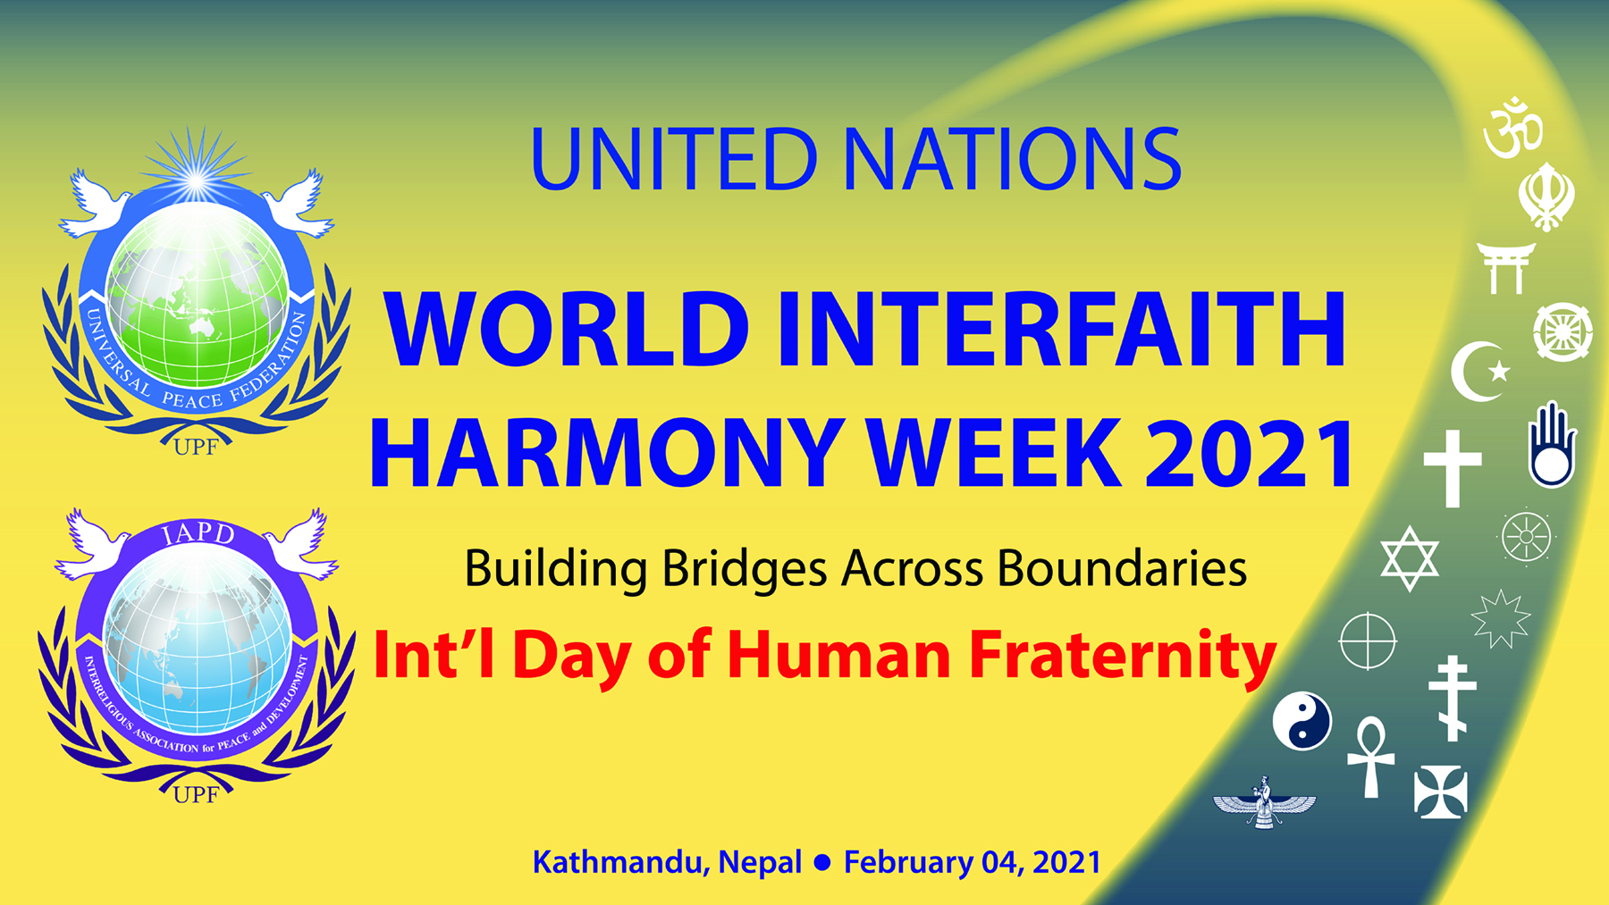
In the celebration of the World Interfaith Harmony Week 2021, in conjunction with the International day of human fraternity, organized a talk program in Nobel Academy, Kathmandu, Nepal which is supported by Universal Peace Federation Nepal.
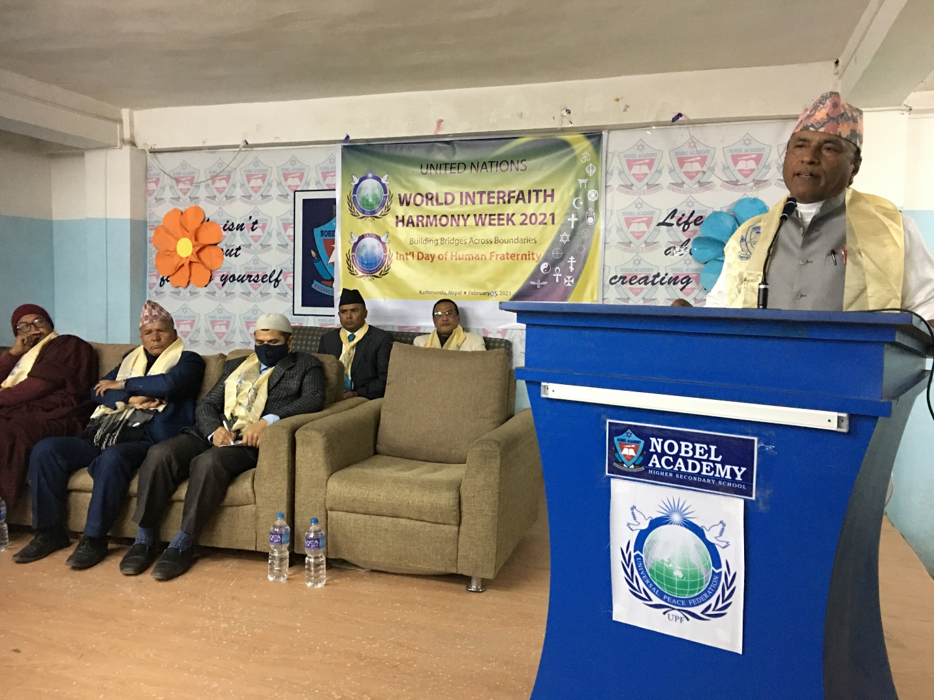
Professor Swami Vinod Aananda, representing Hinduism spoke on the topic where peace starts from one's own self management and discipline; where he also said, peace is there were there is harmony.
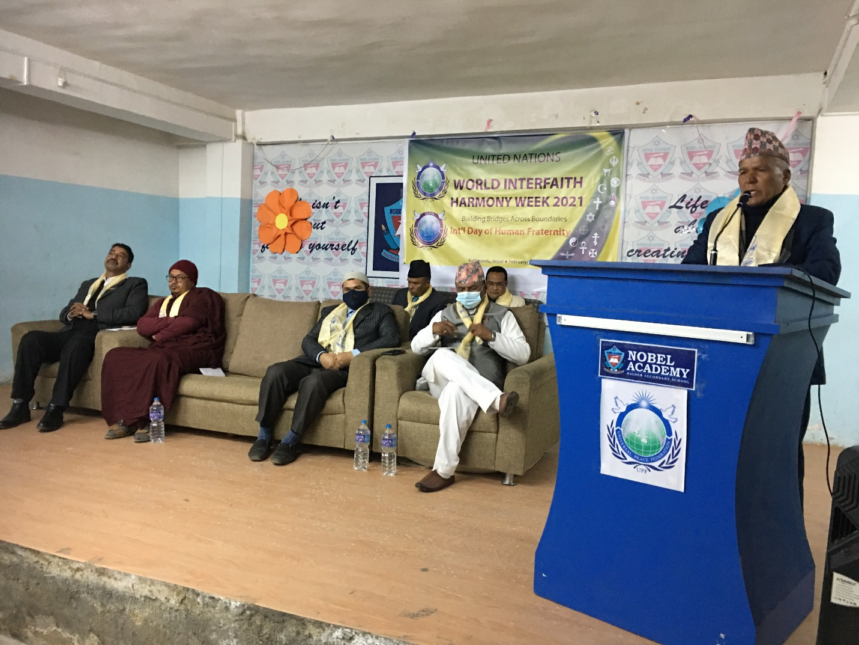
Prof. K. B. Rokaya, a Christian Leader, emphasized on the acceptance of Harmony Week by the UN which is a great beginning for world peace. UPF focused on 3 aspects, peace, religious harmony and promotion of family value which is what is needed the most in today's era. Moreover, he emphasized on living by overcoming every challenging circumstances and one must prepare to die happily with no regrets.
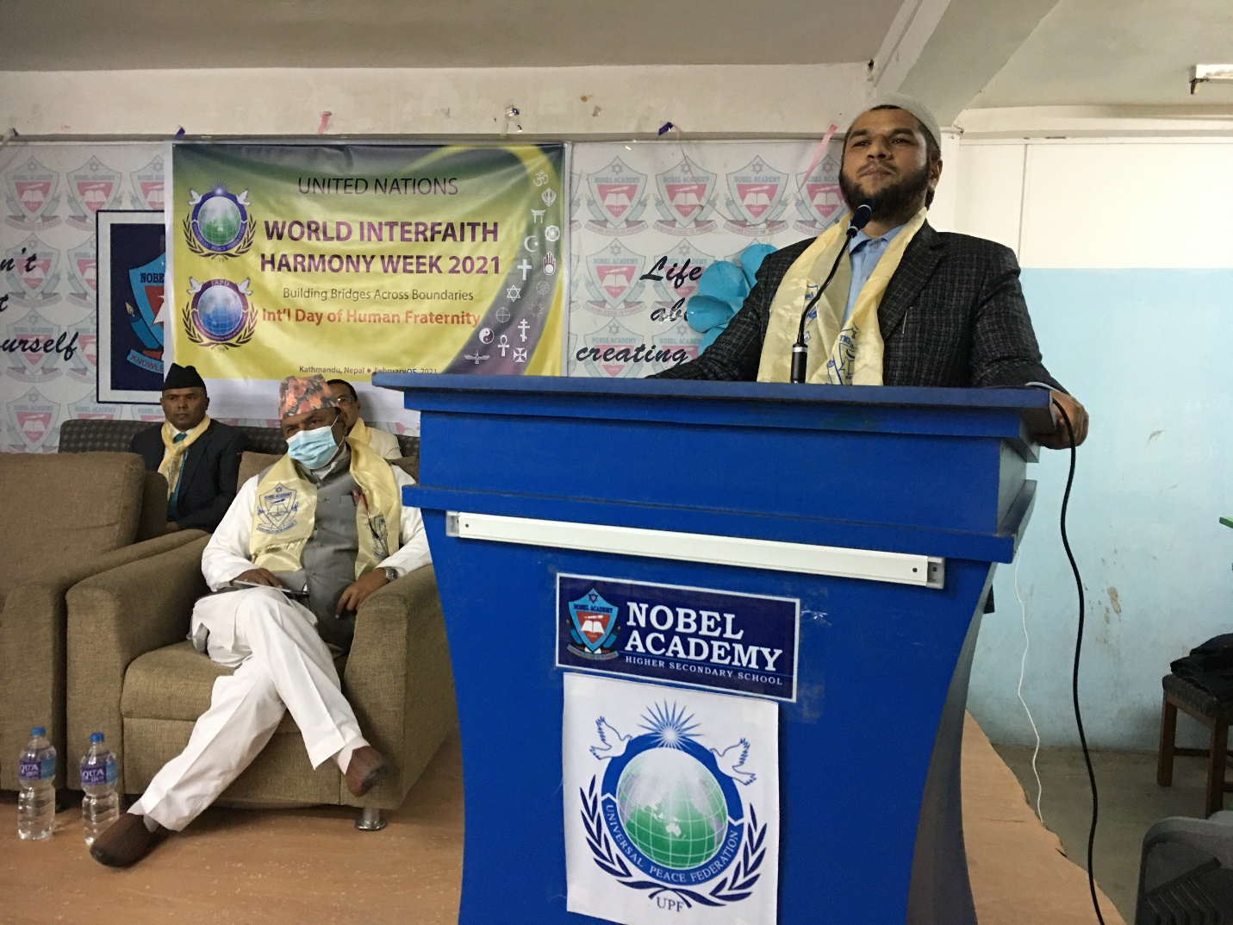
The Islam leader, Moulana Abul Kalam Mia, spoke on developing one's own good character in our life and leaving a way of social problems.
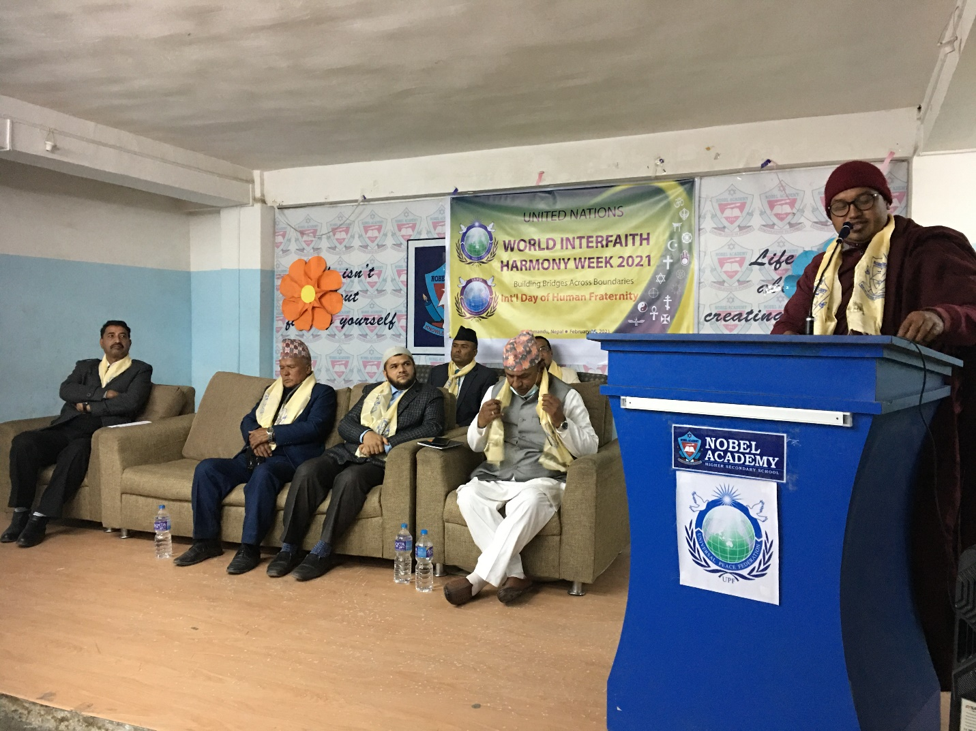
The Buddhist leader, Ven. Bhante Piya Dassi said, “An education of peace is what builds an ideal world rather than an education of violence.” He also said, “Science without religion is lean and religion without science is blind.”
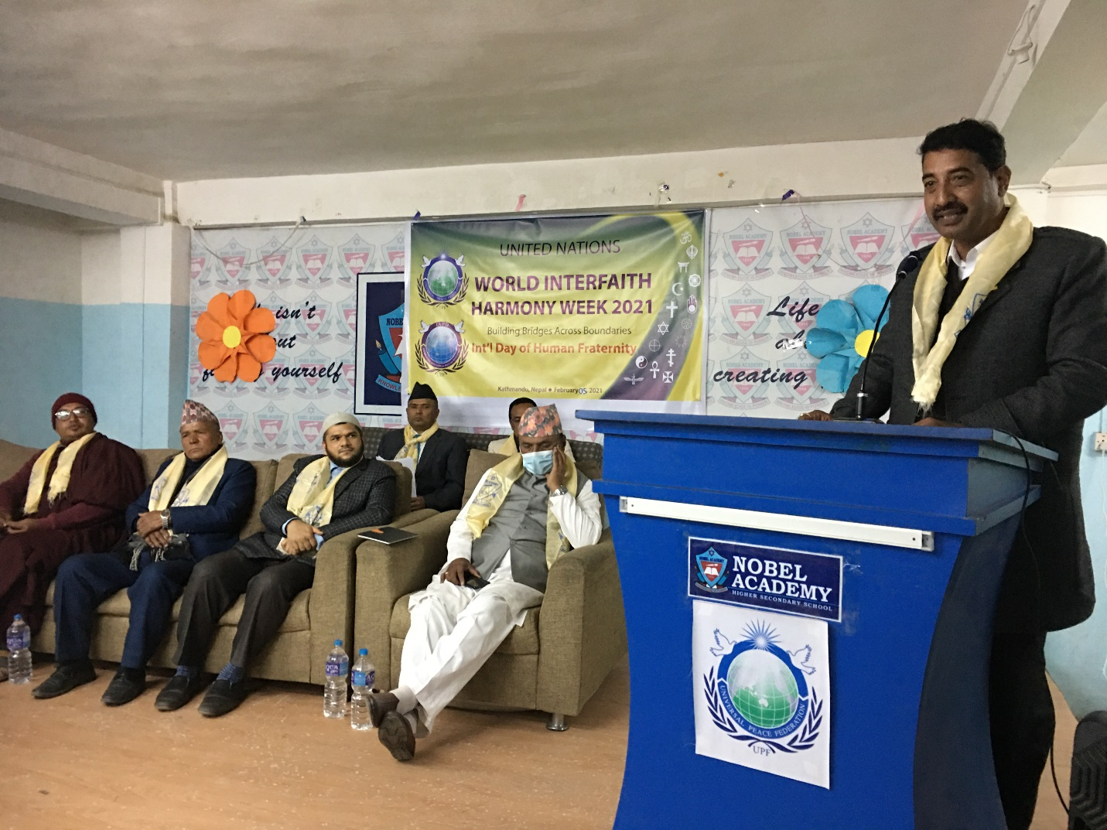
Chairperson of the program, Mr. Surendra Shrestha, Founder of Noble Academy, mentioned that he was grateful to UPF, the host of the program, UN World Interfaith Harmony Week which was conducted in his college premises.
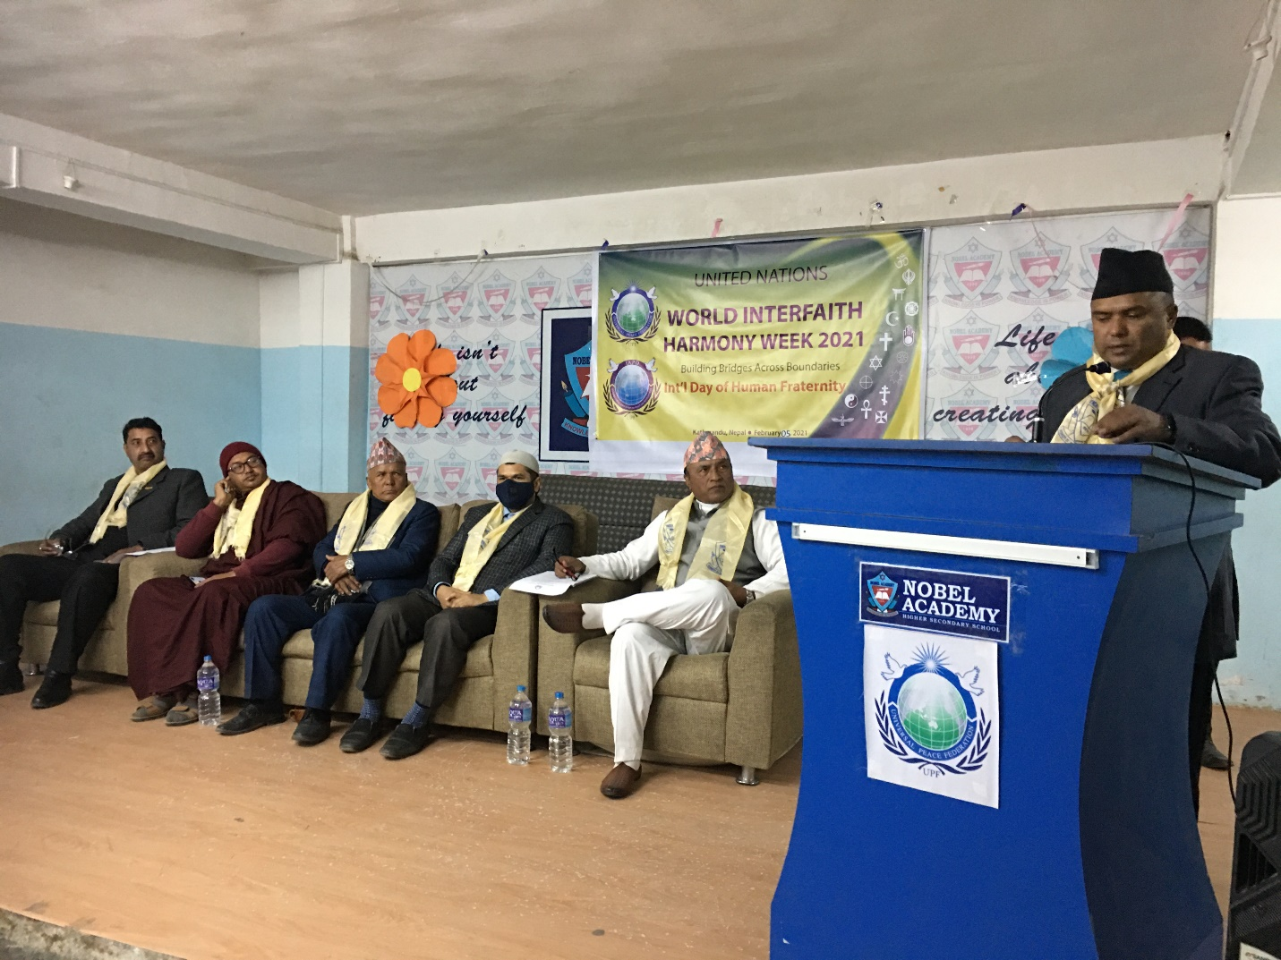
Mr. Binod Dangi, Secretary General of UPF- Nepal, recited the statement of World Interfaith Harmony week, "Building bridges across boundaries."
All the religious leaders made their solidarity for the International day of human fraternity.
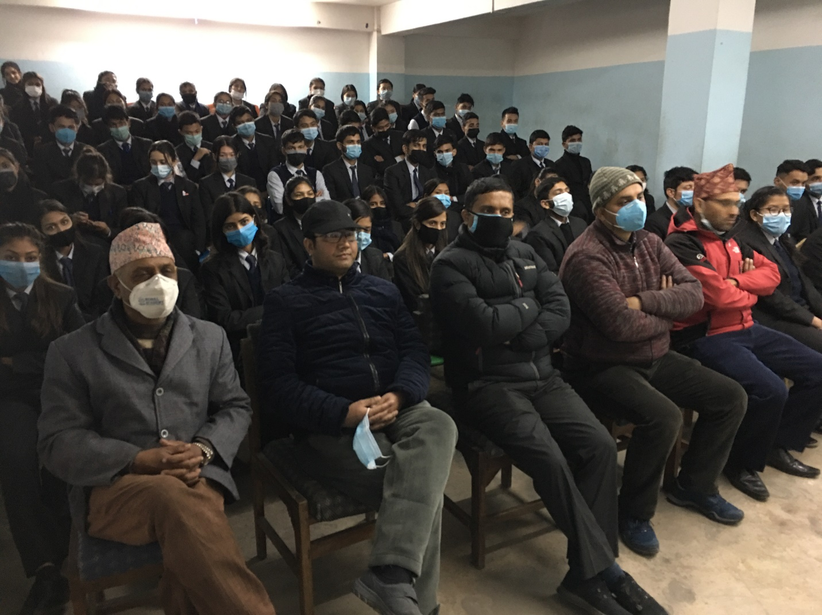
Participants of the program.
Thank you very much.

