**WIHW: EVENT REPORT SUBMISSION**

**PF/PFI Interfaith ‘Harmony in crisis…’ February 7, 2021**

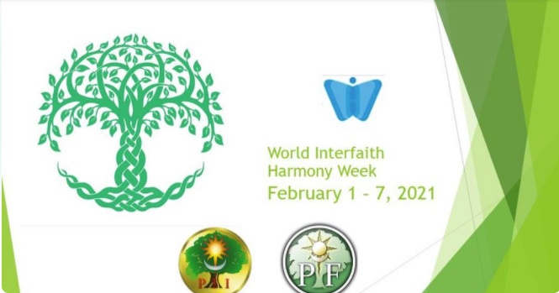

Facebook: <https://www.facebook.com/events/195726712253925?active_tab=about>

Pagan Federation International: <https://www.facebook.com/paganfederationinternational/>

Livestreamed: <https://www.facebook.com/paganfederationinternational/videos/3646980058725798>

On Sunday February 7, 2021 PF and PFI came together for an online gathering.

“Harmony in crisis..” The issue of interfaith dialogue and the language one uses in order to engage and initiate honest and positive conversations is a topic that is ever present. Especially considering the interaction between the pagan/heathen communities and those of other faiths and how we build bridges to create harmony, more so in a world that is currently in the midst of huge transformations and transitions. Our guest speaker was Lyn Baylis from Pagan Seminary. She is an experienced interfaith practitioner and she shared her insights and best practices with respect to finding a common language, and a common ground on which we can build a more harmonious dialogue.

There were numerous questions from attendees with regard to communicating with those who are too ill to speak. Or can’t be reached because of being quarantined during this COVID crisis. We discussed the power of prayer and visualising our loved ones and sending healing energy.

Kiran Bali was our second guest speaker. Kiran is a URI Global Trustee-at-large. She too talked about communicating but also emphasised the need to ‘Walk the Spiritual talk’. Too often we hear people saying one thing but doing something quite the opposite. She talked about the importance of the environment, Mother Earth, animals and all living beings.

After a lively discussion Morgana closed the gathering with a prayer to Brigid at the season of ‘Imbolc’.

Blessed Be, Hail Brigid!

