China World Peace Foundation launched "peaceful space exploration" initiative

Date：2021-Febrary-04 - ROSA DALMIGLIO-World Peace Journalism
On August 6, the international science &technology salon of "peaceful use of Mars and expansion of human civilization" jointly sponsored by China World Peace Foundation, Embassy of the United Arab Emirates in China and Mars Society（China） was successfully held in Beijing Peace Garden Museum. The purpose of this event is to strengthen the international cooperation relationship through dialogue and communications, and promote the "space technology" and "public welfare" along the Belt& Road. Diplomats, research organizations, entrepreneurs, representatives of science &technology &culture, and youth representatives from over 12 countries along the Belt &Road in Europe, America and Africa, participated in the event.

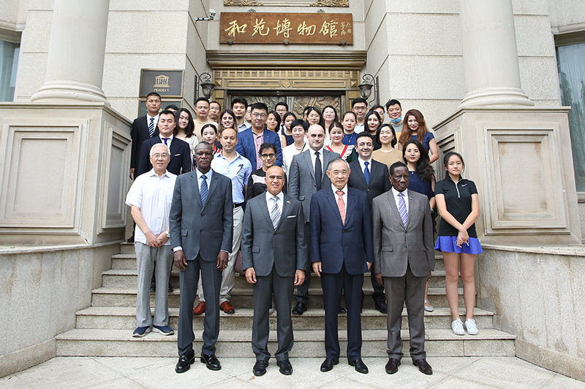
This event puts forward the "peaceful exploration of space" initiative. The initiative says: "the achievements of various countries in exploring Mars show the progress of human civilization of science and technology . The Mars spacecrafts of U.A.E.'s hope, China's Tianwen-1 and the U.S.'perseverance 'have been launched one after another. To surpass over space is the starting point of our dream. We advocate the set up of harmonious safe and shared space order,the cherishing of space resources , the promotion of Belt&Road space science&technology public welfare and the benefit of mankind.

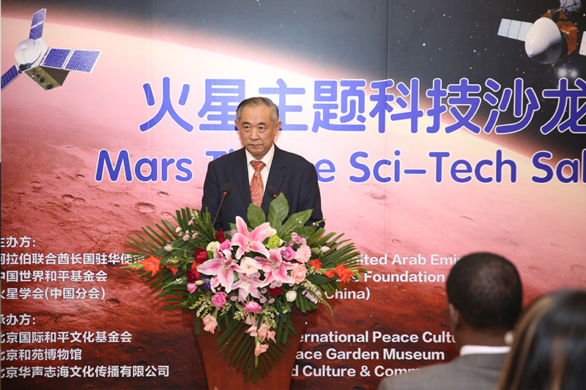
Picture:Dr. Li Ruohong, Chairman of China World Peace Foundation, President of Beijing International Peace Culture Foundation.

Dr. Li Ruohong, chairman of China World Peace Foundation and President of Beijing International Peace Culture Foundation, said in his speech that studying Mars has practical and far-reaching significance for understanding the evolution of the earth, carrying out space peace dialogue, cherishing space resources, disseminating multi cultures, promoting industrial development, expanding the international circle of scientific and technological friends, and benefiting mankind with wisdom. Through the "Belt&Road Cultural Interactive Atlas" with the UNESCO scientific planning, we support the educational, cultural, tourism workers and young friends of all countries to contribute to the great cause of peace and technology.

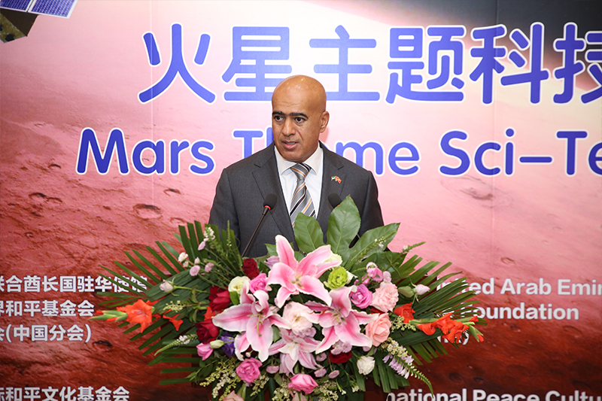
Picture:UAE Ambassador to China,H.E.Dr. Ali Obaid Al Dhaheri

H.E. Dr. Ali Obaid Al Dhaheri, Ambassador of the United Arab Emirates to China, congratulated China on the successful launch of tianwen-1 and introduced the progress and achievements of UAE's "Hope" and other Mars projects. He said that China and UAE are moving in the same direction and believe that together they can stimulate human imagination and inspire people all over the world.
Ms. Ling Ziyan, chief planner of Mars Society in China, introduced the history of human yearning for and exploration of Mars, as well as related activities of the Chinese branch of Mars Society. Mr. Man Dumai, head of the North China division of the Mars Society, shared his experience of witnessing the launch of Tianwen-1.
The project director of Huasheng Zhihai Cultural Communication Co., Ltd.
introduced the Mars Base 1 Touring Base project, its Space C Programme is committed to making a voice for China's space industry, expanding China's influence of Space aviation, and stimulating the young generation's enthusiasm for space exploration and helping the development of China's space industry by means of experiential and interesting science popularization.

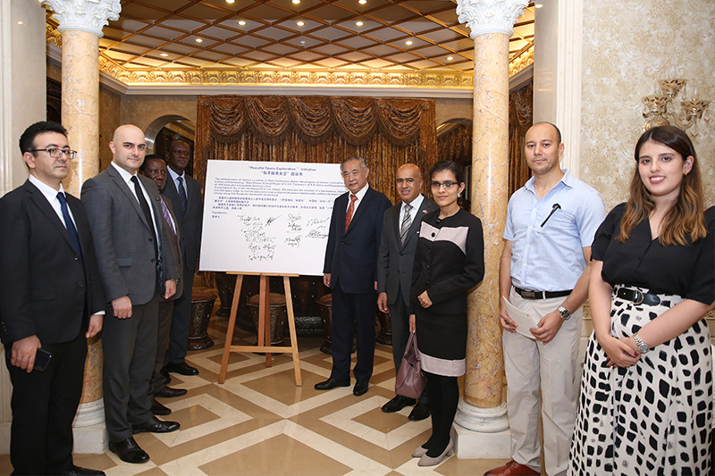
It is informed that the event was undertaken by Beijing International Peace Culture Foundation, Beijing Peace Garden Museum and Beijing Huasheng Zhihai Cultural Communication Co., Ltd.

头条推荐
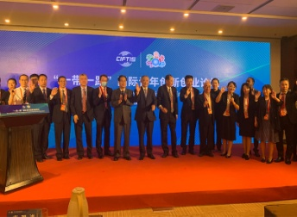
LiRuhonglaunchedCoop...
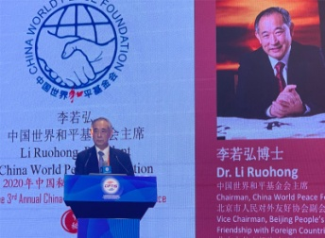
LiRuohonginSinoPeruI...
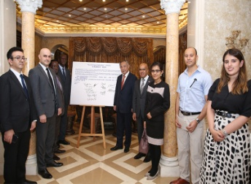
ChinaWorldPeaceFound...

