WORLD INTERFAITH HARMONY WEEK
PEACE NETWORK – PAKISTAN
REPORT OF EVENTS
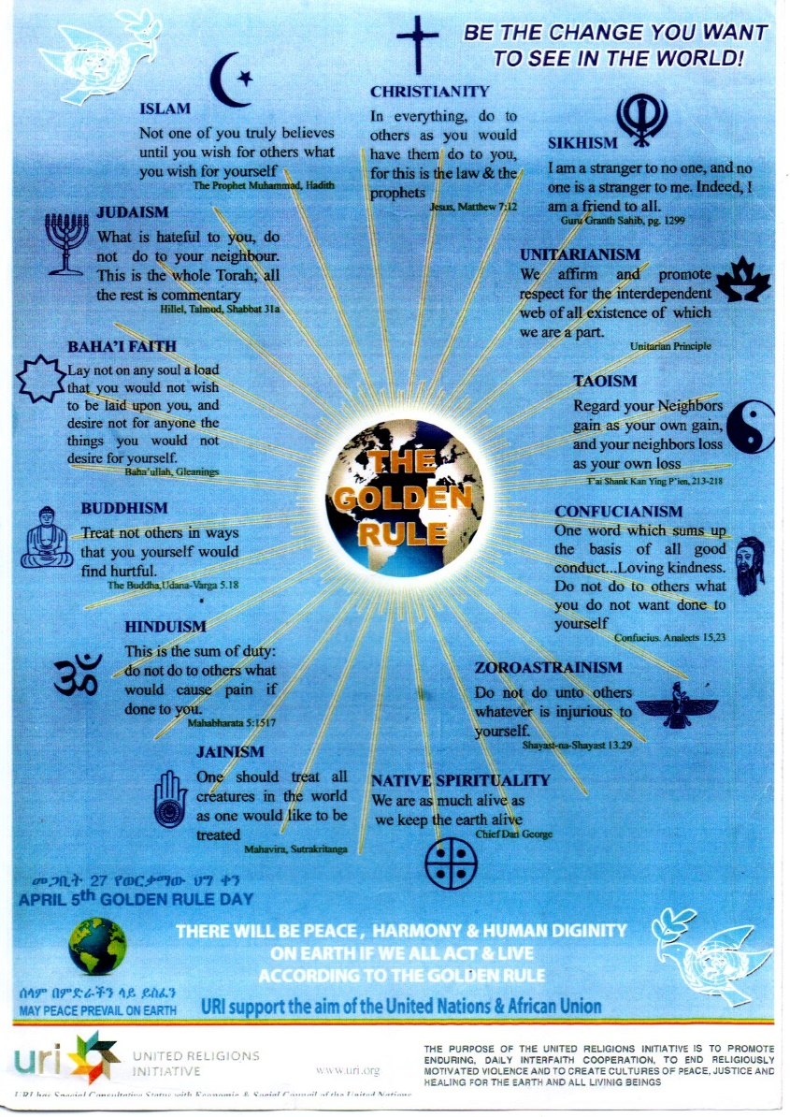

Organizer: Jibran Masih Gill (Coordinator)
United Religions Imitative (URI – CC)
Venue: Rawalpindi / Islamabad – Pakistan
Contact No: 0333-5693082 (WhatsApp)
Email: jibrangill333@gmail.com
Day 1 – 1st February 2021
Participants:
- Molana Muhammad Nasif Mahmood (Coordinator for District Rawalpindi - Human Rights
and Minorities Affair Govt of Punjab Pakistan).
- Molana Hazrat Qari Younas Hazrvi (Khateeb Jamia Masjid Raja Bazar Rawalpindi)
- Molana Shahbaz (Khateeb Jamia Masjid Ganj Mandi Rawalpindi)
- Ijaz Gill (Religious Scholar)
- Ch. Muhammad Asif Mehmood (Religious Scholar)
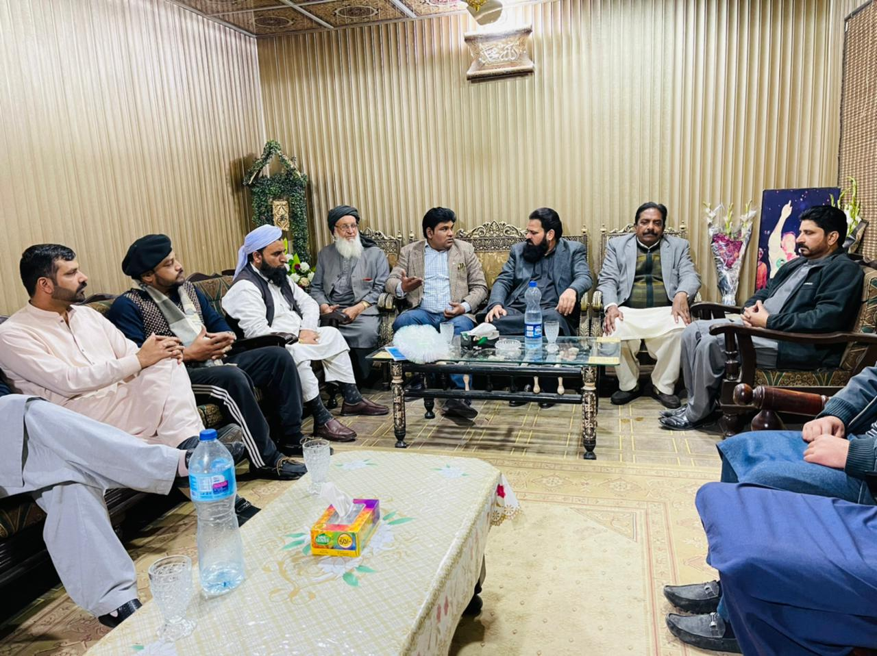
Molana Nasif Mahmood has provided space for meeting a very well come to me, and I am very much happy that we have all agreed at world interfaith harmony, all has appreciated this effort and all participants has made solidarity by putting golden rule interfaith page in display.
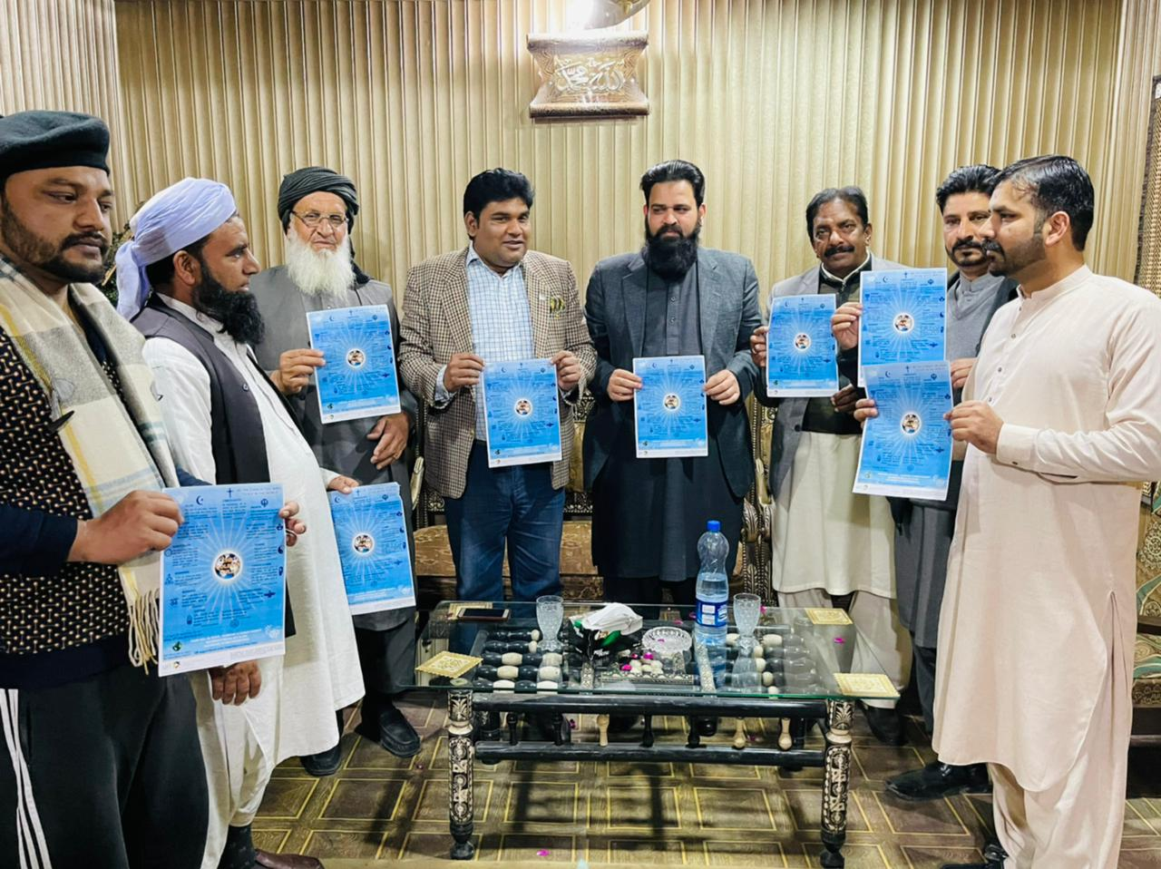

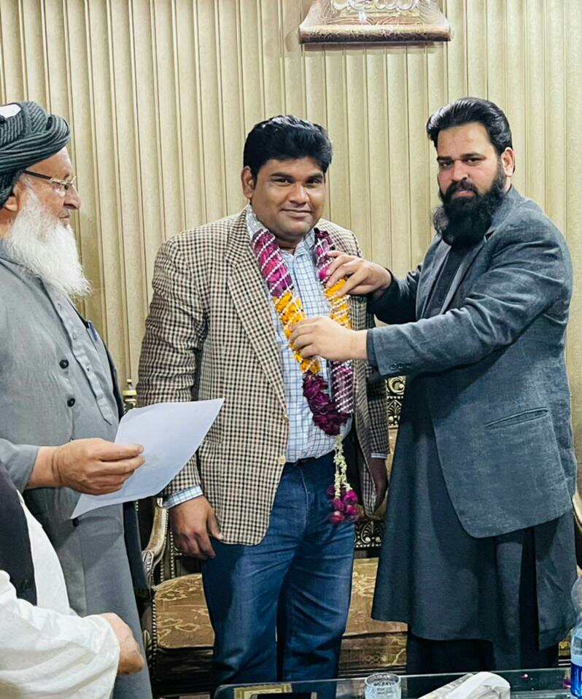

I have Another meeting was held with Miss Faiza Kanwal (CEO - Health Department, Govt. of Punjab, Pakistan)
I have joined her in her office and given a briefing at world interfaith harmony and presented her golden rule interfaith harmony. She has appreciated the efforts made in this regard. She was very happy at this activity.
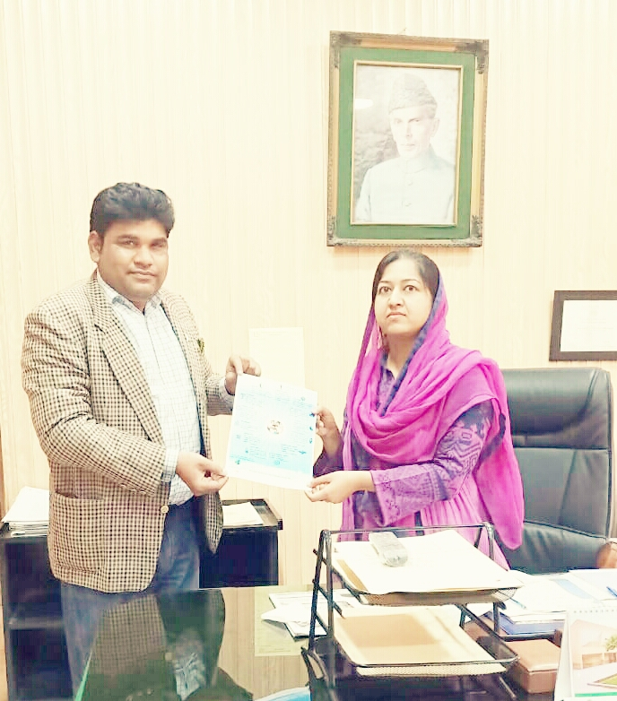

Day 2 – 2nd February 2021
Participants:

1. Archbishop Dr. Joseph Arshad - Rawalpindi / Islamabad
2. Dr. Sassi Malik Sher - Deputy CEO Chaklala Cantonment Board Rawalpindi Govt. of
Pakistan.
3. Fr. Anthen Ilyas - Parish Priest Lalkurti Catholic Church Rawalpindi Cantt.
4. Sr. Thecla Barkat - Incharge Catherine's Hostel
5. Sr. Alice Lezar - Principal St. Catherine's Convent School
6. Sr. Gulnes - President St. Convent School
7. Sr. Serwat - St. Convent School
8. Sr. Iram - St. Convent School

Venue:

Catholic Church, Lalkurti Rawalpindi Cantt, Pakistan
In Catherine's hostel, we have provided food items to needy students of all religions and provided awareness to them about interfaith harmony world week.
All appreciated this effort of world week and said that this is a need of time right now and this is actual humanity. I think that with this activity of interfaith harmony week we have provided awareness to many people and this effort will result more peace in world.
More to add that me and Dr. Archbishop Dr. Joseph Arshad Rawalpindi have welcome to Madam Dr. Sassi Malik Sher - Deputy CEO Chaklala Cantonment Board, Rawalpindi Govt. of Pakistan to Bishop House, and there was a cake cutting ceremony together regarding interfaith world harmony week. She has delivered her message that we all are united for world interfaith harmony.
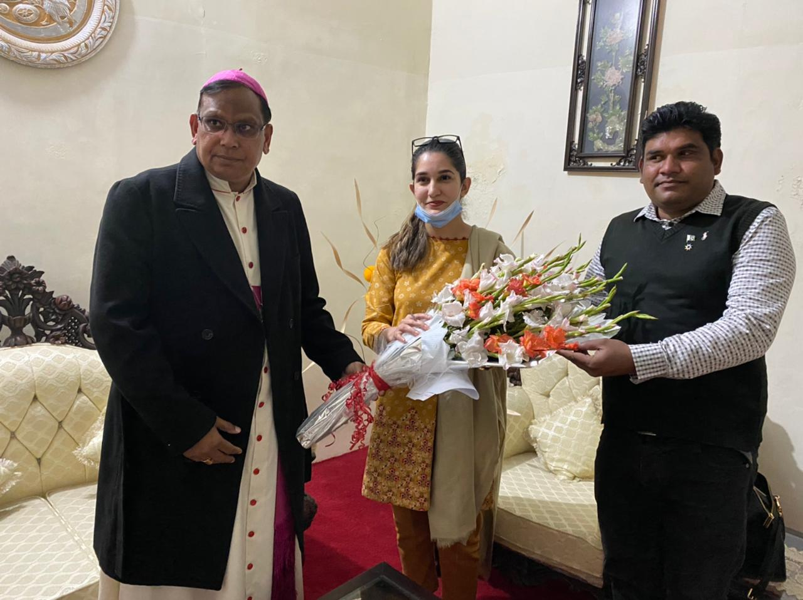
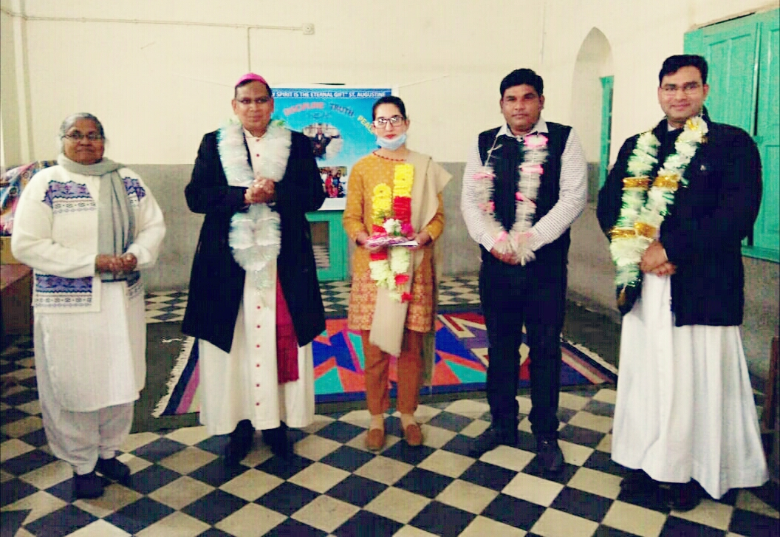

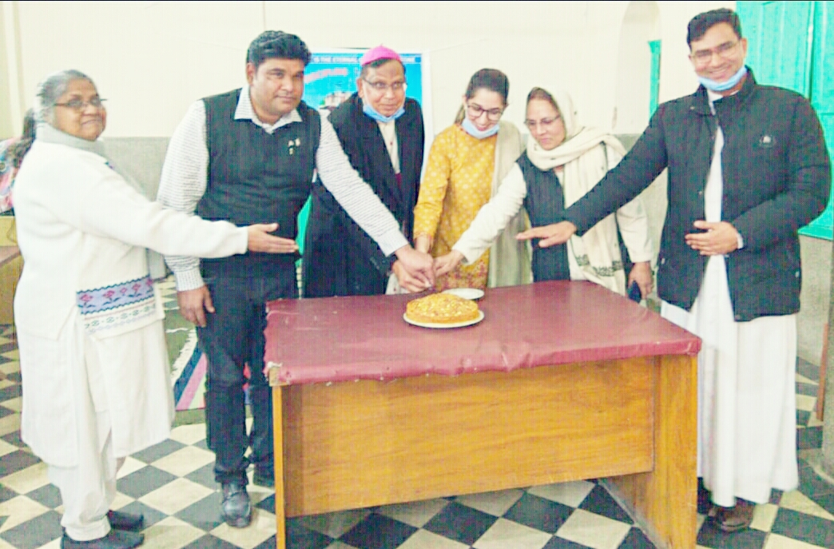
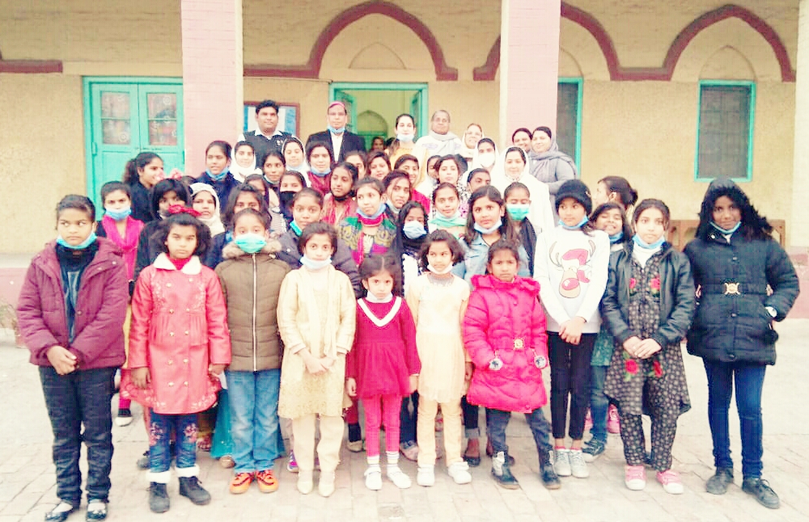

Day 3 – 3rd February 2021
Participants:

1. Pir Syed Muhammad Izhar Bukhari - Chairman Interfaith Committee - Govt. of Punjab,
Pakistan - Chairman District Peace Committee Rawalpindi Division, Pakistan - Member
Royait-e-Halal Commitee.
2. Om Parkash Narrain - General Secretary All Hindu Punchayat Balmike Sabha, District
Rawalpindi Pakistan
3. Daleep Kumar - President All Hindu Punchayat Balmike Sabha, District Rawalpindi
Pakistan.

Venue:

Markzi Jamia Masjid Muhammadi Lalkurti, Rawalpindi Pakistan

I have delivered a message of world interfaith harmony week to Pir Sb and discussed in detail about unity of all religions and as this meeting was held in Jamia Masjid Muhammadi which is a sign of unity already. This is actual reflection of interfaith harmony and this will build up a more peaceful environment in the world. There was a strong message that all religions are united for peace. Pir Sb has congratulated upon this activity and was very much satisfied. At the end, we all have prayed for the unity of all religions and interfaith harmony for Pakistan and the world as well.
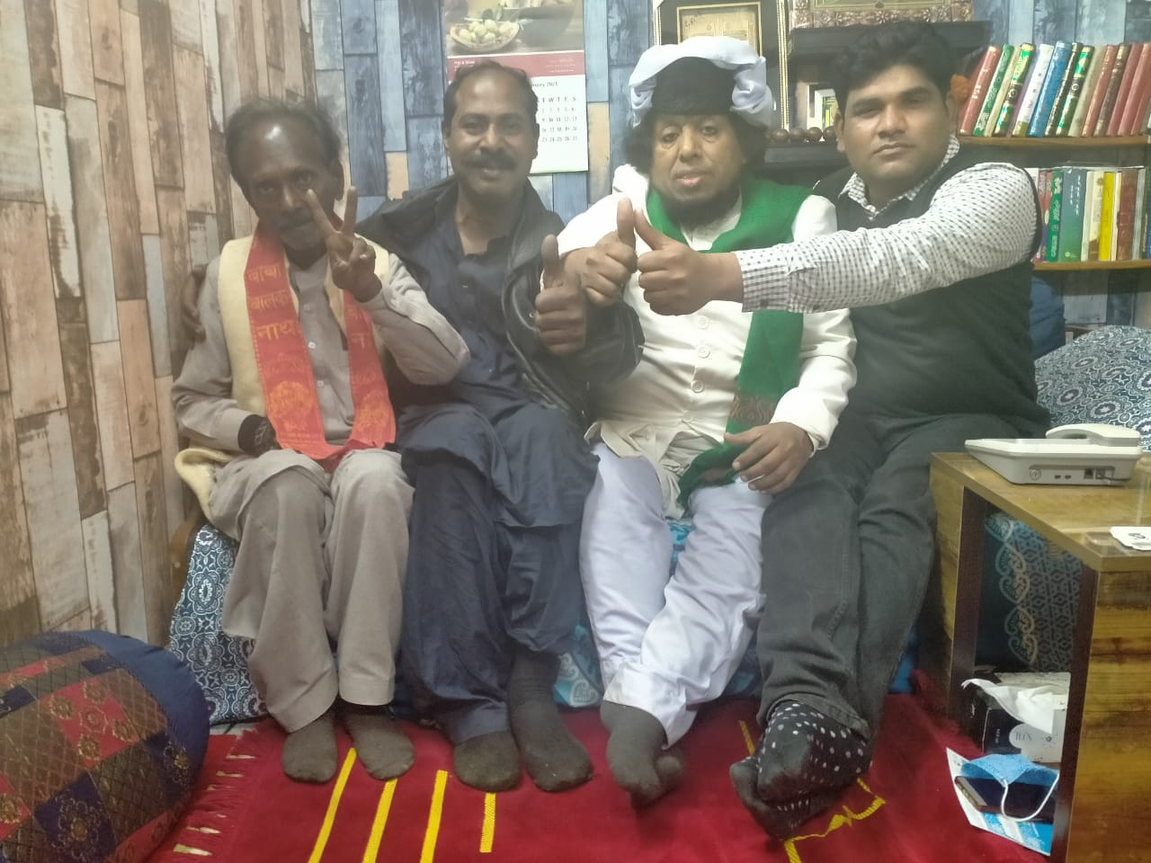

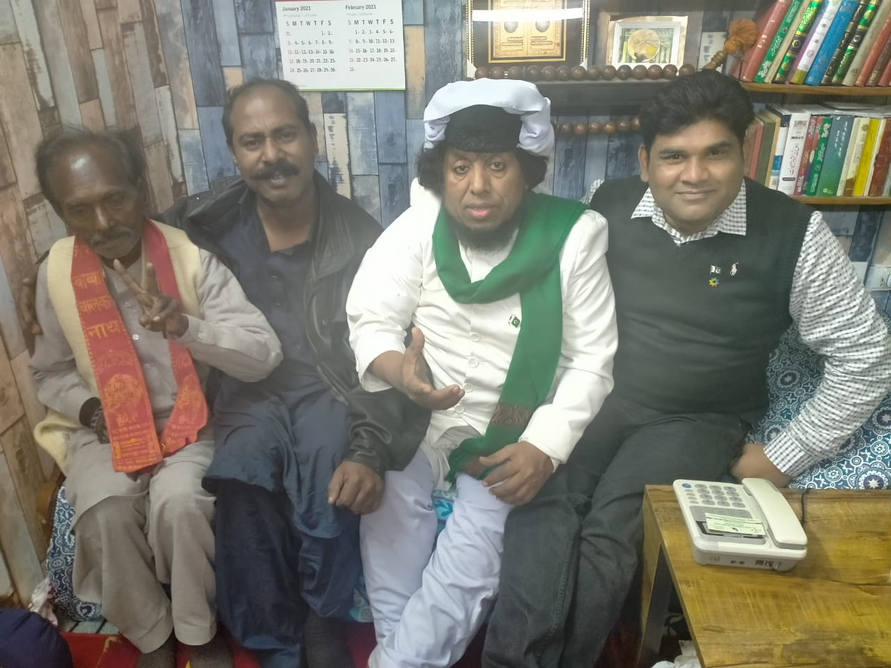

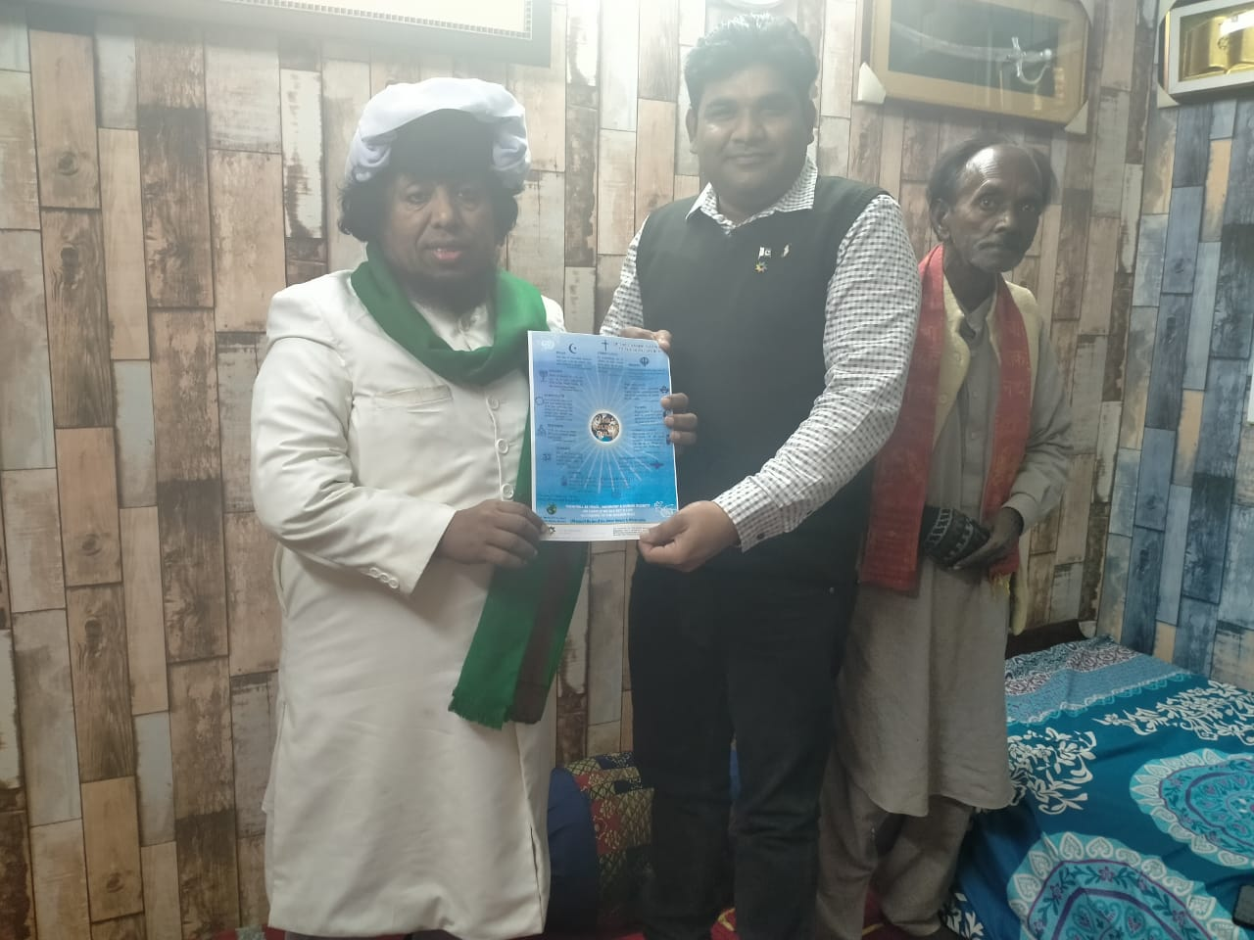
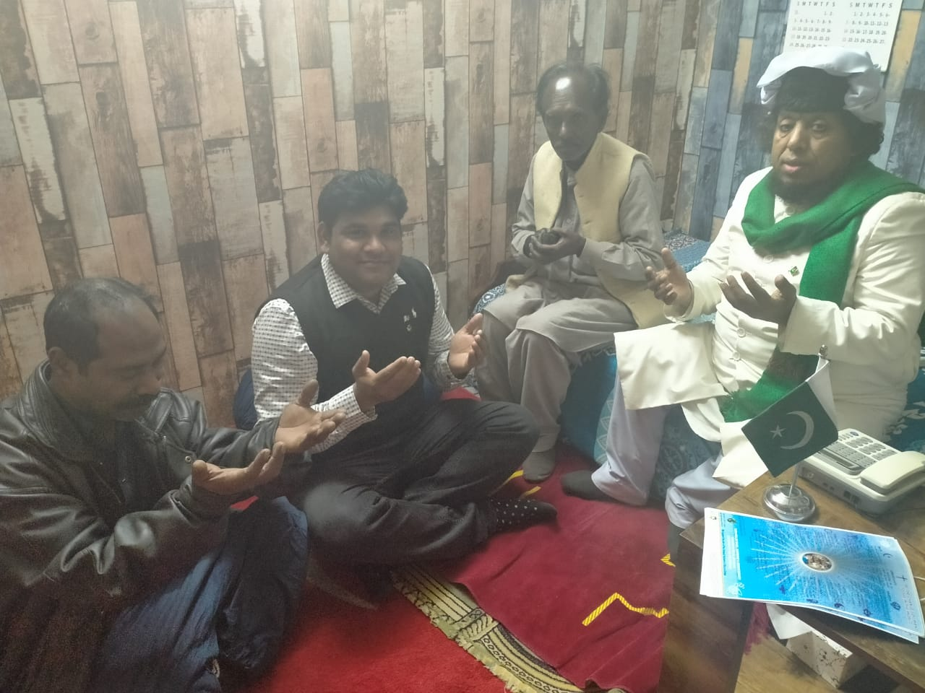

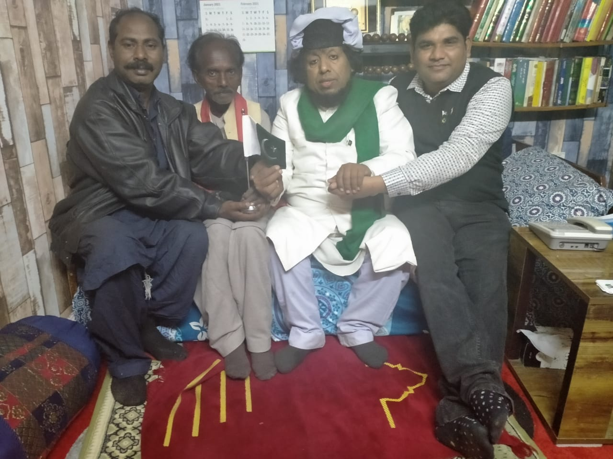

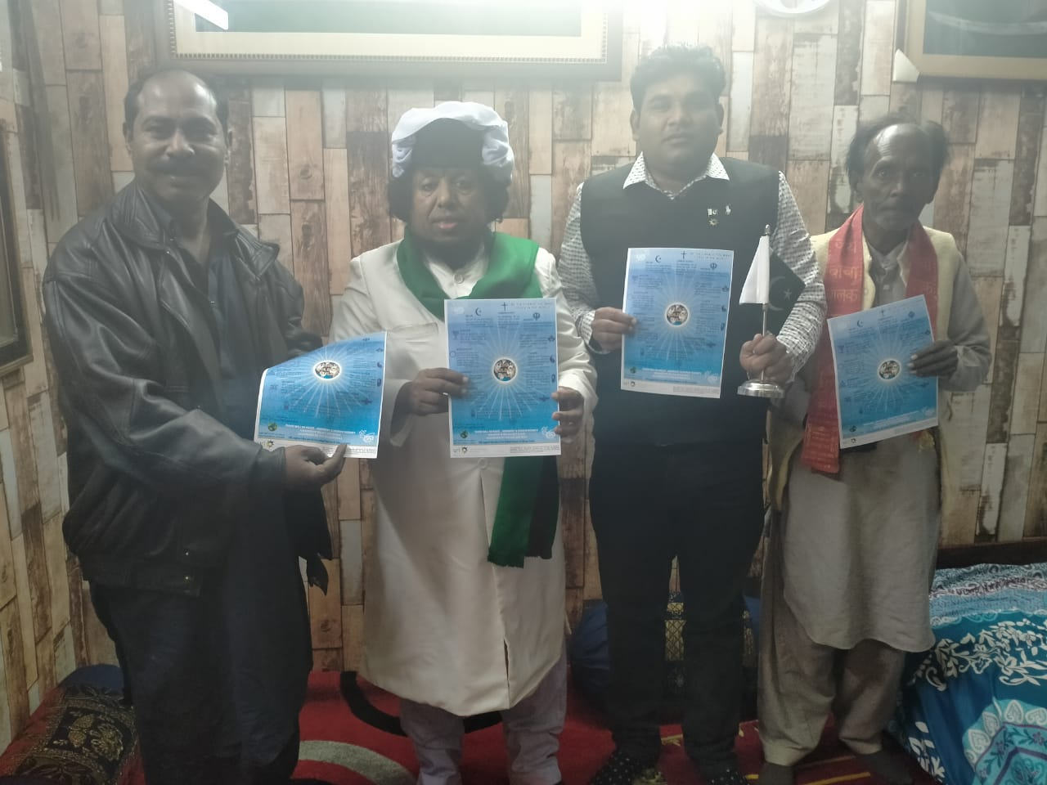

Day 4 – 4th February 2021
Participants:

1. Archbishop Dr. Joseph Arshad – Rawalpindi / Islamabad
2. Molana Iqbal Rizvi – Divisional Khateeb Markazi Jamia Masjid, Jamia Masjid Road
Rawalpindi, Govt. of Punjab - Pakistan
3. Molana. Nasif Mehmood - (Coordinator for District Rawalpindi - Human Rights
and Minorities Affair Govt of Punjab Pakistan).
4. Prof. Munawar – NUML University, Islamabad
5. Attaullah Imrani – Bahi Community

Venue:

Khatoon-e-Fatima Catholic Church, F-8/4, Islamabad, Pakistan

I have informed the participants about World Interfaith Harmony Week in detail and all participants have admired that this is very good effort for human being to get rid of religious violation. And this activity will surlily help to bring peace in Pakistan and all over the World. At the end of Seminar there was cake cutting ceremony.
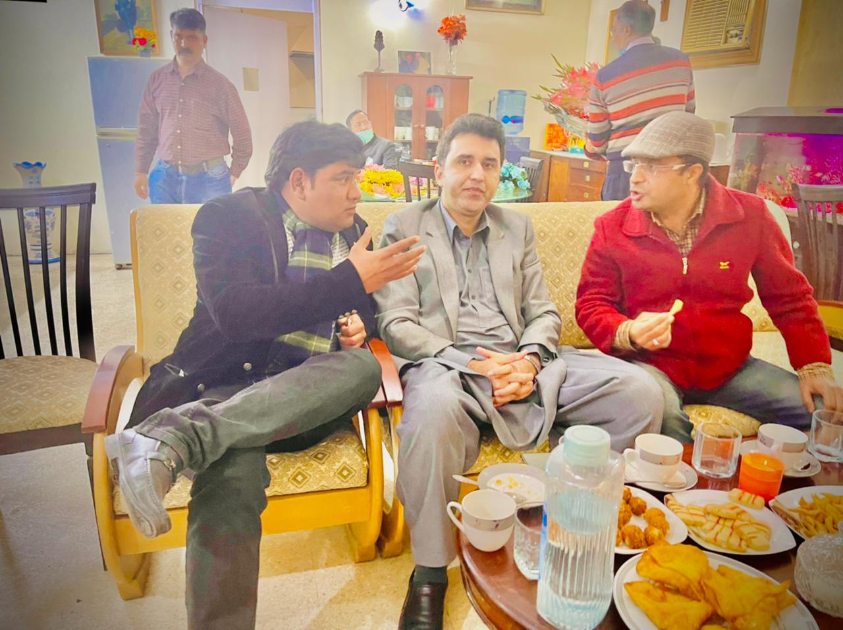

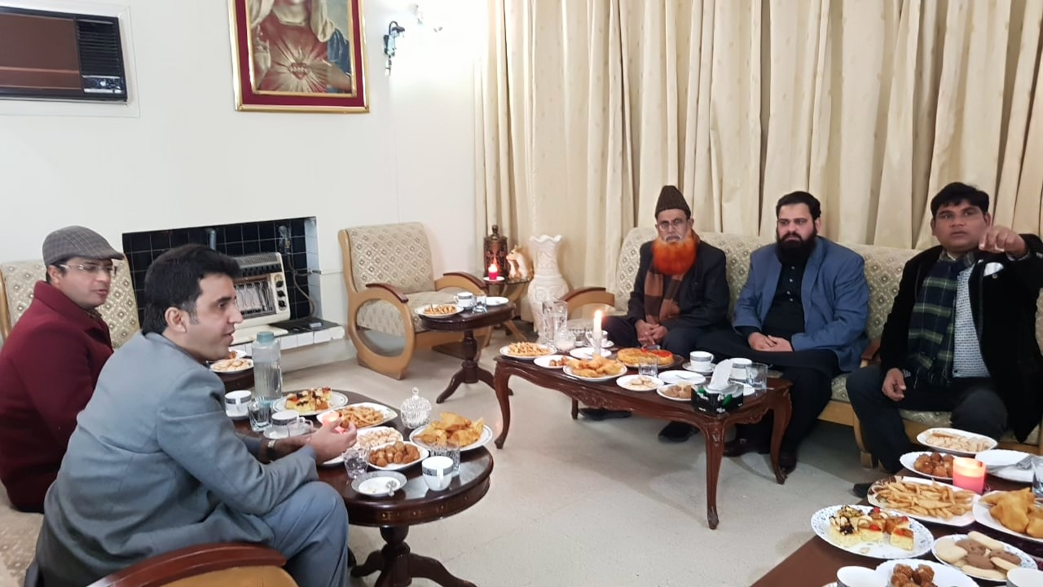

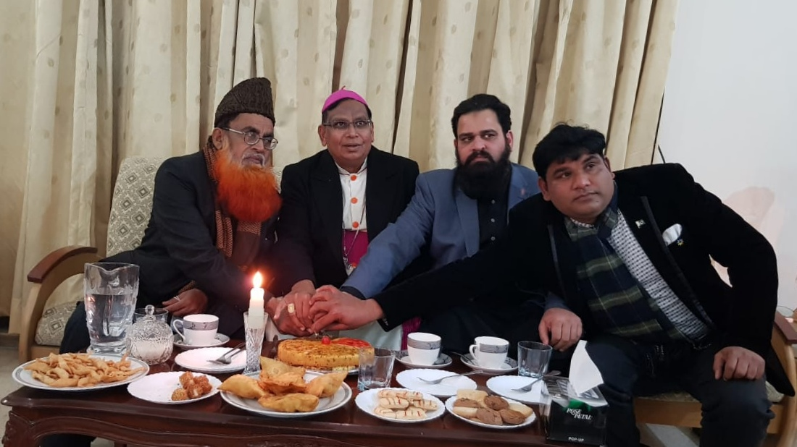

Day 5 – 5th February 2021
Participants:

1. Gurdeet Sardar Partaf Sing – Panja Sahab Hassan Abdal
2. Sarwar Masih Bhatti
3. Om Parkash – Secretary General All Hindu Panjchait, Lalkurti Rawalpindi Cantt Pakistan

Venue:

Gurdawara Panja Sahab – Hassan Abadal
Lalkurti Mandar

I have informed to preacher of both the religions about Interfaith Harmony Week and presented both of them Interfaith Harmony Golden Rule. I have informed that we are celebrating this week from 1st of Feb. 2021 to 7th of Feb. 2021. Which will promote peaceful Pakistan throughout the world. And we altogether of all religions are celebrating this week.
We think that this week is very important as this is the need of time in all over the world. We are learning a lot out of this week’s activities and people are appreciating Golden Rules.
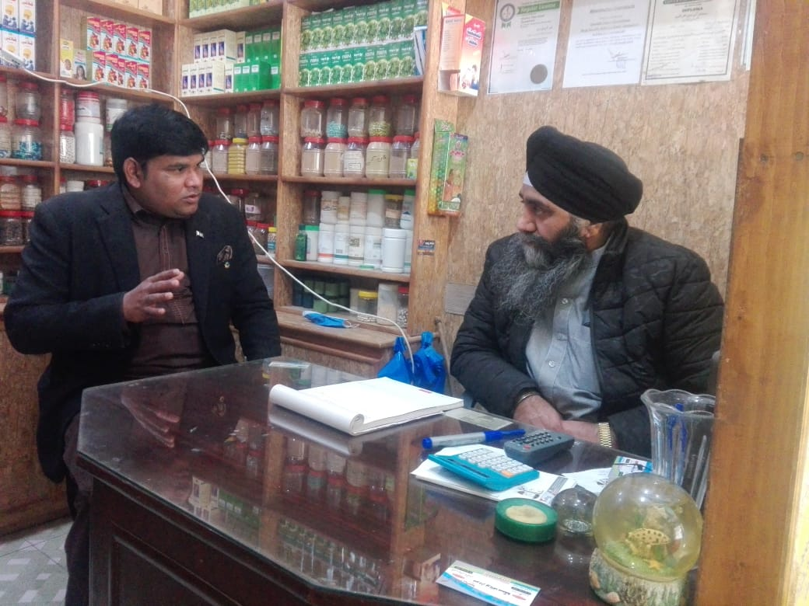

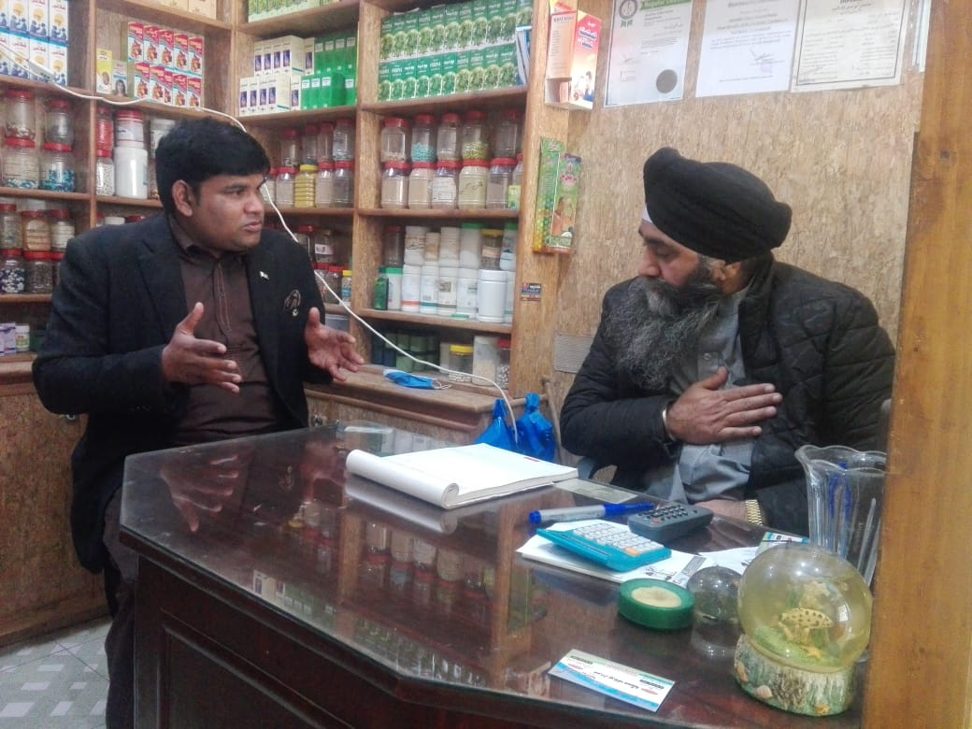

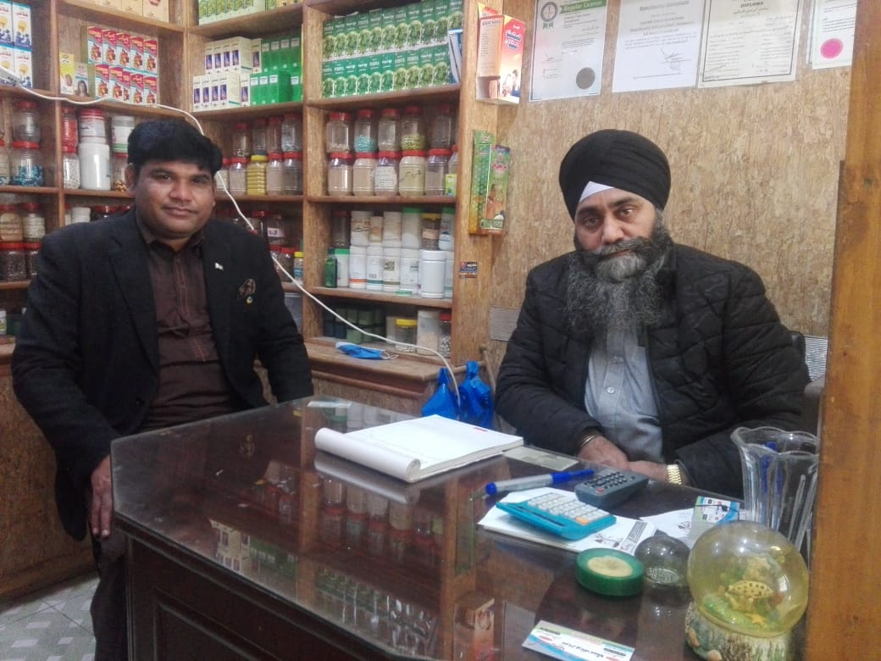

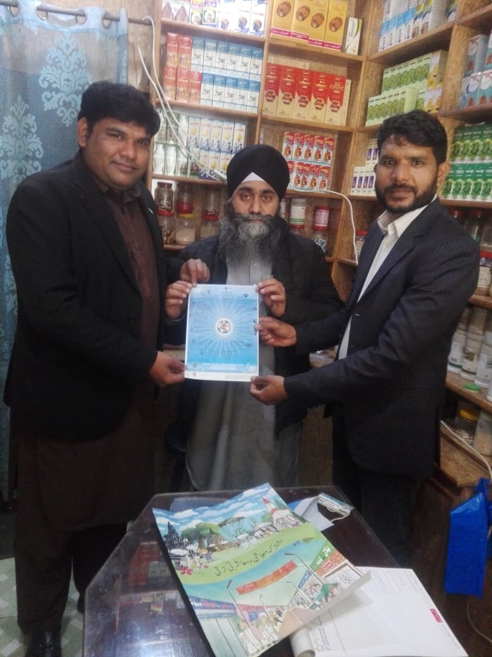
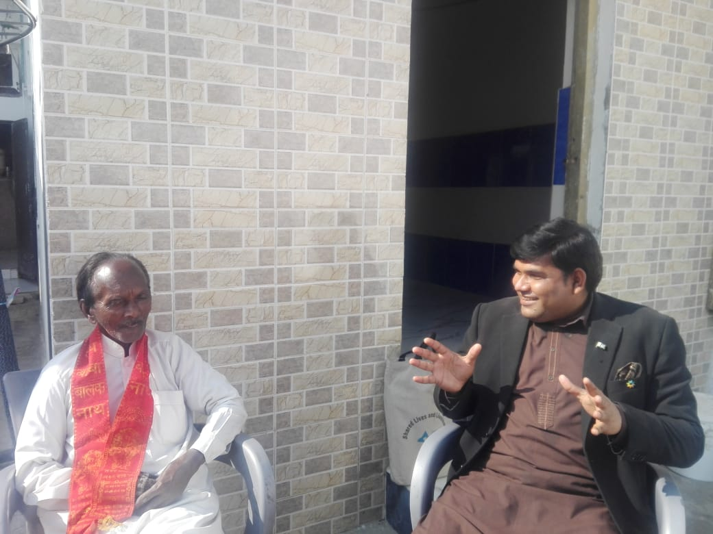

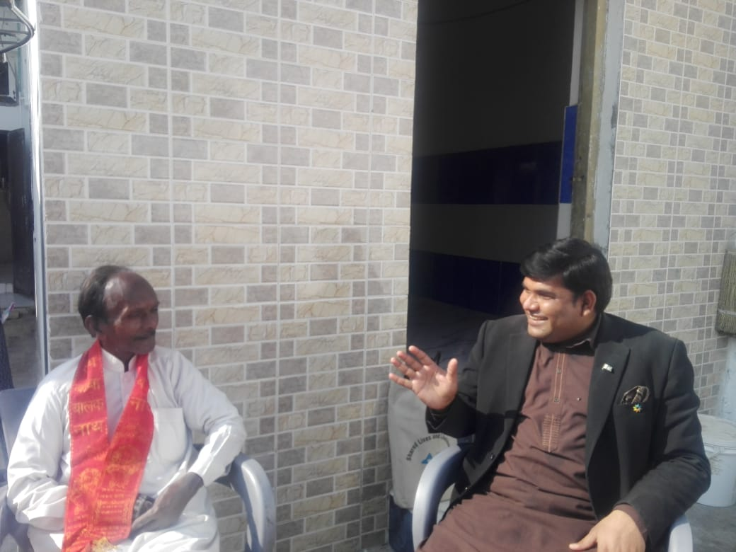

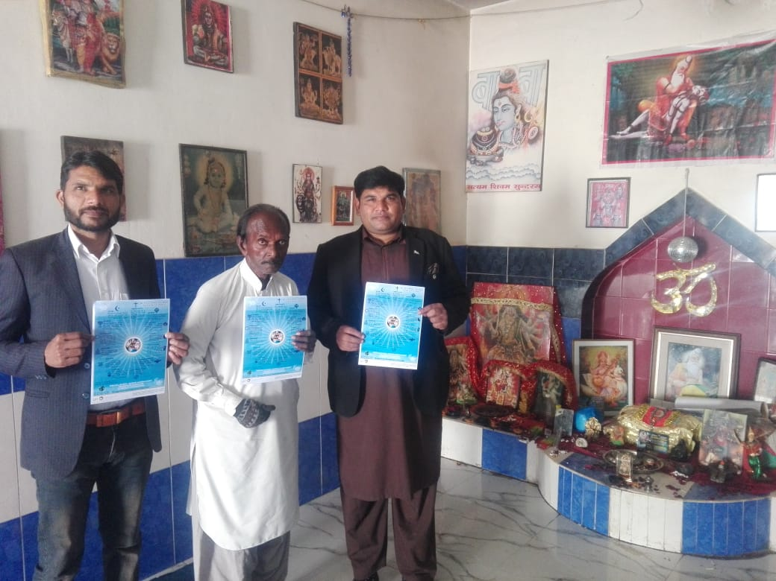

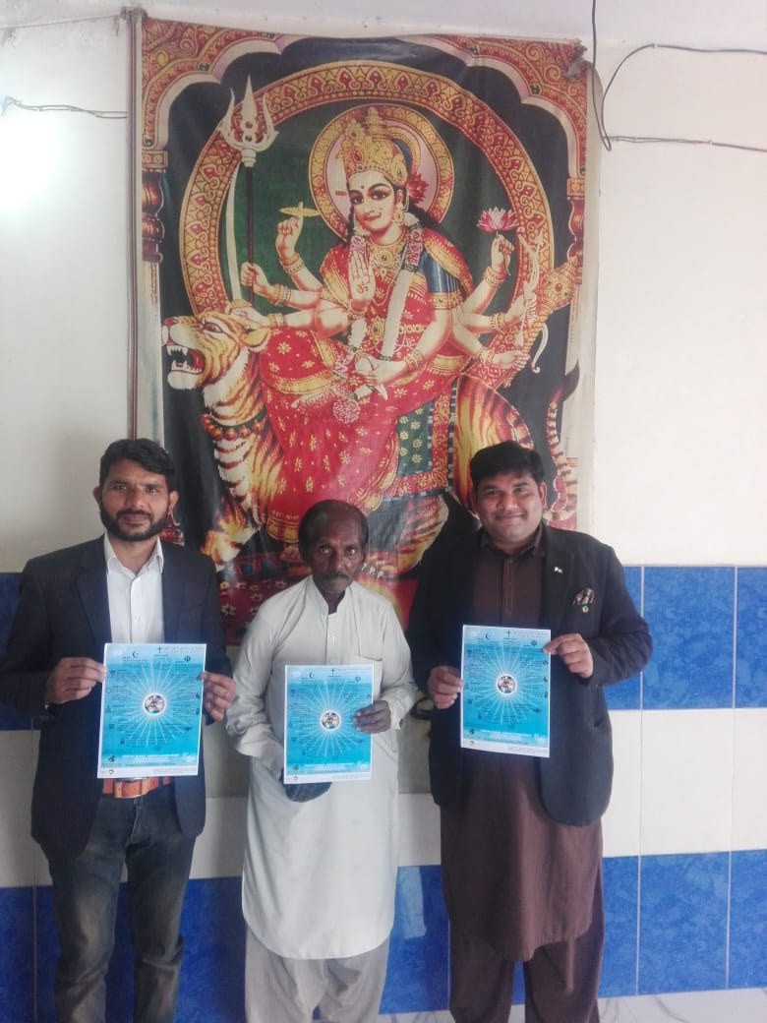

Day 6 – 6th February 2021
Participants:

1. Dr. Ihsan Ghani – District Officer Health Department Rawalpindi Govt. of Punjab, Pakistan
2. Dr. Fayyaz
3. Lady Dr. Miss Rafia
4. Dr. Qamar Zaman
5. Sarwar Masih Bhatti
3. Om Parkash – Secretary General All Hindu Panjchait, Lalkurti Rawalpindi Cantt Pakistan

Venue:

World Interfaith Harmony Week Free Medical Camp - Lalkurti Mandar
Catherine Covenant Girls School, Lalkurti Rawalpindi Pakistan

With respect of World Interfaith Harmony Week, I have arranged a free medical camp outside Lalkurti, Rawalpindi Pakistan Mandar. Surroundings of this mandar there is thickly populated all religion and we have provided medical checkup and medicines to many people and with this I have guided them for World Interfaith Harmony Week and suggest them to promote this. All people have appreciated this effort especially illiterate women at lower level. They all were happy at this effort and facility.
Secondly we have provided awareness to the girls of Catherine Convent school, District health officer accompany us, also we have provided medicines to girls of all religions. Also school staff participated in this activity and they have appreciated it with deep heart.

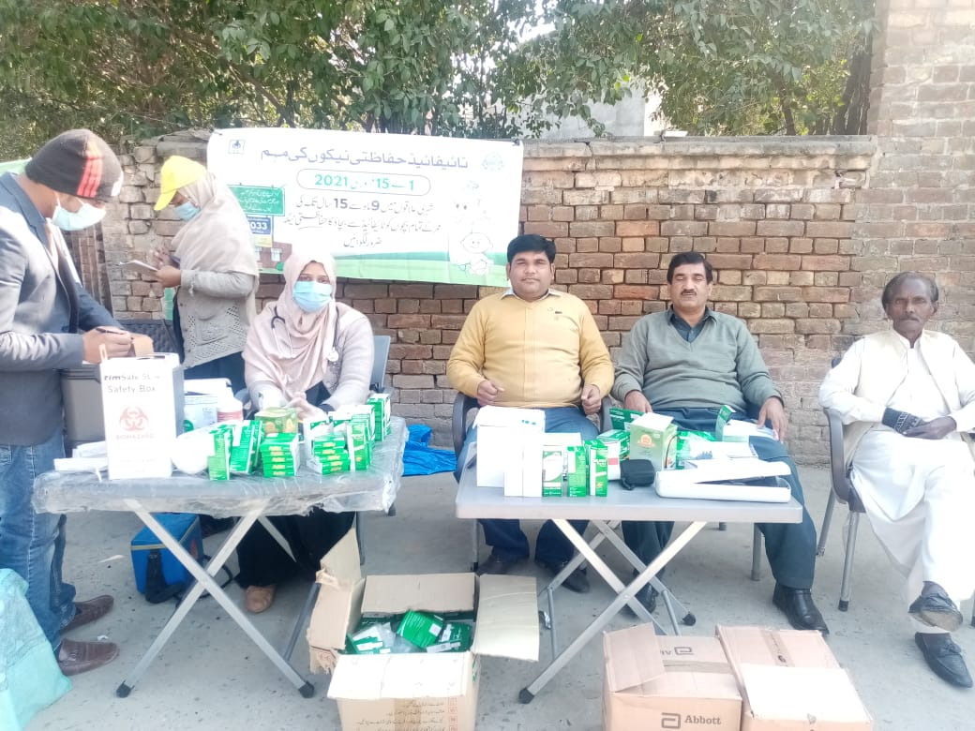
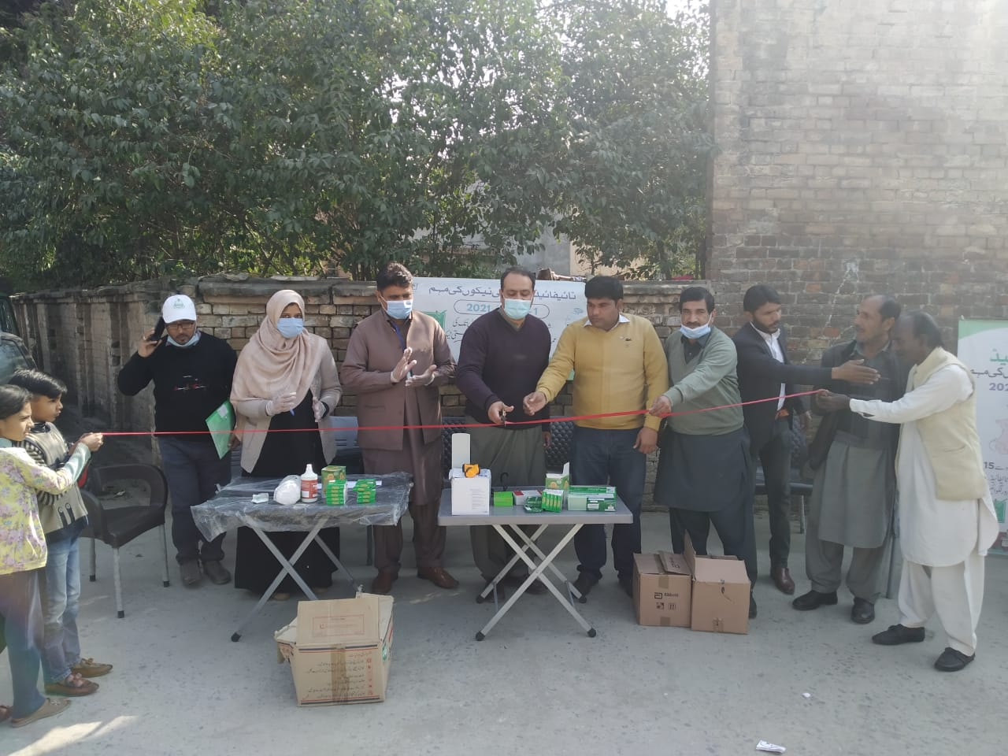

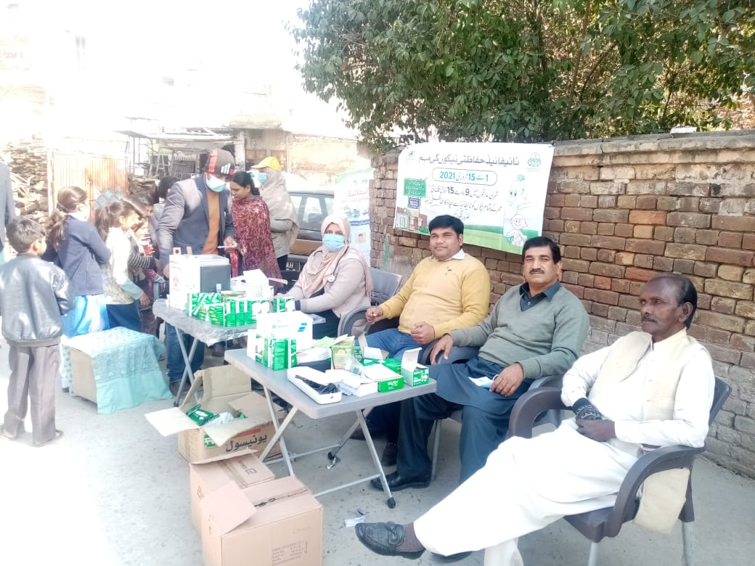

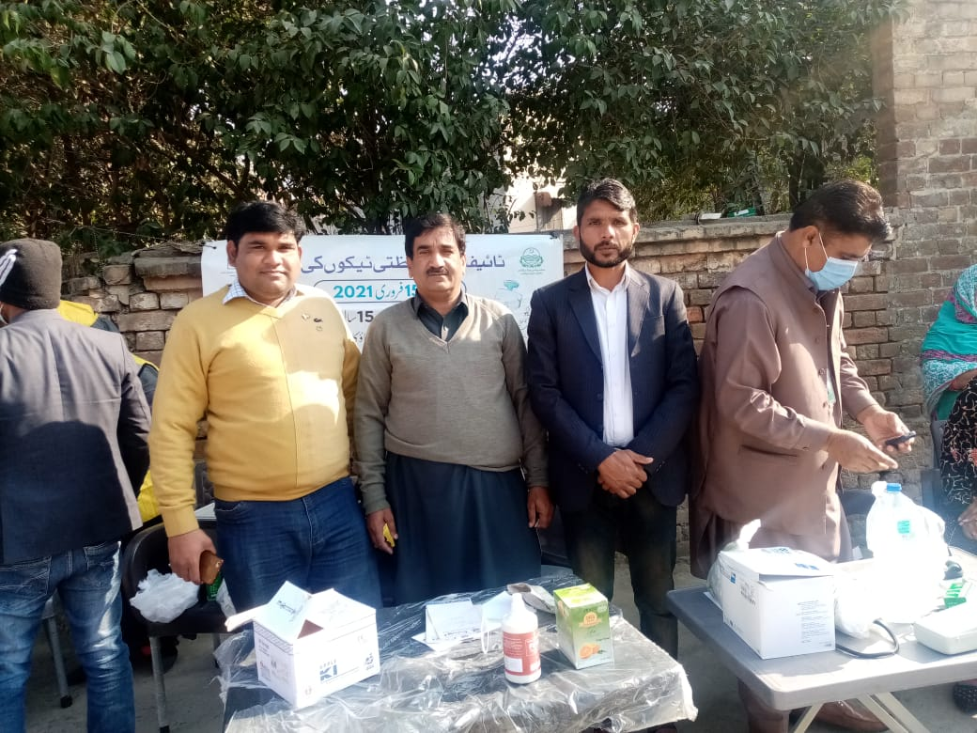

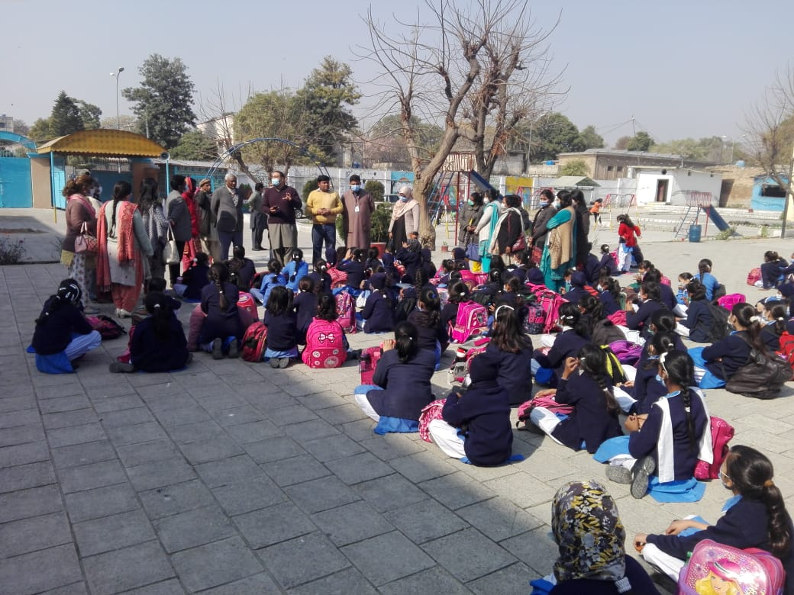
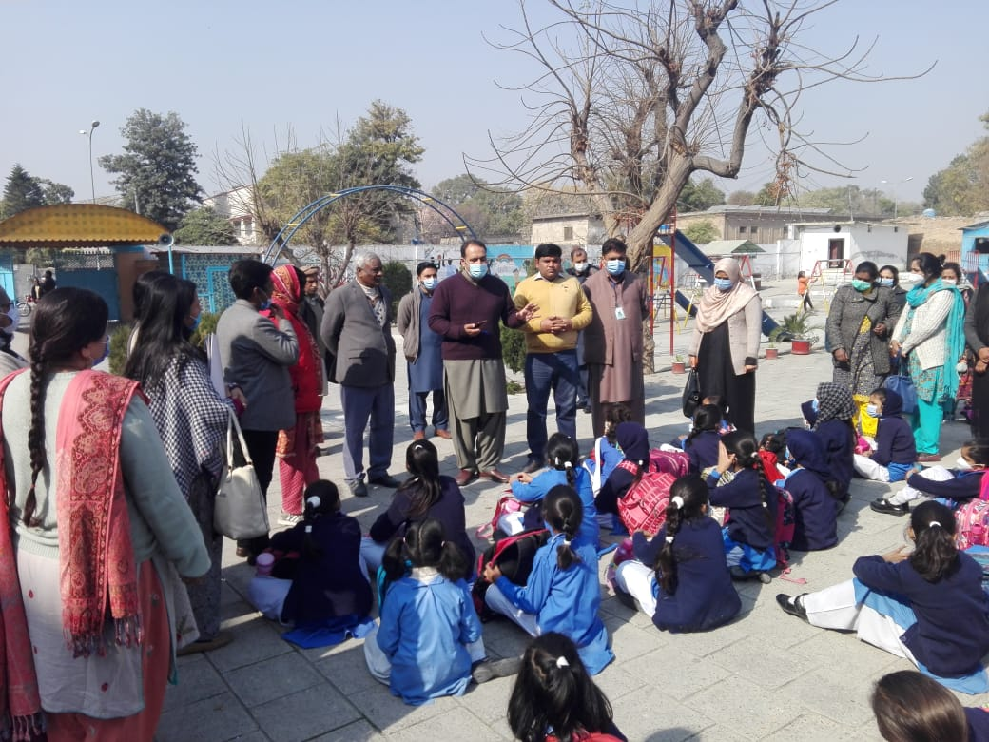
Day 7 – 7th February 2021
Participants:

1. Sister Sajida Niamat – Administrator St. Joseph’s Hospice Association
2. Dr. Kezia
3. Dr. Fayyaz

Venue:

St. Joseph’s Hospice Association – Westridge Rawalpindi Pakistan

I have conducted a seminar at World Interfaith Harmony Week at the venue mentioned above, and provided medicines free of cost to deserving people of the said organization of all religious. The goal of this week to serve such type of deserving people and to give awareness about World Interfaith Harmony Week, and I have completed the last day of the said week with a beautiful message to these needy people. At the end, I have provided Golden Rule to the participants.

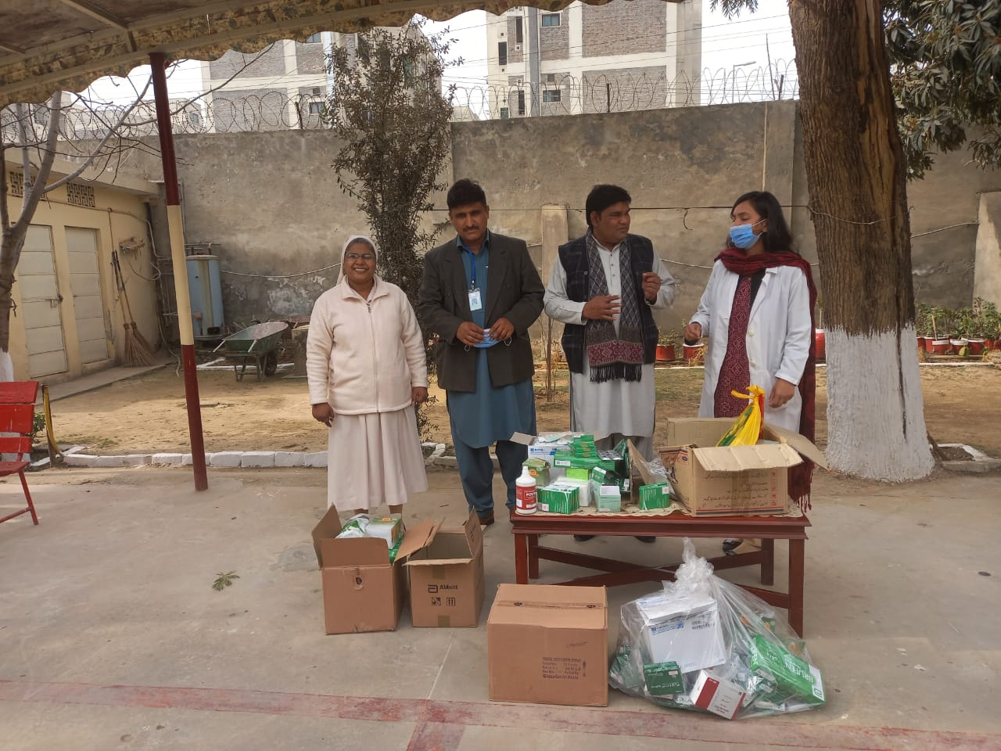

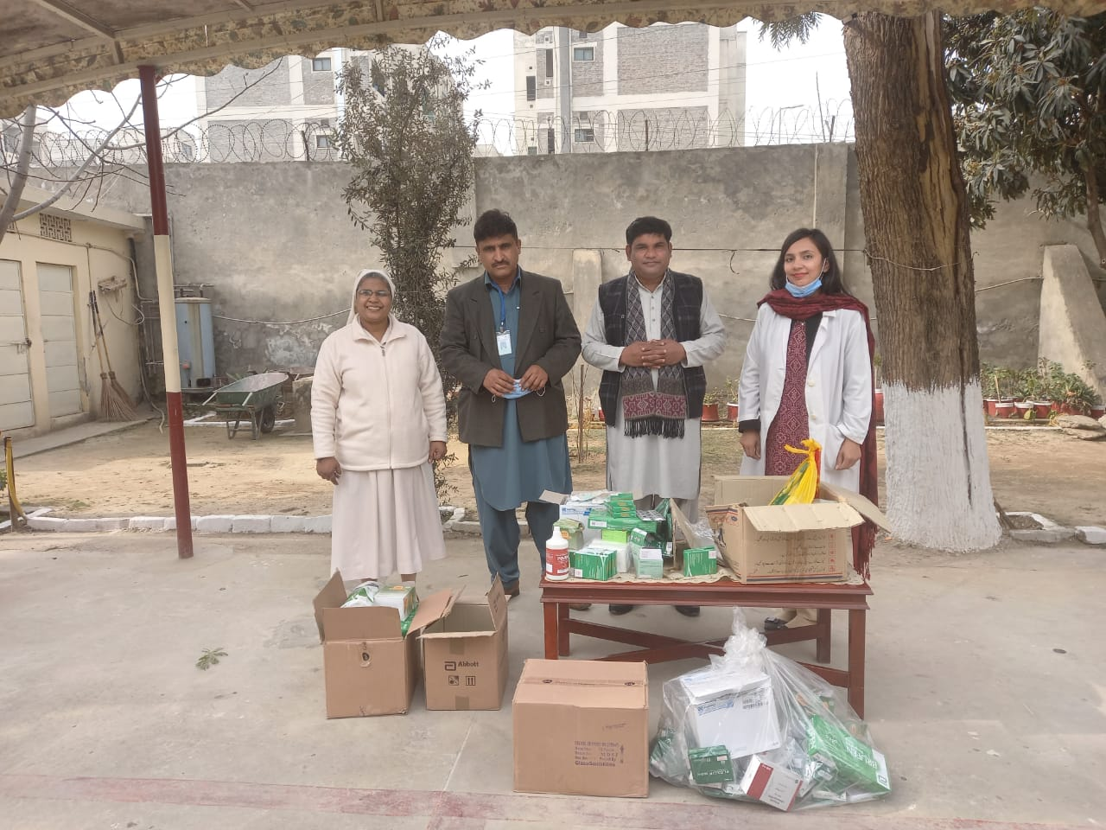
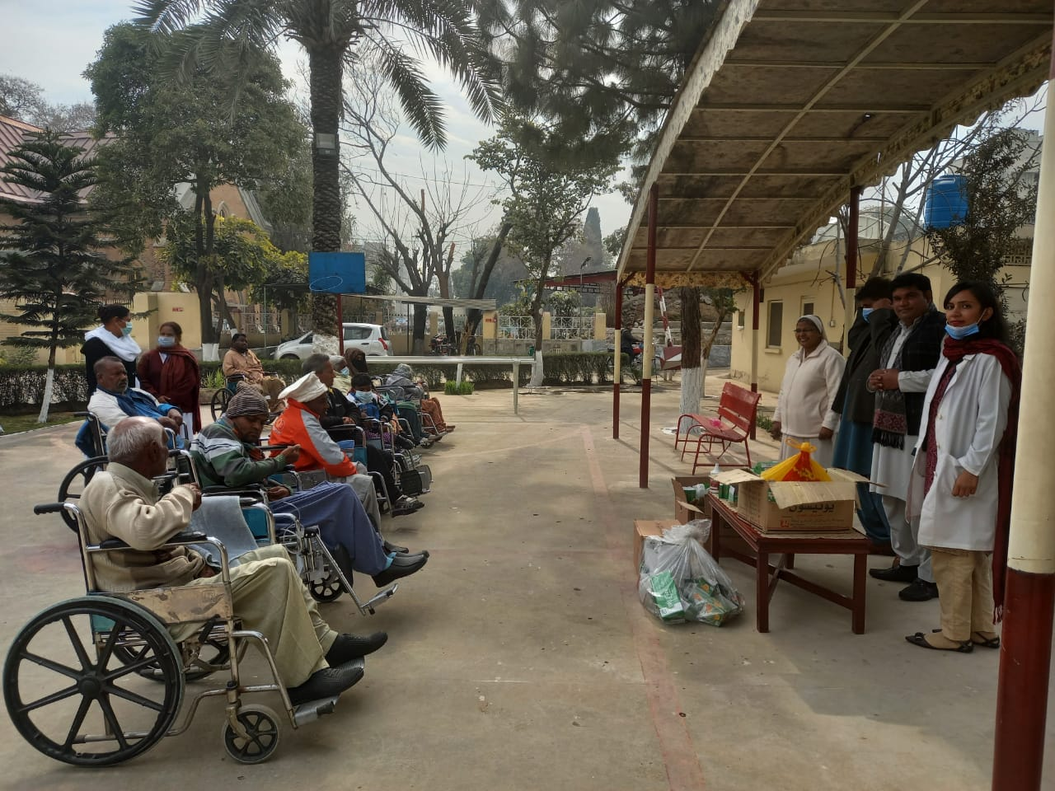

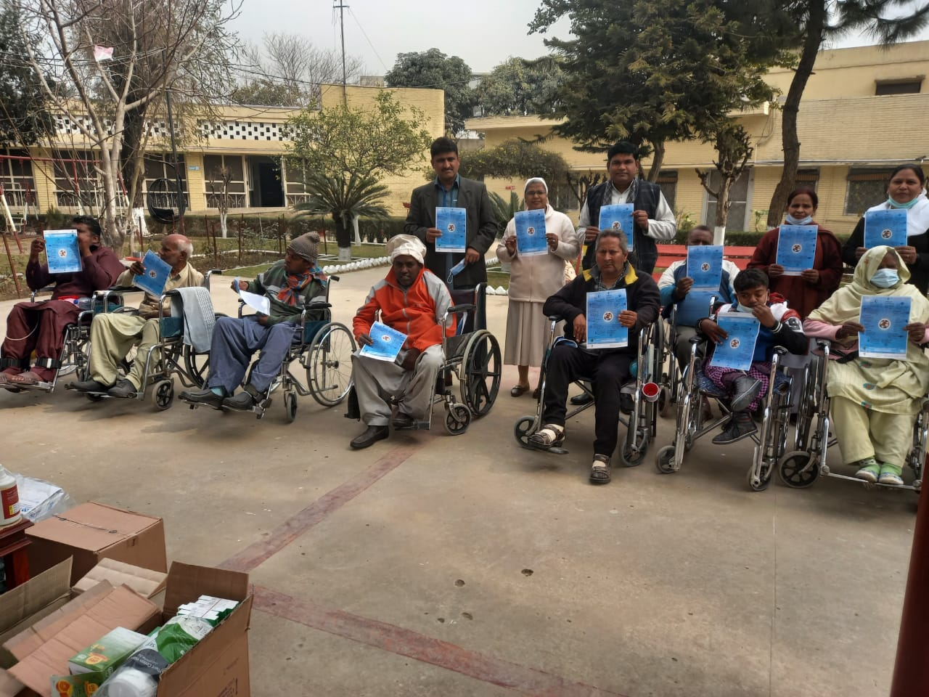

Conclusion:

I have conducted seminars / workshops for World Interfaith Harmony Week for 7 days (from 1st to 7th Feb. 2021). People appreciated this practice and were very happy with it that this is the need of time. I am personally satisfied with this activity that I was able to give strong message to people about World Interfaith Harmony Week.

Jibran Misah Gill
Dated: 8th Feb. 2021

