Event Report for tree planting in Malawi

During the World Interfaith Week communities come together from deferent areas in Malawi to address the importance of nature and deforestation issues within the country by teaching and sharing knowledge with the youngsters about the future of forests in Malawi.
As for many Malawians have no awareness of the deforestation impact in the country.
The majority of the population in Malawi lives in rural areas and the country economy is based on agriculture. Currently Malawi is being affected with climate changes due to the vast deforestation occurring in the country affected by the need of using wood in order to be convert it into energy so that can also be used for cooking in form of charcoals.
Every 10 minutes a field equivalent a soccer ball pitch is cut down in Malawi, not only is linked to floods but also affects negatively the organic matter that has a huge in pact in enriching the soil with nutrients. Reducing the forest also impacts the wildlife that play an important role in the ecosystem and the fish supply also reduces in the Malawi biggest lake.
Due to the diversity of people joining the event, it was decided to proceed with the tree planting during the WIHW in order to celebrate with the entire world.

Tree planting
The tree planting took place in 3 different cities in Malawi where by all the members involved coordinated and delegated each actives. It took a few weeks to plan and to look for donations towards plants. The planting started by training the youth on afforestation, the importance of trees, climate changes, and how to plant trees.
In Lilongwe the event was conducted by the Environmental Impact Club, Chinsapo Youth Network and Wildlife and Natural Resources Conservation and Rehabilitation Trust organizations where the planting of trees occurred in four schools (Chinsapo Primary and Secondary Schools, Athens Private School, and Chankhandwe Primary) with the aim to plant a total of 3000 plants.
The total number of trees planted was of 2411 in which included mango tress, m´bawa and mthethe trees and 412 people were involed.

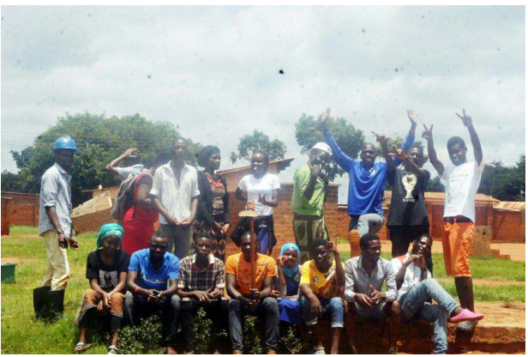
WNRCRT CC and Stakeholder representatives during the Capacity Building Training on
Afforestation

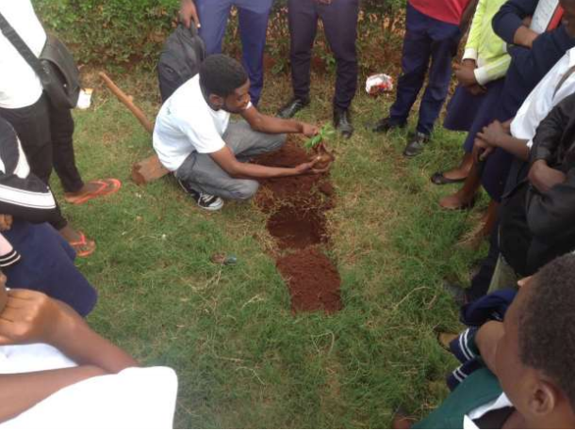
Sipho Gondwe of Lilongwe CC demonstrating on tree planting to secondary school leaners

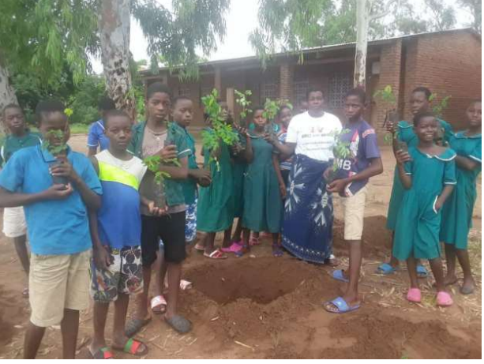
Chankhandwe Primary School leaners ready to plant trees within their school.

The second tree planting took place in Blantyre
The tree planting was organized by the Lunzu organization evolving the Nasonjo Primary school in the Lunzu area where by 300 trees were plant and the Andiseni Primary Scholl in Chigumukikr zone in Blantyre rural area where 200 trees were also planted.
Almost 900 people participated in both schools planting and community members including teachers, forestry officers, village Headmen and others.
A parallel project also was conducted by the Sasonjo Girls Club and the Mother Group at Nasonjo Primary school in which focus on producing handmade Sanitary Pads that are allocated for girls in order to reduce the numbers of young girls missing classes during their menstrual cycle every month. As very poor community the girls cannot afford buying pads. Plans have been made to build a Changing room at Nasonjo Primary school to be used by the girls.
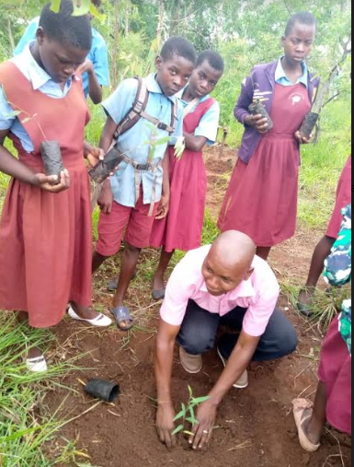
Henry Ngombe- Demonstration how to plant a tree.

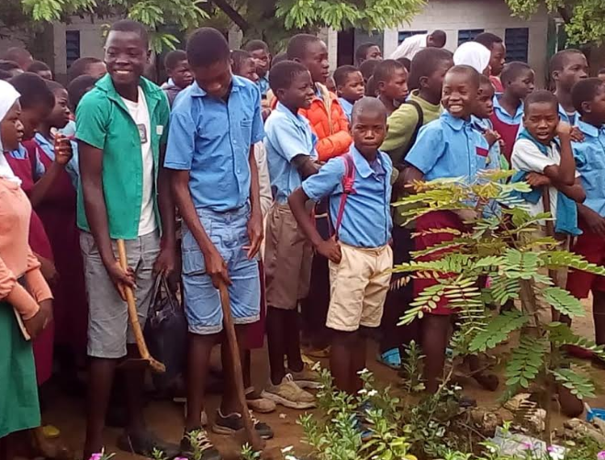
Students involved on the project

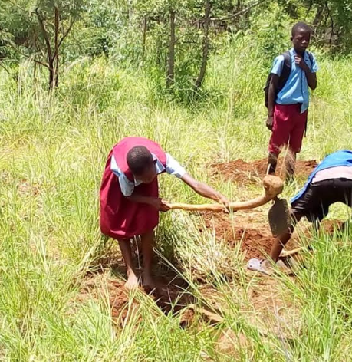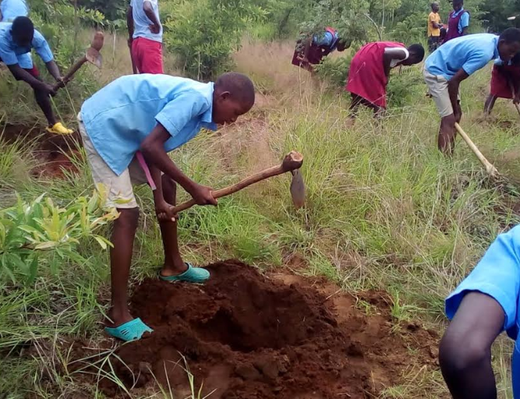
Students taking action on platong trees

The 3rd event took place in Karongo
Nthora community brought awareness to the primary school students about climate change and the challenges faced in order to improve the forests in the country. With little resources, it was possible for the students to plant 80 trees.

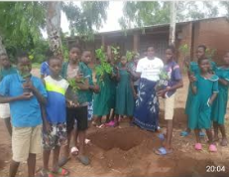

Students prepared for the tree planting
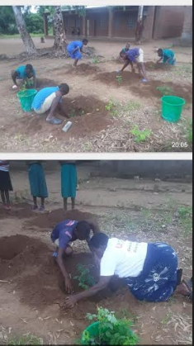
Students planting trees

Conclusion

Despise being a very poor community with lots of challenges during the process of planting tree, it was possible to plant a total of 2991 trees all around Malawi. Bringing people of deferent faiths, background and cultures and different locations to support afforestation in Malawi and to teach the young generation how to take care of the trees in order for Malawi to progress in nature. The event was the best opportunity to show the people that diversity and inclusion within the communities makes a huge in pact in everyone’s live.

