Interfaith Harmony Breakfast on 6th February 2020

Faiths Together in Lambeth continued its tradition of marking the UN's interfaith harmony week with a Thursday breakfast. This year the breakfast took place at Streatham Mosque with around 70 people of all faiths and none attending.
The event took on greater significance as a show of unity after the incident in Streatham High Street on Sunday afternoon, 2nd February. A man who was already being watched by the police attacked and injured shoppers with a knife before being shot dead.

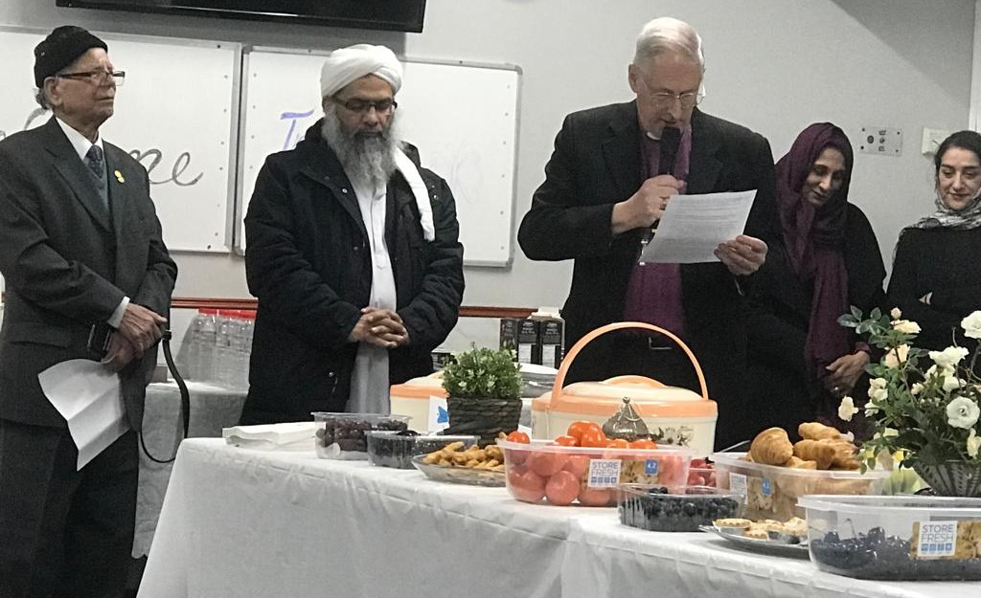

At the beginning, Imam Mumtaz recited verses from the Holy Qur’an and then the Bishop of Southwark shared words he had spoken in the House of Lords on Monday 3rd February.
“My Lords, I have nothing but admiration for the response of the emergency services and the police in this incident, in the recent one at Fishmongers’ Hall, and in the one two and a half years ago at London Bridge, very near my cathedral. It is incumbent on me to try to correct what might be a mishearing of an earlier contribution. The response of the community in each of these cases has been remarkable and resilient. A major part of that response has come from the Muslim community, which has shown its conviction and commitment to peace-desiring and law-abiding ways of living and supporting the wider nation. The Statement said nothing about this because it did not have to, but I feel incumbent as a Bishop to do so.
The community response yesterday was very remarkable. The rector of the parish was immediately out on the streets, giving refreshments to the emergency services. The parish church was open for prayer. Yesterday and at noon today—when I was able to be present—a large number of people from the community came. First thing on Thursday morning, the rector and I will be going to the Streatham mosque, at its invitation. It is immensely important for the nation to be aware of this wider dimension.”
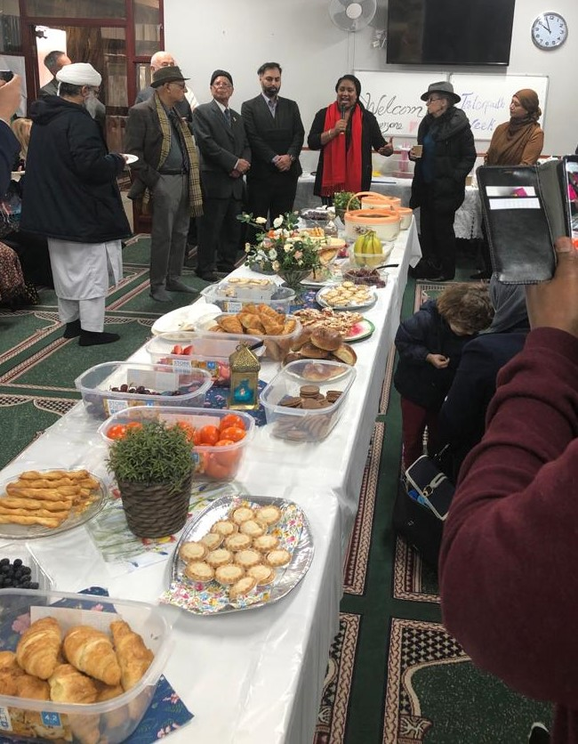

Bell Ribeiro-Addy, MP for Streatham since 12th December, spoke at the breakfast and is pictured below with local Jewish and Muslim leaders.

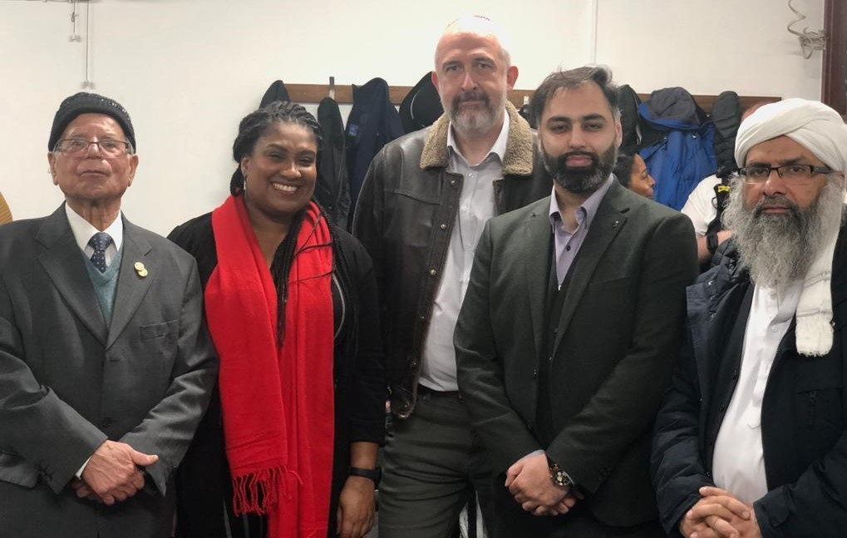
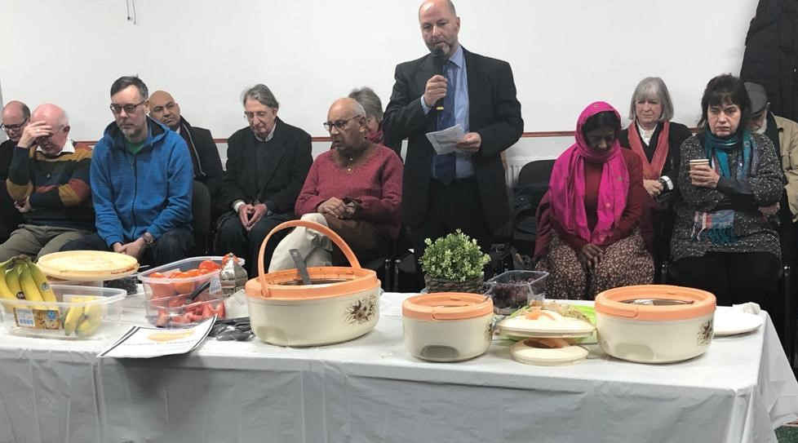

Phillipe Cotgreave de Rahman introduced prayers offered by members of
South London Inter Faith Group.

The spirit of community harmony was evident to everyone present. Great appreciation was expressed to the hosts, and especially to Mohammed Ijaz, Chair of Trustees, and Mrs Ijaz.

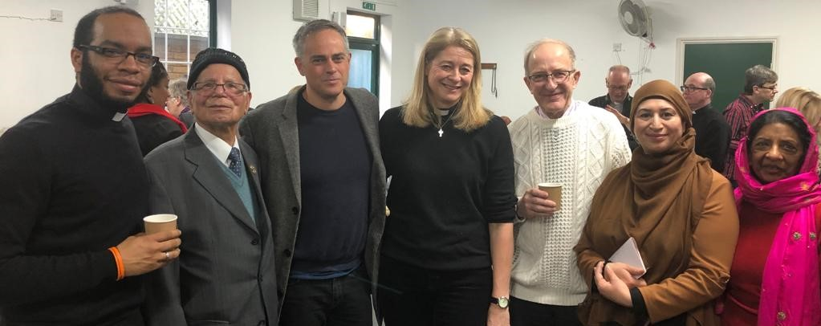

At the breakfast, Dan May-Miller of Streatham Baptist Church publicised the
Streatham Stands Together events taking place two days later,
which included a visit by Sadiq Khan, Mayor of London.
https://www.swlondoner.co.uk/its-personal-mayor-of-london-attends-streatham-vigil-after-terror-attack/

Afterwards, Rabbi Nathan Godleman wrote his Thought for the Week for
South London Liberal Synagogue

“It has been an unsettling week, to say the least. I found myself in Haifa last Sunday, watching images of emergency vehicles parked across the top of Prentis Road in the aftermath of the terrorist attack. Upon arriving back, my first duty was to attend the annual interfaith breakfast, held this year at the local mosque and hosted by our good friend, Mohammed. As I looked around the room this morning, beyond all the visible differences that set us apart, I sensed a togetherness that was more pronounced than before. Adverse events can have such an effect. As we think about all those directly affected, let us return to synagogue not quite as usual on Saturday. Something has changed; not to deter us, but to strengthen us. Our community, as part of a wider one in Streatham.”

