INTRODUCTION
PRE-EVENT ACTIVITIES
EVENT ACTIVITIES
HIGHLIGHTS ON COMPETITION AND SUCCESS RECORDED
SHORTCOMINGS OF COMPETITION
SOUCES OF FUND AND TOTAL EXPENSES
SCORE AND RESULT TABLE
GALARIES OF CONTESTANTS
CONCLUSION

INTRODUCTION

Peace for All Countrymen all Time (PACT) Initiative is a Non-Governmental Organization was born out of empathy by the youth for the youth to reorientate, reshape, enlighten, advocate and encourage ethno religious peaceful coexistence, tolerance and National Integration through different innovative ideas.
The PACT Initiative World Interfaith Harmony Week Creative Art Competition which initially was planned to PACT Initiative Inter University Intellectual Display of Exemplary Art (I-U IDEA) was designed to encourage peace oriented creativity geared towards interfaith constructive mind building of the participants and the audience so as to build ethno religious peaceful coexistence, tolerance and national integration.

PRE-EVENT ACTIVITIES

The event which was supposed to be an inter university creative art competition but was converted to an online contest due to the unavailability of the Kwara State University Dean of Student Affairs, which was as a result of his ill health during the process of request for approval.
An online form was created using Google form on 20th, amended and finalised on 23rd January for registration of applicants. Advertisement of the event started on 25th Jan on Facebook, WhatsApp, Twitter and Instagram. There were a total of 15 applicants
- 10 were successful applicants
- 7 poetry
- 2 essay
- 1 graphic designer
- 5 unsuccessful applicants
- 3 for wrong information
- 2 for late application
Confirmation mail were sent to all the successful applicants with a link inviting them to the WhatsApp group were other information and activities that are to take place in the competition where disseminated. The contestants were informed of the contest timetable which was:
Feb 1-3 submission of work and Recorded Video explaining the concept of their work
Feb 3-4 posting of the submitted works to our social media
Feb 3-8 Online Voting period
Feb 8-9 Computation of Results
Feb 10 Announcement of Winner and Runner Ups
Feb 13 Prize giving
Feb 15 Presenting of Certificate of Merit and Certificate of Participation.
The judges WhatsApp group was also created with 4 judges, 2 for poetry, 1 for essay and 1 for graphic design.

EVENT ACTIVITIES

Feb 1-3
The participants submitted their works between 1st to 3rd of February, there were 7 participants out of 10 successful applicants (4 poetry, 2 essay and 1 graphic design) which included the video on the concept of their work. This where submitted to the judges, posted on our social media platforms for commencement of the online voting.
Feb 3-4
Posting of the submitted work to our social media.
Feb 3-8
Online voting took place on our social media platforms simultaneously
Feb 8-9
Computation of all the result were done based on three things (Submitted work, video and online voting) in ratio 50:10:40.
Feb 10
Result and Score Table

Highlight on the Competition and it successes

- Total number of 15 applicants (10 successful applicants and 5 unsuccessful applicants)
- The competition was able to reach able to reach over 4 thousand people with Facebook accounting for about 97%, Instagram at about 2% and Twitter 1%.
- The competition was also able to engage over 500 youth with Facebook accounting for about 78%, Instagram with about 13% and Twitter with about 9%.
- There were suggestions which included a suggestion for the organization to organize and create a platform that will have features which will support dynamic collaboration and ensure continues progress in the advancement of our agenda (to create ethno religious peaceful coexistence, tolerance and national integration through the youth creativity for the purpose of educational, social and economic improvement of all Nigerians and the world at large). This platform will also stand as a centerpiece for sharing information on different forms of engagement used by different people and organizations towards ending the menace of ethno religion and communal crises.

SHORTCOMINGS OF THE COMPETITION

It was found out during the period of online voting that some of the submitted works were not posted online for voting also the contestants did not understand the rules for the online voting and the process of the online voting due to inability of the organizing team to foresee it as an hindering factor thus the voting didn't go as intended instruction which eventually led to a parallel score on the online voting.

SOURCES OF FUND AND TOTAL EXPENSES

The online contest was devised to help the organization reduce cost and also reach as many people as possible in which that was achieved.
Total Income And Expenses Account
Items | Cost | Total
INCOME
Member Donation | Bello Bashir = 10,000 | 18,000
 | Sanni Ahmed = 6000
 | Olaniyan Yusuf = 2,000
EXPENSES
Cost of graphics designing (certificates and handbill graphic) | 10,000
Online registration portal | 3,000
Cash Prize | 5,000
 |  | 18,000

The Cash Prize was supposed to be N10,000 (N5,000 for Poetry and Essay Category and N5,000 for Graphic design and Fine Art Category) but as a result of a single contestant in the graphic design and fine art category it was decided by the organization that certificate of merit for the position of 2nd runner up should be issued in place of the cash prize to the single contestant in the category.

SCORE AND RESULT TABLE

CONTESTANT NO | JUDGES SCORE | SOCIAL MEDIA SCORE | TOTAL | POSITION
CONTESTANT 1 | 36/50 | 30/50 | 66 POINTS | 2ND RUNNER UP
CONTESTANT 2 | 28/50 | 25/50 | 53 POINTS | *1ST RUNNER UP BY DEFAULT
CONTESTANT 3 | 32/50 | 30/50 | 62 POINTS
CONTESTANT 4 | 35.5/50 | 30/50 | 65.5 POINTS | 3RD RUNNER UP
CONTESTANT 5 | 35/50 | 30/50 | 65 POINTS | 5TH POSITION
CONTESTANT 6 | _______________ | _____________ | _____________
CONTESTANT 7 | _______________ | _____________ | _____________
CONTESTANT 8 | 34.5/50 | 30/50 | 64.5 POINTS
CONTESTANT 9 | 43/50 | 30/50 | 73 POINTS | WINNER
CONTESTANT 10 | _____________ | _______________ | ______________

By Default means as the only contestant of his category he is the winner of his category (Graphic Design and Fine Art Category) and by so he comes immediately behind the winner of Poetry and Essay category winner.

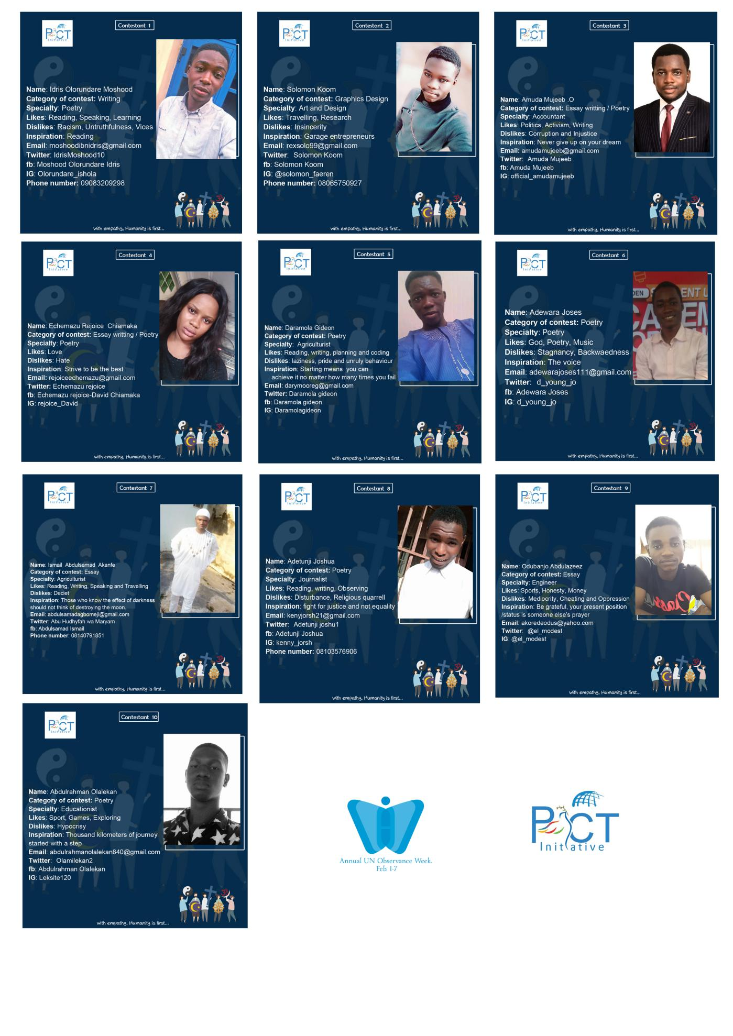

CONCLUSION

PACT Initiative wants to reiterate that the way to ending ethno religion and communal crises is long but achievable with every hands on work toward achieving it.
Also, we want to encourage World Interfaith Harmony Week organizer to look towards Africa on advising the governments, organising symposia and conferences on issues bordering interfaith hostility and possible ways to achieving interfaith harmony throughout the continent and the world at large.
Lastly, we will like to appreciate everyone that contributed towards the success of the contest contest starting from the judges for doing the work of humanity through us, the PACT Initiative team and most especially the financial donors.

