****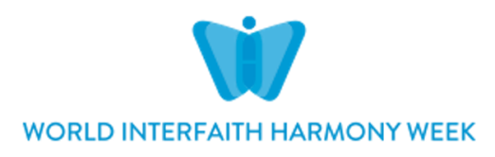

**Interfaith Scotland World Interfaith Harmony Week Event**

**We will not be Prisoners of Hate**

**Barlinnie High Security Prison, Scotland**

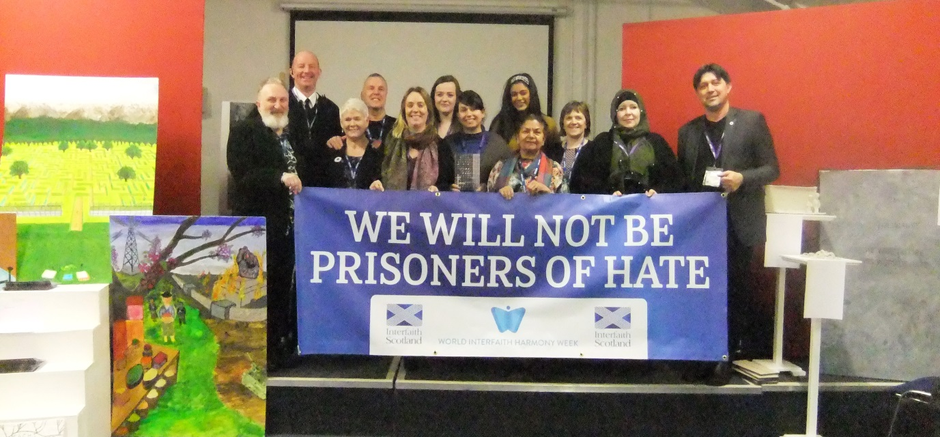

On 3rd February, as part of World Interfaith Harmony Week, a delegation of faith community representatives from the Christian, Jewish, Muslim, Hindu, Sikh and Baha’i religions visited Barlinnie prison to engage with the prisoners on an interfaith programme entitled ‘**We will not be prisoners of hate’**.

The planning for the day had begun some months before when Interfaith Scotland was contacted by Fife College Head of Prison Contracts (Scotland) and Barlinnie Prison who asked for help to engage with prisoners, some of whom had violent backgrounds and others who had the potential to commit crimes motivated by racial or religious hatred. A team of diverse faiths worked together to plan the programme.

The men in the prison who had agreed to engage in the interfaith programme had begun an educational journey that explored the root cause of hatred and climaxed in them learning about the genocides that had resulted from deep division and hatred of what is perceived as ‘the other’. The men produced artwork and poetry that had been inspired by their learning. Based on the theme of the interfaith engagement the book of poetry was entitled **‘we will not be prisoners of hate’.** This was there first **World Interfaith Harmony Week** experience.

On the 3rd of February, Interfaith Scotland facilitated a programme which included a testimony from a Muslim survivor of the Bosnian Genocide (Hasan Hasonivic); a testimony from an ex-prisoner who had used his religion to transform his negative life experiences; a moving Q & A session with the prisoners; a viewing of the creative work of the prisoners; and an opportunity for dialogue and engagement with the diverse faiths that had entered the prison.

Over the course of the day over 100 prisoners engaged in the World Interfaith Harmony Programme .

The image at the start of the report was of the delegation who visited the prison, for security purposes no photographs of the actual prisoners could be taken.

**Below is the cover of the book published by the Prisoners and an excerpt from a Prisoner’s Poem**

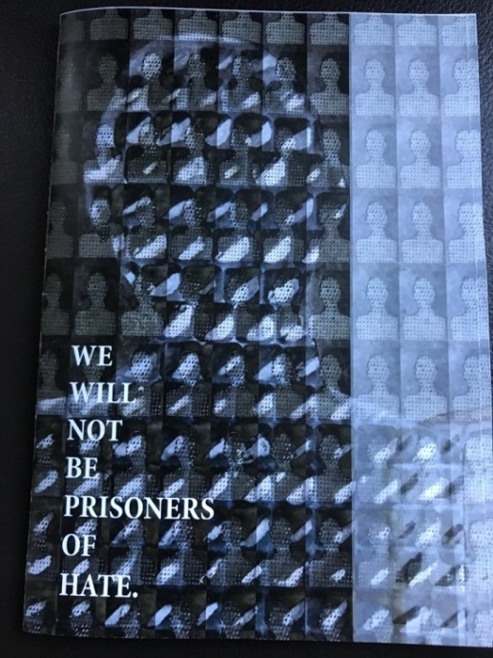

…Turn off the news it’s too hard to watch

I don’t want to see that, burns my mind like a torch.

Let’s take the distraction, it’s not us that suffer.

It’s happening again. Is it any wonder?

We can’t walk away from their faces,

Even if they’re far away. Those places.

We must acknowledge the horror – do what we can.

**I see you. I remember you. With you I stand.**

**Comments from some of the Prisoners and Interfaith Delegation**

*I found it very moving to hear the stories of the two speakers, both of whom after harrowing experiences had turned their initial hatred of ‘the other’ into a powerful force for positive change in the world. Seeing prisoners engaging in dialogue with people from such diverse faith backgrounds was incredible. The prisoners had also created powerful works of art that formed the backdrop to the event. I was left feeling that this had been a transformative interfaith experience for all those involved.* **A Christian participant**

*I found the visit to Barlinnie very powerful.  The ex-prisoner’s testimony was extremely powerful and he obviously drew strength from the prisoners' reactions as they encouraged and applauded him to continue in difficult moments.  The message he gave that although we come from distinct religions and cultures we are all 'human beings’ really stood out.  The poetry written by the prisoners and their artwork are amazing and, for me as an educator, demonstrated an impressive depth of learning.  I feel very privileged to have been invited to this World Interfaith Harmony Week event.* **A Scottish Education Specialist**

*"This was a unique experience for pretty much everyone involved in this event. I had never been inside a prison before and was keen to see the artwork of the prisoners and how they would engage with us. I wasn't expecting to be quite so moved and amazed by their response to both our speakers and our dialogue and by the artwork they had produced. The theme of resisting hate expressed resonated so strongly in a room filled with stories which could so easily be defined by it and that was obvious from their emotional reactions. This event will stay with me for a long time as I consider how interfaith work can have an even greater reach than we often expect."* **Interfaith Officer, Church of Scotland**

**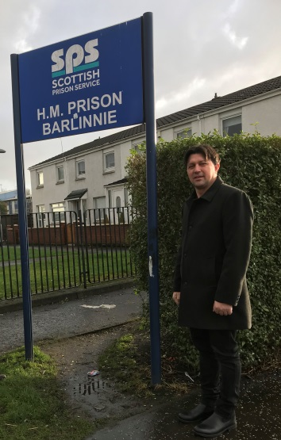***I have never had such an experience as this in all my years of sharing my story. I know that Interfaith Scotland and the World Interfaith Harmony Week Programme had a huge impact – it was an honour to be there.* **Hasan Hasanovic, survivor of the Bosnian Genocide**

*I have a deeper understanding now of where hate comes from (Prisoner)*

*I learned lots of new things I previously had little knowledge of (Prisoner)*

*It wasn’t what I expected…it was far more than I expected, the event has sparked a genuine interest to learn more and to change (Prisoner)*

*..it has inspired me to incorporate some more awareness about not only the world, but family, friends and myself. Inspired to be better (Prisoner)*

*I thought I was going to be bored but it was so educational (Prisoner)*

*I have learnt to treat our fellow men with better respect and compassion*

*I would now like to see people living peacefully – I hope people can live in peace (Prisoner). It was more than I expected – thought it would be generic but it was in depth (Prisoner)*



**Impact**: Interfaith Scotland has now been asked to work with the Planning Partnership of Community Justice Glasgow to **encourage** faith communities to support prisoners on their exit from prison. Together we will develop a support hub.

*From Faith Community congregations, we are asking that you consider whether you could be part of the solution, providing a connection in the individuals’ own communities - to be that one good person that can make all of the difference, signposting to services, connecting into the community and being a role model/mentor –* ***Excerpt*** *from a letter of the Community Empowerment Service.*

**Media Coverage**

Due to the sensitive nature of this event we were only permitted to share the event on facebook. However the engagement with the event was extensive (see below)

