[](http://en.chinaculture.org/)

http://en.chinaculture.org/8707.files/p-2.jpg

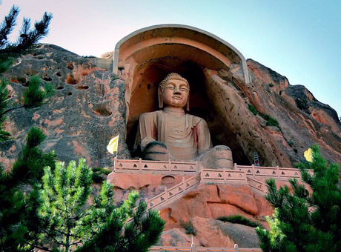

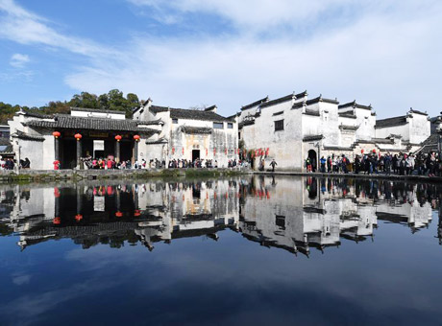

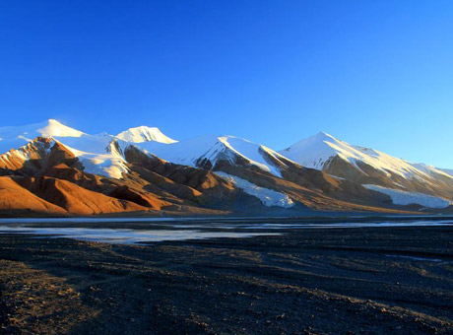

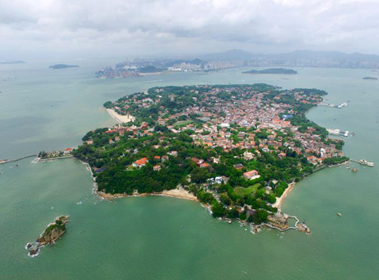

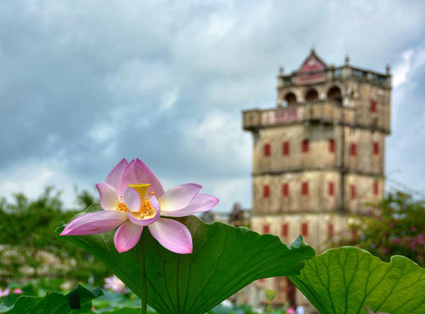

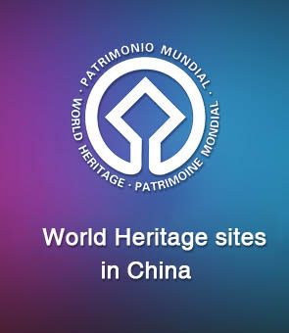

[China claims 55 of UNESCO world heritages with elected new site](http://en.chinaculture.org/2019-07/08/content_1418002.htm)

China's Archaeological Ruins of Liangzhu City were on Saturday inscribed on the UNESCO World Heritage List as a cultural site, bringing the total number of the Asian country's sites on the list to 55.

International delegates congratulated China on the world's recognition of the exceptional site as a concrete testimony of 5,000 years of Chinese civilization and its unique contribution to world civilization.

On Friday, China's Migratory Bird Sanctuaries along the Coast of the Yellow Sea-Bohai Gulf (Phase I) was also inscribed on the World Heritage List as a natural site.

The natural site is located in the Yellow Sea eco-region, containing the world's largest continuous mudflat seashore.

http://en.chinaculture.org/8707.files/p-17.jpg

[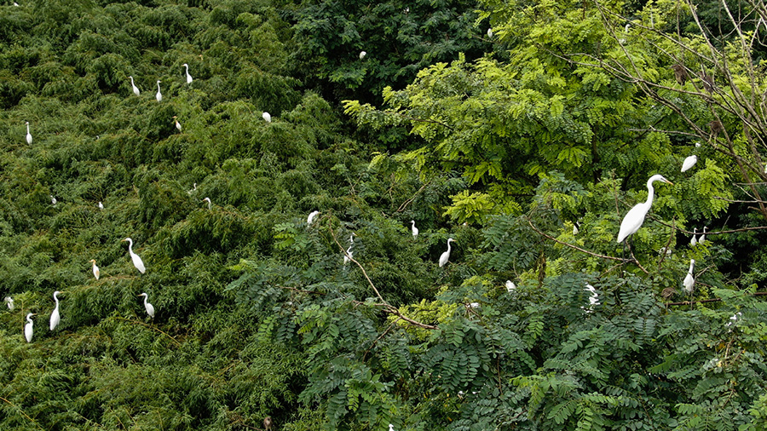](http://en.chinaculture.org/2019-07/08/content_1418010.htm)

[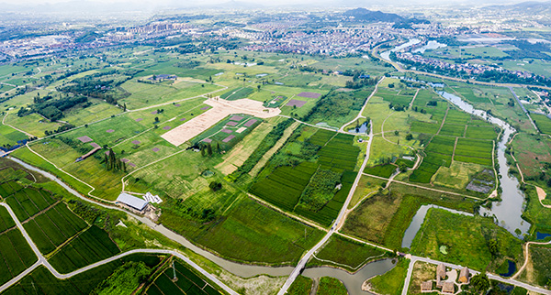](http://en.chinaculture.org/2019-07/08/content_1418005.htm)

[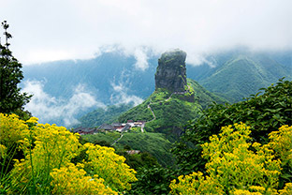](http://en.chinaculture.org/2018-07/04/content_1228221.htm)

[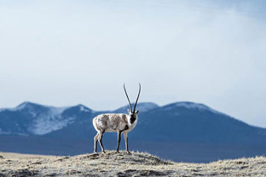](http://en.chinaculture.org/2017-07/19/content_1039971.htm)

[](http://en.chinaculture.org/2017-07/18/content_1039555.htm)

[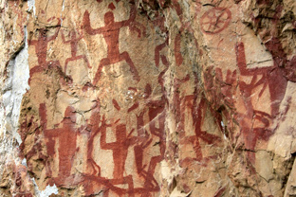](http://en.chinaculture.org/2017-07/19/content_1039932.htm)

[](http://en.chinaculture.org/2017-07/19/content_1039962.htm)

[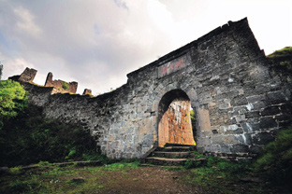](http://en.chinaculture.org/2017-07/19/content_1039921.htm)

[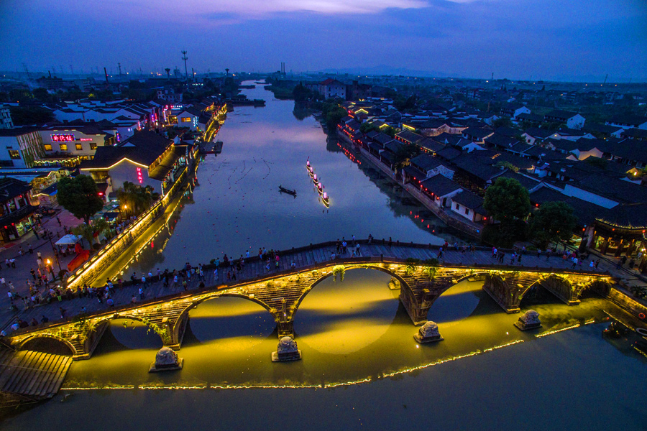](http://en.chinaculture.org/2017-07/18/content_1039608.htm)

[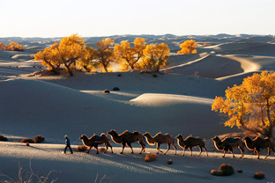](http://en.chinaculture.org/2017-07/18/content_1039596.htm)

[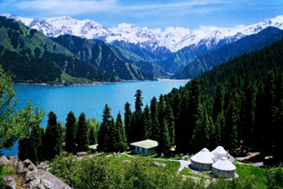](http://en.chinaculture.org/2017-07/19/content_1039987.htm)

[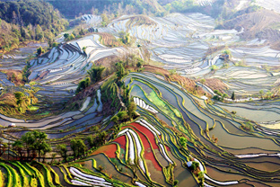](http://en.chinaculture.org/2017-07/18/content_1039527.htm)

[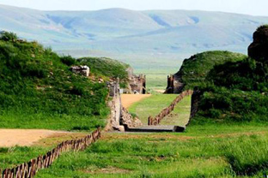](http://en.chinaculture.org/2017-07/18/content_1039599.htm)

[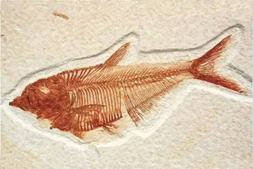](http://en.chinaculture.org/2017-07/19/content_1039937.htm)

[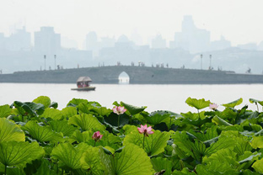](http://en.chinaculture.org/2017-07/19/content_1039925.htm)

[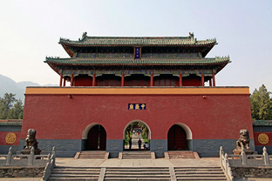](http://en.chinaculture.org/2017-07/18/content_1039540.htm)

[](http://en.chinaculture.org/2017-07/19/content_1039933.htm)

[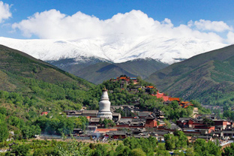](http://en.chinaculture.org/2017-07/18/content_1039566.htm)

[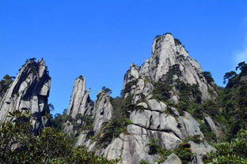](http://en.chinaculture.org/2017-07/19/content_1039970.htm)

[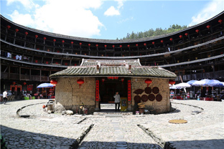](http://en.chinaculture.org/2017-07/18/content_1039530.htm)

[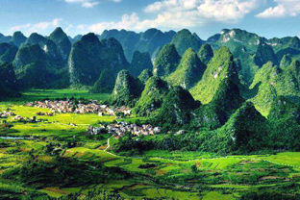](http://en.chinaculture.org/2017-07/19/content_1039978.htm)

[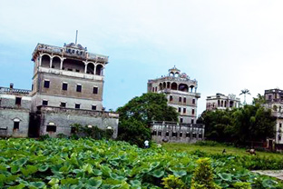](http://en.chinaculture.org/2017-07/18/content_1039551.htm)

[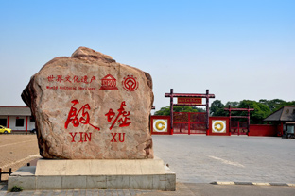](http://en.chinaculture.org/2017-07/19/content_1039927.htm)

[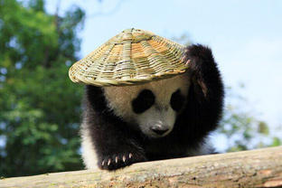](http://en.chinaculture.org/2017-07/19/content_1039973.htm)

[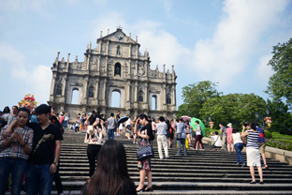](http://en.chinaculture.org/2017-07/18/content_1039533.htm)

[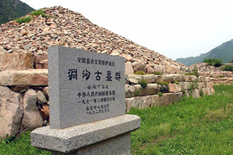](http://en.chinaculture.org/2017-07/18/content_1039514.htm)

[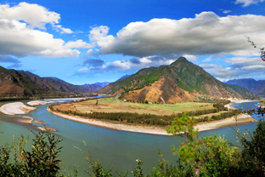](http://en.chinaculture.org/2017-07/19/content_1039983.htm)

[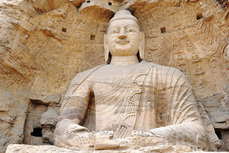](http://en.chinaculture.org/2017-07/19/content_1039930.htm)

[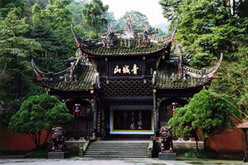](http://en.chinaculture.org/2017-07/18/content_1039565.htm)

[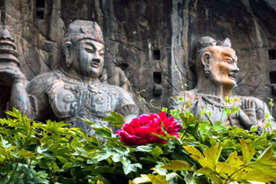](http://en.chinaculture.org/2017-07/18/content_1039556.htm)

[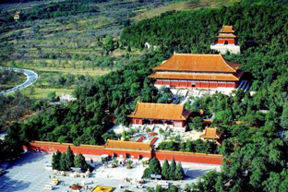](http://en.chinaculture.org/2017-07/18/content_1039549.htm)

[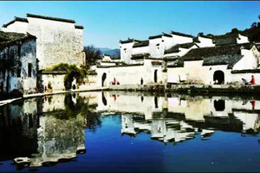](http://en.chinaculture.org/2017-07/18/content_1039522.htm)

[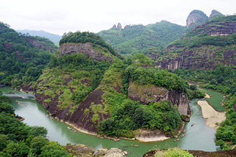](http://en.chinaculture.org/2017-07/19/content_1040000.htm)

[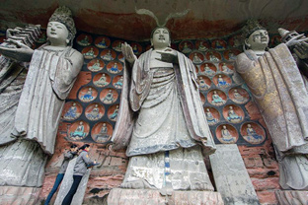](http://en.chinaculture.org/2017-07/18/content_1039529.htm)

[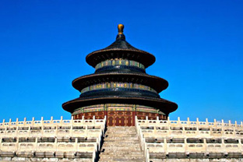](http://en.chinaculture.org/2017-07/18/content_1039605.htm)

[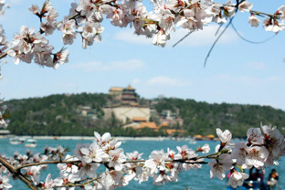](http://en.chinaculture.org/2017-07/18/content_1039601.htm)

[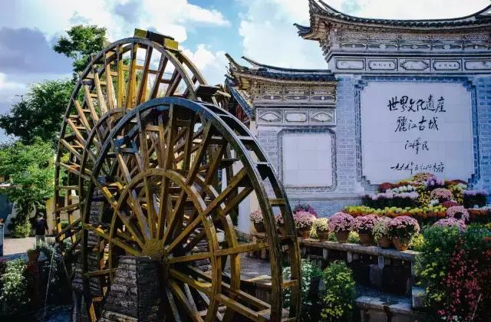](http://en.chinaculture.org/2017-07/18/content_1039575.htm)

[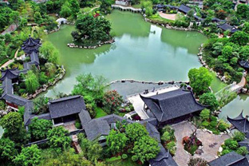](http://en.chinaculture.org/2017-07/18/content_1039525.htm)

[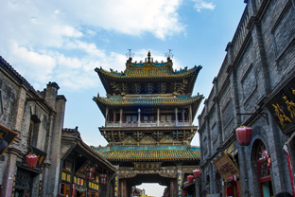](http://en.chinaculture.org/2017-07/18/content_1039511.htm)

[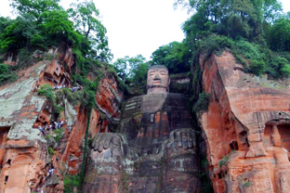](http://en.chinaculture.org/2017-07/19/content_1039991.htm)

[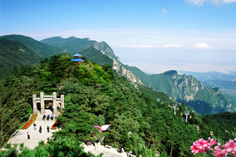](http://en.chinaculture.org/2017-07/18/content_1039558.htm)

[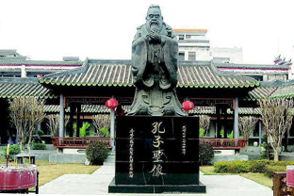](http://en.chinaculture.org/2017-07/18/content_1039604.htm)

[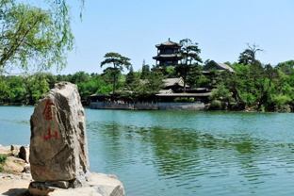](http://en.chinaculture.org/2017-07/18/content_1039568.htm)

[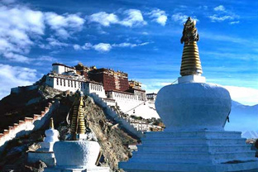](http://en.chinaculture.org/2017-07/18/content_1039538.htm)

[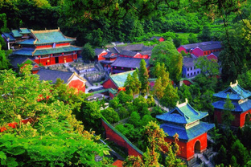](http://en.chinaculture.org/2017-07/18/content_1039495.htm)

[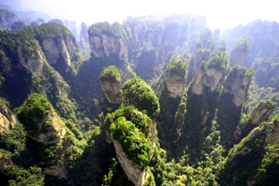](http://en.chinaculture.org/2017-07/19/content_1039985.htm)

[](http://en.chinaculture.org/2017-07/19/content_1039967.htm)

[](http://en.chinaculture.org/2017-07/19/content_1039942.htm)

[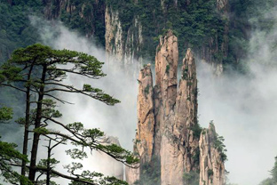](http://en.chinaculture.org/2017-07/19/content_1039994.htm)

[](http://en.chinaculture.org/2017-07/18/content_1039610.htm)

[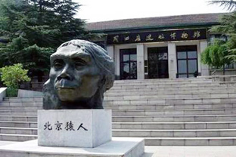](http://en.chinaculture.org/2017-07/18/content_1039592.htm)

[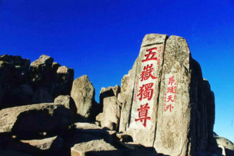](http://en.chinaculture.org/2017-07/19/content_1039998.htm)

[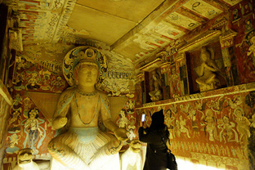](http://en.chinaculture.org/2017-07/18/content_1039563.htm)

[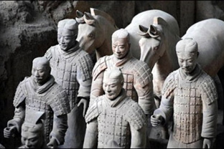](http://en.chinaculture.org/2017-07/18/content_1039561.htm)

[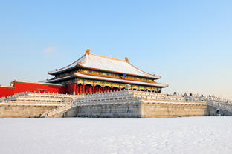](http://en.chinaculture.org/2017-07/18/content_1039544.htm)

Copyright 2018. All rights reserved. The content (including but not limited to text, photo, multimedia information, etc) published in this site belongs to China

CHINA-UNESCO-INTERFAITH-TOURISM in occasione del 10° Anniversario del WIHW

ROSA DALMIGLIO—Member of CICE-CHINA INTERNATIONAL CULTURAL EXCHANGE offered to WORLD INTERFAITH HARMONY WEEK_ IN OCCASION OF 10°ANNIVERSARY 2020