Civility: key to harmony amid diversity

COFFEE WITH WARREN, with Warren Harbeck

*Cochrane Eagle*, February 7, 2019

“We as people of faith have a very important role to play” within our ethnically and religiously diverse society. We must act in ways that reflect “kindness, compassion, mercy and love” – ways that reflect civility – if we are to be “a beacon of hope in an often-cruel world.”

So spoke Calgary **Mayor Naheed Nenshi** at Tuesday’s Prayer Breakfast sponsored by the Calgary Interfaith Council and hosted by Beth Tzedec Congregation as part of United Nations World Interfaith Harmony Week (Jan. 31-Feb. 7).

Mayor Nenshi was addressing a gathering from across the Calgary area’s rich religious spectrum on the theme, “I Choose Civility: Listening, Caring, Engaging.”

“I worry about how the lack of civility impacts the rest of our lives,” the clearly concerned community leader said. Amidst “increased tribalism, how do we go to a place where each of us is looking out for the wellbeing of all?”

To start with, we must reject negativity and divisiveness and embrace “the spirit of humility,” he said, then concluded his remarks as a Muslim speaking in a Jewish synagogue by quoting the prayer of the Christian Saint Francis of Assisi:

“Lord, make me an instrument of Your peace; where there is hatred, let me sow love….”

Mayor Nenshi’s words well reflect the vision of the Calgary Interfaith Council (CIC), of which I’m honoured to be a member. It was formed in 2017 to represent “the hope of religious leaders for a new and re-energized interfaith effort that would more effectively harness the wisdom and good works” of the Calgary-area’s religious communities “for the greater good.”

Its membership share the core values of “respect for religious diversity, compassion for those in need, building bridges of understanding, and fostering interfaith relationships through education, dialogue, mutual worship experiences, and social justice.”

This is all about the practice of civility in the home, workplace and public arena.

“The Calgary Interfaith Council functions on the principle that listening, caring, and engaging others with respect and humility are essential to building healthy and harmonious relationships among people of all faiths and backgrounds,” the preamble to the CIC’s Civility Pledge declares (see attached).

“Hospitality is central to all religious and ethnic traditions. Civility is the most basic ingredient in hospitality. As such it is the virtue that sustains a pluralistic society. Civility makes it safe for us to live together and learn to celebrate our differences so that we may experience the benefits of diversity.”

Yes, and I’m sure you, my coffee companions, will agree with the ten points on the CIC Civility Pledge. Give it some thought, and if you so choose, go to their website, [calgaryinterfaithcouncil.org](http://www.calgaryinterfaithcouncil.org/), and sign a copy.

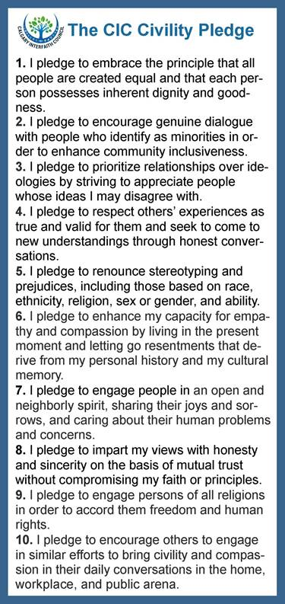

© 2019 Warren Harbeck

COFFEE WITH WARREN with Cochrane Eagle columnist Warren Harbeck, Ph.D.

“Connecting people and ideas”

Box 567, Cochrane, Alberta, Canada T4C 1A7

Phone/Fax: (403) 851-0174

E-mail: [JoinMe@coffeewithwarren.com](mailto:JoinMe@coffeewithwarren.com)   Web Site: [www.coffeewithwarren.com](http://www.coffeewithwarren.com)