Calgarians asked to back civic civility
Chris Nelson, For The Calgary Herald
January 26, 2019
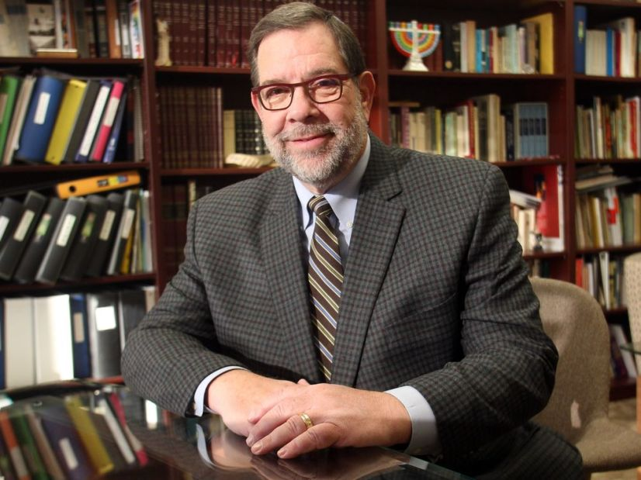
Rabbi Shaul Osadchey is leading this year's interfaith week in Calgary. Postmedia

Calgarians are being urged to take a civility pledge as part of this year’s interfaith celebration week that kicks off on Thursday with an opening ceremony at Calgary City Hall.
It is the third time the event has been held in the city. In its inaugural launch, the interfaith celebrations won the United Nations gold medal for the best such event worldwide.
Now representatives of all faiths in the city have decided to expand the range of activities to include a more secular component by asking clergy to lead the push to get Calgarians to sign a civility charter as a way of re-establishing a more inclusive and well-mannered dialogue between individual and groups.
Rabbi Shaul Osadchey, spiritual leader of the Beth Tzedec Congregation and chair of the interfaith week, said those Calgarians signing the pledge will agree to prioritize relationships over ideologies by striving to appreciate people who hold different views, welcome diversity of opinion and culture, renounce stereotyping and prejudices and let go of past resentments.
“This idea arose due to the decline of civility in politics here in Canada and most dramatically in the United States,” he said. “If people don’t speak to each other, then things will continue to fragment in our society.
Story continues below

“Our goal is to promote understanding and respect and to do that you have to be able to speak to people in a way that affirms their own value and worth. When we speak to others we are there to learn and understand and to care.
“These values are ones we teach in all of our religious traditions and we are trying to promote the fact these are applicable as well in people’s personal lives and their relationships. In a healthy relationship, one has to learn how to speak with other people.”
Clergy will be using the various prayer services across the city during next weekend to urge their collective congregations and followings to sign the pledge. It is also available for Calgarians who are not part of any religious group to sign by visiting calagaryinterfaithcouncil.org.
Osadchey said since the launch of the first interfaith week in 2017 interest has steadily increased across Calgary and he expects to see that momentum continue with the varied activities that will follow the official launch on Thursday at 6.30 p.m. at a ceremony inside the atrium at city hall.
Mayor Naheed Nenshi and Premier Rachel Notley are pledging support for the week on behalf of both the city and province.
In addition to promoting the signing of the civility pledge across all faith groups, organizers have also introduced an interfaith breakfast to this year’s agenda. It will be hosted at Beth Tzedec, 1325 Glenmore Trail S.W., on Feb. 5, 8-9.30 a.m. The theme will be I Choose Civility: Listening, Caring and Engaging.
“We believe the breakfast will truly reflect that prayer is not the sole domain of one particular denomination but that God hears the prayers of everyone,” added Osadchey.
The week concludes with a dinner hosted by The Church of Jesus Christ of Latter-day Saints at 2021 17 Avenue S.W., 6-8 p.m. on Feb. 7.
Calgary interfaith celebrations are the part of UN World Interfaith Harmony Week and join with similar efforts throughout Canada and the rest of the world to promote peaceful coexistence in the face of intolerance, prejudice and conflict.
The city’s interfaith council said that during the last couple of years great strides have been made in creating dialogues and educational programs to foster greater understanding, harmony and respect among all faiths in Calgary.

