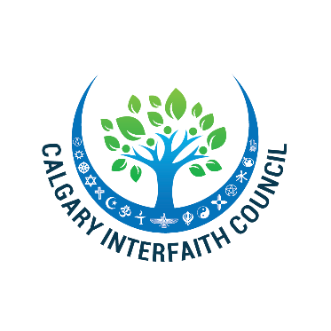

2019 UN World Interfaith Harmony Week is here!
Please join us for these important opportunities to:
- express your support for interfaith harmony and respect!
- Speak out about civility for your February 1-3 sermon!
- discover new ways to engage with other faiths!
- network with religious leaders from Calgary’s diverse interfaith community!

Please join us for these exciting events:

- Opening Ceremony- January 31st at 6:30 pm at City Hall Atrium devoted to the theme of “I Choose Civility: Listening, Caring, and Engaging.”
- Interfaith Prayer Breakfast- February 5th at 8:00 am at Beth Tzedec Congregation. Keynote speaker- Mayor Naheed Nenshi, on Civil Discourse.
- Closing Dinner- February 7th at 6:30 pm at the Church of Latter-Day Saints on 17th Ave. featuring dialogue, YYC Drummers, and launch of the Civility Pledge

Please find the WIHW Visa and Civility Pledge attached. We ask you to publicize these events to your members and encourage their attendance.
For additional information, contact Rabbi Shaul Osadchey at rabbi@bethtzedec.ca or at 403-255-8688.

From the CIC Interfaith Team:
Malik Ashraf, Pastor Wallace Bomhuse, Sister Ger Curran, Rev. Debra Faulk, Rabbi Mark Glickman, Dalton Harding, Rev. Dave Holmes, Rev. Adrian Martens, Rabbi Shaul Osadchey, Imam Azfar Rizvi, Imam Fayaz Tilly

