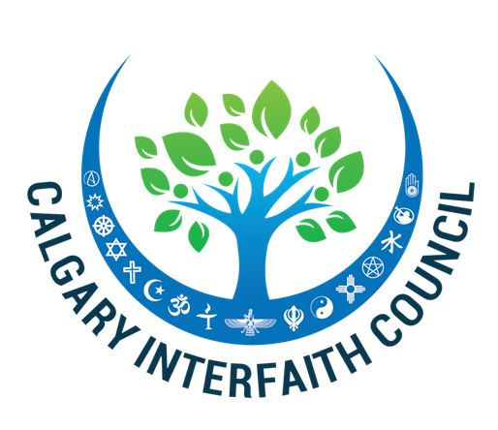
LEADERSHIP TEAM

Co-Chair
Rabbi Shaul Osadchey

Secretary
Imam Fayaz Tilly

Treasurer
Sister Ger Curran

Dialogue
Pastor Wallace Bornhuse
Rev Adrian Martens

Education
Rabbi Mark Glickman

Worship
Cantor Russell Jayne

Social Justice
Rev. Debra Faulk
Rev. Dave Holmes

CONGREGATIONAL
MEMBERSHIP ROSTER

Al-Madinah Calgary
Islamic Assembly

ABT Synod, Evangelical Lutheran Church in Canada

Beth Tzedec Congregation

Bethany Care Society

Calgary Jewish Federation

Church of Jesus Christ of Latter-day Saints

Deer Park United Church

Knox United Church

Roman Catholic Diocese
Of Calgary

St. Lawrence
Anglican Church

Temple B’nai Tikvah

Unitarian Church

2019 UN World Interfaith Harmony Week

Report by the Calgary Interfaith Council

To Your Majesty King Abullah II, HRH Prince Ghazi bin Muhammad,
Dr. Minwer Al-Mheid, distinguished judges and members of the Royal
Aal-al Bayt Institute:

We are honoured and pleased the share our successful celebration of the 2019 UN World Interfaith Harmony week as part of the global effort to increase respect, understanding and cooperation among the great world faith traditions.

Our report reflects the theme of this year’s program, “I Choose Civility: Listening, Caring, Engaging,” which impacted the nearly 2,000 people who attended a variety of events throughout the week.

We extend our appreciation to the staff of the UN WIHW whose resources and encouragement added to the success of our program.

Tel: 403-255-8688 ext. 2
Fax: 403-252-8319
rabbi@bethtzedec.ca
www.calgaryinterfaithcouncil.org

1325 Glenmore Trail SW
Calgary Alberta
T2V 4Y8
Canada

Calgary Interfaith Council

UN World Interfaith Harmony Week
February 1-7, 2019

“I Choose Civility: Listening, Caring, Engaging”

This year’s UN WIHW generated considerable anticipation of another inspiring week of interfaith events whose goal is to continue to build upon the foundation of harmony and respect established from our 2017 and 2018 programs.

The Calgary Interfaith Council (CIC) selected as its focus the growing decline of civility in personal relationships and in public discourse. The concern emanates from the stark display of incivility in American politics and the fear of its spread to Canada and elsewhere. Thus, the theme of our week was “I Choose Civility: Listening, Caring, and Engaging.”

As part of this effort to increase the awareness and the practice of civility, the CIC launched the “Civility Pledge” campaign (see attached) to educate people about the value of civility, what civility is in action, and then to sign the “Civility Pledge” for presentation to city and provincial leaders in advance of upcoming elections. Mayor Naheed Nenshi was one of the first to sign to the “Civility Pledge.”

The planning process for the CIC’s World Interfaith Harmony Week began initially in August, 2017 with monthly meetings followed by weekly meetings during the last two months. Over 25 clergy and religious lay leaders, representing the Baha’i, Buddhist, Christian, Hindu, Jewish, Muslim (Sunni, Shi’a, and Sufi), Sikh, and Unitarian faiths regularly attended these planning sessions. This level of interfaith cooperation was remarkable in itself.

We are proud of the presence of active clergy and laity from these faiths whose passion is for interfaith work and who devote their time, energy, and resources to enhancing the quality of life for all Calgarians and to creating a global model of interfaith harmony.

The Calgary Interfaith Council, through its highly regarded UN Interfaith Harmony Week program, has resulted in significant organizational growth and progress toward its goal of being the central address and voice of the Calgary interfaith community. Our website (calgaryinterfaithcouncil.org) currently serves as a calendar clearinghouse of all interfaith events in the city as well as a resource for interfaith speakers and for locating houses of worship throughout the area. Due to wonderful recognition as the First Prize Winners of the 2017 King Abdullah II World Interfaith Harmony Award, numerous religious, civic, and social justice organizations in Calgary have reached out to us for collaboration and advice.

A Week of Inspiring Programs and Relationship Building

The Calgary 2019 UN World Interfaith Harmony Week was designed to stimulate learning, dialogue, educational, social action opportunities to all participants based upon the teaching that the world stands upon the foundation of sacred wisdom, a spiritual bond to God, and service to humanity. The programs were spearheaded by the Calgary Interfaith Council with the co-sponsorship of the Calgary Council of Christians and Jews, the Calgary Jewish-Muslim Council, the Habitat for Humanity Interfaith Build Project and the Intercultural Dialogue Institute. They were held at synagogues, churches, and mosques.

January 31st- Opening Ceremony at City Hall with Mayor Naheed Nenshi and Anim Kazim, Member of the Alberta Legislature

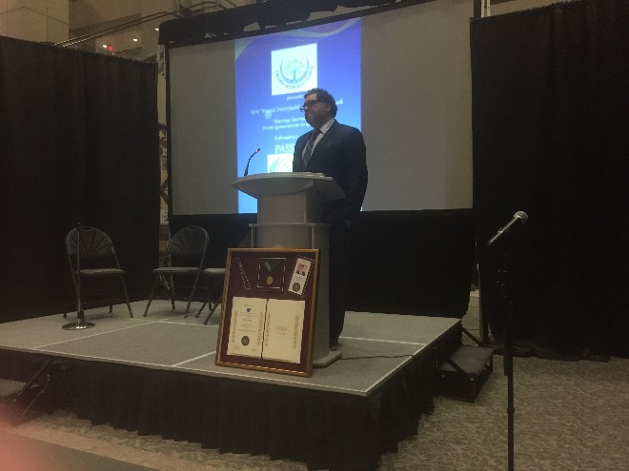

With a growing attendance each year, hundreds of participants were inspired by 15 faith traditions, including the Indigenous People, presentations of proclamations from the City of Calgary and the Province of Alberta by Mayor Naheed Nenshi and MLA Anam Kazim, Indigenous and religious music, and a program that highlighted two models of how civility can be implemented within and beyond the individual house of worship. Rabbi Shaul Osadchey shared the Lil Faider Interfaith Scholar-in-Residence program that fosters religious literacy and Rev. Tony Snow discussed his United Church’s efforts to embrace reconciliation with the Indigenous Peoples.

Display tables from the various faith traditions enabled attendees to learn more about the respective religions and their presence in Calgary. (A video of the ceremony is attached.)

February 1st-3rd Calgary Houses of Worship devote sermons to theme of “Civility and Public Discourse”

February 5th Interfaith Prayer Breakfast - “I Choose Civility: Listening, Caring, and Engaging”; Hosted by Beth Tzedec Congregation and attended by over 125 civic and religious leaders. Mayor Naheed Nenshi was the keynote speaker.
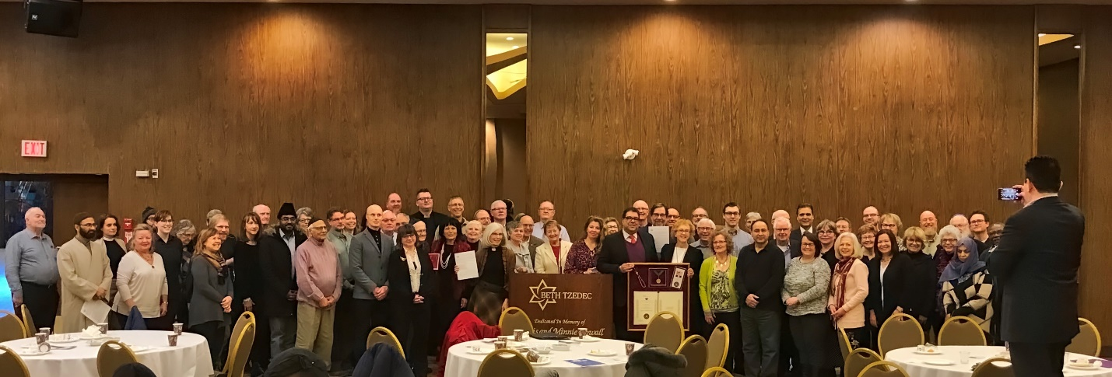

February 7th Concluding Dinner & Celebration of Interfaith Harmony Week; Hosted by The Church of Jesus Christ of Latter-day Saints and attended by over 90 people.

The CIC 2018 UN World Interfaith Harmony week capped off its full program with a celebration of the successful events of the past week along with an eager desire to translate the goodwill and newly created interfaith friendships into future interfaith activities. The joy and energy of the evening was heightened through partaking of a delicious vegetarian meal featuring various ethnic cuisines and prepared by EthniCity, a social enterprise that hires and trains new immigrants to pursue employment in the food and beverage industry. Along with table conversation about the week’s theme of “I Choose Civility: Listening, Caring, Engaging,” the evening featured entertainment by the YYC Drummers.

February 12th My Story at Mt. Royal University This event gives voice to post-secondary students as they have come to understand what faith and religion mean to them and their unique journey and experiences along the way.

Additional Notes about the CIC’s UN World Interfaith Harmony Week:

Through the efforts of the CIC, the observance of the UN World Interfaith Harmony was expanded to the entire province of Alberta. Premier Rachel Notley made the proclamation before the entire Alberta Legislature who voted unanimously to accept it. It is our intention to work toward the adoption of the UN WIHW by the Canadian Parliament.

Each participant was provided a “WIHW Visa” complete with the background information about the CIC, UN WIHW, Proclamations and the schedule of events. (see attached)

Media coverage of the week’s activities- from major newspapers to television to the internet- was extensive in light of our previously success UN WIHW programs in 2017 and 2018. The Calgary World Interfaith Harmony Week program represented a positive antidote to the prejudice, intolerance, and ignorance that had emerged from the darkest corners of society. This event captured the hope and hearts of Calgarians who have come to value diversity and respect for one another as one of the city’s greatest assets.

Attachments:
- Calgary Interfaith Council’s Visa for 2019 UN WIHW
- Civility Pledge
- Opening Ceremony Outline and Video Link
- City of Calgary Proclamation
- Province of Alberta Proclamation
- Media Coverage

We extend our appreciation to the UN World Interfaith Harmony organization for providing encouragement and resources to enable us to demonstrate the strength of interfaith cooperation.

Respectfully submitted,

Rabbi Shaul Osadchey, Co-chair, Calgary Interfaith Council Leadership Team

