Better World Organization celebrated World Interfaith Harmony Week 2019
Harmony Lunch in the Juvenile Center
Under the theme of “If you want to go fast, go alone. If you want to go far, go together” Better World organization for Community Development celebrated WIHW 2019 with different activities. The organization invited young people of different faiths to participate in the activities. We believe on the theme we used for this year; that if we go a lone (which means work or live alone) we are able to go fast but not far! But if we go, work and live together despite of any differences among us we are able to go far and achieve deep goals and create better world where all people live in peace and happiness. That is why, young Yazidis, Christians, and Muslims together celebrated World Interfaith Harmony occasion by working together and implanting activities together to develop their community and create harmony among people of different faiths, ethnicities, and backgrounds.
Juvenile Center in Duhok governorate, Kurdistan region of Iraq has a number of 60 boys’ prisoners from the age of 12 to 18. In addition, to 10 ISIS child solders. The organization believes that supporting this group of people and also raising their awareness about the acceptance of people of different faiths is very important as they are the future of the nations. We wanted to create a moment of hope and harmony among the children of different faiths and ethnicities exist in the Juvenile center through a harmony lunch. The children are eating same food every day in the juvenile center, so we decided to cook traditional famous and special cuisine to celebrate the World Interfaith Harmony occasion.
Better World organization conducted this activity on 11th February, 2019. It was planned to be conducted during the first week of February but due to some legal issues we couldn’t’ make it happen in the first week.
The organization team who consisted of Muslims and Christians prepared and organized the event. The event started with a harmony meal where all the children in the Juvenile center, the management team of juvenile center and the Better World Organization team set together and had a lunch. The children were very happy as many of them were missing such food. After the lunch a small activity conducted where the aim behind World Interfaith Harmony explained to the children and some photos that indicated to the interfaith harmony and peaceful coexistence distributed among them. Some of the children expressed their ideas of what they seen in the photos. In the end four of the children sang songs and created very happy environment.
The organization was not able to take many photos due to the sensitivity of the place and for the protection of the children (Do No Harm).
Photos of the Event:
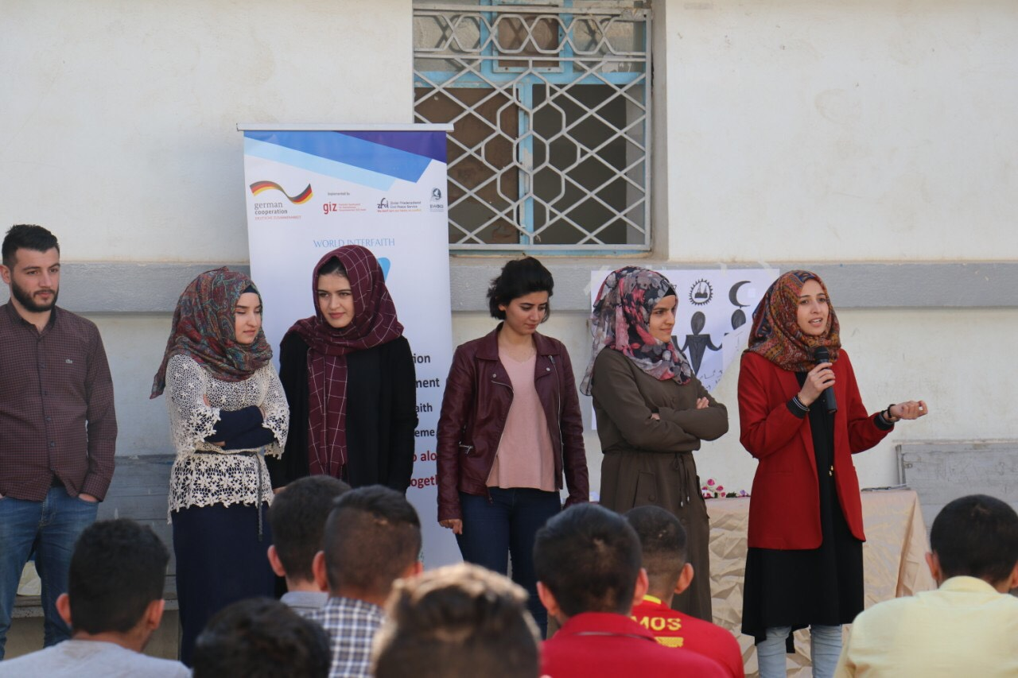
Photo 1: Better World organization team give brief explanation about UN/WIHW
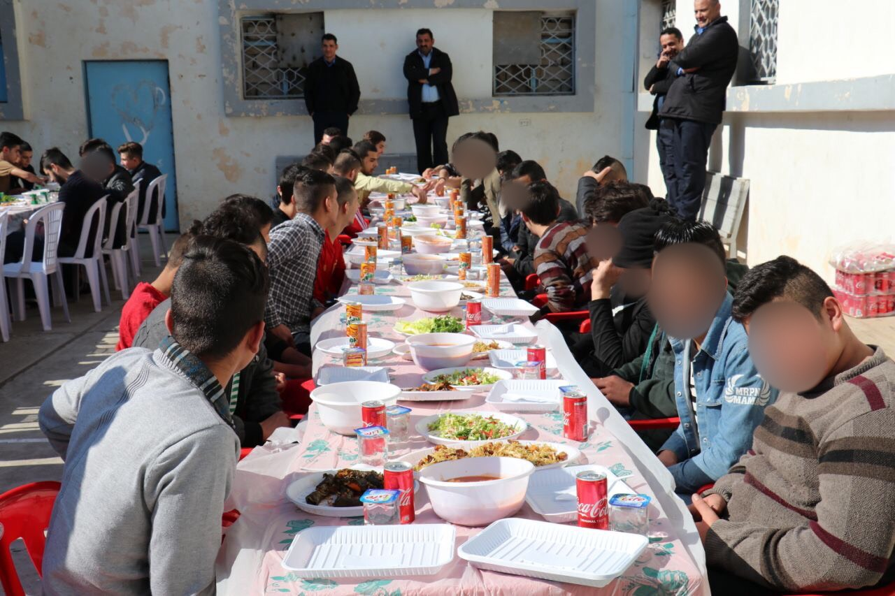
Photo 2: Juvenile Center prisoners setting on the Harmony Lunch. The faces of boys are not visible for the protection of them
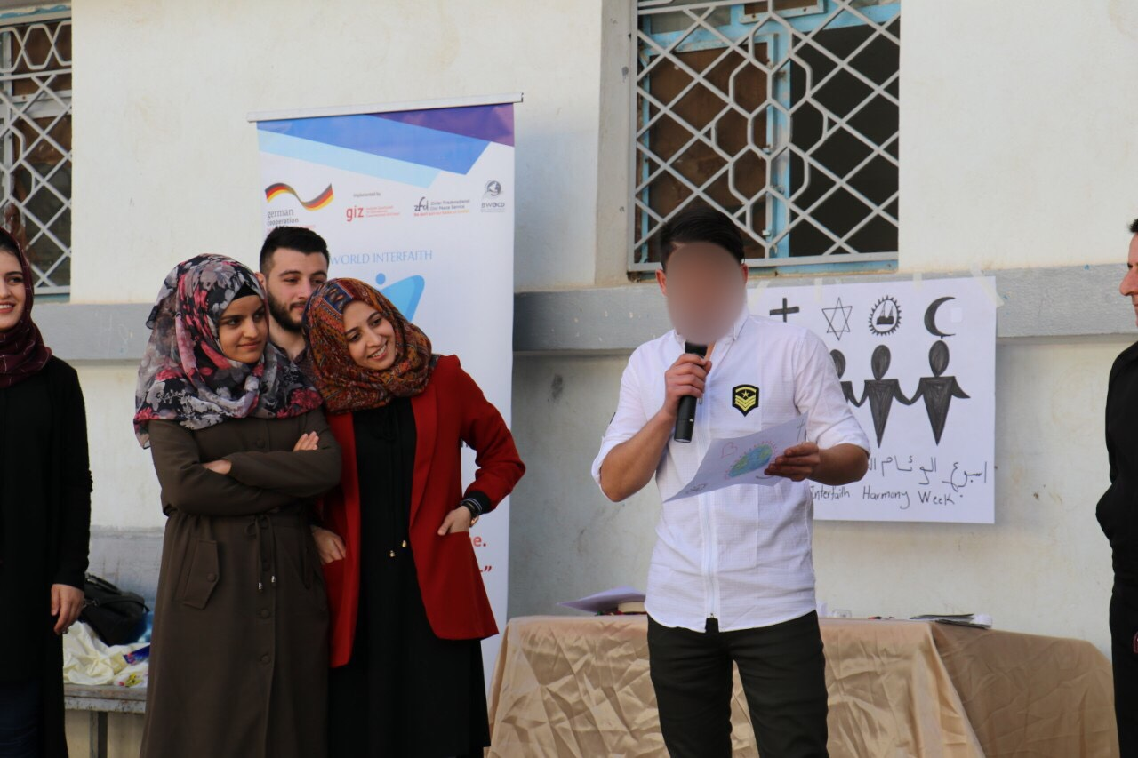
Photo 3: Boys participating in expressing their thought about some interfaith photos shared with them.
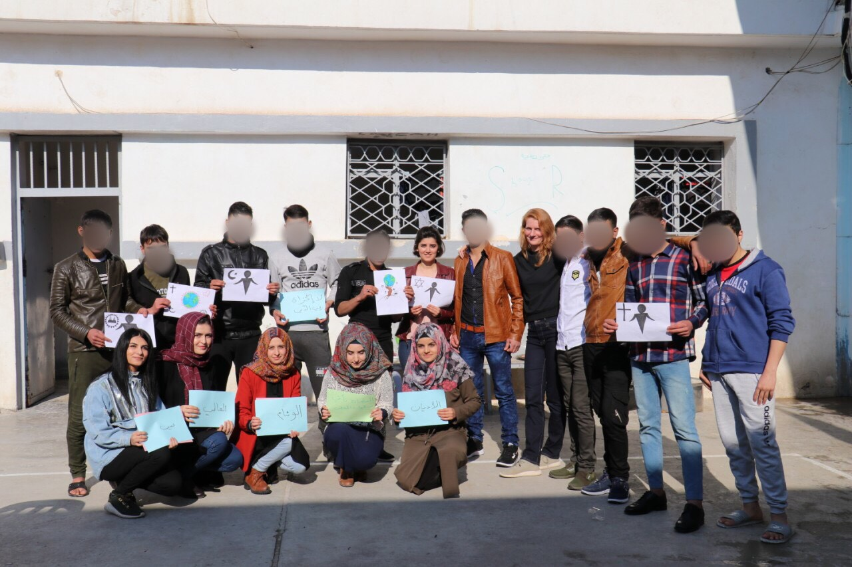
Photo 4: Group photo

