Interfaith Paths to Peace
Presents

The 4th Annual

Community
Interfaith
Peace Concert

A celebration of United Nations
World Interfaith Harmony Week

February 9, 2019

St. Paul United Methodist Church
Louisville, Kentucky

Call To Unity!

This evening’s Peace Concert is to promote interreligious and intercultural music and dialogue for global unity and peace.
There are many who seek to divide people of faith – this
concert intends to bring us all together as one – regardless
of our faiths, traditions, or backgrounds.
May peace and harmony prevail on planet earth!

Presented in partnership with
Sister Cities of Louisville

A special welcome to the students and faculty from the School
of Music at the Universidad de Las Américas (Quito, Ecuador)!
They are in Louisville participating in a reciprocal Jazz exchange program with the University of Louisville, sponsored by Sister Cities of Louisville. They will perform both Jazz and indigenous music
at UofL’s 2019 JazzFest on February 13th and in local schools during their weeklong visit.

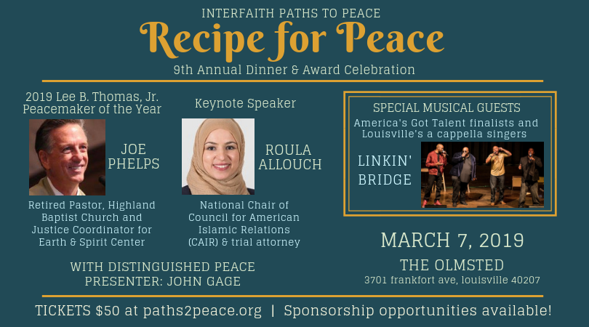

Thank you to our host for this evening’s concert!

St. Paul United
Methodist Church

Words of Welcome

Haleh Karimi
Executive Director, Interfaith Paths to Peace

Master of Ceremonies:
Harry Pickens
Renowned Jazz Pianist & Community Peacemaker

Ahle-e Qulub
Sufi Musicians

Church of Jesus Christ
of Latter-day Saints Choir
Louisville Members

Sulh
Southeast Asian Intercultural Music Ensemble

Gregory Rahming
International Opera Singer

Accompanied by Harry Pickens

Crescent Hill Baptist & The Temple Combo Choir
Led by Dr. Louie Bailey
Members of Temple Choir Shir Chadash
and Crescent Hill Baptist Church Choir

Musicians from Universidad de Las Americas
Students and Faculty from Ecuador & Colombia

One World – One Peace – One Humanity

Closing Meditation
led by Harry Pickens

ANNUAL EVENTS.
ONGOING IMPACT.

World Peace Day – New Year’s Day community gathering calling for global peace.  Community Peace Concert – A United Nations Interfaith Harmony Week event using the music of many faith and cultural traditions to showcase  our shared humanity.  Recipe for Peace Gala – Dinner and awards celebration recognizing outstanding peacemakers in our community.  National Day of Prayer – A call for unity in our nation, held in partnership with Signature Healthcare.  Interfaith Iftar Dinner – Opportunity for the community to join our Muslim friends as they break their fast one evening during Ramadan. | Hiroshima/Nagasaki Peace Lantern Ceremony – Lakeside ceremony with music, reflections & lantern floating in remembrance of the atomic bombing victims & all who have gone before us.  Hunger Walk – Walk/run, organized in partnership with Dare to Care, to raise awareness of hunger in our community.  Bobby Ellis Memorial Vigil to End Hunger – Candlelight vigil to remember the legacy of Bobby Ellis (9-year-old who died of hunger in 1969) by committing ourselves to eliminate hunger in our community.  Community Interfaith Thanksgiving Dinner – In remembrance of the 2015 River Road Mosque defacing, reminding us of the power of unity during times of extremism.

CONTACT US.
GET INVOLVED.

2500 Montgomery St.  Louisville, KY 40212  (502) 214-7322  Facebook:  Interfaith Paths to Peace  Instagram & Twitter: @paths2peacelou  Visit our website &  join our newsletter!  paths2peace.org | 