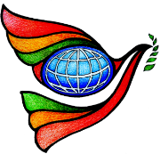
World Interfaith Harmony Week 2019
Ecumenical Prayer
Department of Social Welfare and Development IX,
Conference Hall Zamboanga City February 1, 2019 9:00 am-11:00 am
Sponsored by: Department of Social Welfare and Development

As we celebrate the World Interfaith Harmony Week 2019 with the theme “Celebrating Truth, Sincerity and Forgiveness” the Department of Social Welfare and Development IX conducted their Ecumenical Prayer and celebrated their 68th Anniversary last February 1, 2019 held at the Regional Office, Conference Hall, Zamboanga City.
In our present situation, the Ecumenical prayer aims to bring Muslims, Christians and other living faiths to be in solidarity with all to celebrate the spirit of the World Interfaith Harmony Week and to also help bring Peace to the Community and the Family setting. In this special gathering, three (3) different religious leaders gave their meaningful messages that should be pondered by all.
Fr. Sebastiano D’Ambra, PIME the convener of this weeklong celebration (World Interfaith Harmony Week) and the founder of Silsilah Dialogue Movement emphasized that everyone must reflect about what is happening in our society. We must also spread positivity instead of spreading negativities that is deteriorating the good relationship between Muslims and Christians. Truth, Sincerity and Forgiveness should be always in our hearts so we can do our mission better and together we can do something good.
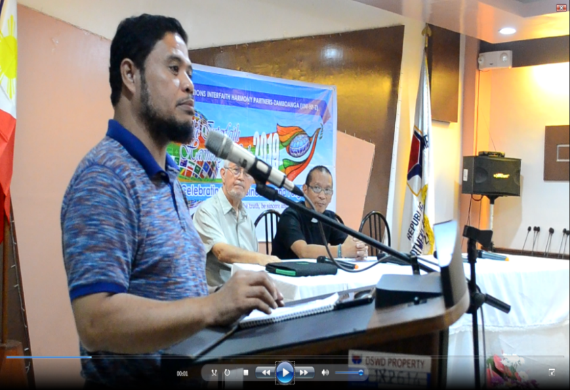
Ustadz Abdulwakil Kasim, from the Ulama Council of Zamboanga Peninsula and the chairman of Ulama Crisis Management Committee pointed out that Islam is a religion of Peace and Islam is for Peace. Misconceptions about Islam is because of social media. However, we must not let other people divide us, Muslims and Christians, who are working together for Peace and for the common good. And lastly, Rev. Arturo A. Veladiez, from the United Church of Christ in the Philippines said that we must always have faith and we have to see the real image of God in us. As faithful human beings, we should discuss the things that unite us and not the things that divide us.
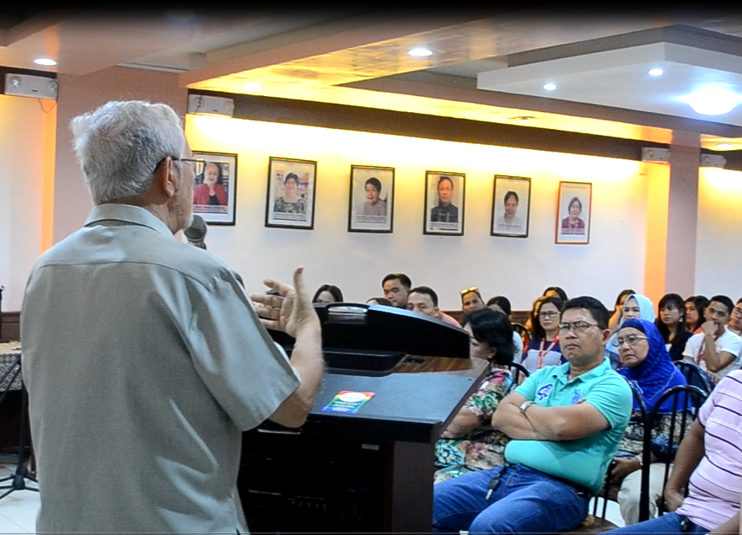
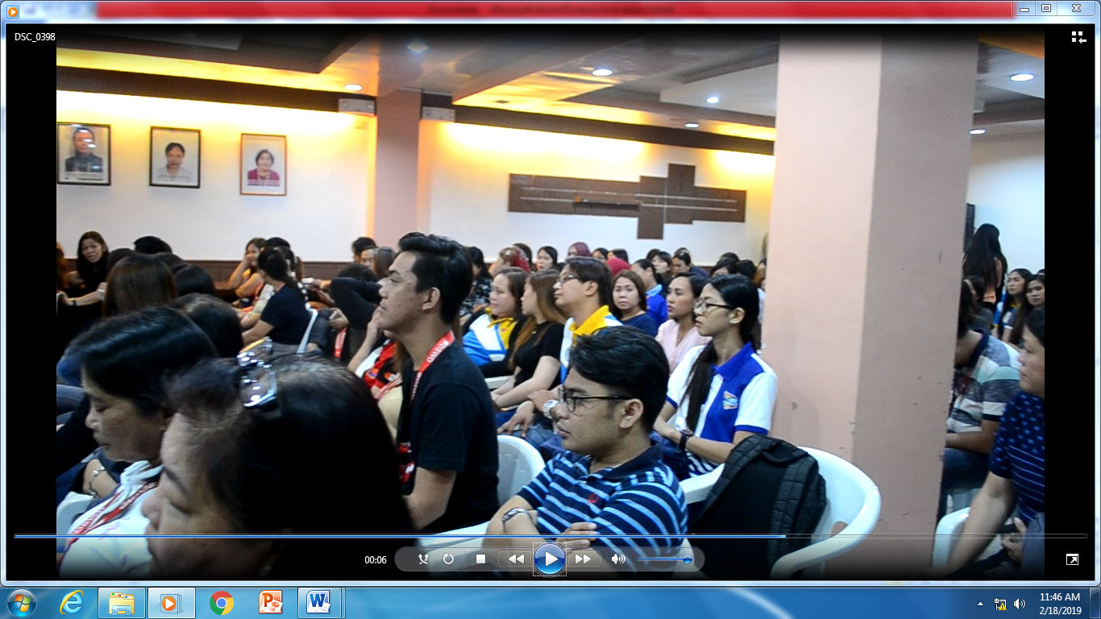

This gathering has brought Muslims, Christians and other living faiths to be as one in this week’s special celebration and to continue to work together for Peace. In addition, we must be Truthful and Sincere in everything that we do and Forgiveness should be always in our hearts for us to be a better person.

